Use this model of a cultural iceberg and add your personal experiences with English speaking cultures.
Please save your final iceberg as a pdf file and upload it to Moodle.

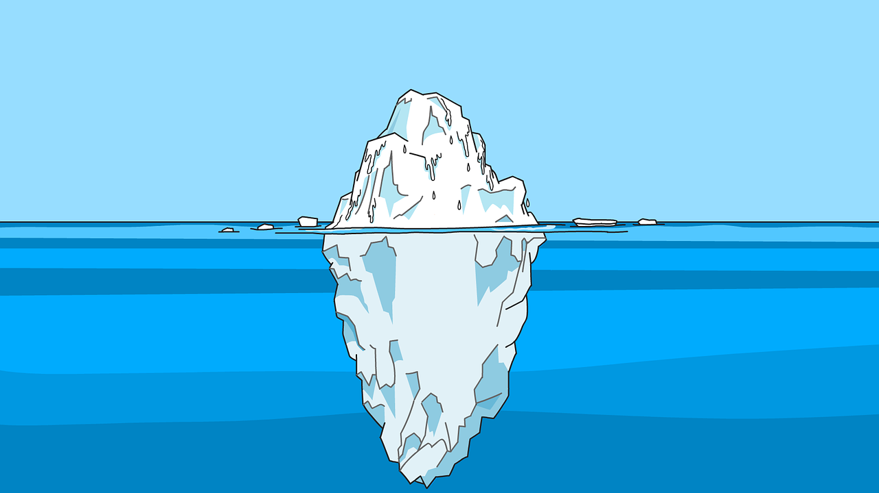
The Cultural Iceberg
Food and Eating Habits
Music Dress
Literature Arts and Crafts Games, ……. Dance
Celebrations and Customs
Surface Culture
Deep Culture
manners and etiquette punctuality and time concept of beauty religious belief
facial expression and eye contact tone of voice
body language and touching cleanliness
showing emotions nature of friendships
attitudes towards elders and children

role of group and individual
competition or cooperation
gender roles
definition of obscenity
core values

