Teaching Literature &

Promoting Intercultural Competence



J. Schumm
WS 2017-18

Teaching Literature & Promoting Intercultural Competence

COURSE OBJECTIVES
- To help you to develop thoughtful and principled approaches to using literature and promoting intercultural competence in the language classroom
- To provide you with tools for developing your own classroom materials and for using them in a way that is relevant to your learners
- To present ways of using literature which will help learners to improve their English
- To expand your knowledge of high-quality young adult literature (YAL) by reading new works specifically written for young adults
- To introduce approaches that can be used to build intercultural understanding in the EFL classroom.

MATERIALS
Handout provided by the teacher, selected reading and exercises. Resource books as well as children and YAL can be found in the course’s HAPP and on moodle.

ASSESSMENT In order to successfully complete the course you must:
- Attend the course regularly (3 absences = “nicht genugend”)
- Prepare materials for using a literary text in the classroom
- Give an in-class presentation of a young adult novel (in groups of 3-4)
- Write online reviews of 4 children/young adult literature (moodle platform)
- Design a class reading project (in pairs)

GRADING PLAN Coursework will be weighted as follows:
10% preparation of materials for literary text (uploaded to moodle), 10 % in-class presentations, 30 % online reviews and 50 % class reading project.

PREPARATION OF CLASSROOM MATERIALS FOR A LITERARY TEXT
For this task, you will be required to choose a literary text (e.g., short story, poem, excerpt from a novel, a novel) that you would like to use in the language classroom and decide on the age group/level that it could be used with most effectively. You should then prepare a double lesson or a sequence of lessons in which you would use the text. Your lesson plan(s) should include: overall rationale, steps (pre-, while- and post-reading tasks) and rationale behind them. In class, you will be required to present the rationale behind your reading activities in small groups and other students will have the chance to try them out and give you feedback. Afterwards, you should upload your materials and lesson plan to our moodle site.

IN-CLASS PRESENTATION OF A YOUNG ADULT NOVEL
For this task, you will be required to work in groups of 3-4 and give a clearly structured presentation of a young adult novel to the class. We will discuss various approaches to giving a book presentation in class which you will be encouraged to apply in the activity. You can use powerpoint, but it should not be your only visual. Length: max. 15 minutes.
Your presentation should 1) include creative elements (visuals, acting, etc.), 2) give a clear picture of the main characters and the conflicts they have to solve as well as the main themes of the novel, 3) actively involve the audience and 4) close with an evaluation of the novel.

ON-LINE REVIEWS OF CHILDREN & YOUNG ADULT LITERATURE
In order to expand your knowledge of literature written for children and young adults, you will be required to read 4 children/young adult novels (2 books for years 1-3 and 2 books for years 4-8) and write short reviews of them on moodle. Your choice of book should not include any books you have read for your presentation and group reading project.
The purpose of the review is to critically evaluate the text, not just inform readers about it. You will be required to fill in the following sections on moodle.
- Plot Summary: Remember that your audience has not read the work. What kind of summary can you provide of the main points or main characters that will help your readers gauge their interest? What are the main issues in the book? What genre does the book belong to? Who is the intended age group? Don’t forget to include: the book title, author’s name, number of pages and year published in the heading.
- Teacher’s Perspective: How could you use the book in the language classroom? What level/age group would you use the book with? What are the themes? What books could you combine with it?
- Your Evaluation: What worked well for you? What major themes does the book introduce, and how effective are they? Did the book appeal to you on an emotional or logical level? Does the author’s text adequately reach the intended audience? On a scale of 1-5, how many stars would you allot the book? Why?
CLASS READING PROJECT
This project will be done in pairs. You will be required to design a reading project that includes a choice of 3-4 books dealing with the same theme. Details on how to setup the project will be discussed in class. See the course HAPP for student samples. For the reading project, you will be required to hand in two parts:

- A short introduction (5 pp.) which includes short summaries of the books, reasons for choosing books and theme, intended age/level and rationale for the pre-, while-, and post- reading activities.
- The reading project packet for the class (copiable materials) which includes teacher’s instructions and required materials. The reading project should be divided into three sections: pre-, while- and post-reading activities. Approx. 3-4 activities should be prepared for each section.

PARTICIPATION
Participation is an essential and required part of this course. Class time will be used primarily to discuss and apply, rather than to lecture about, course concepts. Attendance alone does not constitute participation. Participation includes 1) preparing reading assignments and materials for literary texts on time, 2) taking an active role in class discussions (posing questions, taking risks in answering questions, providing examples, etc.) and 3) supporting classmates in group work.

KEEPING UP WITH WORK
If you miss a class, do NOT contact your teacher to find out what you missed. You should find someone in class who can tell you what we did. Contact person’s name: _____________

DEADLINES
Deadlines are extremely important for teachers. Make sure you finish your work on time. However, students who have a good cause may request an extension to an assignment deadline. Extensions should be requested BEFORE the hand-in deadline.
The following criteria will be used to assess your project: Use these criteria for your self-assessment
Assessment | 1 | 2 | 3 | 4 | 5 | 6 | 7 | 8 | 9 | 10
Preparation of materials for literary text
10p
You have designed pre-, while- and post-reading activities for a literary text with a specific age group/level in mind and have uploaded it to moodle.

Due date: Nov. 14 (in-class) and Nov. 21 (online)

In-class Presentation of a Young Adult Novel: (groups of 3-4) 10p

You have presented a YAL book in your group.
Your presentation
- includes creative elements (visuals, acting…),
- gives a clear picture of the main characters of the novel and the conflicts they have to solve,
- actively involves the audience,
- is clearly structured,
- and ends with an evaluation of the book.

Due date: Dec. 5 and Dec. 12

Additional reading of children’s books and YAL + Online Reviews
30p (5+5+10+10)

In addition to the book you present in class and the books you read for your class reading project, you have to read at least
2 books for lower school (yrs 1-3) and
2 YAL books for years 4-8 and write short reviews of them on Moodle.
Due date: by Jan. 9

Class Reading Project: (in pairs) 50p

You have designed a class reading project that includes a choice of 3-4 books.
Your project includes 2 parts : 1) a short introduction (5 pp) including book summaries, rationale for choice of book/theme, intended age group and rationale behind tasks 2)the project package for the students (copiable materials) and short teacher’s instructions

Due date: Feb. 3

Active participation
You have participated actively in class discussions, group-work as well as online activities.
Final Grade:
10=excellent, 9=very good, 8=good, 7=average, 6=fair, 5=poor, 4-0=very poor - no evidence

Tentative Course Outline
Session | Content | Homework
(1)  Oct. 10 | Introduction: course overview  Using Literature in the Language Classroom | Read: Examining the reasons for using literature and What is Young Adult Literature? by Blasingame
(2)  Oct. 17 | Choosing a young adult novel for in-class presentations  Approaches to using literature in the EFL classroom | Pick novel and sign up on moodle  Read: Selecting Texts by Nuttall
(3)  Oct. 24 | Evaluating Literature for Classroom Use | Read: A picture book is worth a thousand words by Hempel
(4)  Oct. 31 | Getting started: Using picture books and exploring suitable tasks for beginners | Read: Playful learning with short plays by Surkamp OR Poetry in the Intermediate Classroom by Albers
(5)  Nov. 7 | Working with literary texts in the language classroom: short stories, poems, plays | Prepare pre-, while-, and post- reading tasks for a literary text
(6)  Nov. 14 | Sharing Materials and giving feedback in small groups  Setting up and designing group reading projects | Upload lesson plan and materials for a literary text  Finish reading novels for in-class presentation
(7)  Nov. 21 | Reading Circles: discuss books for in-class presentation  Creative ideas for book presentations | Prepare presentation  Read: Teaching Young Adult Fiction by Matz and Stieger
(8)  Nov. 28 | Group Reading Projects: discussion of class reading projects (theme, structure, choice of books)  Other creative ideas  Using booklets: the pedagogy of the blank sheet  Reading diaries and reading logs  Lapbooks | Decide on theme for group reading project, age group, possible books
(9)  Dec. 5 | Book presentations
(10)  Dec. 12 | Book presentations | Finish on-line book reviews
(10)  Jan. 9 | Promoting Intercultural Competence in the EFL Classroom | Read: Developing the intercultural dimension by Byram et al
(11)  Jan. 16 | Promoting Intercultural Competence in the EFL Classroom
(12)  Jan. 23 | Promoting Intercultural Competence in the EFL Classroom | Finish group reading project
(13)  Jan. 30 | Extended Office hour
Unit 1: Using literature in the language classroom 
What is literature for you?
Task 1) A group of teachers from all over the world was asked to answer this question. Read some of their responses and then write your own.

- Literature is ‘feelings’ and ‘thoughts’ in black and white.
- Literature is the use of language to evoke a personal response in the reader or listener.
- Literature is a world of fantasy, horror, feelings, visions . . . put into words.
- Literature means . . . to meet a lot of people, to know other different point of views, ideas, thoughts, minds . . . to know ourselves better.

Literature …

Task 2) Below are a few quotations which ‘define’ literature and have certain implications for the approach we adopt to using literature in the language classroom. Read the quotations (A-D) and then match them with the corresponding implications (1-4).

Definitions of Literature

A. Literature could be said to be a sort of disciplined technique for arousing certain emotions.

Iris Murdoch, The Listener, 1978

B. Literature is the question minus the answer.
Roland Barthes, NYT, 1978

C. Literature, fiction, poetry, whatever, makes justice in the world. That’s why it is almost always on the side of the underdog.
Grace Paley, Ms, 1974

D. In the allocation of the label ‘great literature’ to a literary work we cannot be making a judgment which is objective or factual, however much we like to think that we are. A value judgment is constituted by the social and historical conditions which determine our particular ideology. The teachers and professors who have the power to decide which books make up an English Literature syllabus reflect in their choices, . . . a fundamental structure of beliefs and interests which reflect the particular culture or section of society into which they were born
and in which they grew up.
Brumfit & Carter, 1986, p.17

Implications for approach to teaching

- Literary texts have a powerful function in raising moral and ethical concerns in the classroom. The tasks and activities we devise to exploit these texts should encourage our students to explore these concerns and connect them with the struggle for a better society.

2. The texts traditionally prescribed for classroom use may generally be accorded high status, but often seem remote from, and irrelevant to, the interests and concerns of our students. In fact, being made to read texts so alien to their own experience and background may only increase students’ sense of frustration, inferiority and even powerlessness. We therefore need to select texts for classroom use which may not be part of the traditional literary canon, but which reflect the lives and interests of our students.

3. Literature provides wonderful source material for eliciting strong emotional responses from our students. Using literature in the classroom is a fruitful way of involving the learner as a whole person, and provides excellent opportunities for the learners to express their personal opinions, reactions and feelings.

4. We should not expect to reach any definitive interpretation of a literary text with our students. Rather we should use the text as the basis for generating discussion, controversy and critical thinking in the classroom.

Task 3) Discuss the following questions in small groups. Be prepared to report back on the most important points that were raised in your group.

- What has your experience been like so far concerning literature in the language classroom? Consider your school experience, teacher training, classroom observations.

- What types of literature did you encounter in school? During teacher training?

- How important of a role do you think literature should have in the language classroom?

- Do any of the thoughts or ideas mentioned in the previous activities seem relevant to your teaching now or in the future? If so, why? In not, why not?

- How do you think literature can be used most effectively in the language classroom? Consider various age groups, types of schools.

- Why do you think some language teachers are hesitant to using literature?

Add your own questions:

Why use literature in the language classroom?

Task 4) Below is a list of reasons for using literature with the language learner. Think about which reasons are the most important. Then list your reasons in order of importance (1-highest, 12-lowest). Once you have finished compare your responses and explain the reasons for your rankings.

Literature should be used with students because:
_______ it is very motivating.
_______ it is authentic material.
_______ it has general educational value.
_______ it is found in many syllabuses.
_______ it helps students to understand another culture.
_______ it is a stimulus for language acquisition.
_______ it develops students’ interpretative abilities.
_______ students enjoy it and it is fun.
_______ it is highly valued and has a high status.
_______ it expands students’ language awareness.
_______ it encourages students to talk about their opinions and feelings.
_______ it prepares students for their university studies.
Are there any other reasons for using literature that you want to add to this list?

Task 5) Read the text Examining the reasons for using literature (on moodle site) which discusses some of the reasons for using literature in more depth. Then decide whether you would still rank the reasons for using literature in the way that you did.



(Materials in Unit 1 pp. 6-8 adapted from: Lazar, G. (1993). Literature and Language Teaching. A guide for teachers and trainers.)

Unit 2: Approaches to using literature with the language learner

Task 1) Below are descriptions of three possible approaches* to using literature with the language learner, the methodological principles underlying each one and some notes about the selection and organization of the material they use. Read through all of them and then together with a partner draw up a list of some of the advantages and disadvantages for each approach.

*Each approach has been dealt with separately for clarity’s sake. In practice, a combination of practices is often used. Using literature to enhance intercultural understanding is often integrated into all 3 approaches.

A language-based approach
- Methodological Assumptions – Studying the language of the literary text will help to integrate the language and literature syllabuses more closely. This approach sees literature solely as language practice material, where the focus is on the language used in the literary text, and incorporating practice tasks which activate language skills. The primary aim is to use literary texts as a resource for stimulating language activities.

- Selection and Organization of Material – Material is chosen for the way it illustrates certain features of the language and can be used as a resource for stimulating language activities.

Literature as content
- Methodological Assumptions – This is the most traditional approach, frequently used in tertiary education. Literature itself is the content of the course, which concentrates on areas such as history and characteristics of literary movements; the social, political and historical background to a text; literary genres and rhetorical devices, etc. Students acquire English by focusing on course content, particularly through reading set texts and literary criticism relating to them. The mother tongue of the students may be used to discuss the texts, or students may be asked to translate texts from one language into the other.

- Selection and Organization of Material – Texts are selected for their importance as part of a literary canon or tradition.

Literature for personal enrichment
- Methodological Assumptions – Literature is a useful tool for encouraging students to draw on their own personal experiences, feelings and opinions. It helps students to become more actively involved both intellectually and emotionally in learning English, and hence aids acquisition. Excellent stimulus for group work.

- Selection and Organization of Material – Material is chosen on the basis of whether it is appropriate to students’ interests and will stimulate a high level of personal involvement. Material is often organized thematically, and may be placed alongside non-literary materials which deal with a similar theme.

Task 2) Look at the following advantages and disadvantages of using each approach and match them with the appropriate one.
Advantages
- Students are helped to develop response to literature through examining the linguistic evidence in the text. They are encouraged to draw on their own knowledge of English, so this approach may provide useful exposure to, or revision of, grammar and vocabulary in interesting new contexts. It is a way of justifying the inclusion of literature in the language syllabus since it fulfills students’ main aim – to improve their knowledge of the language.

- Involves learner as whole person, and so is potentially highly motivating. Demystifies literature by placing it alongside non-literary texts.

- Genuinely educational approach in that understanding of texts is enhanced by situating them within their literary and historical contexts. Students are exposed to a wide range of authentic materials.

Disadvantages
- May demand a personal response from students without providing enough guidance in coping with various linguistic aspects of the text. Students may have difficulty responding meaningfully to some texts because the texts are too remote from students’ own experience. Alternatively, some groups of students may dislike having to discuss personal feelings or reactions.

- If applied too rigidly, so that analysis of the text is undertaken in purely linguistic terms with little chance for personal interpretation, this approach could become very mechanical and demotivating. Also, it may not pay sufficient attention to the text’s historical, social or political background which often provides students with valuable cultural knowledge to interpret what they read.

- This approach may be most appropriate to a fairly select group of ‘literary-minded’ students. Material may be very difficult linguistically, and therefore demotivating for the average student. The approach may rely too heavily on the teacher to paraphrase, clarify and explain, resulting in very little student participation. A large part of the lesson may be carried out in the students’ mother tongue, with students dependent on ready-made interpretations from the teacher.

Task 3) Now think about students you are teaching or will be teaching in future.
- Would you use literature with them?
- If so, what approach(es) do you think would be most suitable? Why?
- Would you use any particular genre with them? Why?
A language-based approach to using literature
Task 4) Below are a few language-based activities which make use of a literary text in the classroom. Read through them and discuss the following questions:
- What is the teacher’s main aim in using this activity?

- For which of the activities do you think the teacher’s aim could have also been achieved by using a non-literary text? What particular advantages might there be in using literary texts instead of non-literary texts to teach or revise a particular language aspect?

- Are there any activities which you think would help students to improve their competence in reading a literary text?

- Think about some of the activities or techniques that are commonly used in the classroom (e.g., True/False questions about a reading comprehension; finding synonyms for new items of vocabulary etc.). Write down at least 3 techniques that are used. Can you use any of these techniques and activities to exploit a literary text with your students? What would be your objectives be?

Activity 1
Students are given three very short and simple poems in English, but without their titles. They are also given a list of six titles – three genuine and three invented. After reading the poems, they have to decide which title is most appropriate for each poem.

Activity 2
Students are given an extract from a novel or short story in which all of the tenses are removed. They are provided with the actual verbs to fill in. After completing this task, they compare their text with the original.

Activity 3
Students read a dialog from a play or a novel and then improvise their own role play of what happens next.

Activity 4
Students are given a piece of descriptive writing from a novel or short story from which all adverbs and adjectives have been removed. They rewrite the text adding those they think will make the text lively and compare their version with the original. They may use dictionaries for help.

Activity 5
After students have read a novel or short story, they are given three different summaries of it. They have to decide which summary is the most accurate.

Literature as content: How far to go?
This kind of approach examines the history and characteristics of literary movements; the social political and historical background to a text; the biography of the author and its relevance to his or her writings; the genre of the text, etc. Some language teachers would argue that this type of approach should be reserved for the literature teacher rather than the language teacher, and is only successful when used with learners who have a specialist interest in the study of literature. Nevertheless, there are important elements in this approach which can be usefully applied to the teaching of literature in the language class.
Some points to consider when applying this approach
- The amount of background information you give a group will depend on a number of factors: time available, to what extent the text refers to specific historical or mythological events or characters, the interest of the students in the literary characteristics of the text etc.
- When designing materials, you will need to rely on your intuition to some extent concerning what information will help students’ understanding and enjoyment of the text.
- You will also need to consider how you will present the information: before or after the students have read the text, as a mini-lecture, as a reading or listening comprehension or as a research project in which students collect the information themselves and present their findings to the class etc.
- The type of background information you provide will depend on what is relevant or appropriate for the text.

Types of background information:

- Biographical information of the author
- Historical or mythological information
- Philosophical, religious or political ideas that arise in the text
- Places, objects or other texts referred to in a text
- Genre of the text
- Relationship of the text to the literary movements of the time
- Historical, political or social background against which the text was written
- Distinct features of the author’s style
Literature for personal enrichment
In this section we explore ways of encouraging students to draw on their experiences, feelings and opinions when using a literary text.

Situation: You have decided to use literature in your 3rd form class at a local gymnasium to introduce unit 7 of More. It deals with the topic of friendship. There are 17 kids in the class (10 boys, 7 girls) between 12-13 years old. One boy joined the class in September, but is well integrated.

Task 5) Look at the pre-activities and poems and discuss the following questions:
- What is the purpose of the pre-activities? Which one do you feel is most effective? Can you come up with other activities?
- While-reading activities?
- Post-reading activities? Try to integrate skills.
- Would you have any reservations about doing this task with this class? If yes, why?
Pre-activities:
- Think about your best friend. What qualities make him/her a true friend? Tell your partner about them.

- A new kid has joined your class. Write down the three most important pieces of advice you think s/he should consider in order to make new friends. Discuss in pairs or groups. Do you all agree?

- To have good friends you must be a good friend. Look at the list below and tell your partner which points are most important for you to be a good friend. Would you add any other points?

- Good friends listen to each other.
- Good friends don't put each other down or hurt each other's feelings.
- Good friends try to understand each other's feelings and moods.
- Good friends help each other solve problems.
- Good friends give each other compliments.
- Good friends can disagree without hurting each other.
- Good friends respect each other.
- Good friends are trustworthy.

Poems:

A Time to Talk - Robert Frost

When a friend calls to me from the road
And slows his horse to a meaning walk,
I don't stand still and look around
On all the hills I haven't hoed, to hoe - hacken
And shout from where I am, 'What is it?'

No, not as there is a time to talk.
I thrust my hoe in the mellow ground, hoe – die Hacke
Blade-end up and five feet tall,
And plod: I go up to the stone wall
For a friendly visit.

Friendship – Shel Silverstein
I’ve discovered a way to stay friends forever -
There’s really nothing to it.
I simply tell you what to do
And you do it!

True Friendship - Samantha Sumler

True friends are for life
Until the end
They're more than special
They're your bestest friends.

They're the ones you can go to
When you're in despair despair - Verzweiflung
The ones that'll help you
Even when you got gum in your hair!
They're the ones who'll laugh
And go laughing with you all through the night
The ones who'll help you
Help you with all their might
To have a good friend
You have to be one
So be nice to one another
So you can be friends forever
And that's how to be the best friend you can be.
Possible Post-reading Task: Friendship Recipes

Create “Friendship” recipes using friendship-related words for the special ingredients. Provide students with examples of real recipes so their writing can be put into a recipe format.

Recipe for Friendship

You’ll need:
1 cup Humor
2 ears for Listening
2 cups Patience
6 cups Love
1 1/4 cup Humor
a pinch of Fun

In a large bowl mix the Time and Patience together until blended evenly. Add one cup of the Humor, two Ears, and the entire six cups of Love. Mix in the remaining quarter cup of Humor and sprinkle a pinch of Fun over the mixture. Bake carefully for 20 years at 200°F. Makes enough friendliness to last a lifetime!

Unit 3: Selecting and evaluating materials

In this unit, we will focus on how to select texts and materials which are suitable for use with your students.

Task 1) Compare your list of criteria for selecting literary texts based on Chapter 10 ‘Selecting texts’ from Nuttall’s book Teaching Reading Skills in a foreign language.

Task 2) Then discuss the following questions:
    - Which criteria are the most decisive for you?
    - How would you go about selecting texts?
    - To what extent do you agree with Nuttall (1996) when she says:

“[R]eadability in the broad sense is not just a matter of language. It depends also on other factors… Most important of all are the familiarity with the topic, cultural background, the conceptual complexity of the content and the interest it has for the reader. A text that grips a reader will carry him/her along in spite of its difficulty [on the language level].” (p. 176)

Selecting Texts
When deciding on using a literary text with your students, you should consider three main areas:
- The type of course you are teaching
- The type of students who are attending the course
- Certain factors connected with a given text
Task 1) In groups of 3, come up with a course profile of students. To get you started think about groups you have already taught, are teaching at the moment or are going to teach in the future. Make notes about the students using the boxes below and add any other information you find necessary. Try to be as specific as possible.

Type of Course

Level of students:
Students’ reasons for learning English:
Kind of English required on the course: (e.g., General English, English for Specific Purposes (Business, Technical), English for Academic purposes

How intensive is the course? (e.g., three hours a week for a year, two hours a day for four months, etc.)

Is there a syllabus? Yes No
Is it flexible? Yes No
Is literature included? Yes No

Can you include literary texts on this course? Why/Why not?

What kinds of texts will be most suitable? Short stories? Poems? Novels? A full-length play? Why?

Type of Students

Age of students:

Interests/hobbies of students:

Cultural or ethnic background/nationality of students:

Students’ previous experience of reading literary texts:

Linguistic proficiency:

Intellectual maturity:

Task 3) Working in groups of three, collect one copy of texts A, B and C as well as three copies of text D. Decide on who will read A, B and C. Everyone should read text D. Then use the scales below and mark how far you think your texts compare against the values on the scales. For example, if you think that your students are too old to enjoy your text, you mark it towards the end the scale which says ‘too old to enjoy text’.

Age of students

too old to enjoy text ---------------------------------------------------------- too young to enjoy text

Intellectual maturity of students

too developed to find ---------------------------------------------------------- too immature to find text challenging understand text

Students’ emotional understanding

too developed to be --------------------------------------------------------- too immature to
challenged by the text relate to text

Students’ linguistic proficiency

too advanced to be -------------------------------------------------------- too elementary to cope challenged by the text with the text

Students’ literacy background

too well-developed to be ------------------------------------------------------ insufficient to cope challenged by the text with the text

Students’ interests/hobbies

far removed from themes/------------------------------------------------------ close to themes/ content of text content of text

Students’ cultural background

too remote from text to ---------------------------------------------------- close enough to text for help comprehension easy comprehension

Task 4) After you have completed the scales, finish the following sentences. Then discuss in your rankings and evaluations of the texts in your groups. What conclusion can you draw?

- I would/might try using Text(s) _________ with my students because _________________________________________________________________________

- I’m not sure if I could use/I would not be able to use Text(s) ____________ with my learners because ___________________________________________________________

- I think my students need a text that ___________________________________________

A checklist of criteria for choosing literary texts

Type of course
- Level of students
- Students’ reasons for learning English
- Kind of English required
- Length/intensity of course

Type of students
- Age
- Intellectual maturity
- Emotional understanding
- Interests/Hobbies
- Cultural background
- Linguistic proficiency
- Literary background

Other text –related factors
- Availability of texts
- Length of texts
- Exploitability
- Fit with syllabus

(materials in units 2 & 3 adapted from: Lazar, G. (1993) Literature and Language Teaching.)

Unit 4: Reading is fun!!

- Make reading an everyday topic. Reading is fun. Reading is cool. WE all read.
- Read stories in relaxed atmosphere. Read stories as a special treat after hard work.
- Create a class library:
- Start reading whole books (picture books, stage 1 readers) as early as possible.
- Use reading logs and reading diaries to keep track of Ss reading.
- Give credit to book reports and reading
- Invite students to present books regularly, reserve space for book recommendations on pin-board.
- Create reading circles to discuss books.
- Use books for active vocabulary expansion.
- Allow as much free choice as possible. Consider different reading tastes and reading abilities.

Purpose of reading

Brainstorm the multiple purposes of reading in the foreign language classroom.

How do we read?
- Skimming: quickly running one's eyes over a text to get the gist of it.
- Scanning: quickly going through a text to find a particular piece of information.
- Extensive reading: reading longer texts, usually for one's own pleasure. This is a fluency activity, mainly involving global understanding
- Intensive reading: reading shorter texts to extract specific information.

NOTE: The different ways of reading are not mutually exclusive.

Example: We often skim through a passage to see what it is about before deciding whether it is worth scanning a particular paragraph for the information one is looking for. In real life reading purposes vary constantly. Therefore, exercise types should also vary according to the text studied and the purpose of reading it. It would be highly artificial to work on a page of classified ads and propose exercises that require detailed reading of every single advertisement.

You don't have to know every single word in a text.

- Read the text and try to understand the general meaning of the story. (All the words in italics are nonsense words.)

A country girl was walking along the snerd with a roggle of milk on her head. She began saying to herself, 'The money for which I will sell this milk will make me enough money to increase my trund of eggs to three hundred. These eggs will produce the same number of chickens, and I will be able to sell the chickens for a large wunk of money. Before long, I will have enough money to live a rich and fallentious life. All the young men will want to marry me. But I will refuse them all with a ribble of the head - like this . . .'
And as she ribbled her head, the roggle fell to the ground and all the milk ran in a white stream along the snerd, carrying her plans with it.

1. Now look at the nonsense words again. Can you guess what they might mean?
Would you feel comfortable to read a text with as many unknown words?

The 5 Finger Rule: Students read the first and second page of a book and use their fingers to count the number of unknown words that they cannot easily guess from the context. If the number exceeds 5 unknown words per page, the text is probably too difficult for joyful reading.

Improving students’ confidence: Encourage “top-down” reading skills rather than focusing on every unknown word: Fast reading activities help students gain confidence and focus on content and gist.

Fast Reading:
Basic skimming. Give Ss 30 seconds to "read" a text, collect info on board. Give them 2 - 3 minutes to read the text again (1 page), collect inf. on board. Ask Ss to write a 50 word summary of the text (in groups). Only then allow them to read the text slowly!

Try out fast-reading with the following text:

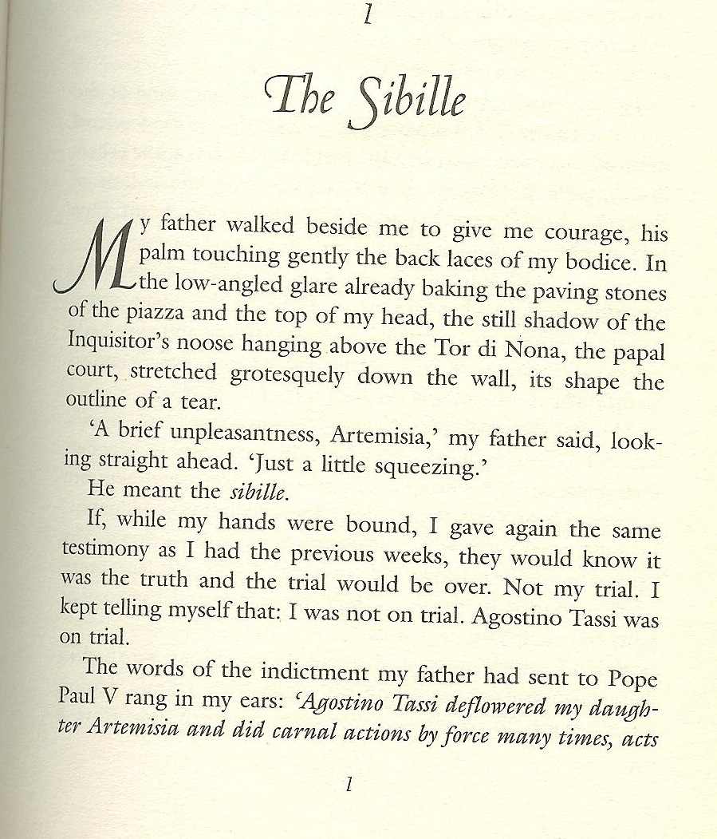
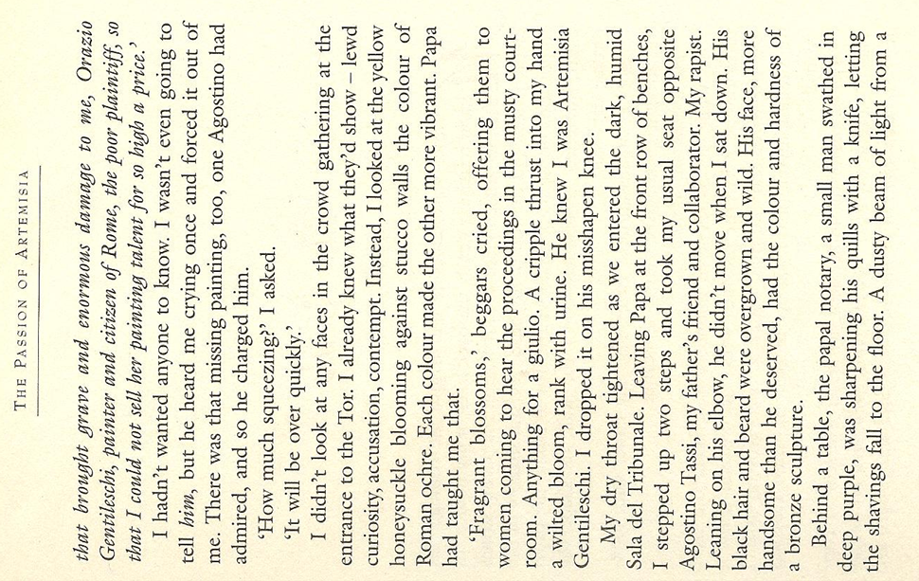
Classroom procedures:
Important: Reading is a silent activity --- encourage silent reading.

Why? Work with a partner and collect arguments why students should read silently and on their own.

Can you think of any exceptions? When and where would it be meaningful to read a text aloud?

Constructing reading comprehension exercises

Pre-reading
Purpose: Creating a reason to read (awaken interest/expectations) or give some idea of the content before the students see the text.
Prepare difficult vocabulary before students see the text.

While reading
Start with global understanding and move towards detailed understanding.
Don't ask too many questions - don't "kill" the text.

Post reading:
Design a follow-up activity. Don't separate reading comprehension from the other skills. A follow-up oral or written activity will give the reading text a purpose.

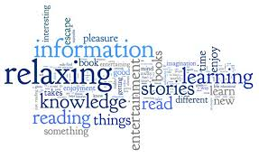

(materials on pp 18-26 adapted from Lis Pölzleitner’s handout .)

Unit 5: Getting Started - Story time for Beginners

Pre-reading activities
- Pictures: Show a picture related to the text. Students guess what the text might be about.
- Kim’s game: Show Ss a picture for about 1 minute (best done projector), then have pupils write down or call out all the details they remember. This can also be done at a later stage in the story.
- Titles, Headlines: Give title. Have students guess what the story might be about. They might start like this: I think …. // I hope ….// I don’t want …..//
- Themes: Pick a theme from the book and have Ss react to it based on their experience, etc.
- Select 4-5 words: Write these words on board. Ss for associated words. What might the story be about?
• Getting in the Mood: This is a guided fantasy. The teacher asks Ss to close their eyes and then describes a picture of the beginning of the literary work. Ss are invited to inhabit this scene in their minds. When the teacher is done describing the scene, Ss are asked to make a note of how they felt, see, say etc. or they could draw/paint a scene.

While-reading and post-reading tasks and activities
- Matching: text and pictures
- Ordering pictures: For picture books, copy picture pages without text (1 set per group), read story, Ss find matching pictures, put them in correct order. Then compare.
- Ordering jumbled sentences or paragraphs: Cut into strips if possible.
- Gap filling: Take any short text, leave out words or phrases. Leave space where the word is missing.
- Picture corrections: Separate the picture and the text. Change the text so that it represents things slightly differently from the picture. Students spot the mistakes and correct the pictures!!!
- Draw a picture: Listen to the story, imagine the scenes in detail, then draw or paint a scene…
- Summary with visuals: Ss can summarize the main events of a chapter/story with drawings, pictures, diagrams etc. and present this as a poster.

Samples of reading tasks for beginners
The Trouble with Gran:
- Gran Tours Travel Agency
Design an ad for Gran Tours Travel Agency. Where can you go? What is the place like? What can you do there? What can you eat there? Use an A4 sheet and design a very nice ad!
- Vocabulary
Choose 5 words or phrases from the book. Try to use them in new sentences.

The Lighthouse Keeper’s Lunch
- Recipes
Mrs. Grinling is a very good cook. These are the ingredients she uses for her delicious food. Which of these ingredients does she need for each dish?
Apples, bananas, bread, butter, cherries, chicken, chocolate sauce, cream, eggs, fish and shrimps, flour, ginger ale, grapes, icing sugar, lettuce, cheese, milk, mustard, orange juice, oranges, peaches, pineapples, potatoes, salt, sausages, sliced cucumbers, sliced tomatoes.
- Write the names of the dishes and the ingredients for each one. Which of the dishes do you like? (1 = the dish you like the best, 8 = the dish you like the least)

Basic reading tasks for beginners
The purpose of these tasks is to make the learners read parts of the text in detail and use some of the new language actively. These tasks should be short and easy – we do not want to spoil the fun of reading.
Find the printable worksheets on www.epep.at  Book Chat:  Choose your favorite page in the book and describe it to your teacher or co-teacher.  What do you see?  What is happening in the picture?  Write a Postcard  Imagine you are one of the characters and write a postcard to a good friend. Tell your friend where you are and what it is like there. (no past tense necessary for this task!) Draw a picture on the front side of your card. | 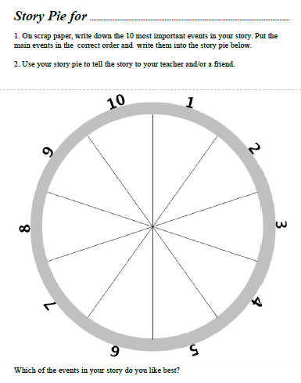
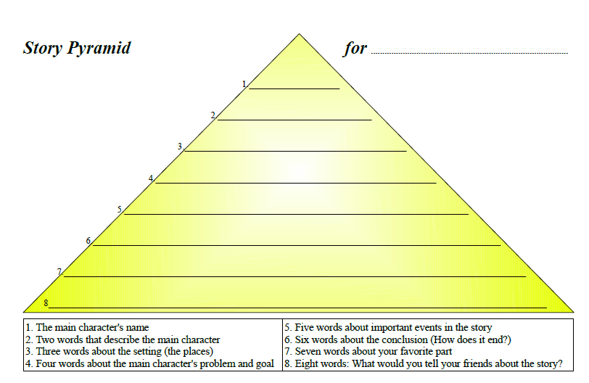 | 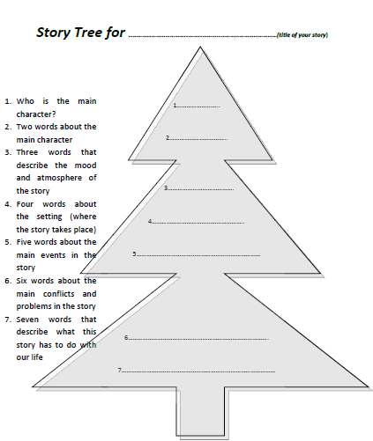
Find this and similar books in our library or get your own copy.

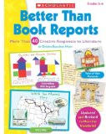
More useful ideas from
Christine Boardman Moen (Boardman Moen 1992)
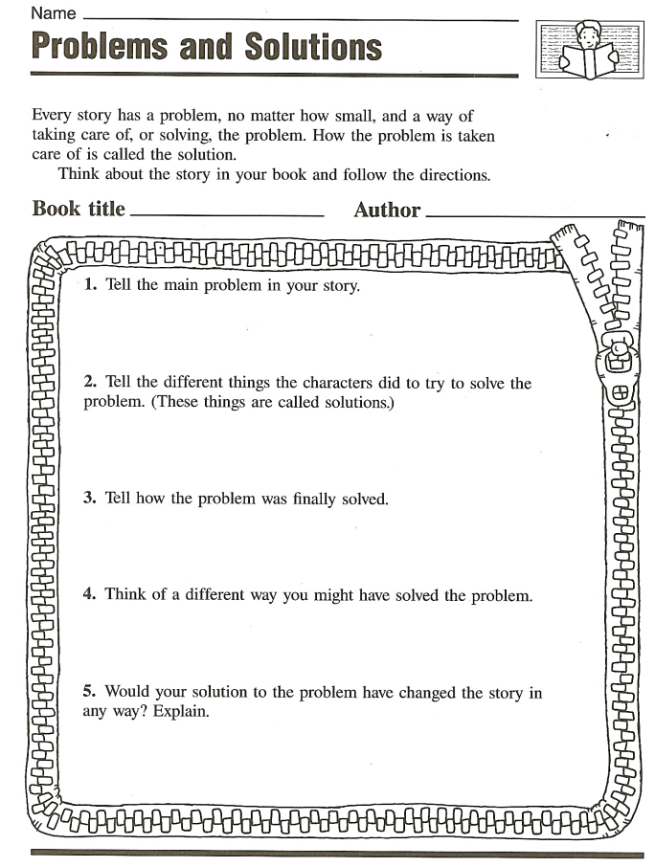 | 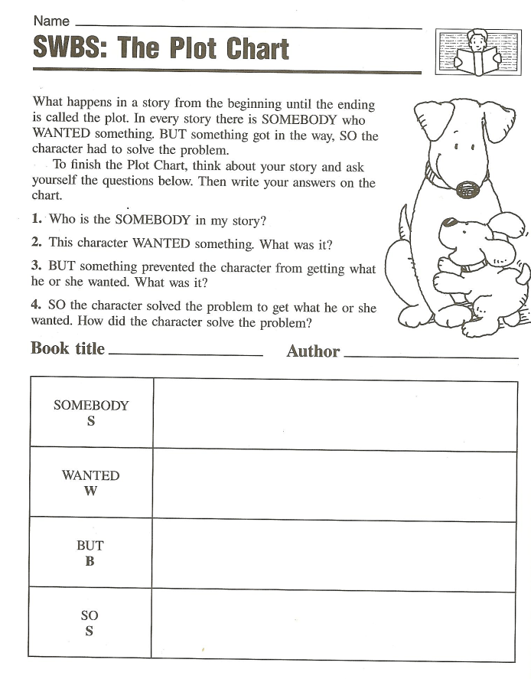
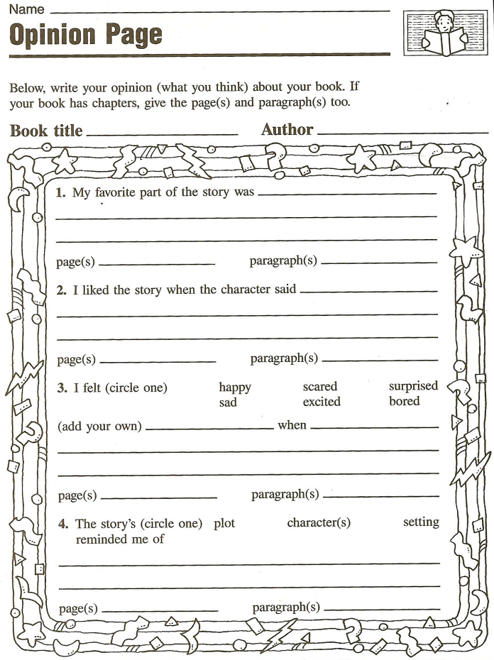 | 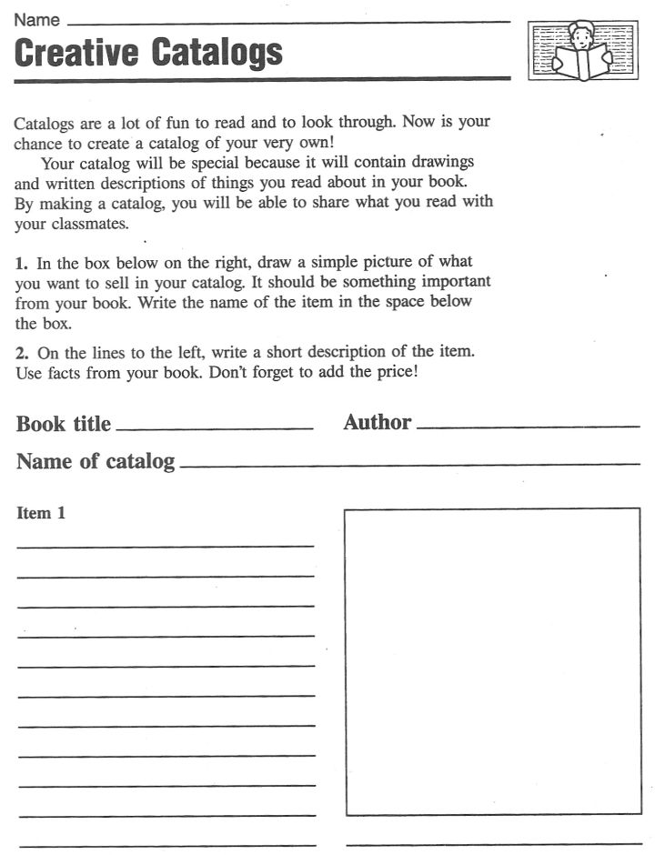  Tip: Groups can design a catalog of several pages for an interesting book.

Exploiting texts for vocabulary expansion

- Choosing vocab phrases: Students choose 3-5 new phrases that they want to remember and write them on vocab cards.

- Lexical Furniture: put the new phrases in suitable places in your house/home. E.g: the verb “to separate” would go into the kitchen, under the sink, because there I separate my waste….

- Connect a Pair: Take 10-12 vocab cards that you want to remember and put them on the desk in front of you. Now form five to six pairs and find some connection for each pair. Example: use both in the same sentence or make up a little story, of match opposites or say how they are alike...

- Word Webs: On an A4 sheet create a web of words around a topic in your story.

- Acrostic Puzzles: Write the title of your book on the page vertically. Then find one fitting word or a short sentence for each letter. Your words should have something to do with the story.

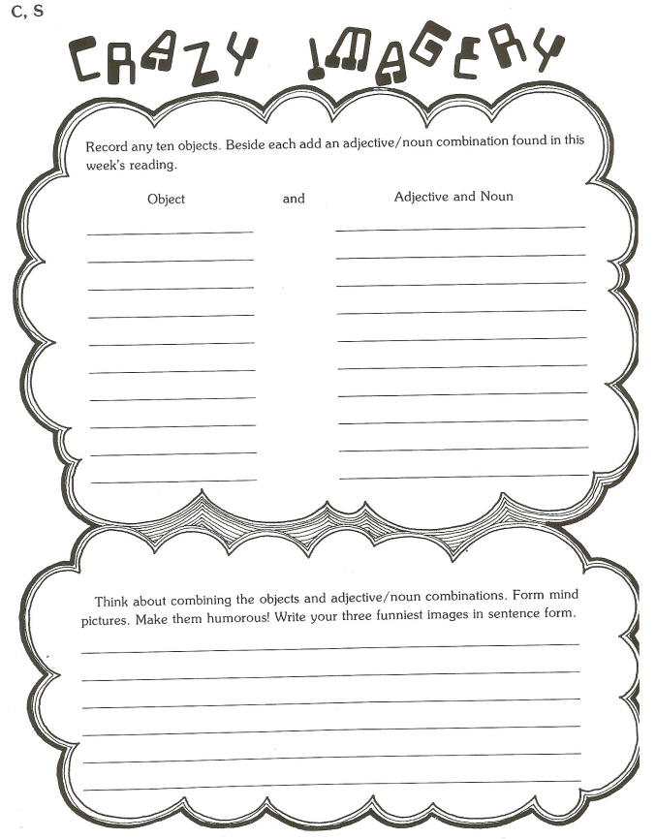
- Personal Properties: Choose 10-15 new words that you want to remember and collect your personal associations with each of them
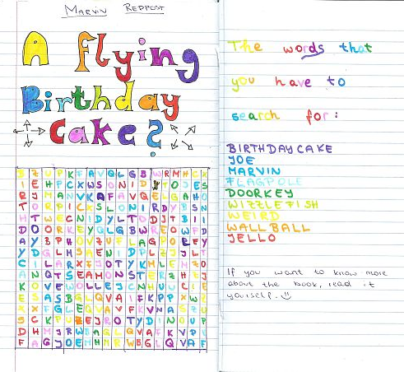
  - Weight
  - Shape
  - Texture

- Wordcycle

- Word Search

- Crosswords

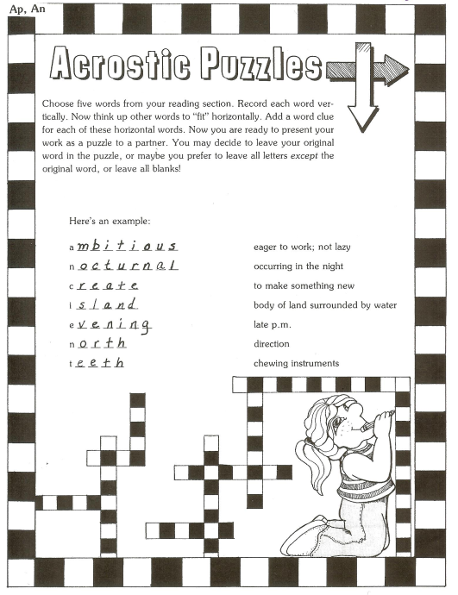
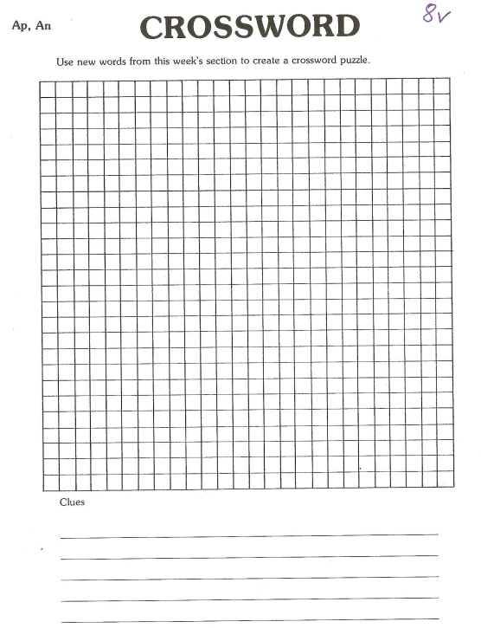

Find these and more great ideas in
J. Szabos, Reading, A Novel Approach, (Szabos 1984)
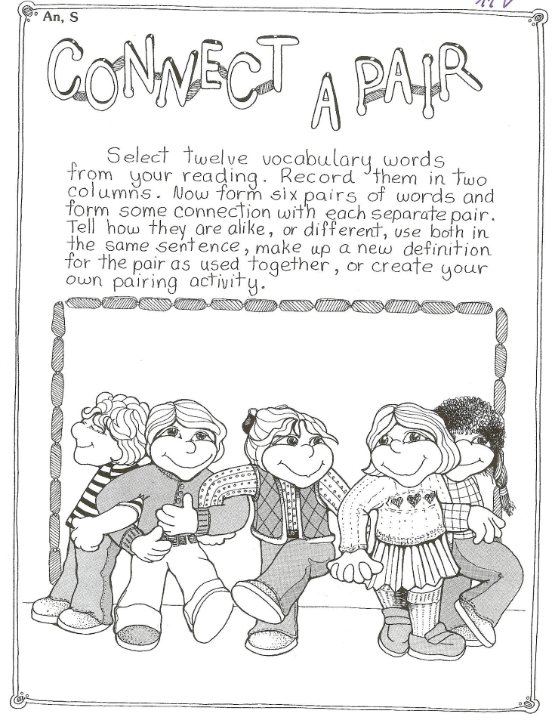 | 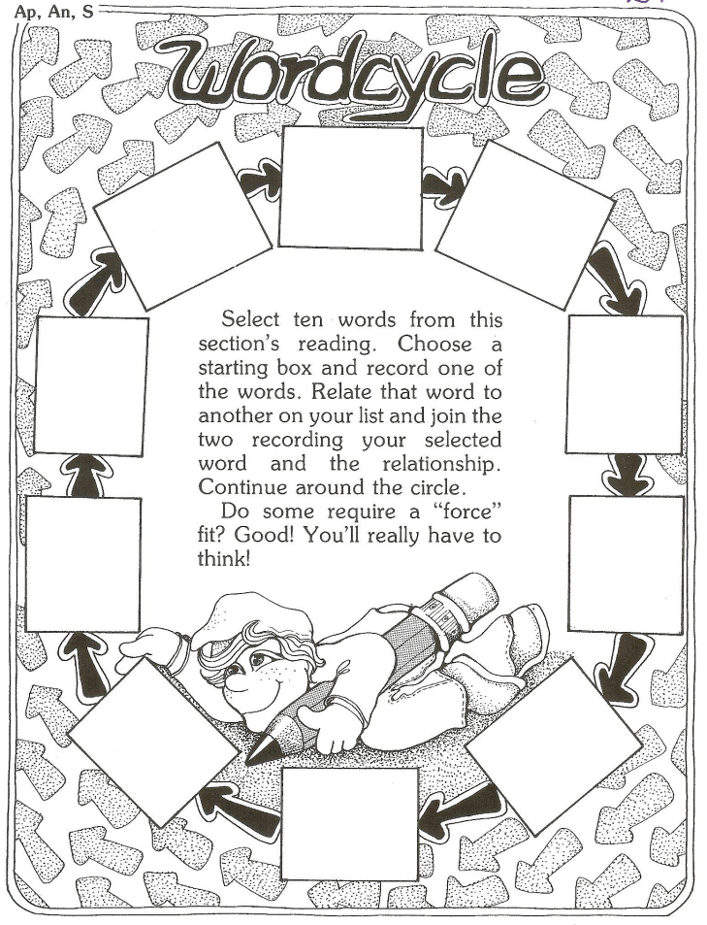
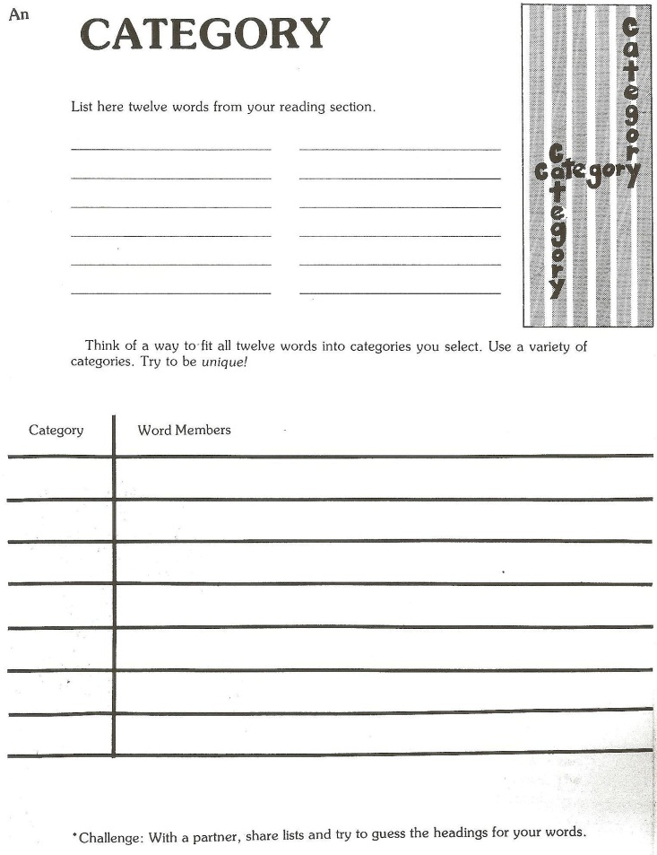  Homework: Go to our library and have a look at the special shelf for our course (Handapparat). Find three to five other interesting reading and vocab building activities and bring copies along to our next session. | 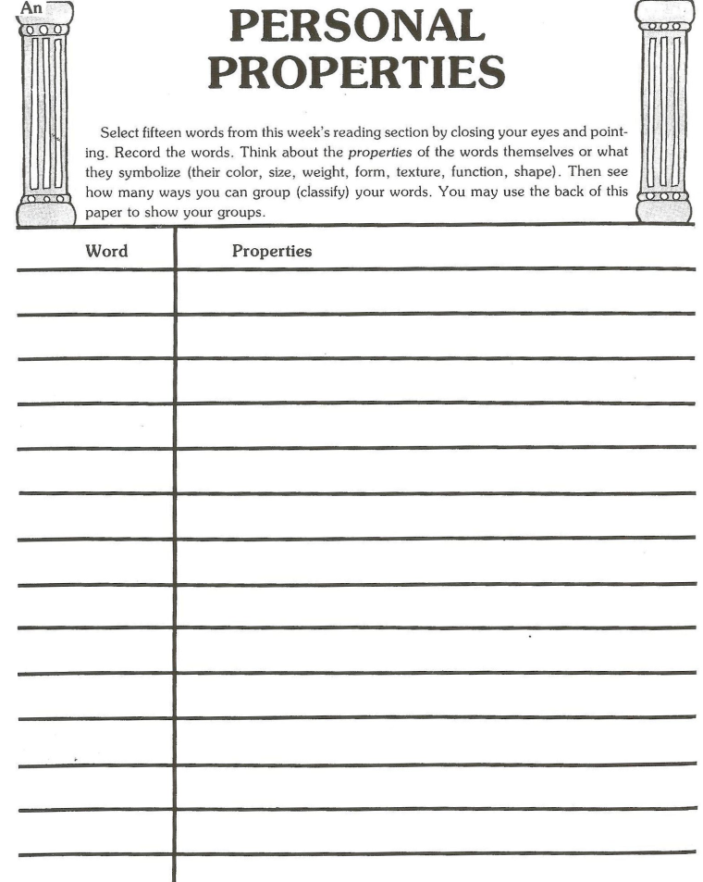

Unit 6: Working with short stories

Why work with short stories?
- Their length means that they are accessible. This means that they can usually be completed within a few lessons.
- They can be less daunting for language learners to read or reread on their own. Students also get the feeling of achievement at having come to the end of a whole text, much sooner.
- Learners are less likely to tire of them.
- There are many subgenres to choose from.
- Language issues are less likely to interfere heavily with reading.

Preparing to work with short stories
According to Paran and Robinson (2016), there are three important points teachers should consider when choosing a short story that they would like to teach.

- Culture – Most stories are embedded in a particular local or national culture. Therefore, teachers need to consider how they will prepare their pupils so that they can better understand them.
Here is a list of some cultural aspects to consider when using literary texts with students:
- Objects or products that exist in one society, but not in another
- Proverbs, idioms, formulaic expressions which embody cultural values
- Social structures, roles and relationships
- Customs/rituals/traditions/festivals
- Beliefs/values/superstitions
- Political, historic and economic background
- Institutions
- Taboos
- Metaphorical/connotative meanings
- Humor
- Representativeness

- Chunking – A very useful technique when dealing with short stories is to present them in chunks or sections. The chunks will often correspond to different paragraphs in the original, and may sometimes correspond to stages or elements in the situation/problem pattern. If possible, copy each chunk on a separate piece of paper, giving it out in the relevant lesson. By chunking the text, it is broken up into shorter, more manageable sections for reading and teaching. At the end of each chunk:
- teachers can ask learners if the chunk is the end of the story? In doing so, you can open discussion about stages of a narrative text. Learners can thus develop an idea of the essential ingredients of short stories and narratives in general
- teachers can ask predictive questions (What will happen next?)
- teachers can ask questions that require readers to return to the text and revise: What have you learned about the characters so far? What would you like to happen to the characters?

- Language work – Learners should be encouraged to read each chunk quickly to get the gist of what is happening. More intensive language work can be done in the post-reading stage. However, in any story, there are words or phrases which may be significant in the story. Therefore, words that are essential for understanding should be pre-taught (e.g., before reading a chunk)

Selection of Reading Activities for Short Stories (see also activities for novels - Unit 9)

Pre-reading Tasks
- Working on vocabulary in the story: Before Ss read the short story or a chunk, the teacher should pre-select difficult but essential vocabulary and write these words on cards. On separate cards, their definition should be written. These cards are then placed in a container and Ss have to select one. They are then asked to move around and find their partner (word or definition). Once everyone has found his/her partner, they can quiz each other or compare their solutions with an answer sheet.

- Predicting the story: Before reading the short story, Ss are given a sheet with the names of the main characters and a few words to describe them (e.g., relationship to each other, jobs, age, etc). Ss are also given a few sentences from the short story which the characters use in the text. Ss are asked to build any story around these elements.

While-reading Tasks
- Interviewing a fictional character: While reading the short story, Ss should keep notes about the main characters (e.g., what is said about their actions, personality, relationships, etc). This information can be kept in a chart. Working in pairs, Ss should focus on one character and imagine that s/he will be interviewed by a journalist. Taking it in turns Ss should role play the interview – one student plays the journalist while the other student is the character.

- Dramatizing the story: Ss should use a dialog given in the text and dramatize the story. Ss can act out their versions in front of the class, or record them to play back or share online.

- Talk show: Have S’ role play a chat show in which they play characters in the short story as well as the chat show host. This can be done in small groups or in front of the class. To prepare, Ss should discuss what they already know about the characters and their view of what has happened in the story so far before doing the role play.

Post-reading Tasks
- Writing a sequel/continuation of the story: Ask Ss to write a sequel. In doing so, they are required to show their understanding of the characters, storyline etc.

- Working on reporting vocabulary: Have Ss to substitute all the instances of ‘said’ in the text with other reporting verbs (protested, explained, stated, announced, informed etc)

- Reviewing previous views of characters: In this task Ss are required to consider their previous views of the characters. Would they change or add any adjectives which they had previously written down about the characters?
Unit 7: Working with Poetry

Why work with poems?
- There is a tremendous variety of poetry.
- They vary in length – extremely short ones are ideal to begin with. Many are well-suited to a single classroom lesson.
- They vary in complexity – poems for children may be accessible alternatives.
- Reading poetry enables the learner to experience the power of language outside of more standard written sentence structure and lexis.
- Texts which are not exactly poems, such as songs, folk songs, some advertisements, might also be considered.

Preparing to work with poetry
Before you begin to work with poetry with your students, you might want to consider some of the following points:

- Dealing with difficult language – Since poems are often short, difficult language can be more of a challenge for learners than in other genres. Teachers may decide to pre-teach any essential vocabulary or use it to do dictionary work. Another option would be to gloss difficult words by providing a short definition or translation in the margin or at the bottom of the text. Teachers may also decide to deal with difficult language that will help learners to think about the themes of the text.

- Dealing with poetic techniques – Reading poetry not only includes language knowledge and skill in reading and listening, but also poetic literacy. Teachers need to consider how they want to sensitize their learners to this. While it is probably not necessary to go into great detail, certain terminology such as ‘rhyme’, ‘rhyme scheme’, ‘stanza’ will probably useful. Since poets usually play with grammar, vocabulary, lines and verses in patterned ways, readers of poetry should be attuned to this.

Selection of Activities for Poems

- Gapping words or sentences: Many poems lend themselves to taking words out and asking learners to work creatively to supply the missing words or lines. When doing tasks like this, it is important that the words or sentences that have been removed from the poem are important to the meaning of it and get the learners to think about the themes of the poems. For younger learners, teachers can provide the missing words while older learners should be encouraged to play with language and find suitable words/ideas.

- Walkabout with poems by one poet: Teachers choose 4 to 5 poems by the same poet and hang them up around the classroom. Pupils should walk around, read the poems and stand by the one they like best. The groups or the whole class can discuss their choices.

- Walkabout focused on one theme: As above students walk around and read poems dealing with the same theme. This activity can be a way to introduce a theme and/or get pupils to move around when energy levels are low.

- Walkabout about critics’ reviews: Hang up different opinions about a poem and have pupils read them and decide what they agree and/or disagree with. Such a task can be used to raise learners’ awareness that there are varying opinions and it is not necessary that they like everything they read.

- Poem in every lesson: Begin every lesson with a short poem which you write on the board or project on the wall. Let pupils read it and discuss it quickly. Poems by Roger McGough, Robert Frost, e e cummings or from books like the Chicken Soup Series for Kids/Teenagers may be suitable.

- Reading aloud: Teachers can read poems aloud to call students’ attention to how to pronounce words, stress, rhythm etc. Choral reading can be done to provide learners with the opportunity to work on pronunciation in a less threatening way. Alternatively, small groups can do a performance of a poem by reading it aloud in order to show their interpretation.

- Jumbled version: S’s are given a jumbled version of the poem (either lines or verses) and are asked to put it back together again.

- Filming the poem: S’s should imagine that they are filming the poem. They have to decide what visual image they would provide for each line or verse of the poem.

- Drawing the poem: S’s can draw their associations with a verse or line in the poem.

- Genre transfer: S’s can rewrite the poem in a different form of discourse. Ballads or narrative poems work particularly well for this. S’s can write a newspaper article or the script for a soap opera.

- Writing their own poem: S’s can write their own poems, using the original as a model.

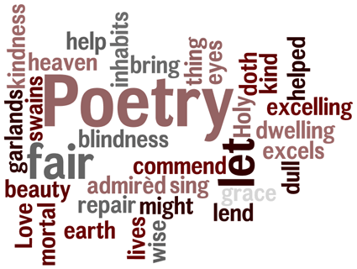

Unit 8: Working with plays

Why work with plays?
- Drama is in every society and has a rich history.
- It offers many possibilities for action-oriented methods.
- It provides opportunities to improve oral skills: fluency, pronunciation, confidence & nonverbal features.
- It provides exposure to language in conversation and in a meaningful context.

Preparing to work with plays
Before you begin to work with plays with your students, you might want to consider some of the following points:

- Going beyond the text - It is important that you and your students go beyond the printed text and experience it as a play. This can be done by either acting out certain parts of the play, by going to the theater to see a production, or by watching a film version. If you decide to have learners put on the entire play, much of it can be done as group work, with students taking on various roles: actors, directors, script advisors, designers, etc.

- Extract or Entire Play? – This is an important question to consider and most likely depends on the purpose for using a play in the language classroom as well as how much time you have. For example, if you are interested in working on learners’ orals skills, working with an extract may be enough.

- Choosing the text – When choosing a play, you may want to consider what background information learners will need to come to terms with it. Will they require cultural or historical information? Do they need to know what genre the play is in order to understand it? Should they know anything about the author? When working with extracts, you’ll need to consider how much information about previous events in the play learners will require to be able to understand it. The language of the text should also be considered. Are there any features of the text that might pose difficulties: sudden changes of topic, characters meaning something different than what they actually say, use of rhetorical or literary devices, etc.

Selection of Reading Activities for Plays (see also activities for novels - Unit 9)
This site has a lot of free resources, scripts with visuals and written versions of the narratives. The scripts are well-suited for language learners: http://www.aaronshep.com/rt/

- Acting out a scene: This is probably the most obvious task. Ss can act out a scene or part of a scene in groups. This can be done with or without accessories. Special attention can be placed on nonverbal communication, emotions, etc.

- Acting out a scene with a specific emotion in mind: Ss are given cards with certain emotions on them (happiness, anger, sadness, etc.) and are required to act out a scene by displaying those feelings. In doing so, they also have to consider intonation, stress, etc.

Before/After the scene: Have Ss predict & dramatize what they think happens before or after reading a scene.

Key words to role play: For this task, give Ss key words from a scene and get them to write their own scenarios from the key words & act them out, before or after they have read the originals.

- Making a radio play: For this task you can have Ss make a radio play and record the scene. They can record their radio play by using their smart phones. Ss can then listen to the different recordings in the last five minutes of future classes or online. After listening to the recordings, Ss can discuss different interpretations and what they liked about them.

- Re-writing a scene: For this activity, Ss could either modernize a scene (this has been often done with Shakespeare), or imagine that it is set in a completely different location (in space, for example). Then they read out their new versions.

Dubbed mimed dialogue: Use any extract. Ss mime a scene at the front of the class while the other Ss, sitting at their desks, ‘dub’ the scene, i.e., read what the characters actually say aloud. The miming group should follow with actions to what is read/said, rather than the other way round. This is an excellent way to get Ss to focus on their ‘acting’ or on their ‘speaking/reading’ and not both at the same time. This activity works well with mixed ability classes, where some students are better at speaking or reading aloud, others are better at acting.

- Language functions: Ss should read an extract and decide on which language functions the different lines fulfill – is a particular line a threat, apology, disagreement, etc.

- Advertising the play: Ss can choose a piece of music (with or without lyrics) that they feel could be the ‘theme song’ for the play. Ss could design a poster or advertisement for the play.

- Working with reviews: Ss could read authentic reviews of the play and decide which ones they agree with. Alternatively, Ss could write their own reviews of the play.



Unit 9: Working with novels

Why work with novels?
- Working with novels allows elements of extensive reading to come into the classroom.
- It gives students the chance to work on one topic in more depth.
- There is a wide range of contemporary young adult literature (YAL) to choose from. YAL is written specifically for a teenage audience and usually appeals to teenagers for various reasons; the novels are appropriate to their language level, reading skills, emotional maturity and life experience. YAL can also work as a transition to adult reading.
- Novels provide students with contextualized cultural information which they have to come to terms with during the reading process.

Selection of Reading Activities for Novels and Longer Works
Pre-reading Activities
- Pictures: Show a picture related to the text. Ss guess what the text might be about. For books: show book-cover only. Ss imagine story (plan for a few minutes, then Ss mill around exchanging their invented stories. To make it even more exciting: Divide class into 4 groups, show each group a different picture from the book. Then form new groups - Ss exchange what they’ve seen and discuss what the story could be about.

- Kim’s game: Show Ss a photo/magazine picture or objects related to the story for about 1 minute and ask Ss to jot down all the details they remember. This can also be done at a later stage in the story.

- Getting in the Mood: This is a guided fantasy. The teacher asks Ss to close their eyes and then describes a picture of the beginning of the literary work. Ss are invited to inhabit this scene in their minds. When the teacher is done describing the scene, Ss are asked to make a note of how they felt, see, say etc. or they could draw/paint a scene.

- Select 4-5 key words about the narrative: Write the key words on the board. Ask students for associated words. What might the story be about?

- Select key words from the first chapter: Provide Ss with 10 key words from the first chapter and have them predict type of book, plot, setting, characters, etc.

- 10 questions to predict plot: Give Ss 10 questions about the book. They should be able to put the storyline together while answering them.

- Sealing the time capsule: After reading the first pages/section of the text, Ss write down their predictions about events they think might occur as the story unfolds on cards. These cards are collected by the teacher and after the students have read the text, they are read again.

- Ordering jumbled sentences or paragraphs: Cut sentences or paragraphs from the first chapter into strips and have Ss put them in some order that makes sense. They should explain why they ordered them that way and then compare with book. Ss can also be asked to predict content.

- Covers and Titles: Copy the cover of the book w/out title and have Ss come up with possible titles. Give Ss title of the book and have them come up with a cover, including blurb on the back.

- Choose the prediction: Have Ss read the first chapter and then provide them with 4 predictions as to how the story will continue. Ss choose a prediction and then read the next chapter to see if they are right. Alternatively, Ss can write their own prediction.
While-reading Activities
- Prequel: Have students write Chapter 0.

- Summaries with gaps: Provide a summary of a section/chapter with gaps for Ss to fill in. A more challenging variation of this task is to write a summary with incomplete sentences.

- Writing summaries in small groups: In small groups, Ss are required to write a summary together in which they take it in turns to write one sentence. Summaries are then collected and redistributed to other groups which can add points or comment on what aspects they feel are missing.

- Summary with visuals: Ss can summarize the main events of a chapter/story with drawings, pictures, diagrams etc. and present this as a poster.

- Collecting vocabulary: The teacher identifies specific semantic fields in the text and asks Ss to collect vocabulary which belong together while reading.

- Jumbled events: The teacher provides a jumbled list of events which happened in a section/ chapter and Ss are required to put them in the right order.

- Jigsaw reading: Different groups are given different sections of a text and by consultation with each other, must reconstitute a complete narrative (e.g. short story) or chapter.

- Comic strip: Ss re-create a scene in the book or a synopsis of the story as a whole using the popular graphic novel-style and using text bubbles to insert important lines, quotes, and thoughts from the text.

- Character diary: Ss choose a character from the book and compose a diary or journal with a set number of entries discussing important events in the story from the character's point of view.

- Scenarios: Ss can film a scene from their book and upload it. Those interested in film could write a screenplay to go with it.

- Silent Dialogs: Choose a thought-provoking sentence or dialog from a book. Working in pairs, Ss continue the dialog whereby A writes a response and then passes the text to B who replies. Ss can then compare their dialogs in groups of 4, 8 etc.

- Speech-bubble Poster: Have Ss collect good sayings/interesting sentences from their book and collect them on a poster in form of speech bubbles.

- D.E.A.R. (Drop everything and read): The teacher spontaneously asks Ss to pull out their books during class time and start reading. The teacher might decide to do this spontaneously when pupils are not concentrating or as weekly ritual on a certain day.

Post-reading Activities
- Cover designs: After reading the book, students come up with their own book covers.

- Round robin summary: In small groups of 5, Ss are required to summarize the whole story in 5 sentences. Each person in the group writes the first sentence and then passes it to the next person who adds another sentence etc. In the end, the group should have 5 summaries. These can be read in the group and a vote can be taken on the best one or they can be given to another group for comments etc.

- Last page plus one: Ss write the next few paragraphs after the end of the story.

- The book on a postcard: Ss are asked to write about the narrative text in exactly 50 words and write their text on a postcard which they decorate.

- Point of no return: After reading the text, Ss decide on the point at which the outcome became inevitable and should write it down. If Ss don’t think there was such a point, they should give reasons why. This can be done using a pyramiding technique, students decide on their point in pairs, fours etc.

- What if …? This could be a follow-up task to ‘point of no return’. Ss imagine the moment before the ‘point of no return’. What if circumstances had been different? What alternative choices could the characters have made? This exercise can give rise to useful language work: past conditionals (If X had happened, Y would have resulted . . .) and past modals (could have made, might have etc.).

- Casting Sessions: Ask Ss to consider the film version of the novel. They can cast the characters with real actors or peers. They should give reasons for their choices.

- Illustrator: Ss are asked to illustrate 3 key scenes from their book and explain their choice.

- Novel Museum: Ss imagine that the characters in the novel were real people and that their local museum wants to dedicate a room to them and their lives. The room should contain real artifacts from the characters’ lives. Ss should present objects from the characters’ lives on a table and include a label explaining why the item is important, where it is from and what role it played.

- Plot on the line or Storyboard: Write seven to ten main events on separate sheets. Add simple drawings and illustrations. In your presentation hang up one picture after the other using clothes-pegs and a string or stick your pictures on the board with magnets or blue-tack. Talk about each picture using your own words. Don't give away the ending.

- Plot diagram/ Plot mountain: Draw a “fever curve” of the ups and downs in the novel. Peaks of suspense or conflict…., label the curve. In your presentation use your own words to explain each of the events briefly.

Homework. Choose a literary text (e.g., short story, poem, excerpt from a novel, novel ) that you would like to use in the language classroom and decide on the age group/level that it could be used with most effectively. Then consider what approach(es) you would use to make it relevant for that group. Prepare a double lesson or sequences of lessons in which you would use the text. Your lesson plan should include: overall rationale, steps (pre-, while- and post-reading tasks) and rationale behind them. Bring your text to the next class with prepared activities that your fellow students can try out.

The following books in our HAPP may be helpful in getting you started.

Bassnett, S., & Grundy, P. (1993). Language through Literature. Essex: Longman.

Carter, R,. & McRae, J. (1996) Language, Literature & the Learner. Creative Classroom Practice. Essex: Longman.

Collie, J., & Slater, S. (1987). Literature in the Language Classroom. Cambridge: CUP.

Duff, A., & Maley, A. (1990). Literature. Oxford: OUP.

Duff, A., & Maley, A. (1999). The Inward Ear: Poetry in the Language Classroom (Cambridge Handbooks for Language Teachers) Cambridge: CUP.

Lazar, G. (1999). A Window on Literature: Literary Texts for Early and Mid-Intermediate Learners of English. Cambridge: CUP.

Lindstromberg, S. (2004). Language Activities for Teenagers (Cambridge Handbooks for Language Teachers). Cambridge: CUP.

Paran, A., & Robinson, P. (2016). Literature. Oxford: OUP.

Spiro, J. (2004). Creative Poetry Writing. Oxford: OUP.

Williams, M., Wright, T., & Lazar, G. (1993). Literature and Language Teaching: A Guide for Teachers and Trainers (Cambridge Teacher Training & Development). Cambridge: CUP.

USEFUL RESOURCES
Recommended Reading:
Bassnett, S., & Grundy, P. (1993). Language through Literature. Essex: Longman.

Beach, R., Appleman D. & Hynds, S. (2010). Teaching Literature to Adolescents. New York, NY: Routledge Chapman & Hall.

Blasingame, J. (2007). Books That Don’t Bore’ Em. New York, NY: Scholastics.

Bredella, L., & Delanoy, W. (1996). Challenges of literary texts in the foreign language classroom. Tübingen: Günter Narr Verlag.

Brown, J. E., & Stephens, E. C. (2011). Teaching Young Adult Literature. Sharing the Connection. Mason, OH: Cengage Learning.

Brumfit, C.J. & Carter, R.A. (1986). Literature and Language Teaching. Oxford: OUP.

Carter, R. & McRae, J. (1996), Language, Literature & the Learner. Creative Classroom Practice. Essex: Longman.

Carter, R. & Long, M. N (1991). Teaching Literature. Essex: Longman.

Celce-Murcia, M., & Brinton, D. (Eds.) (2001). Teaching English as a Second or Foreign Language. Boston, MA: Heinle & Heinle.

Collie, J., & Slater, S. (1987). Literature in the Language Classroom. Cambridge: CUP.

Delanoy, W., Eisenmann, M. & Matz, F. (2015). Learning with Literature in the EFL Classroom. Frankfurt: Peter Lang.

Duff, A. & Maley, A. (2007). Literature (new edition). Oxford: OUP.

Duff, A., & Maley, A. (1990). The Inward Ear: Poetry in the Language Classroom (Cambridge Handbooks for Language Teachers) Cambridge: CUP.

Freeman, J. & Jones, B. (Eds.). (2000). The Barnes & Noble Guide to Children’s Books. New York, NY: Barnes & Noble Books.

Greenwood, J. (1988). Class Readers. Oxford: OUP.

Hall, G. (2005). Literature in Language Education. New York, NY: Palgrave Macmillian.

Holzmann, C. (2014). 101 Young Adult Novels for your English Language Class. Innsbruck: Helbling Languages.

Kramsch, C. (1993) Context and Culture in Language Teaching. Oxford: OUP.

Lazar, G. (1993). Literature and Language Teaching. Cambridge: CUP.

Lazar, G. (1999). A Window on Literature: Literary Texts for Early and Mid-Intermediate Learners of English. Cambridge: CUP.

Lindstromberg S. (2004). Language Activities for Teenagers (Cambridge Handbooks for Language Teachers). Cambridge: CUP.

Maley, A. & Moulding, S. (1985). Poem into Poem. Cambridge: CUP.

McRae, J. (1991). Literature with a small ‘l’. Hong Kong: MEP Mongraphs.

Monseau, V., & Salvner, G. (2000). Reading Their World. The Young Adult Novel in the Classroom. Portsmouth, NH: Boynton/Cook.

Nunan, D. and Carter, R. (2001). The Cambridge Guide to Teaching English to Speakers of Other Languages. Cambridge: CUP.

Paran, A. (Ed.). (2006). Literature in language teaching and learning. Alexandria, VA: TESOL.

Paran, A., & Robinson, P. (2016). Literature. Oxford: OUP.

Robb, L. (2000). 50 Fabulous Discussion-Prompt Cards for Reading Groups. Snap-Apart Question Cards That Build Comprehension & Spark Great Discussions about Character. New York, NY: Scholastic, 2000.

The cards are available on line at: https://amymerrell.wikispaces.com/file/view/DiscussionPromptCards_4ReadingGroups.pdf

Rosenblatt, L. M. (1995). Literature as Exploration. New York, NY: MLA.

Spiro, J. (2004). Creative Poetry Writing. Oxford: OUP.

Strouf, J. L.H. (1998). Literature Lover’s Book of Lists. Paramus, NJ: Prentice Hall Press.

Strouf, J. L.H. (1997). The Literature Teacher’s Book of Lists. Center for Applied Research in Education.

Williams, M., Wright, T. & Lazar, G. (1993). Literature and Language Teaching: A Guide for Teachers and Trainers (Cambridge Teacher Training & Development) Cambridge: CUP.



Useful Websites:
**http://epep.at/ Lis Pölzleitner’s website for language teachers
**http://rezensionen.schule.at/ Christian Holzmann’s website with reviews of literature for classroom use which are organized according to themes.
**http://www.101yans.com/ website that accompanies the book 101 Young Adult Novels for the English Classroom
**http://www.goodreads.com/ Contains lists of top young adult novels
http://www.ala.org/alsc/ American Library Association: Association of Library Services to Children
http://www.ala.org/yalsa/ American Library Association: Young Adult Library Services Association
http://www.bookcentre.ca/ Canadian Children’s Book Centre (CCBC)
http://gws.ala.org/category/literature-languages Links to authors’ & illustrators’, expanding the classics, favorite children’s stories websites and more.
http://www.clcd.com/ Children’s Literature Comprehensive Database
http://people.ucalgary.ca/~dKbrown/ The Children’s Literature Web Guide – Internet Resources Related to books for Children and Young Adults
http://www.education.wisc.edu/ccbc/ The Cooperative Children’s Book Center, University of Wisconsin-Madison
http://www.cynthialeitichsmith.com/
http://americanindiansinchildrensliterature.blogspot.co.at/ American Indians in Children’s Literature provides perspectives of indigenous peoples in children’s and young adult books.
http://www.fairrosa.info/ Fairrosa Cyber Library of Children’s Literature
http://www.reading.org/ International Reading Association
http://comminfo.rutgers.edu/professional-development/childlit/ChildrenLit/index.html Kay E. Vandergrift’s children literature page
http://comminfo.rutgers.edu/professional-development/childlit/ Kay E. Vandergrift’s Special Interest Page
http://www.usbby.org/index.htm / The United States Board on Books for Young People (USBBY) serves as the U.S. national section of the International Board on Books for Young People (IBBY), which was founded to promote international understanding and good will through books for children and adolescents.
http://ccb.lis.illinois.edu/guide.html The Center for Children Books
http://www.carolhurst.com/index.html Has a free monthly newsletter on adolescent literature
www.jumpintoabook.com More book suggestions
www.lauracandler.com/strategies/literacystrategies.php Useful strategies for reading
https://www.teachingenglish.org.uk/article/get-lit-literature-a-teachers-best-friend?utm_source=facebook&utm_medium=social&utm_campaign=bc-teachingenglish
Get Lit Up website sponsored by the BBC
http://www.booktrust.org.uk/ a website set up to get families and pupils reading. Lots of great ideas and book suggestions
http://www.librarything.com a website to record books you have read and to chat about them. Teachers can set up a group for class and ask pupils to record their reading.

