Teaching Literature and Culture
  - PS 4: 511440 Group: Elisabeth Pölzleitner
Session | Content | Homework
1 | Intro, course overview  Why teach literature? (Brainwriting)  Meeting poem  General ideas about reading and responding to literature  Choose a young adult novel and form groups. | Book ordering
2 | Getting started: Story time for beginners:  Using picture books:  The Snagglegrollop, The Trouble with Mom.  Picture books: exploring suitable tasks for beginners | Start reading your YAL novel 1 for session 5
3 | Exploiting texts for language learning and vocabulary improvement  Intercultural Learning: EPOSTL p. 29 and Byram (2000)
4 | Reading diaries and reading logs (lower school, upper school)  10-minute free-writing response | Finish reading your 1st novel by next week. Post a first review.
5 | Group Reading Projects and Reading circles:  Setting up reading programs in lower school  Designing group projects  Independent reading and class readers  Groups work with discussion prompt cards
6 | Ideas for creative book presentations in class and online.  Groups plan presentations | Prepare your book presentation task
7 | Group presentations | Find a partner and choose the books for your group-reading project.  Start reading…
8 | Group presentations continued (if necessary)  Using booklets: the pedagogy of the blank sheet  How to wet students’ appetite
9 | Reading projects in upper school (modern classics) | Read more YAL novels and post your reviews.
10 | Poetry projects for different ages  Formats: acrostics, limericks, recipe poems, found poetry…  Painting poems  Themes in poetry  Forms (poems from the underground?)  From poem to story, from story to poem
11 | Using Videos: Active viewing tasks  Garfield: List of video-tasks | Read more YAL novels and post your reviews.
12 | Course Roundup: tying up loose ends | Read more YAL novels and post your reviews.

Assessment:
Course requirements and assessment | 1 | 2 | 3 | 4 | 5 | 6 | 7 | 8 | 9 | 10
Reading project in cooperation with the PH and NMS Hasnerplatz: 10p
You have prepared an appropriate task for the NMS reading project
You have worked professionally with the NMS students on the project day
You have written a short reflection about your observations and experiences during the project day

Presentation in class: (groups of 4-5) 10p
You have presented a YAL book in your group. Your presentation
- includes a wide variety of creative elements (visuals, acting…),
- gives a clear picture of the main characters of the novel and the conflicts they have to solve,
- actively involves the audience,
- is clearly structured,
- and motivates the audience to read the book.

Group Reading Project: (in pairs) 50p
You have designed a group reading project that includes a choice of 3-4 books. Your project includes the project package for the students (copiable materials) and short teacher’s instructions specifying the age/level, theme/topics, materials needed and any necessary instructions or background info for the teacher .

Additional reading of children’s books and YAL + Online Reviews: 30p (5+5+10+10)
In addition to the book you have presented in class and the books you have read for your group reading project you have read at least
2 books for lower school (yrs 1-3) and
2 YAL books for years 4-8 and written short reviews for them on Moodle.

Active participation
You have participated actively in class discussions, group-work and online activities.

Final Grade:

The following criteria will be used to assess your project:
Use these criteria for your self-assessment. Evaluate your project in each category and write short reflections/
explanations for each category. You will find the document on Moodle. Open the file in your word processor to write your comments and evaluations. For the evaluation bars use: Table Tools/ Design/ Shading as shown in the example.
 | 1 | 2 | 3 | 4 | 5 | 6 | 7 | 8 | 9 | 10
Source text(s) or films are suitable for the age group |  |  |  |  |  |  |  | 8
Tasks are appropriate and appealing for the age-group and would work in an average class (difficulty of tasks, set-up…).  Intercultural competence: The tasks help the learners to develop intercultural competence and language competence  Language competence: Vocabulary expansion/ fluency and proceduralization/ developing top down reading strategies/ oral interaction and speaking to an audience/ writing skills |  |  |  |  |  |  |  |  | 9
The instructions are clear so the students will understand them independently and in groups. |  |  |  |  |  |  |  | 8
Structure and completeness: The project package is complete and well-structured. It is easy to find your way through the materials. |  |  |  |  |  |  |  |  |  | 10
Appealing layout of materials: The package is ready for use in class. (copiable masters e.g. picture size, cards, worksheets…) |  |  |  |  |  |  |  | 8
Total: | 43/45 (86%) good
10=excellent, 9=very good, 8=good, 7=average, 6=fair, 5=poor, 4-0=very poor - no evidence

Meeting Poem

…….fold along this line…………
Lis Pölzleitner
Literature Passionate
Leeks and Peas
Loathes Passivity
Lis Pölzleitner

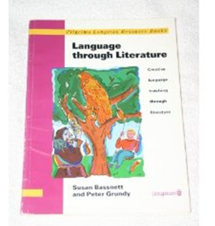
Let’s get to know one another a bit better. Write a “meeting poem” about yourself. Copy your meeting poem on the index card provided by your teacher and always display it in class. Present your poem to the class.

Course Resources

You will find all the course resources in our Moodle course:www4.edumoodle.at/epep
Sign up for the course: Teaching Literature and Culture
Login as a new user and create an account. Choose your own password but please remember it!!!
Warning: Go to the course and click “enroll me” in the left column. Only then will you be able to open the assignments. Otherwise you will see the pages but cannot upload and edit anything.

You will also find useful resources for this course on my homepage:

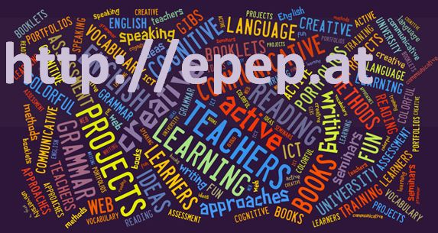
http://epep.at
This page contains lots of creative teaching ideas, downloadable worksheets and links to useful books and other materials for teachers.

Teaching Culture


- I can evaluate and select a variety of texts, source materials and activities which awaken learners’ interest in and help them to develop their knowledge and understanding of their own and the other language culture (cultural facts, events, attitudes and identity etc.).
- I can create opportunities for learners to explore the culture of target language communities out of class (Internet, emails etc.).
- I can evaluate and select a variety of texts, source materials and activities which make learners aware of similarities and differences in sociocultural ‘norms of behaviour’.
- I can evaluate and select activities (role plays, simulated situations etc.) which help learners to develop their socio-cultural competence.
- I can evaluate and select a variety of texts, source material and activities which help learners to reflect on the concept of ‘otherness’ and understand different value systems.
- I can evaluate and select texts, source materials and activities to make the learners aware of stereotyped views and challenge these.
- I can evaluate and select activities which enhance the learners’ intercultural awareness.
- I can evaluate and select a variety of texts and activities to make learners aware of the interrelationship between culture and language.
Council of Europe, p. 29

Book choosing for our young adult reading projects and presentations in sessions 5-7.
Book title and | New words per page | Other comments about the book:
Type of book:
Plot prediction:

Characters:
Settings:
Type of book:
Plot prediction:

Characters:
Settings:
Type of book:
Plot prediction:

Characters:
Settings:
Type of book:
Plot prediction:

Characters:
Settings:
Type of book:
Plot prediction:

Characters:
Settings:
Type of book:
Plot prediction:

Characters:
Settings:

Homework:

- Sign up for our Moodle course. Any further information concerning this course will come through this Moodle platform. Students who have not signed up by next Monday will NOT be part of this course.
- Order a copy of the YAL book you are going to read for the group reading project and enter your choice into the book-choosing-wiki on Moodle. Find all the books on epep.at
- Write your “Meeting Poem” on your name-card to present yourself to the class.

- Culture versus culture
Read the short online article explaining the ICEBERG METAPHOR and have a look at Byram’s intercultural competences and learning objectives. You will find links to both on Moodle.
Highlight the key points that you find relevant for your future teaching and
design your very own CULTURAL ICEBERG on an A4 sheet. You can do this by hand or on the computer. Use any technique or mix of techniques you find useful for this task. The purpose of your ICEBERG is to show what English/American culture means to you. Instead of the abstract terms in Byram’s table or the keywords in some iceberg images that you might find online, refer to concrete experiences that you have had with the British/American culture. Add personal memories, symbols or images and be prepared to share your icebergs with the class next week.
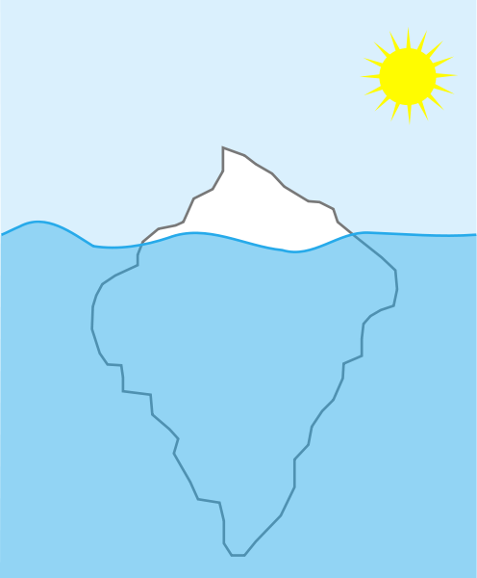

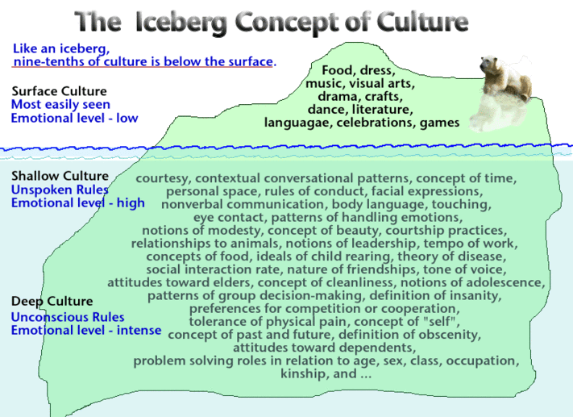
1Indiana Department of Education: http://crossculturalargentina.files.wordpress.com/2012/03/icebergculture.gif

Bassnett Susan and Peter Grundy, (1993) Language through Literature. Essex: Longman Resource Books. 12
Any experiences with the cultures of English speaking countries and people. (NZ, Can, Australia…..)

