Reading is fun: Storytime for beginners

The ten commandments of teaching reading
- Make reading an everyday topic. Reading is fun. Reading is cool. WE all read.
- Read stories in relaxed atmosphere. Read stories as a special treat after hard work.
- Create a class library: Good bookshops are:
http://www.Amazon.de
Wolfgang Steinhauser's bookshop http://www.thebookshop.at
- Start reading whole books (picture books, stage 1 readers) as early as possible.
- Use reading logs and reading diaries to keep track of Ss reading.
- Give credit to book reports and reading
- Invite students to present books regularly, reserve space for book recommendations on pin-board.
- Create reading circles to discuss books.
- Use books for active vocabulary expansion.
- Allow as much free choice as possible. Consider different reading tastes and reading abilities.

How do we start?
Which of these stories would you like to hear? Ask questions to find out what they are about.
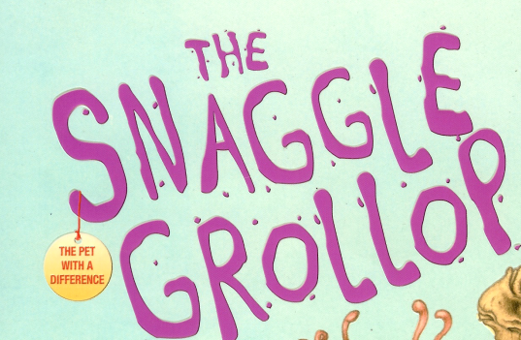 | 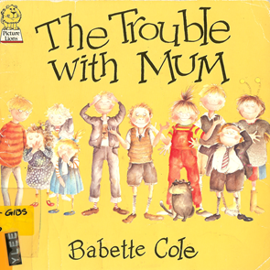
Find the teacher’s notes and the student materials for these activities on www.epep.at
There you will also find other suitable picture books for beginners.

1. Purpose of reading:
Brainstorm the multiple purposes of reading:

2. How do we read?
- Skimming: quickly running one's eyes over a text to get the gist of it.
- Scanning: quickly going through a text to find a particular piece of information.
- Extensive reading: reading longer texts, usually for one's own pleasure. This is a fluency activity, mainly involving global understanding
- Intensive reading: reading shorter texts to extract specific information.

NOTE: The different ways of reading are not mutually exclusive.
Example: We often skim through a passage to see what it is about before deciding whether it is worth scanning a particular paragraph for the information one is looking for. In real life reading purposes vary constantly. Therefore, exercise types should also vary according to the text studied and the purpose of reading it. It would be highly artificial to work on a page of classified ads and propose exercises that require detailed reading of every single advertisement.

3. You don't have to know every single word in a text.
1. Read the text and try to understand the general meaning of the story. (All the words in italics are nonsense words.)
A country girl was walking along the snerd with a roggle of milk on her head. She began saying to herself, 'The money for which I will sell this milk will make me enough money to increase my trund of eggs to three hundred. These eggs will produce the same number of chickens, and I will be able to sell the chickens for a large wunk of money. Before long, I will have enough money to live a rich and fallentious life. All the young men will want to marry me. But I will refuse them all with a ribble of the head - like this . . .'
And as she ribbled her head, the roggle fell to the ground and all the milk ran in a white stream along the snerd, carrying her plans with it.
1. Now look at the nonsense words again. Can you guess what they might mean?
Would you feel comfortable to read a text with as many unknown words?
The 5 Finger Rule: Students read the first and second page of a book and use their fingers to count the number of unknown words that they cannot easily guess from the context. If the number exceeds 5 unknown words per page, the text is probably too difficult for joyful reading.

Improving students’ confidence:
Encourage “top-down” reading skills rather than focusing on every unknown word:
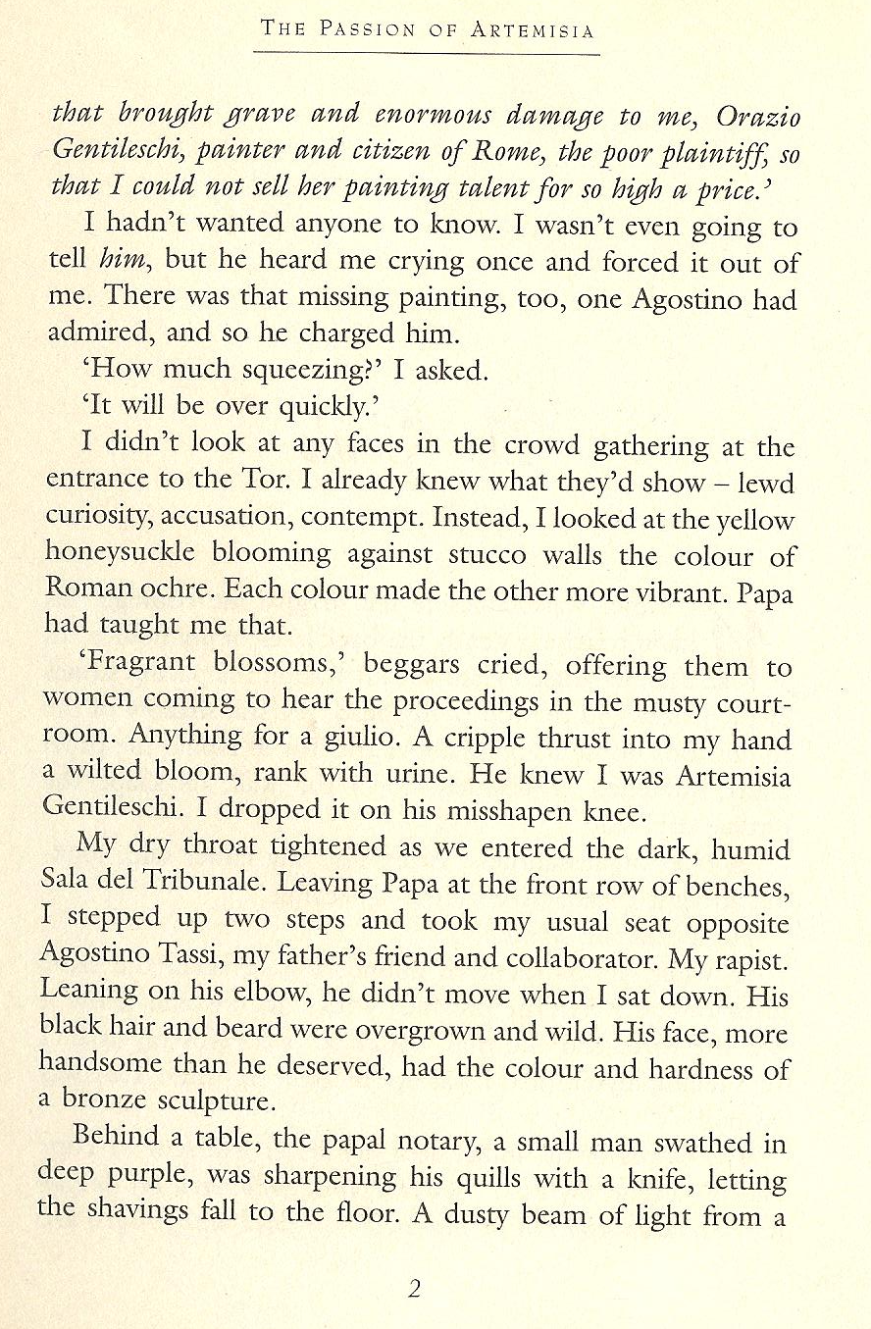
Fast reading activities help students gain confidence and focus on content and gist.
Fast Reading: Basically skimming, give Ss 30 seconds to "read" text, collect info on board. Give them 2 - 3 minutes to read the text again (1 page), collect inf. on board. Ask Ss to write a 50 word summary of the text (in groups). Only then allow them to read the text slowly!
Try out fast-reading with following text.

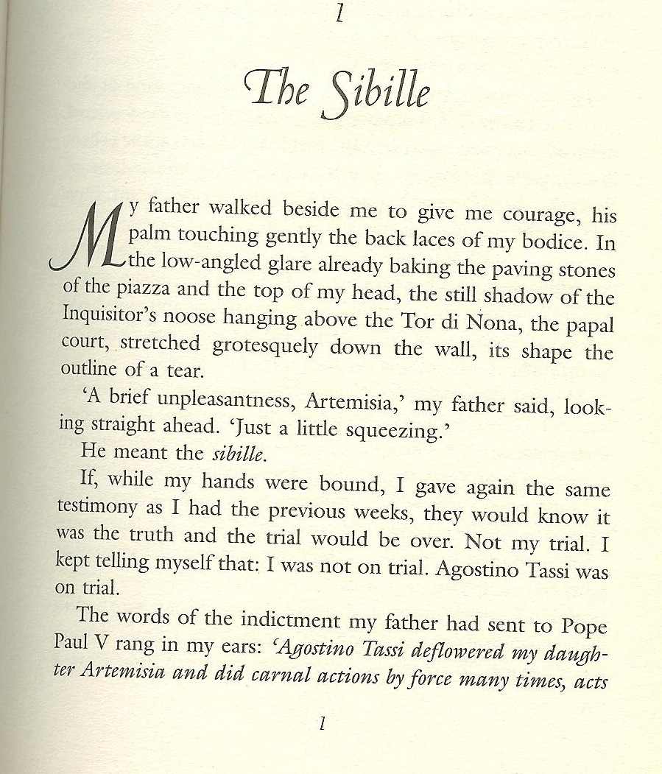

4. Classroom procedures:

Important: Reading is a silent activity --- encourage silent reading.
Why? Work with a partner and collect arguments why students should read silently and on their own.

Can you think of any exceptions? When and where would it be meaningful to read a text aloud?

5. Constructing reading comprehension exercises.

Pre-reading
Purpose: Creating a reason to read (awaken interest/expectations) or give some idea of the content before the students see the text.
Prepare difficult vocabulary before students see the text.

While reading
Start with global understanding and move towards detailed understanding.
Don't ask too many questions - don't "kill" the text.

Post reading:
Design a follow-up activity. Don't separate reading comprehension from the other skills. A following oral or written activity will give the reading text a purpose.

Reading activities for narrative texts

Pre-reading activities
- Pictures: Show a picture related to the text. Students guess what the text might be about. For books: show book-cover only. Ss imagine story (plan for a few minutes, then Ss mill around exchanging their invented stories. Can also be done in carousel format. To make it even more exciting: Divide class in 4 groups, show each group a different picture from the book. Then crossgroup- Ss exchange what they’ve seen and discuss what the story could be about.
- Kim’s game: Show Ss a picture for about 1 minute (best done on OHT), they jot down all the details they remember. This can also be done at a later stage in the story.
- Titles, Headlines: Give title. Have students guess what the story might be about. They might start like this: I think …. is going to…// I hope ….// I don’t want …..//
- Select 4-5 words: Write these words on board. Ask students for associated words. What might the story be about?

While reading and post reading tasks and activities
- Matching: text and pictures
- Ordering pictures: For picture books, copy picture pages without text (1 set per group), read story, Ss find matching pictures, put them in correct order. Then compare.

- Ordering jumbled sentences or paragraphs: Cut into strips if possible

- Two in one stories: cut up two short texts, mix. Ss sort and reconstruct the two stories (Works well with the short texts from children’s books

- Text market: Cut text into N (e.g. 5) pieces. Provide enough cut copies of the text for each student to be able to put together one complete version. Hand out pieces randomly. Each student has N pieces, some of them might be the same. In order to complete their text they will have to exchange those that are surplus for those that they need. In order to do this Ss sell their unwanted pieces as if they were in a market. They walk around describing their pieces and swapping them for the ones they need. The most important rule of the game is that text pieces must never be shown before they are exchanged. When the students have bought all N pieces of the text they sit down and reconstruct the text. Note: The market-phase may be quite chaotic at first, noise dies down as more Ss have bought all the pieces. Fast Ss can then help others.

- Gap filling: any short text, leave out words or phrases. Leave space where the word is missing.

- Gap finder: Leave out words but don't leave any empty space (more difficult). Ss have to find out where a word is missing and write it in. Print texts with double line spacing for this exercise or leave a margin where Ss can write the missing words.

- C-test: print first half of each word, Ss complete the text.

- Picture corrections: Separate the picture and the text. Change the text so that it represents things slightly differently from the picture. Students spot the mistakes and correct the pictures!!!
- Draw a picture: Listen to the story, imagine the scenes in detail, then draw or paint a scene…
- Carousel: Divide your story into 6 to 8 short pieces. Copy sets on different colors, enough pieces to serve the whole class. Distribute the pieces randomly. Students with the same color go together, then meet another group of a different color. The two groups build two concentric circles. (Do this in the hallway or any open area) Then the two students facing each other exchange their story bits (they must not show the cards). After one minute (more or less, depending on the length of the texts) the students in the outer circle move one person to the left. The new partners now exchange the content of their pieces… Do this until the students have heard the content of all the pieces.
- Writing and answering questions: Students write questions for another group
- For further ideas (esp. ideas for novels) see epep.at

Potatoes
Text market
retold by S. E. Schlosser
Teacher instructions: Use for TEXT MARKET. Copy one sheet for each student, cut up. Hand out titles and task boxes to everybody. Shuffle all other cards and hand out 4 to each student. Ss must not show their cards to others. They buy and sell cards as described in the TEXT MARKET activity. (Reading Activities sheet) Students who have got all 4 parts then glue the slips on a worksheet in the correct order and do the follow-up tasks.

We here in Idaho are right proud of our potatoes. Our fields are so chock full of potatoes that you can hear them grumbling when you stick your ear on the ground. "Roll over, you’re crowding me," they say.

Potatoes grow bigger in Idaho than anywhere else. Once, a greenhorn asked me for a hundred pounds of potato. I set him straight real fast. I don't believe in cutting into one of my potatoes. "You buy the whole potato, or you take your business elsewhere," I told him.

Why do our potatoes grow so big? Well, it’s because we feed them like family. Cornmeal and milk every day for breakfast, lunch and dinner. You should taste my wife's mashed potatoes! They are the creamiest mashed potatoes in the whole United States. It’s all the milk our potatoes drink while they’re growing. Makes them so creamy that all my wife needs to do is just boil them and mash them up.

Sometimes, the size of our potatoes creates a problem for the farmers. One fellow I know got trapped for eight hours beneath a potato. His wife came looking for him when he was late to dinner. She had to get the neighbors to help roll it off. But that's just they way it goes when you're farming potatoes in Idaho.

How does the storyteller describe potatoes in Idaho?
Idaho potatoes are:

Design an ad for Idaho potatoes. Be creative. Use your computer or handwrite and draw your ad. Decorate it nicely.

Frozen Dawn
retold by
S. E. Schlosser
Gap finder
Gapfinder: Some words have been lost in this text. Write the missing words in the margin and put numbers to indicate where the words should go.
Example:
1
One winter, it was so that the dawn froze solid. The sun got caught two ice blocks, and the earth iced up so much that it couldn't turn. The first of sunlight froze halfway over the mountain tops. They looked like yellow icicles dripping towards the ground.  Now Davy Crockett was headed home after a successful night hunting when the dawn froze up so solid. Being a smart, he knew he had to do something quick or the earth was a goner. He had a freshly killed bear on his back, so he whipped it off, climbed right up on those rays of and began beating the hot bear carcass against the ice blocks which were squashing the sun. Soon a gush of hot oil burst out of the bear and it melted the. Davy gave the sun a good hard kick to get it started, and the sun's heat unfroze the earth and started it spinning again. So Davy lit his pipe on the sun, shouldered the bear, slid himself down the sun rays before they and took a bit of sunrise in his pocket. | 1: cold

Basic reading tasks for beginners
The purpose of these tasks is to make the learners read parts of the text in detail and use some of the new language actively. These tasks should be short and easy – we do not want to spoil the fun of reading.
Find the printable worksheets on www.epep.at  Book Chat:  Choose your favorite page in the book and describe it to your teacher or co-teacher.  What do you see?  What is happening in the picture?  Write a Postcard  Imagine you are one of the characters and write a postcard to a good friend. Tell your friend where you are and what it is like there. (no past tense necessary for this task!) Draw a picture on the front side of your card. | 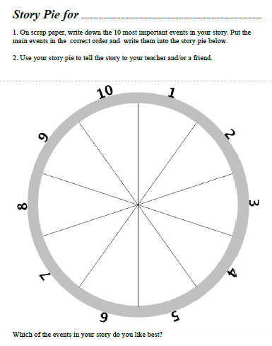
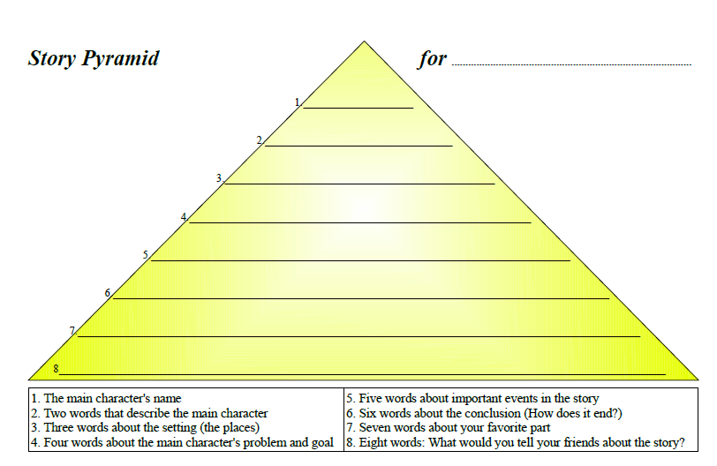 | 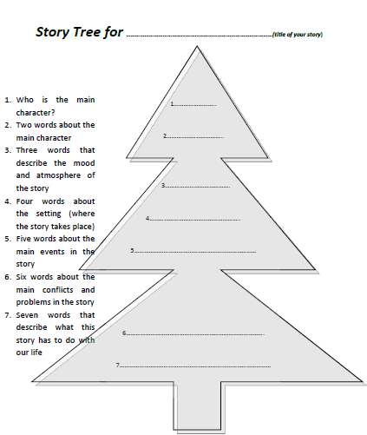

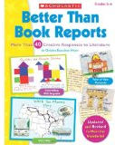
More useful ideas from
Find this and similar books in our library or get your own copy. Find a link on epep.at

Christine Boardman Moen, Better than Book Reports, Scholastic Professional Books, 1992,
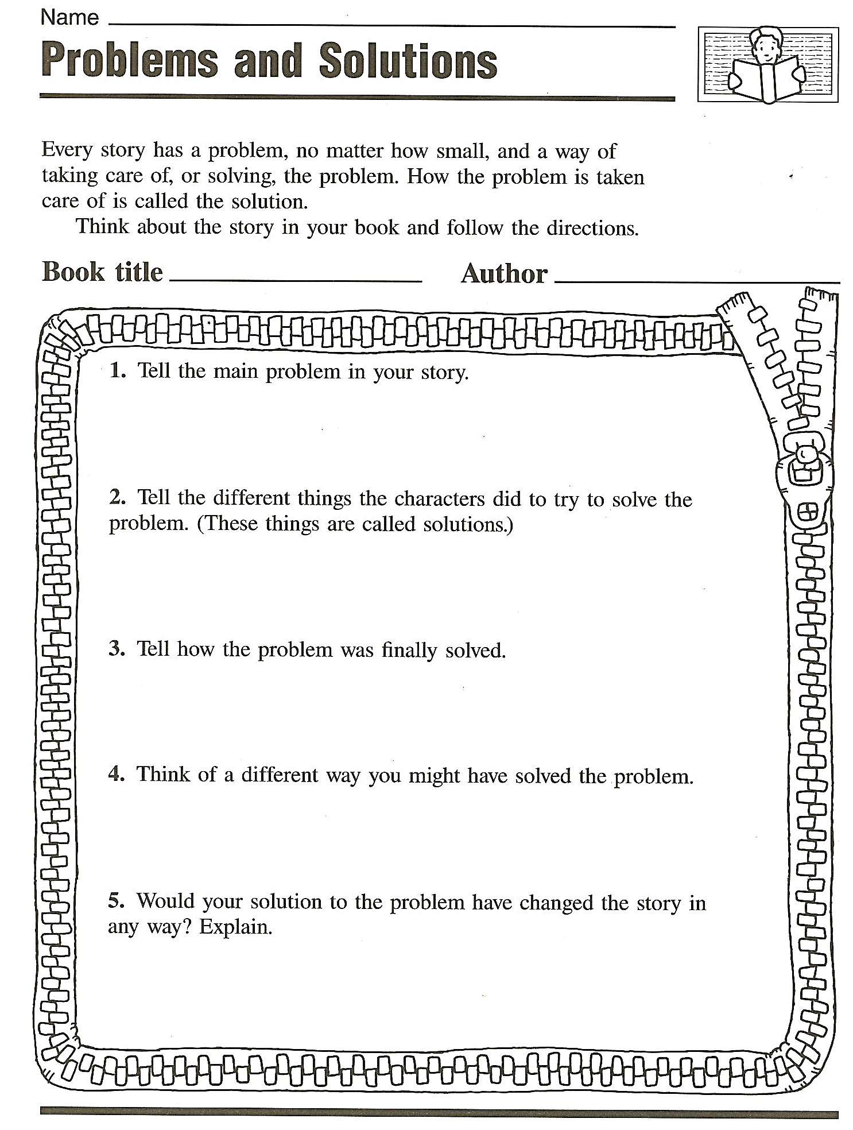 | 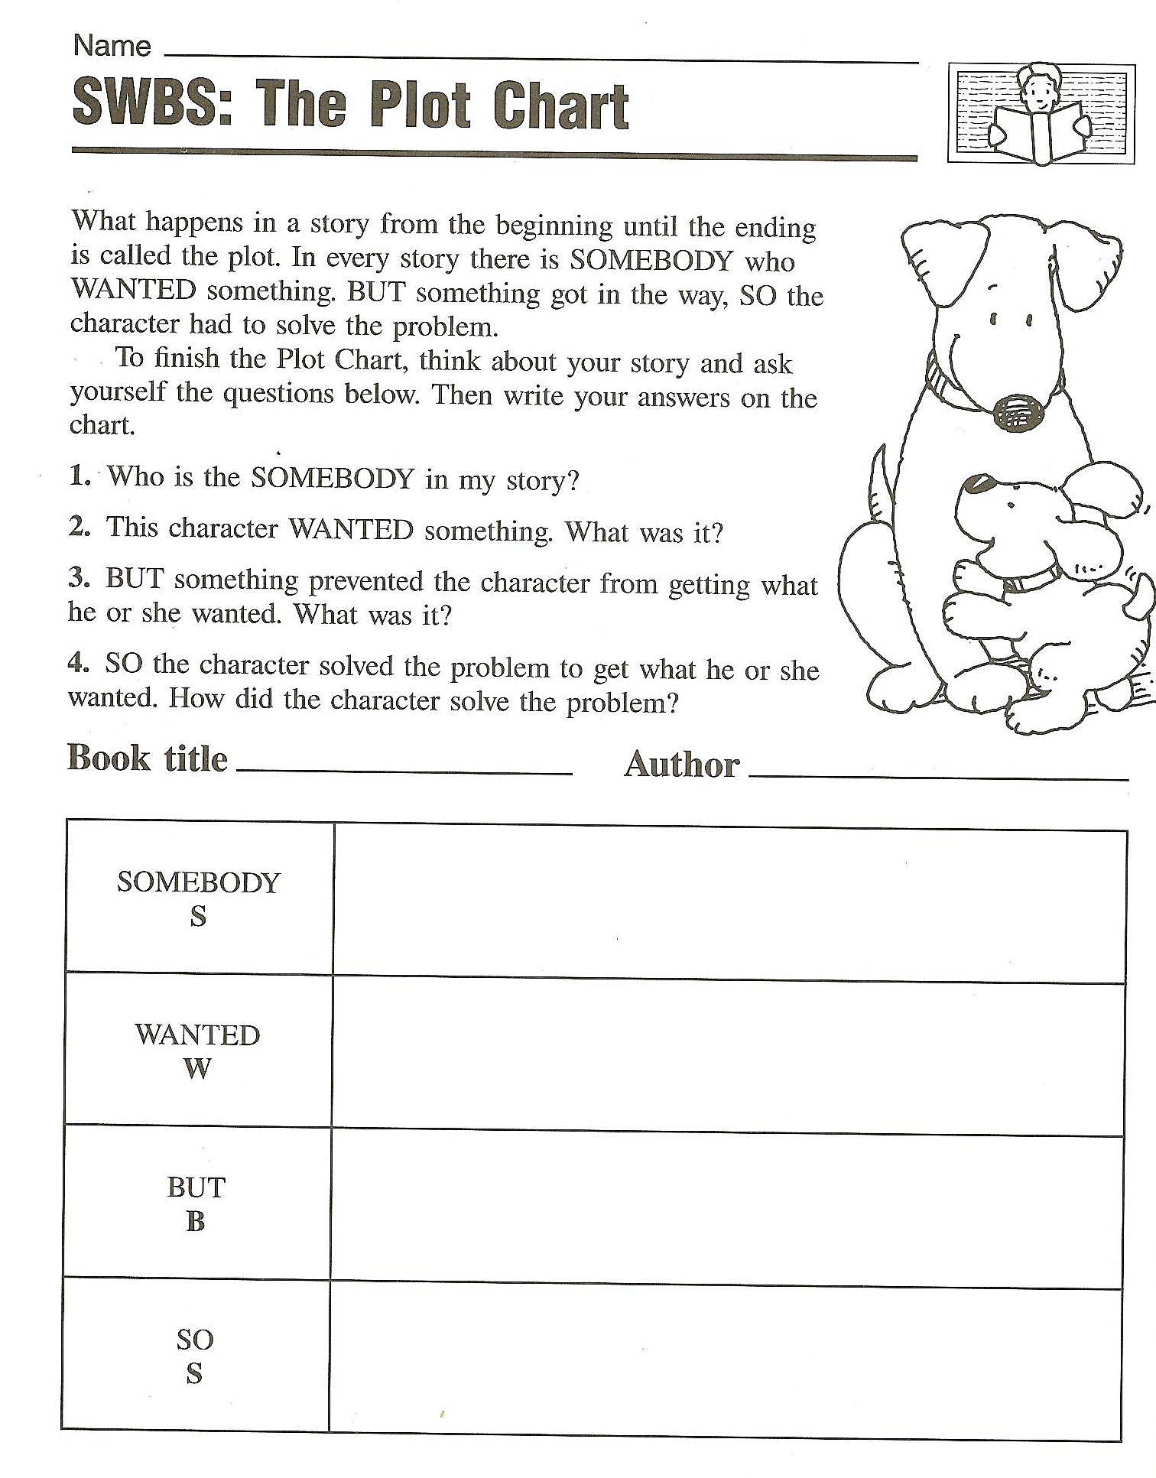
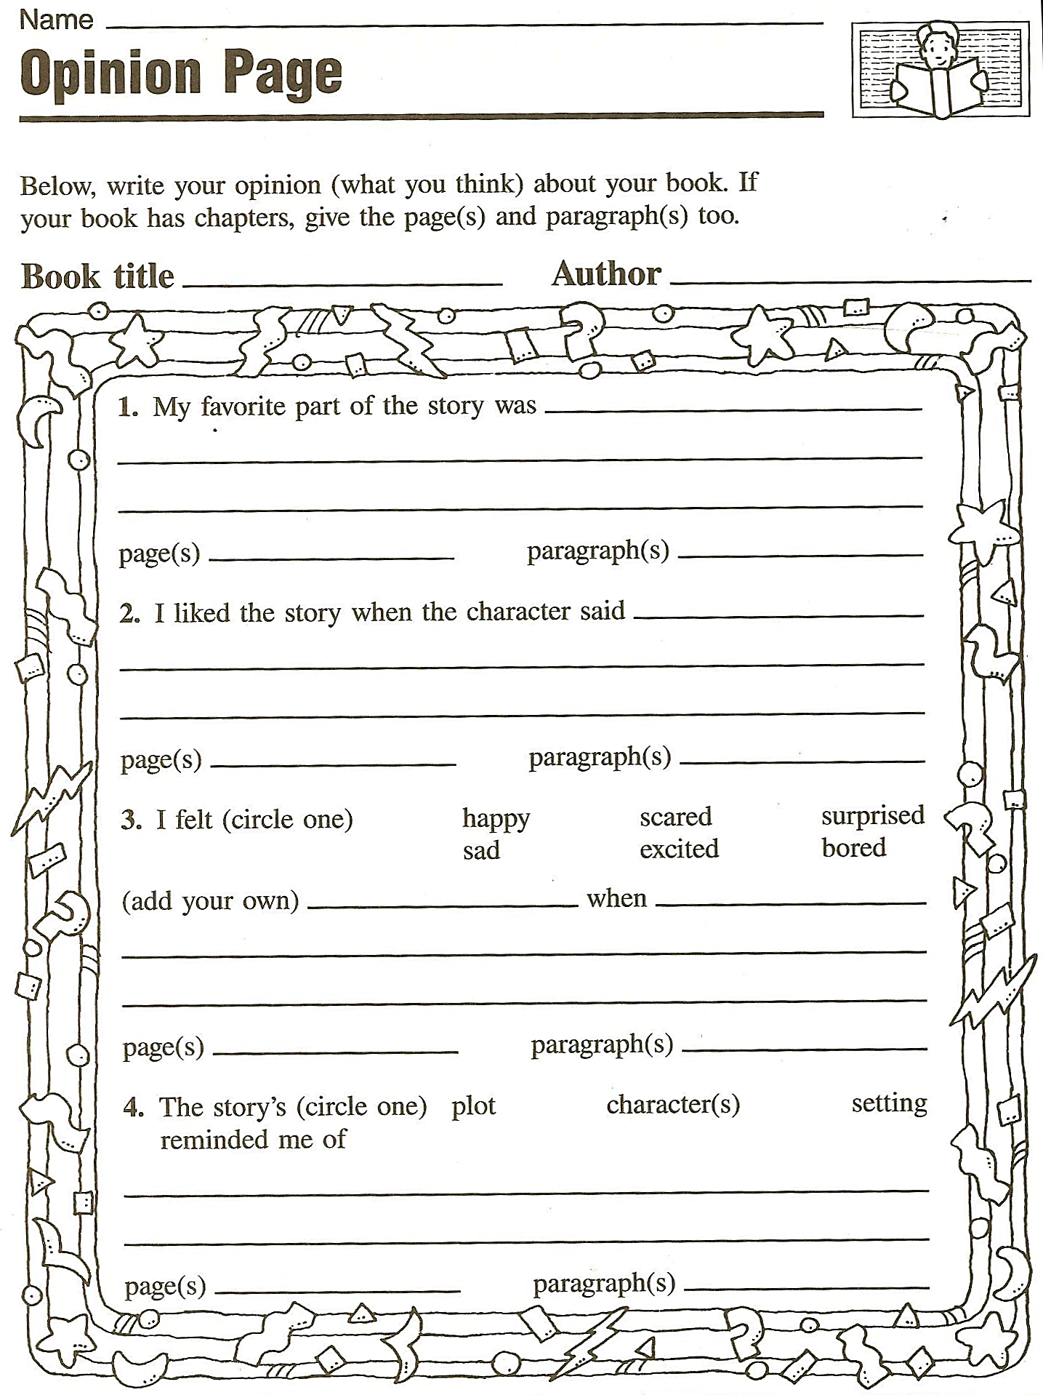 | 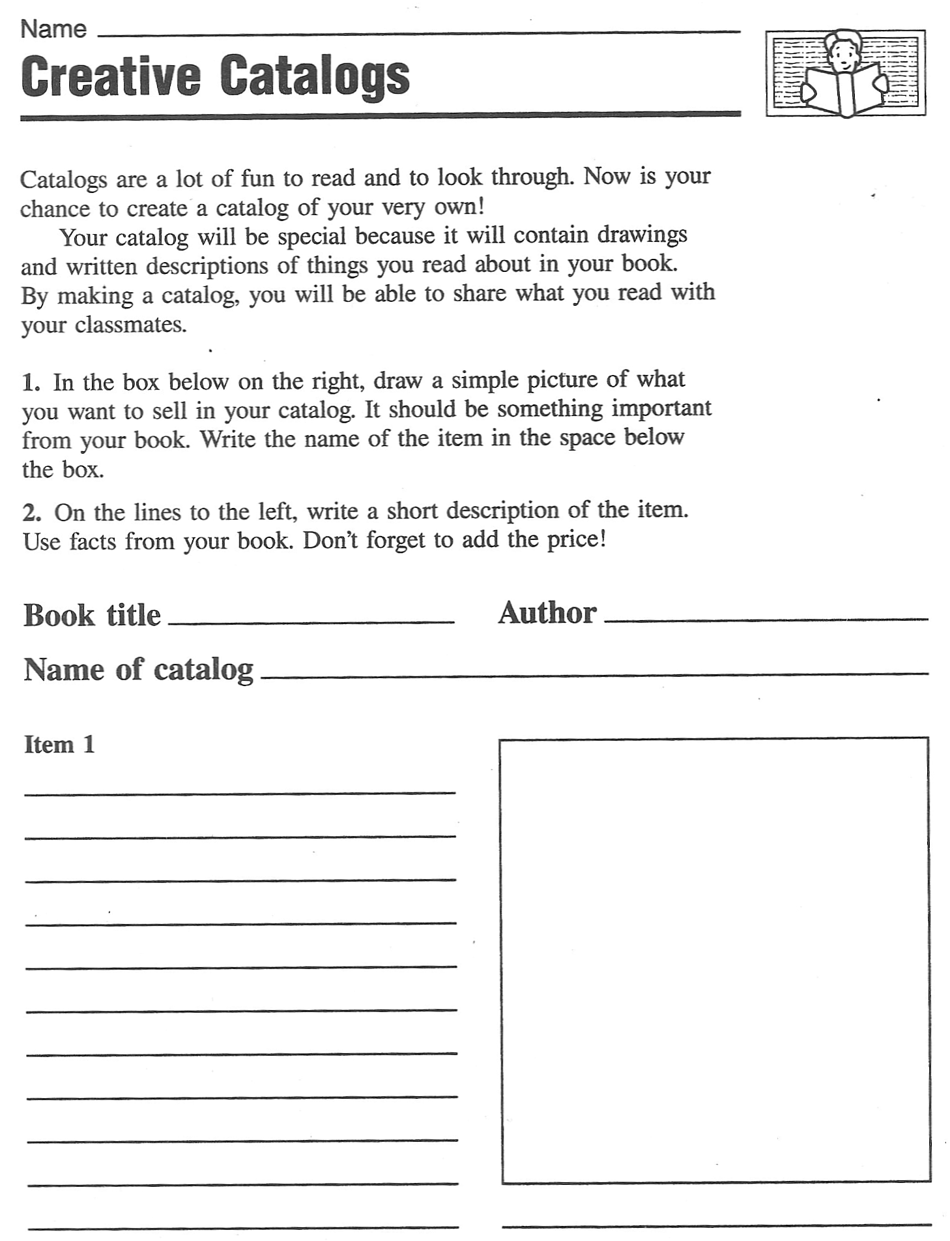  Tip: Groups can design a catalog of several pages for an interesting book.

Exploiting texts for vocabulary expansion:

- Choosing vocab phrases: Students choose 3-5 new phrases that they want to remember and write them on vocab cards.

- Lexical Furniture: put the new phrases in suitable places in your house/home. E.g: the verb “to separate” would go into the kitchen, under the sink, because there I separate my waste….

- Connect a Pair: Take 10-12 vocab cards that you want to remember and put them on the desk in front of you. Now form five to six pairs and find some connection for each pair. Example: use both in the same sentence or make up a little story, of match opposites or say how they are alike...

- Word Webs: On an A4 sheet create a web of words around a topic in your story.

- Acrostic Puzzles: Write the title of your book on the page vertically. Then find one fitting word or a short sentence for each letter. Your words should have something to do with the story.

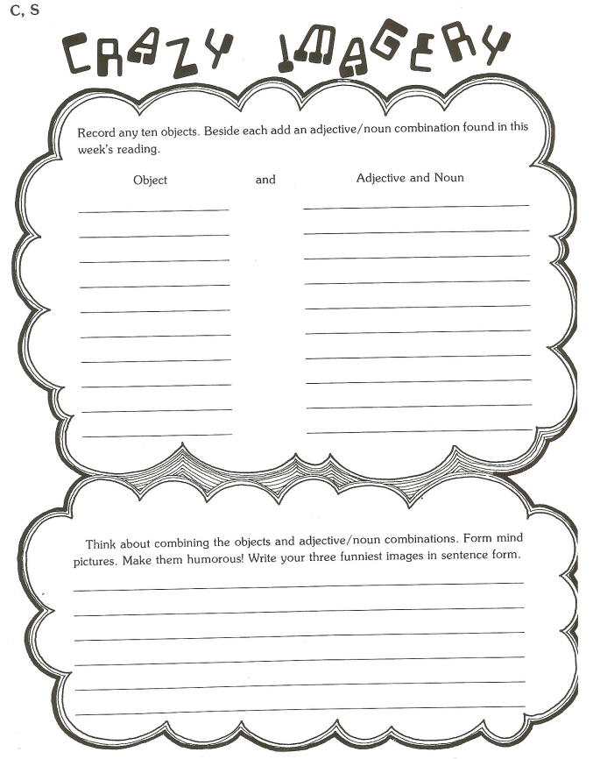
- Personal Properties: Choose 10-15 new words that you want to remember and collect your personal associations with each of them.
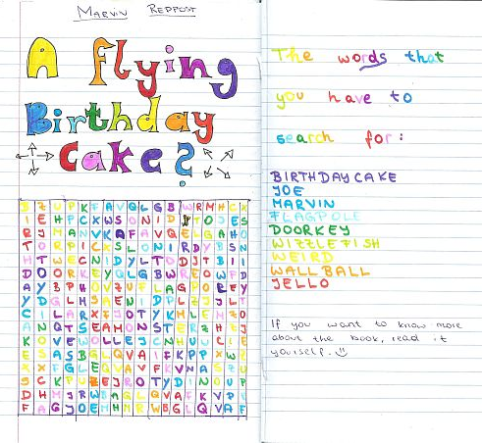
  - Weight
  - Shape
  - Texture

- Wordcycle

- Word Search

- Crosswords

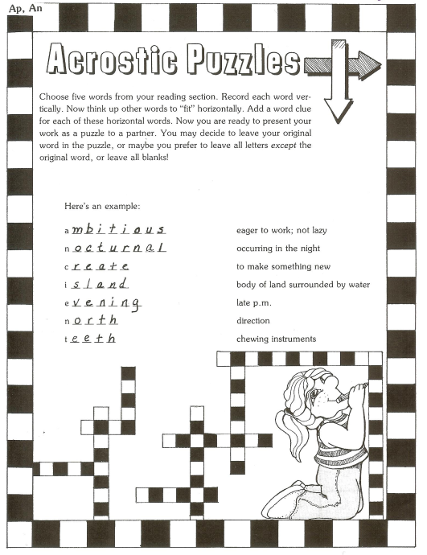
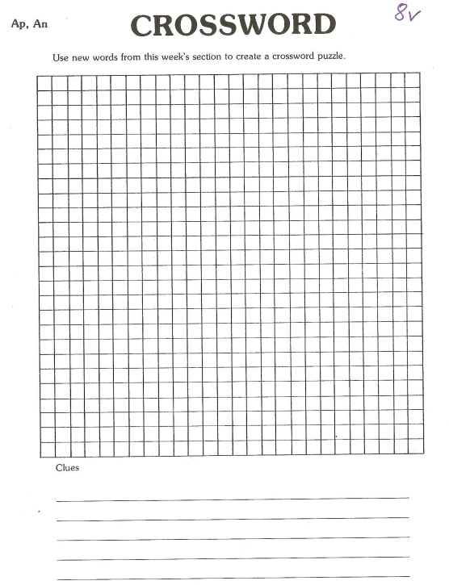

Find these and more great ideas in
J. Szabos, Reading, A Novel Approach, Good Apple Inc. 1984

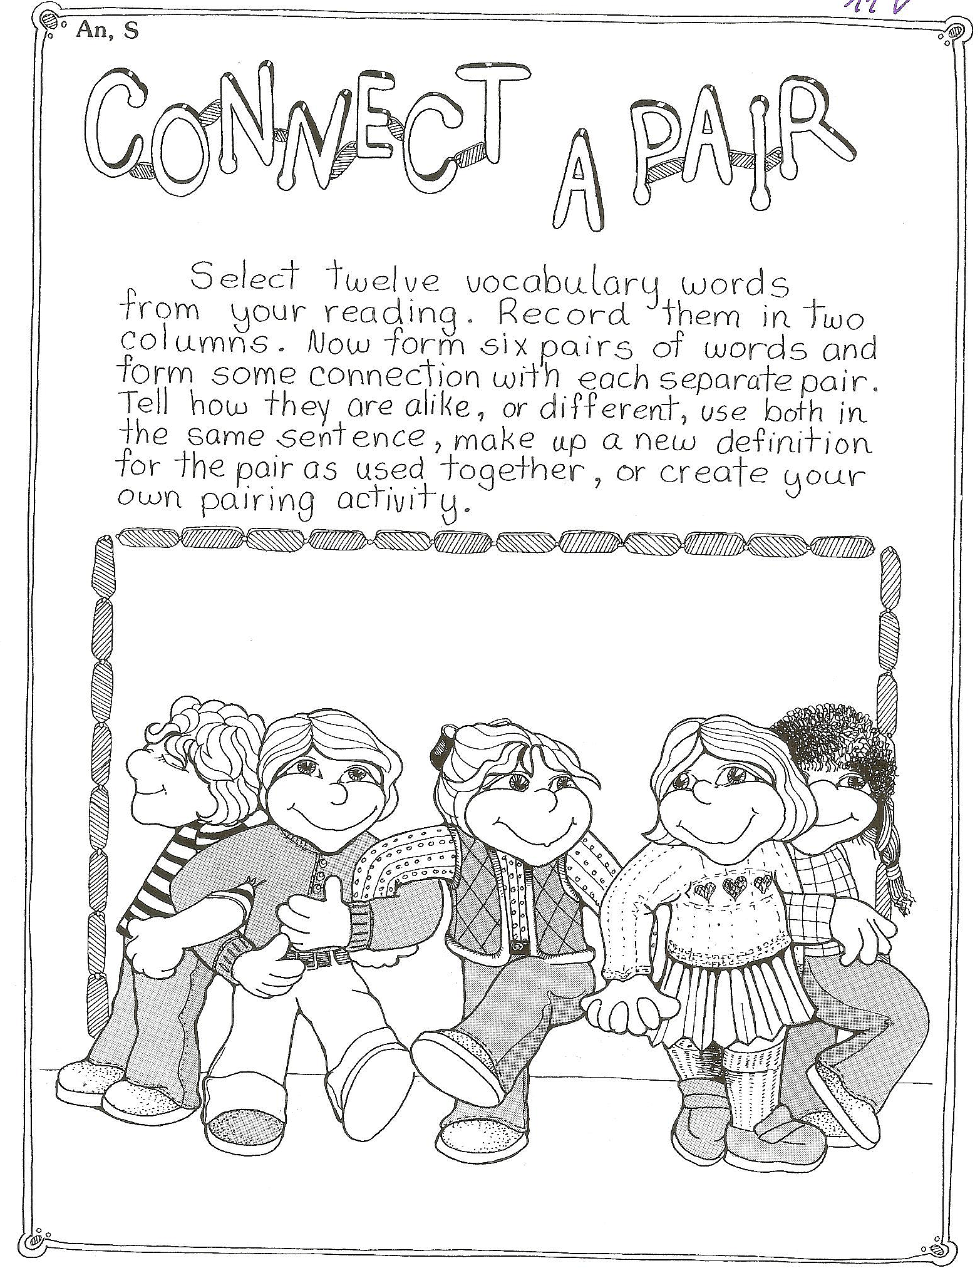 | 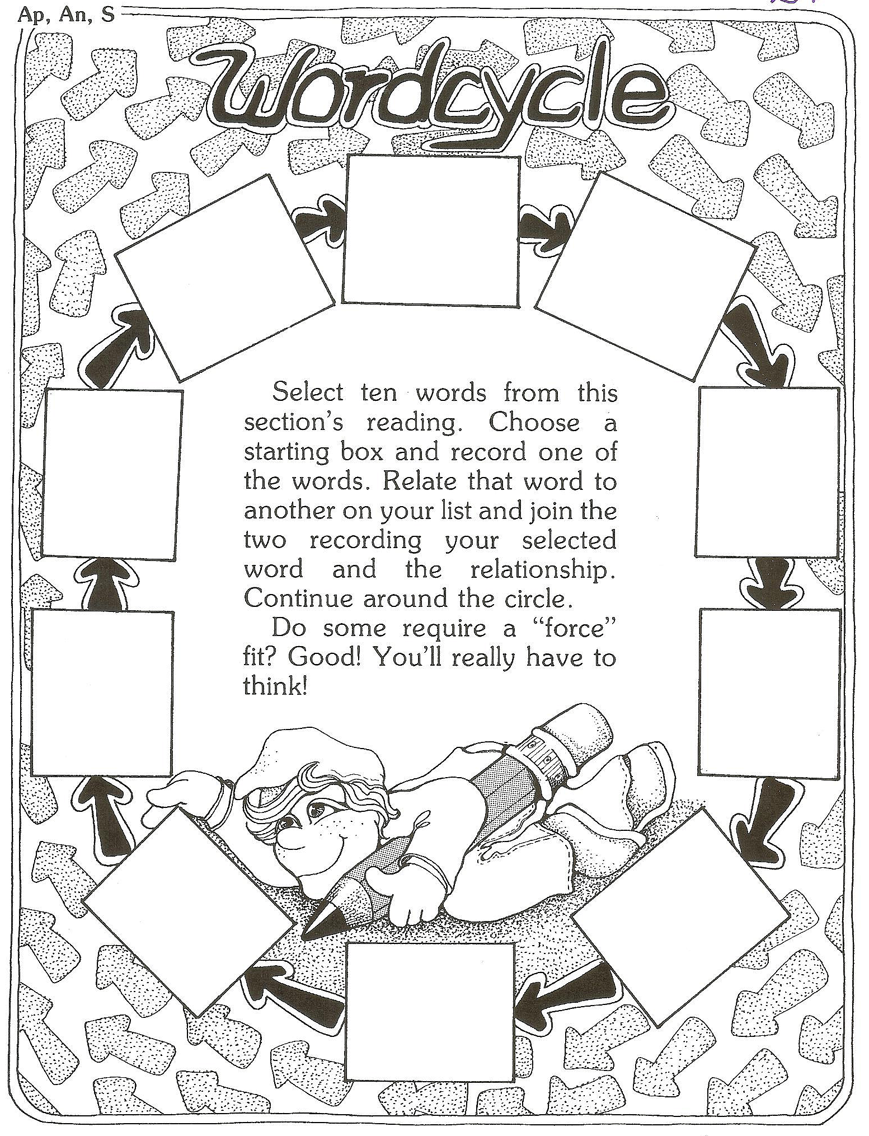
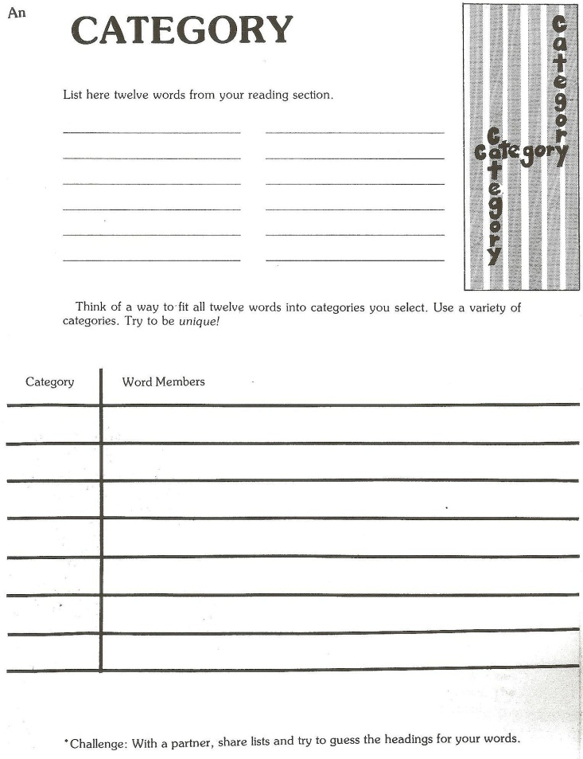  Homework: Go to our library and have a look at the special shelf for our course (Handapparat). Find three to five other interesting reading and vocab building activities and bring copies along to our next session. | 