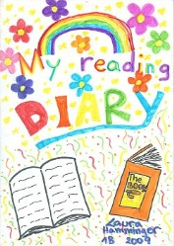
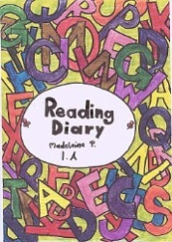
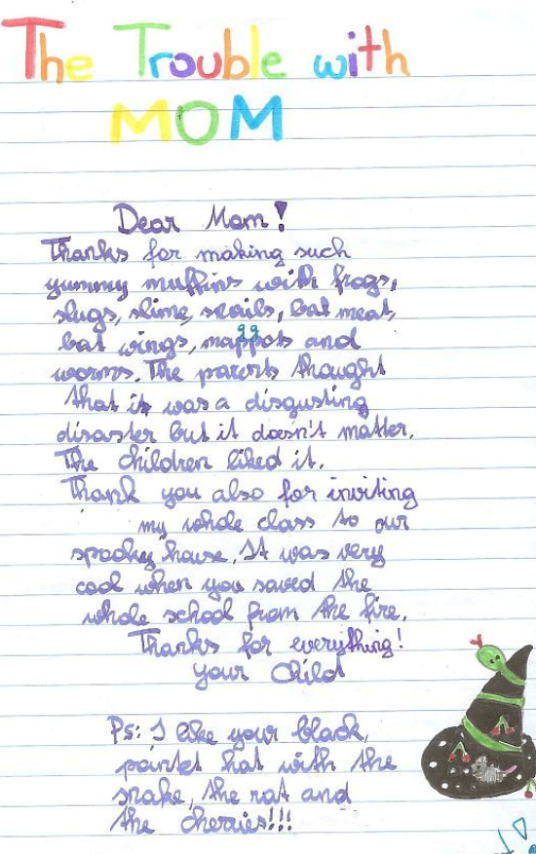
Reading Diaries

Reading diaries for young learners

Tips for my first reading diary

For each book that you have read enter the following information:

Author:
Title of the book:
Your rating: (Tell us how you liked the book, give 1-5 stars for example)
A short summary: What happens in the story. Write 5-7 sentences
Personal Comment:
My favorite character is ….. because…
I don’t like (name of character) because...
I wonder why ….
I like/don’t like the ending, because…

Finding Feelings: Write 5 sentences.
How do the main characters feel in the book? Why?
How did the book make you feel? Why? (Choose from the faces below.)

Add a nice drawing if possible: Draw one item that plays an important role in the book.

Feelings:

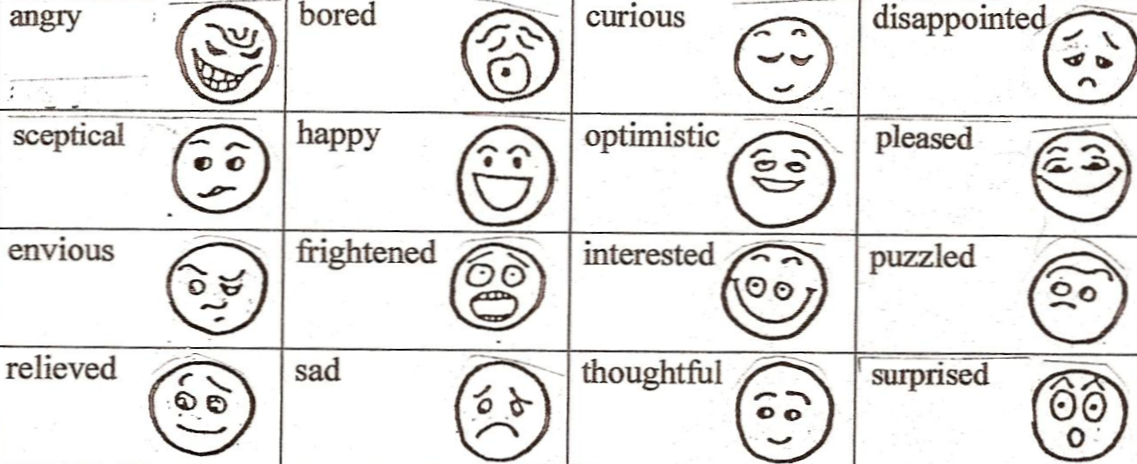

Reading Diaries: Sample pages, year 2

Letters
Twilight: The student is writing a letter to Bella: Year 3
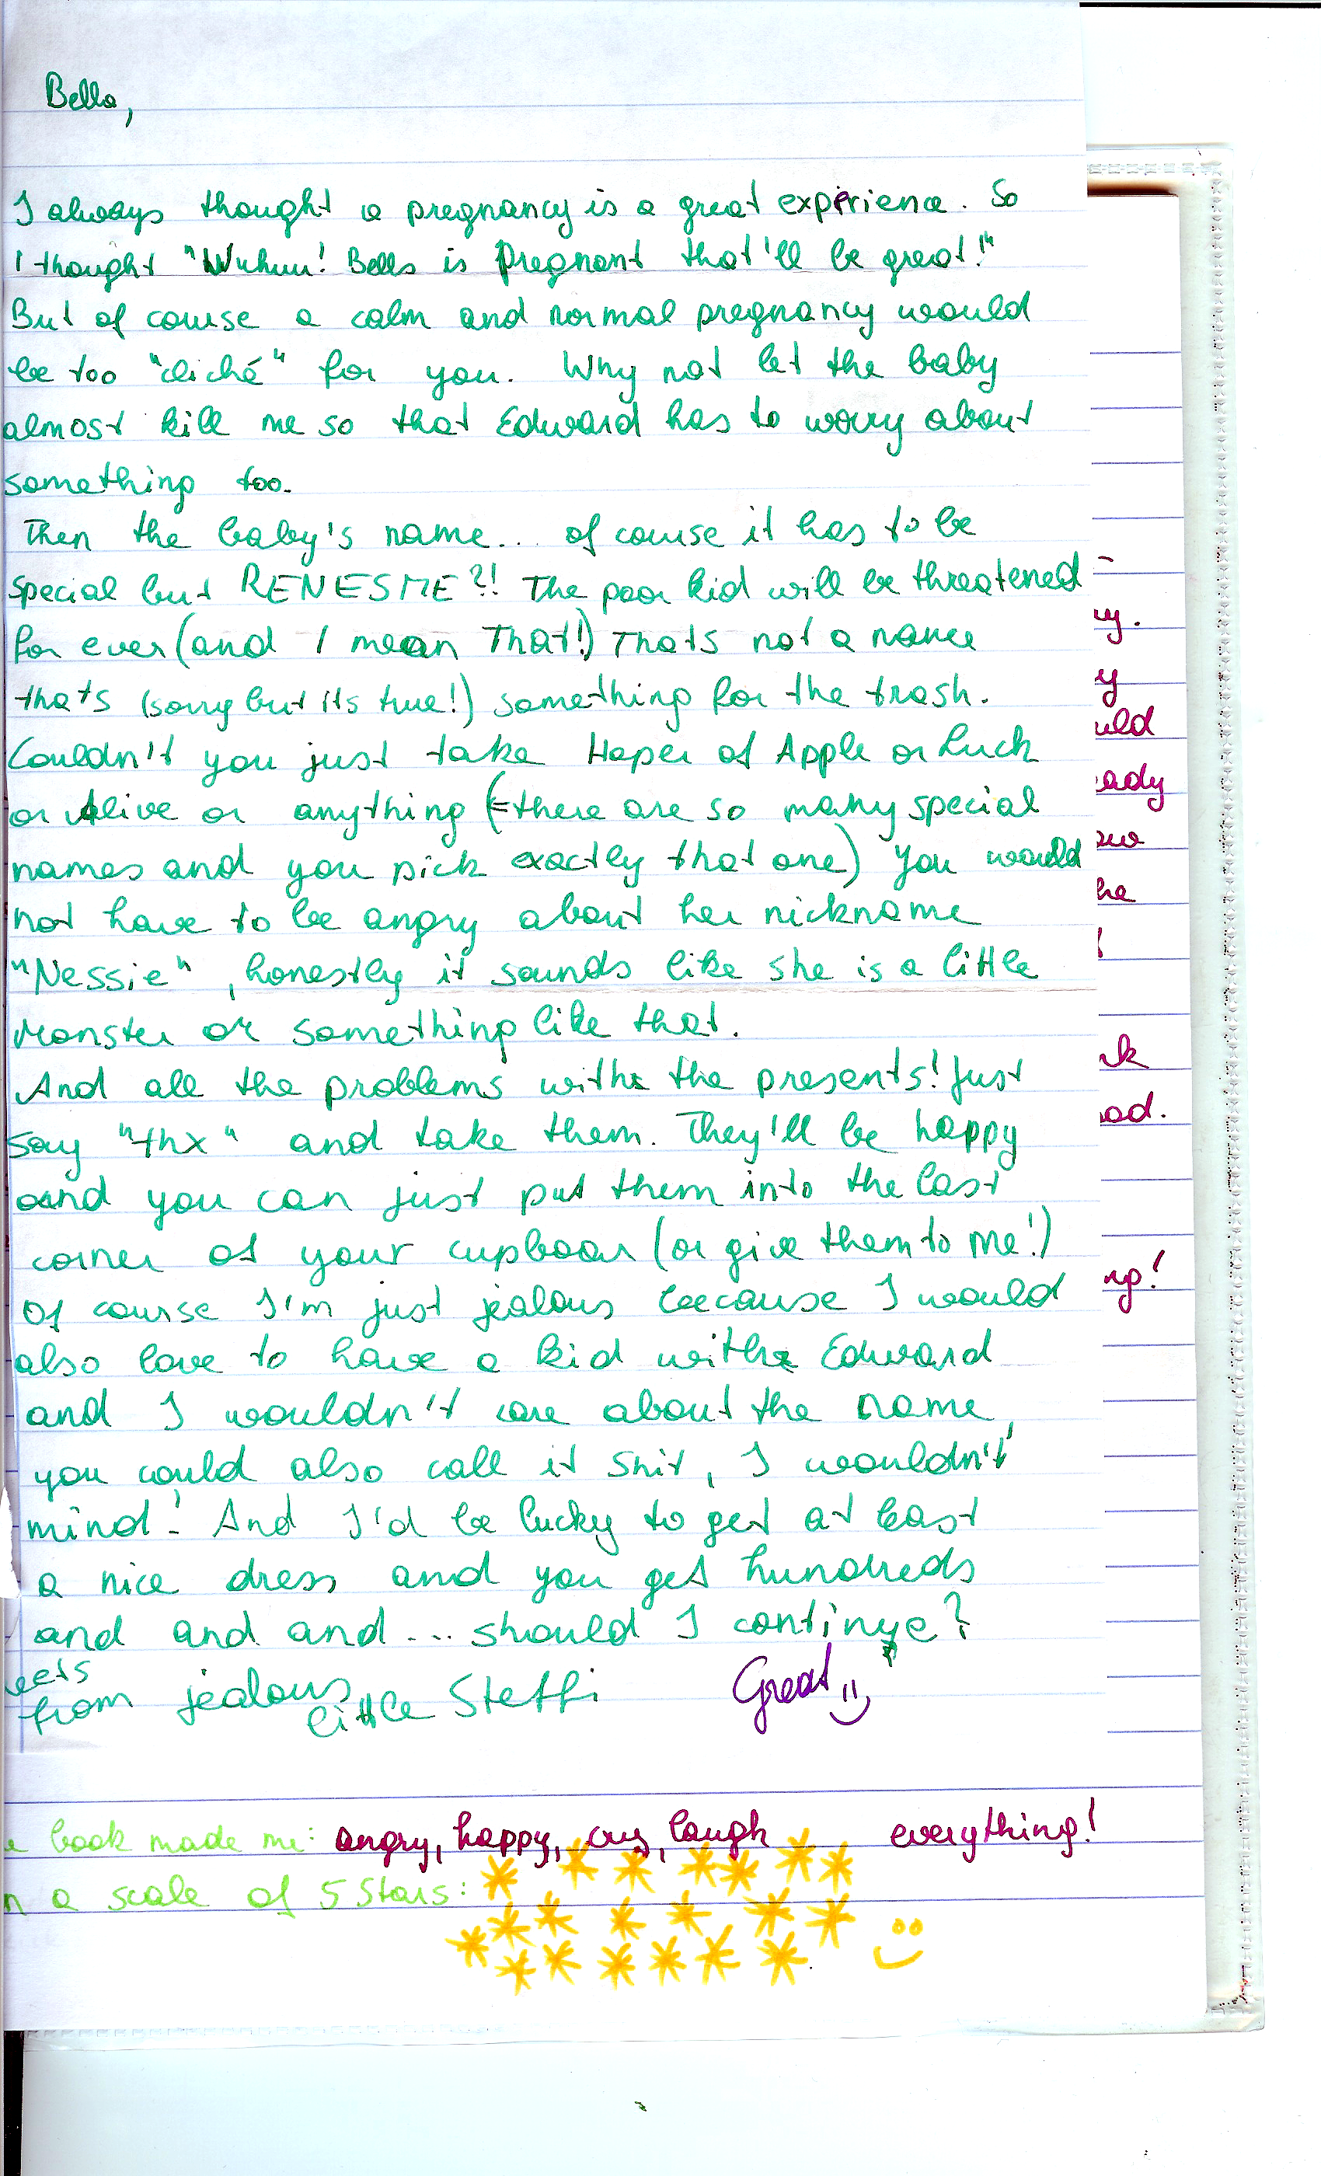

More Letters:
  - Letters to the author or a main character

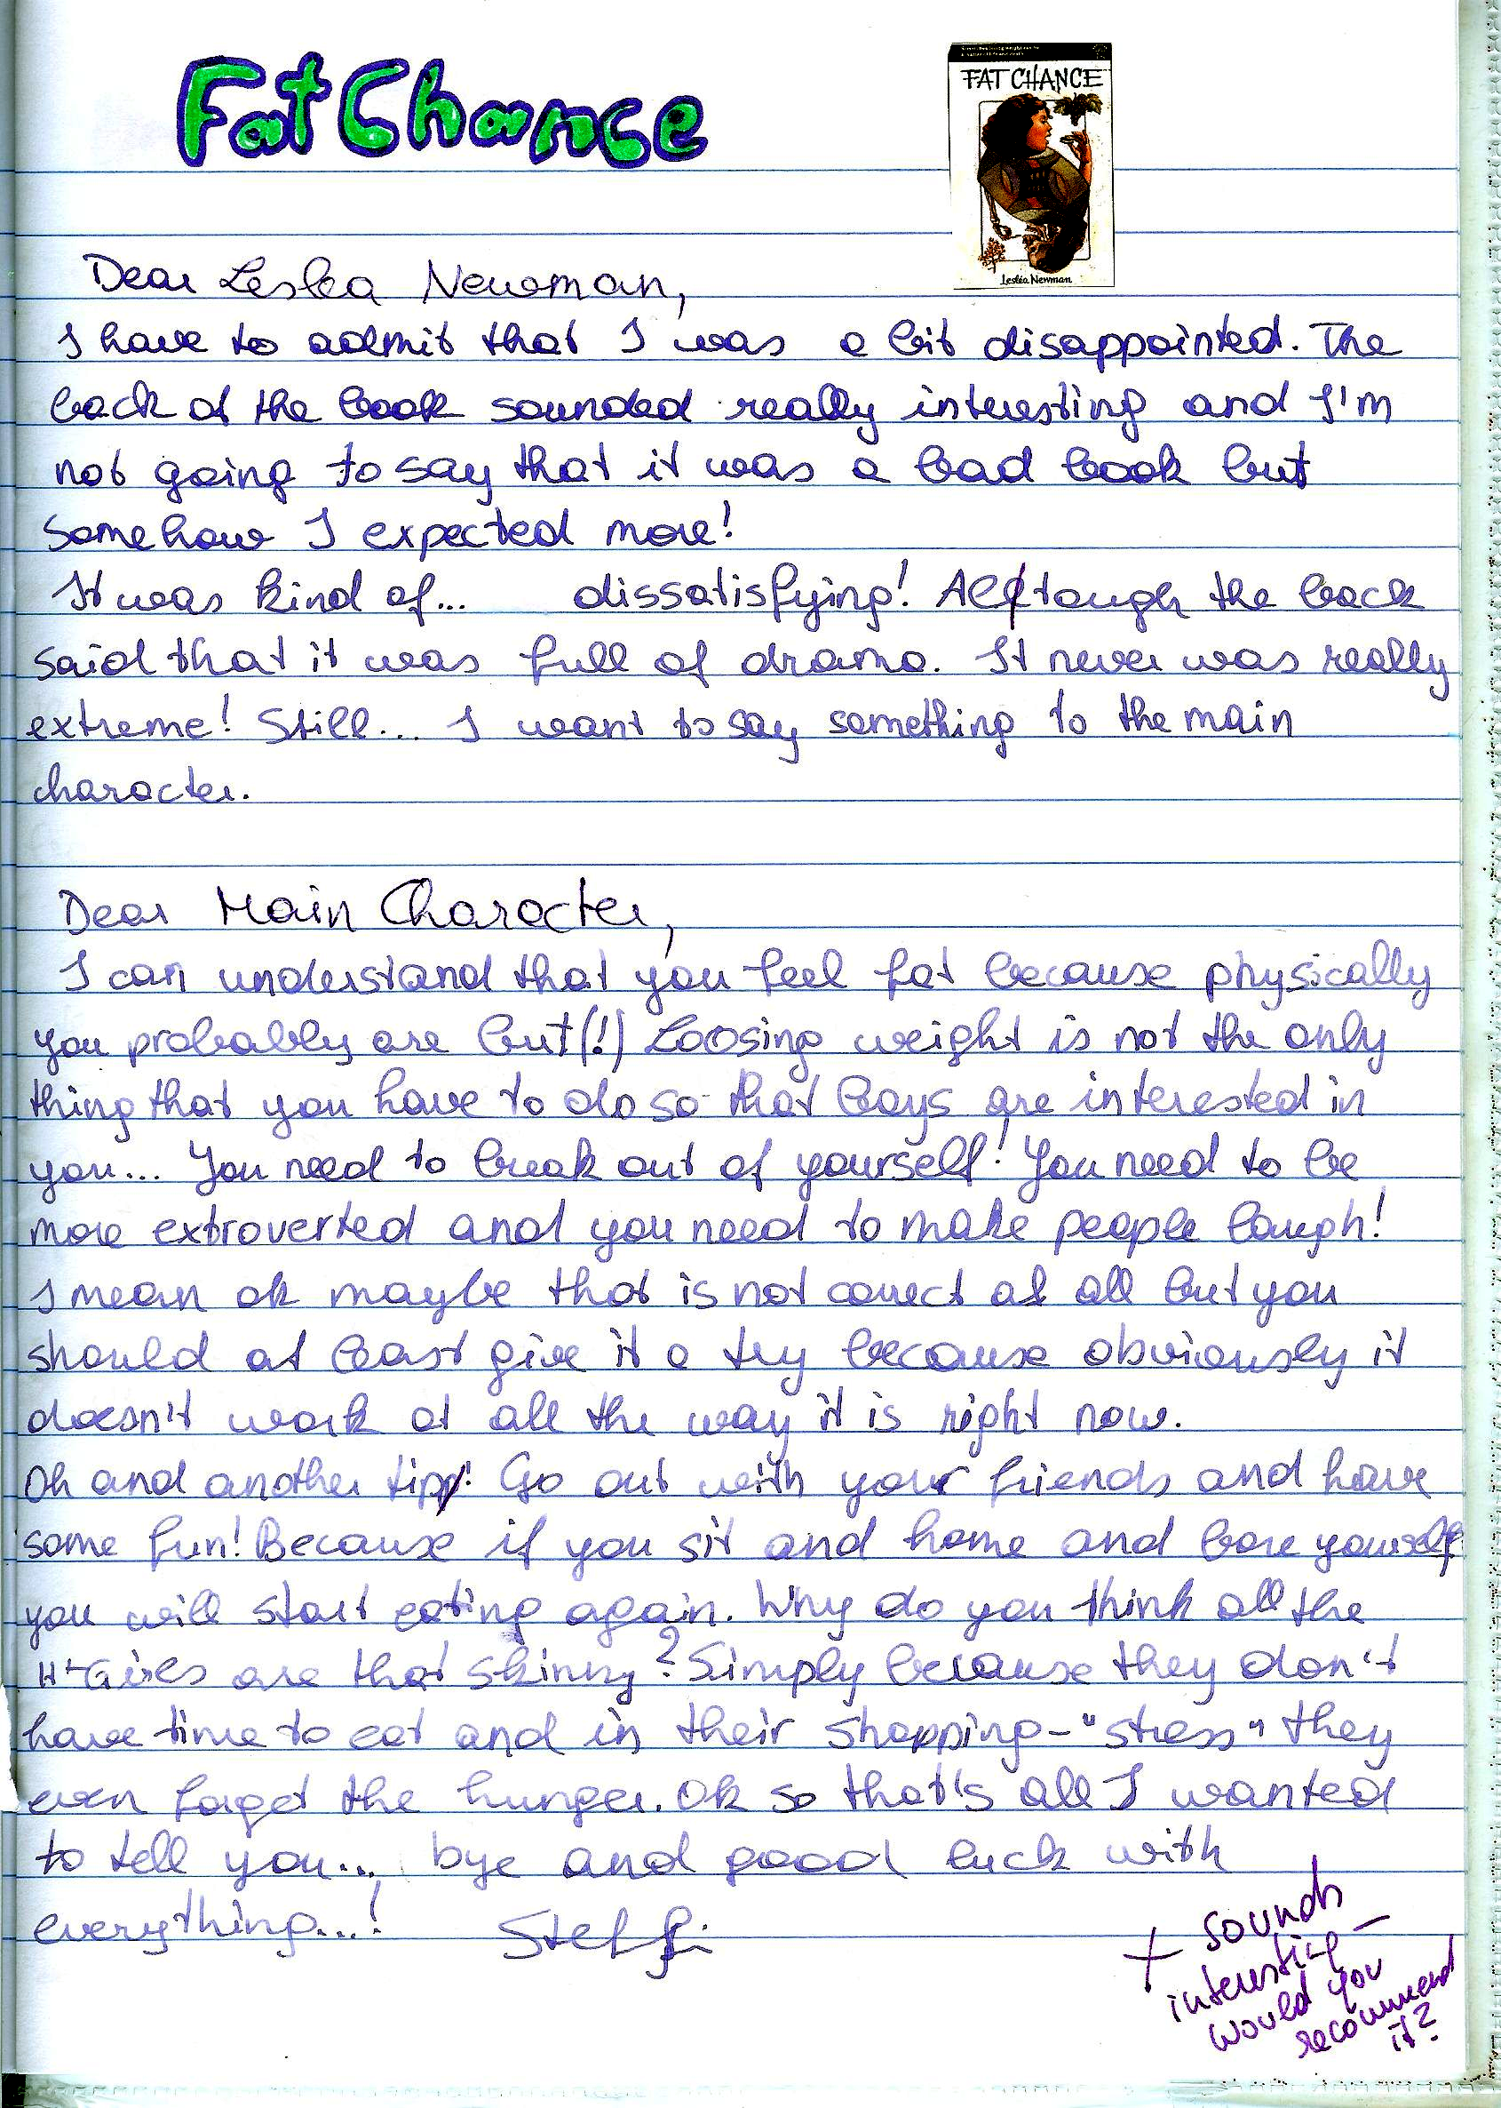

Creative Ideas
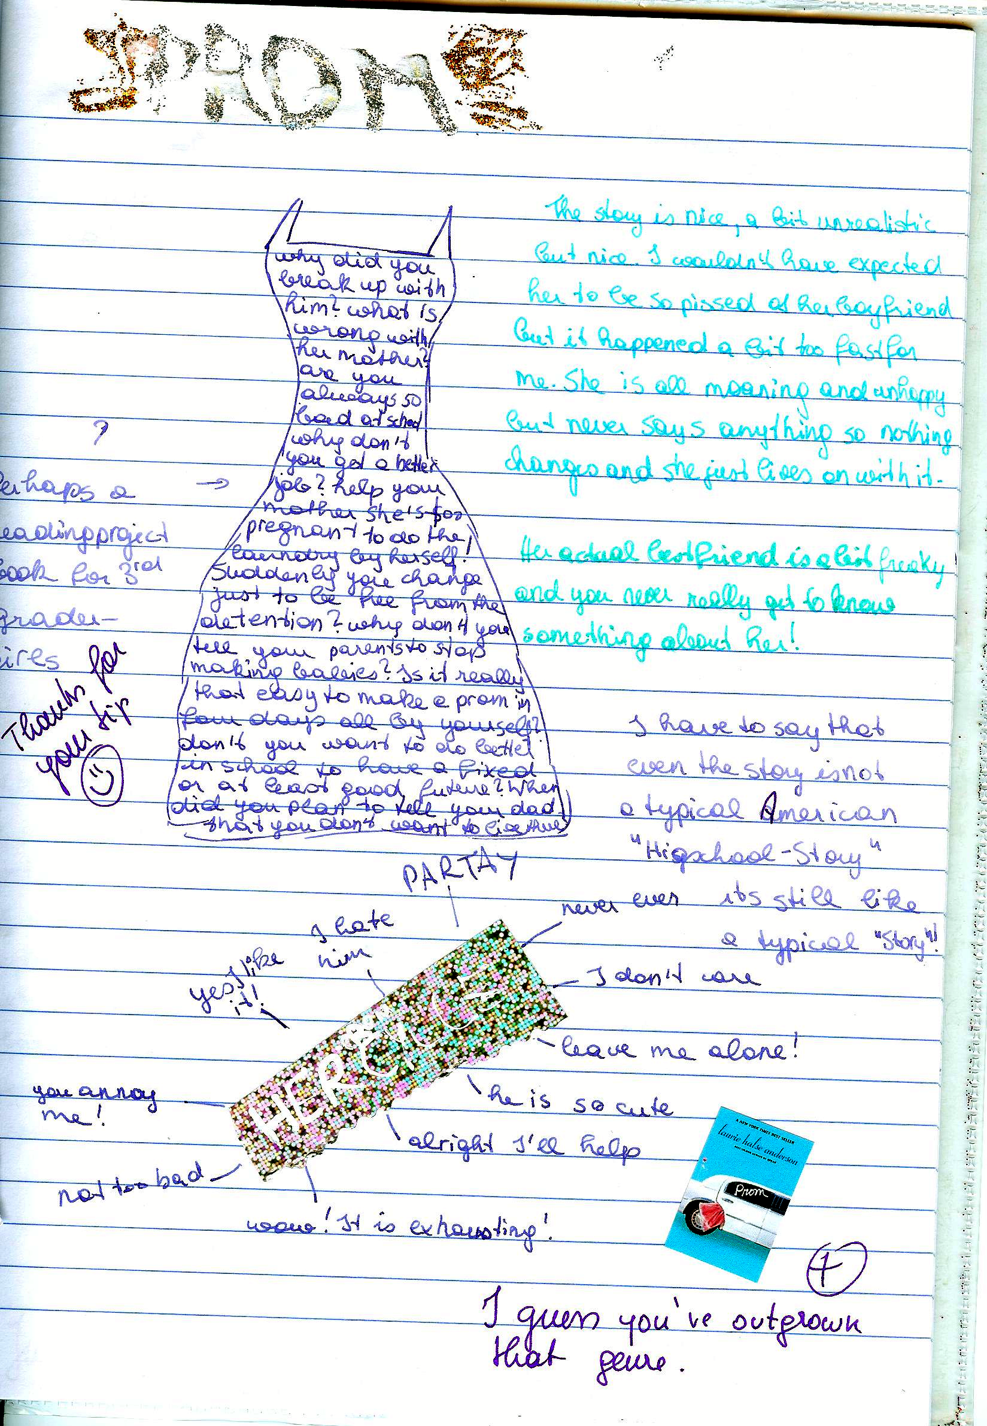

Tips for keeping a reading diary
Effective readers connect with, reflect on, and challenge the text. On your way to becoming such an effective reader use your response journal to try out some of the following tips and techniques.
Read slowly and carefully. Try to imagine the scenes as vividly as possible and try to see life through the main characters' eyes. After reading sit back and think about it for a while, then write a personal response.
Decide how much time you want to commit and stick with it (10 – 15 minutes!)
Write quickly, without worrying about spelling, punctuation, grammar…. Do not pause to think, just keep writing. As you write, follow your thoughts and ideas, do not worry about good organization and coherence. Just let your ideas flow.
Consider some of the following questions:
- Do you enjoy reading this novel or story? Why? Why not? What emotions does the book invoke: laughter, tears, smiles, anger? Record some of your reactions.
- Does the book or its characters remind you of any real life situations or people you know?
- Are the characters interesting and believable? Who is your favorite character? Why is he/she special to you? Is there a character you don't like at all? Why don't you like him/her? Would you like to be one of the characters (acquire a personality trait)? Which of the characters would you become, if you could? Why?
- What are your favorite lines/quotes? Copy them into your reading diary and explain why these passages caught your attention.
- Which are your favorite scenes in this novel? Explain why you enjoyed them.
- Make predictions: What do you think is going to happen next?
- Is the author able to hold your interest throughout the entire novel? How did he or she manage to do this? Or are you bored at times? What exactly makes the chapter/scene boring?
- Is there an idea in the book that makes you stop and think, or prompts questions? Identify the idea and explain your responses.
- Does the book leave you with questions you would like to ask? What are they? Would you like to direct your questions at a particular character? What questions would you like to ask the author of the book?
- Are you confused about what happened (or didn’t happen) in the book? What events or characters do you not understand? Does the use of language in the book confuse you?
- What changes, if any, would you have made in this novel?
- Are there any symbols, symbolic acts or names in the novel?
- Think of the main themes of the novel? What might the author be saying?
- Who else should read this book. Should anyone not be encouraged to read this book? Why?
- Would you like to read more books by this author? Have you already read other books by the author?

Types of Responses
Below you find a number of extracts typically found in response journals:
Affective responses are a kind of raw emotion or a ‘gut reaction’ you have after reading, such as anger, love, jealousy, indignation, contentment, sadness....
e.g.: I was furious when reading the Battle Royal scene. How can these people be so mean and treat a human being like that. I felt like stepping out and hitting them, or sceaming or I don’t know what. I was also shocked at how the main character didn’t even find it so terrible. (He doesn’t have a name! Maybe that has something to say as well, he is invisible and nameless???) He certainly didn’t like being treated like that and was frustrated but not as angry as I was. For him this seems to be quite normal. That makes me even more angry! I really hate these fat politicians, they are the worst hypocrites I have ever seen...
Associative Responses are analogies or associations you have when reading. There are no true and false associations, everyone has their own!!! Let your mind wander, relax (as described in the free-writing technique), this will open the doors for all your associations to flow in.
Look, for example, at the following response of a student to a line from a poem.
...“Something there is that doesn’t love a wall.”(line 1)
I remember when I was young and how I was always sent to my room for punishment of something I had done wrong. I hated being sent to my room, not in the beginning, of course, because I always thought I’d get even with my Mom and show her that I could have a lot of fun in there. As the hours went by, though, I usually ran out of things to do and therefore I would always try to think of a good story to tell sweet ole Dad abourt how mean Mom had been to me. I just hated those four blank walls; I guess that’s because I saw them so often.
or:
Little Richard’s behavior reminds me of this story I read in the newspaper last week. A little boy had played with matches and then hid in the closet because of his bad conscience and fear. Wow, that’s dangerous if little kids react like that. I guess it also has to do a lot with the fear of punishment. These kids must be hit a lot!
You might also note things that strike you as strange or just interesting such as for example this response to the beginning of the novel Song of Solomon by Tony Morrison.
It’s strange that so many characters have Biblical names: Pilate, Magdalena, First Corinthians, Mercy hospital.. (p18). What does this mean?
...
There seem to be a lot of symbols in the book: Watermark (p.11), Red velvet (p.10). I don’t know their meanings yet, maybe it’ll become clearer later.
Also note your impressions of the structure of the text. For example:
The author is constantly jumping back and forth in the lives of the characters. Slowly their history is becoming clear. It’s sometimes difficult to follow. I have to read a page or two until I realize who she is dealing with now! I wonder why she does this!
...
It’s getting worse. I am getting angry with T. Morrison. I feel she is teasing me! Why can’t she just organize her material bxetter? There must be some artistic reason or is it just to be different from the others???
Most of the time your response will be a mixture of all of these approaches. Even the examples above usually include more than just one aspect. Don’t let yourself be stiffled by trying to stick to one aspect. Just let your ideas flow! Don’t forget to write down page numbers, so you can later find exact quotes if you need them.
More examples of reading diary entries

(years 6-7) These examples are unedited, quick responses copied from the learners’ online journals on Moodle.

“The Euphio Question”– Kurt Vonnegut
The first thing I have to mention after having read „The Euphio Question“ is, that I absolutely loved the ending, probably because it was both surprising, and also funny in a way.
The story mildly reminds me of the first one we read. (Top of the food chain/T.C. Boyle) In both stories someone testifies before a commission, telling what has happened, but this story had the “action” or “plot” that I missed in Boyle’s. Although it is, on the second look unrealistic that someone would tell a story in this way before a commission (with all the dialogues and no interaction until the very end with its members), these dialogues etc. make the story easy/fun to read.
One thing I don’t quite understand is how to imagine this feeling you get when listening to the fictional device. At some parts the speaker (sociology professor) describes it as some sort of euphoria and buoyancy, while the people exposed to the sound rather seem relaxed and lazy to me.
Another thing that I didn’t like was the way Vonnegut depicted the wives of Eddie and the narrator: both husbands seem to be used to having a dinner before them when they get home. Maybe that was normal at the time the story was written, but still I can’t help frowning on this type depiction of a wife.
When you have a closer look you can spot some few small details that are a little illogical (for example how does Fred know that the time, when the “whole town went nuts”, “checks” to the second with the time when they switched on the device?) Although I know very well that there might be an explanation for these small details that I didn’t think of yet and that they are completely irrelevant for the plot of the story, I still like it, when everything is logical and makes perfect sense. (In the book I read (also written by Vonnegut) I noticed many and clearer examples of these small things that apparently didn’t fit together, especially with Billy Pilgrim’s time travels.)
I wonder what Kurt Vonnegut wanted to criticize with this short story (as he always does criticize something, that’s for sure). Maybe the fact that people try to make money out of everything possible, without paying attention to who is harmed? It is clear that he wants to say that you shouldn’t want to “buy” happiness, but still I don’t see how buying happiness (through purchasing possession for example) can be dangerous, which is his first argument (I think). This doesn’t mean that I don’t agree with the basic idea, that it is somehow pathetic how we try to become happy.
For me a good story must be/have two things: First of all a message, something to think about, or at least an entertaining story and secondly it must be written in a way that is exciting/funny etc. For me this story fulfills both requirements. (If a story is excellent on one of these two points only, the story can be great too, but if it’s merely “good” in one and mediocre in the other, I tend to forget these stories very fast.)
By Agnes V.

Three reflections on “And Our Flag Was Still There” by Barbara Kingsolver

Paula M.
The story is about a woman talking about patriotism because her daughter has to wear red white and blue to kindergarten for a day to remember the victims of 9/11. I really liked the story because the woman,although she is american herself, critizices the overdoing of patriotism in America. She talks about extreme cases where americans get really racist towars other people just out of " loyalty to their country". I think it is a nice story because she is not really blaming anyone she is just saying that there are a lot of people overdoing it and in the end she says that the meaning of her flag is that " we´re all just people together" and I think that is a really nice way of seeing it.

Paula N:
First of all, I want to point out how much this story touched me. I actually cried a little. I cried because everything in this story seems so true to me and it's very tragic to me how certain people deal with horrible events like September 11, how they blame other innocent people simply because they might have the same religion as the ones who flew into the building, how they make important rights, that courageous people gave their lives for years, seem stupid and not necessary. But I also cried because this story gave me hope that there are people like Mrs. Kingsolver who keep their heart free from hate and blaming minorities, and who believe in the Constitution and everything that came with it and not only for white Americans but for all Americans, whether they or their grandparents immigrated or what beliefs or sexuality they have. I will suggest this story to friends and family because in my opinion this story forces you to think about the often dark truth of so-called "necessary wars for peace and freedom" but also gives you hope that there are people who want this peace and freedom peacefully and for everyone.

Johannes W.
Well, a perfect style, an interesting and well-chosen topic and an optimistic message doesn't leave so much room for associations. But still one question came to my mind immediately: "What type of text is this?" To me it is neither a short-story, nor a speech, a report or an article. It is somehow a mixture of all, isn't it? Since I am a European and actually have never left the continent actually so far, this theme of finding one country's or even one peoples values, identity and community is something rather unknown, odd, funny to me. Of course this is linked to History, I'm perfectly aware of that, but it is somehow weired but at the same time amusing to read. I liked reading it also for the nice style and the well chosen tone and language. I wasn't used to the absence of an actual plot (just the little side-track of her daughter) and also the absence of an actual description of characters, etc. But that again was creating a certain tension because I wanted to know more... I guess this was the very intention of the good and talented author and actually now, at this very moment, it comes to my mind: In my opinion this is an inner monologue... :-)

Reflections on: Paul Auster, a story from The Red Notebook

Love it! Awesome! Simply great! I cannot remember the title anymore but I had the story about a man who survived a concentration camp, while being there fell in love with a woman he had never seen before; they just wrote letters. After all, they married got children and raised them. When the oldest son was studying already, he fell in love with a girl that turns out to be the daughter of the SS officer. Nevertheless both fathers like each-other, they (their children) marry and the family leads a rich, good life.
There are three reasons why I like that story:
1.) I love the style, the language, the tone and THE LENGTH. This is one of the few short stories that really are short. But the quality is on the top and I did not at all have the feeling that I wasted time. Everything important is in, everything that is not necessary and just makes you loose time is not there - this is what I call real expertise.
2.) It is one of the so much wanted, yet so little available stories about the WWII times that is not depressing, full of pain, suffering and "victimism", trying to teach one a lesson, trying to convince one of one certain aspect or making you feel guilty of something others haven't even done... You know all of that horrifying elements are just not there, which -- for a change -- is really relaxing.
3.) This is a real story! I find it simply great to take true tales based on life and to make a novel/story/whatever out of it... And the fact that he -- the author -- had done it in such a good way is also wonderful. You see, I find that short story marvelous, perfectly enjoyable and great to read. I have hardly ever said that a very sheet of paper (that I even got in school) was an experience -- but this single page was one!
There isn't much more to say, for me; I found that an enrichment, something like a little treasure within my long course of educational existence. Thank you for that story.
By Johannes W.

Reflections on “Top of the Food Chain” by T.C. Boyle

I can't believe that the main character, who is talking to the Senator, is so indifferent to all the animals and at last people dying. It's like he doesn't care at all as long as he can say that he fulfilled his job which was to help the people to get rid of the mosquitoes. It was also unbelievable how arrogant he was and how bad he talked about the people in Borneo and how low he apparently thought about them. If he was as much smarter than the people there, I don't understand how he didn't use his wisdom to help the people instead of making everything worse for them. If he at least had been sorry I could maybe find sympathy for him but like this he just makes me want to punch him. I really would have liked to know what the Senator, he was talking to, thought about all that.
By Paula N.

Reflections on the novel Girl with a Pearl Earring
Even though it is not told sadly, to me the story was very sad. It is beautifully told, but it's depressing that Griet doesn't have even one person that she can confide in, and I don't think that anyone would be able to hide their emotions like she does. She's so shy, and sometimes i wanted her to say something or do something, for example when the friend of Johannes Vermeer comes and tries to rape her, but she just pushes him away slightly. Of course, as a maid you can't always speak your opinion, but she has to stand up for herself a little bit, at least in my opinion.
The language was beautiful. I don't know how Tracy Chevalier does it, but she never tells the emotions of anyone, but you still know exactly how they are feeling. I would have liked to have more emotions when her sister had the plague, that was the only time it was overdone in my opinion. I liked that there was not a cheesy ending, but a very realistic one that was not satisfying to Griet, but she could settle with it. As a reader, it kind of felt the same.
By Anna E.

Reflections on “ Magdalena Looking” by Tracy Chevalier

Oh my! There is so much conflict in that simple short story. First of all the women-role problem, ignorance in general, the longing for some acknowledgement, personal needs and poorness all the same.

I felt sorry for that poor little girl, Magdalena. The common theme of a talented daughter of a skilled father who is just not being noticed by him because of gender role and circumstances in which they live in is sad. You want to help them all out of their silly, maybe unnecessary but surely disappointing situation, because you see the escape -- they cannot, maybe should not.
How annoying must it be for a daughter to have a father who hardly ever looks at her, doesn't notice her, while she admires him and wants to be taught by him -- she never paints but a dot. Her abjection is typical for that miserable situation she finds herself in and the ignorance of her father, the unwanted humiliation by her father (looking at her to paint her, giving her the jewelry because of light-reflexion and not beauty) and the final uselessness of all that problematic life does cause the reader pain.
Another aspect is the actual picture that truly exists. Nobody really knows that young woman, yet she is still there, drawn in a fine way, looking very extraordinary, yet familiar. Strange and unfamiliar but at the same time interestingly pretty. I like the way the author has put a whole story around that picture, embedding the little details and relating them with an own anecdote or well explained reason. Nothing happens accidentally -- there is reason behind -- we just cannot see it most of the time. In this story we can, because she wants us to and it works. I like the atmosphere, the jigsaw-puzzle-like coming together of everything and the so very true outlook of great connection, the overall sense -- the living moment for eternity...
By Johannes W.

Now try out FREE WRITING yourself.
Read the three poems and choose one that you find interesting. Do not choose a poem that you have known and worked on before. Write down your thoughts and associations without stopping to think. Do not take your pen off the paper, just keep writing for ten minutes.

Harlem
What happens to a dream deferred?
Does it dry up
like a raisin in the sun?
Or fester like a sore--
And then run?
Does it stink like rotten meat?
Or crust and sugar over--
like a syrupy sweet?
Maybe it just sags
like a heavy load.
Or does it explode?
Langston Hughes
Barbie Doll
This girlchild was born as usual
and presented dolls that did pee-pee
and miniature GE stoves and irons
and wee lipsticks the color of cherry candy.
Then in the magic of puberty, a classmate said:
You have a great big nose and fat legs.
She was healthy, tested intelligent,
possessed strong arms and back,
abundant sexual drive and manual dexterity.
She went to and fro apologizing.
Everyone saw a fat nose on thick legs.
She was advised to play coy,
exhorted to come on hearty,
exercise, diet, smile and wheedle.
Her good nature wore out
like a fan belt.
So she cut off her nose and her legs
and offered them up.
In the casket displayed on satin she lay
with the undertaker's cosmetics painted on,
a turned-up putty nose,
dressed in a pink and white nightie.
Doesn't she look pretty? everyone said.
Consummation at last.
To every woman a happy ending.
Marge Piercy

Incident
Once riding in old Baltimore,
Heart-filled, head-filled with glee;
I saw a Baltimorean
Keep looking straight at me.
Now I was eight and very small,
And he was no whit bigger,
And so I smiled, but he poked out
His tongue, and called me, "****."
I saw the whole of Baltimore
From May until December;
Of all the things that happened there
That's all that I remember.
Countee Cullen.

News Item
Men seldom make passes
At girls who wear glasses.
Dorothy Parker

Download the full-size template from epep.at
Choose one interesting main character in the book/story you are reading and take a closer look at his/her personality. Who is he/she really? Look at the different levels of their personalities, starting with the environment (setting) they live in and move in towards their spiritual centers. Draw a circle diagram like the one on this page and write a few keywords or sentences into each layer of the character's personality.
Slip into the character's mind and consider the following questions:

Environment: Where does your character live/work? What is this place like? How does it affect him/her? Who else is there? How do these other people influence him/her? How does your character get along with them?
Behavior: What does your character do? List a few important or typical actions or activities of your character
Capability: What is your character good at? What strategies does he/she use in the story? Does he/she use them openly and consciously? What skills does he/she have?
Beliefs: What are your character’s basic beliefs? Think of the various ideas that he/she thinks are true, and that your character uses as a basis of daily action. Beliefs can be both permissions and limitations. (e.g.: "I am strong! The positive forces will always win!" or "I am afraid of my stronger enemy, he will certainly kill me." or "I don't do this or that because I think it's wrong.)
Identity: What are your character’s core values and his/her mission in life? What does your character want to achieve?
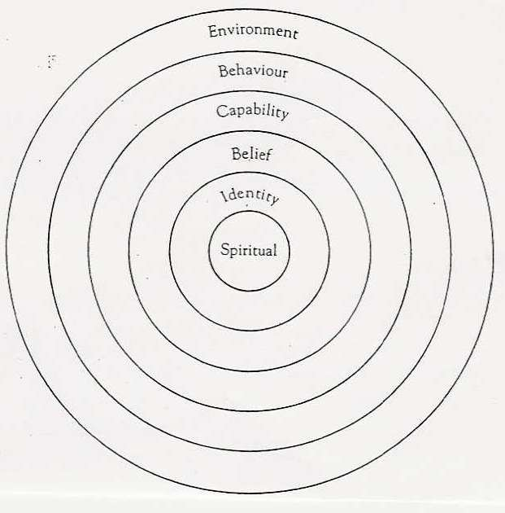
Spiritual: This is the deepest level of any character or person. Here we consider such metaphysical questions as "Why are we here? What is our purpose?" These questions are hardly ever asked or answered openly. Try to slip into your character's mind and answer these questions for him/her. What would he/she say?
Title of Book/Story ...............................................
Author: ...............................................
Character's name: ...............................................

Now do a character profile for one of the main characters in your book:

Teacher’s comment: The text is actually a literary essay – but the student has never heard of this genre at this point.

