Planning and Organizing Reading Projects
It is cool.
I like reading
Remember this:
Look at this!
I am proud of my work.
I can choose my own book.

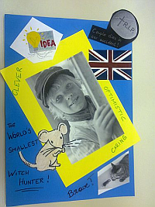

When planning a reading project for your class, consider the following aspects:
- Find suitable books: language level, different tastes and interests, season, class topic
- Book choosing: introduce the books in interesting ways (see “How to wet my students’ interest”, offer a choice for boys, girls, readoholics and reluctant readers.
- Book ordering: time, availability, price
- Pre-reading and warm-up activities: the first chapter is the most important one. If students understand who is who and what is going on, if they can relate to the characters’ dilemmas, they will want to read on. Plan some interesting opening activities to set the scene. Allow the class to read quietly for 30min or more to get into their books. Students who are reading the same book can help one another with comprehension questions. Walk around and help them get into the stories.
- Plan reading time: check other class projects (books they read in German, important test dates…) and decide on a deadline that is not too far away.
- While reading: do not give students too many while reading tasks. Such tasks are helpful if they guide the readers’ focus a bit or if they are asked to collect a few useful phrases from their reading. Don’t overdo it – too many tasks will kill the reading experience.
- Post-reading tasks: Groups meet and share their views, ideas and questions. Most reading projects will lead to some kind of PRODUCT (written or oral) such as
  - Booklets (pedagogy of the blank sheet)
  - Tasks to be completed in the reading diaries
  - Presentations in class or online
Whenever possible give students some choice concerning suitable forms of writing or presenting. Decide on a common FORMAT (e.g. design a booklet… or prepare an online presentation using MyBrainshark.com…) but allow freedom within that frame. Students will be more creative if they feel in charge.

Examples
The following pages show a few examples of tasks that can be used in reading projects. For more ideas visit epep.at. There you can also download a variety of handouts and project packages for your students.

A mini project for one double lesson
Note: in this project students were allowed to read ANY book they wanted to read. Therefore no groups could be formed.

Private reading: Let’s share
- SWBS: The Plot Chart
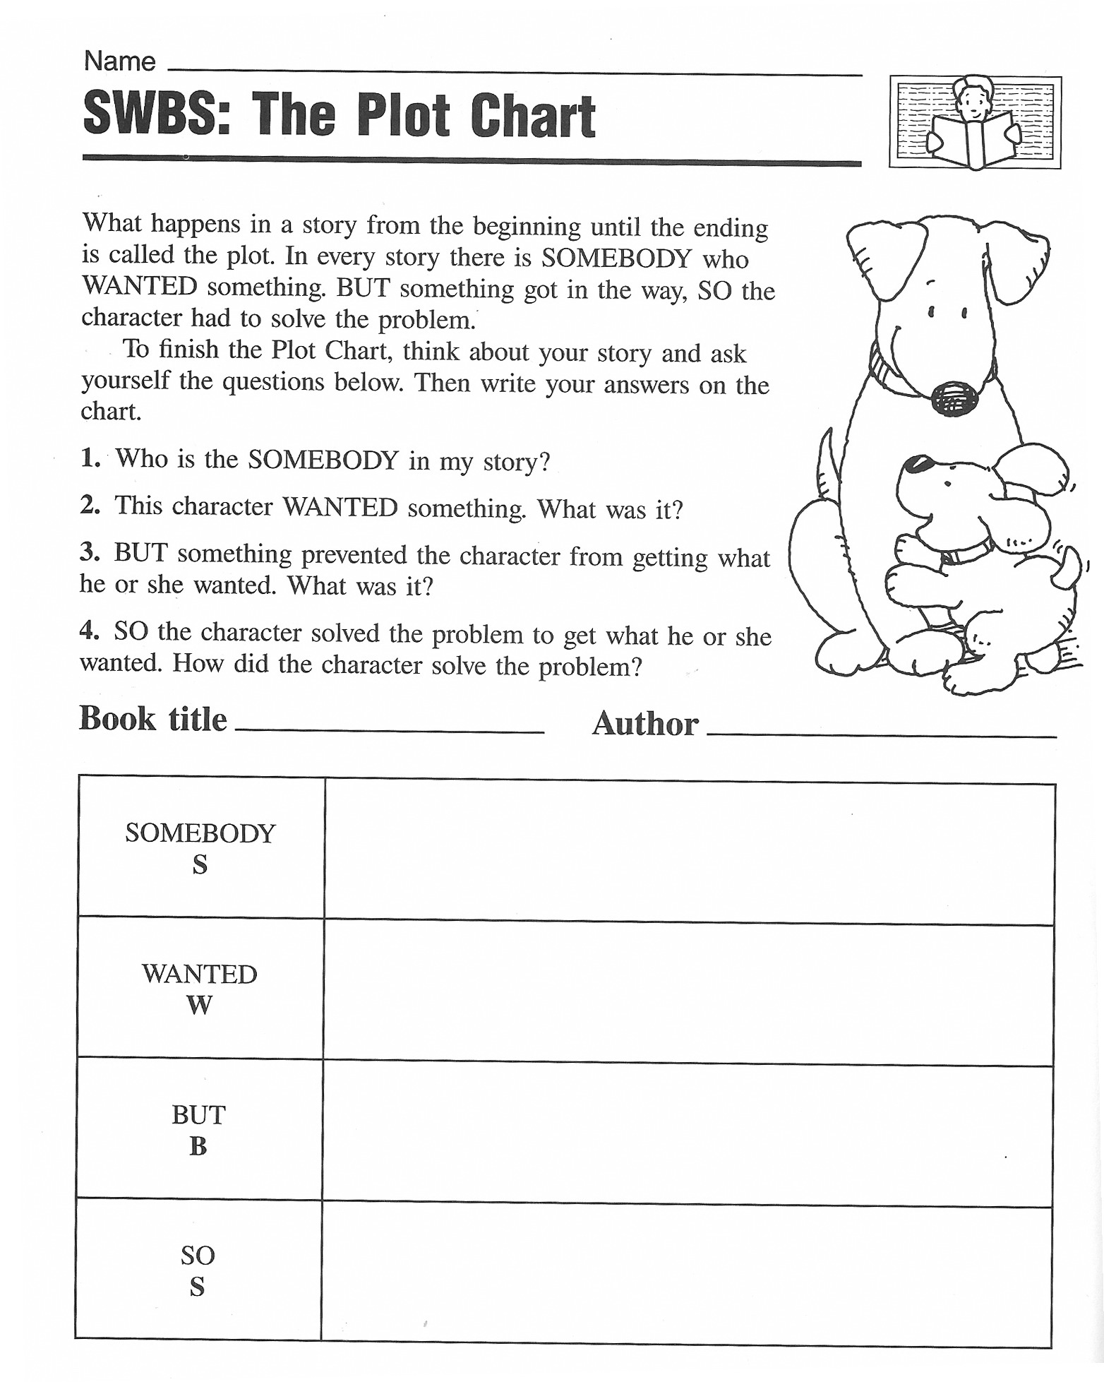
From: Christine Boardman Moen, Better Than Book Reports, Scholastic, 1992
- Sum It Up
Make a sum-it-up card for your book. Fill in the blanks below.
Title:.............................................................  Author:.........................................................  Three important facts:  1.  2.  3. | Write a summary that tells the main idea.  Summary:  ........................................................................  ........................................................................  ........................................................................  ........................................................................  ........................................................................  ........................................................................  ........................................................................  ........................................................................

3.Book-Fair:
Walk around and read all the posted SWBS and SumItUp sheets. Find 3 books that have something in common with your own.

4.Grouping Books Together

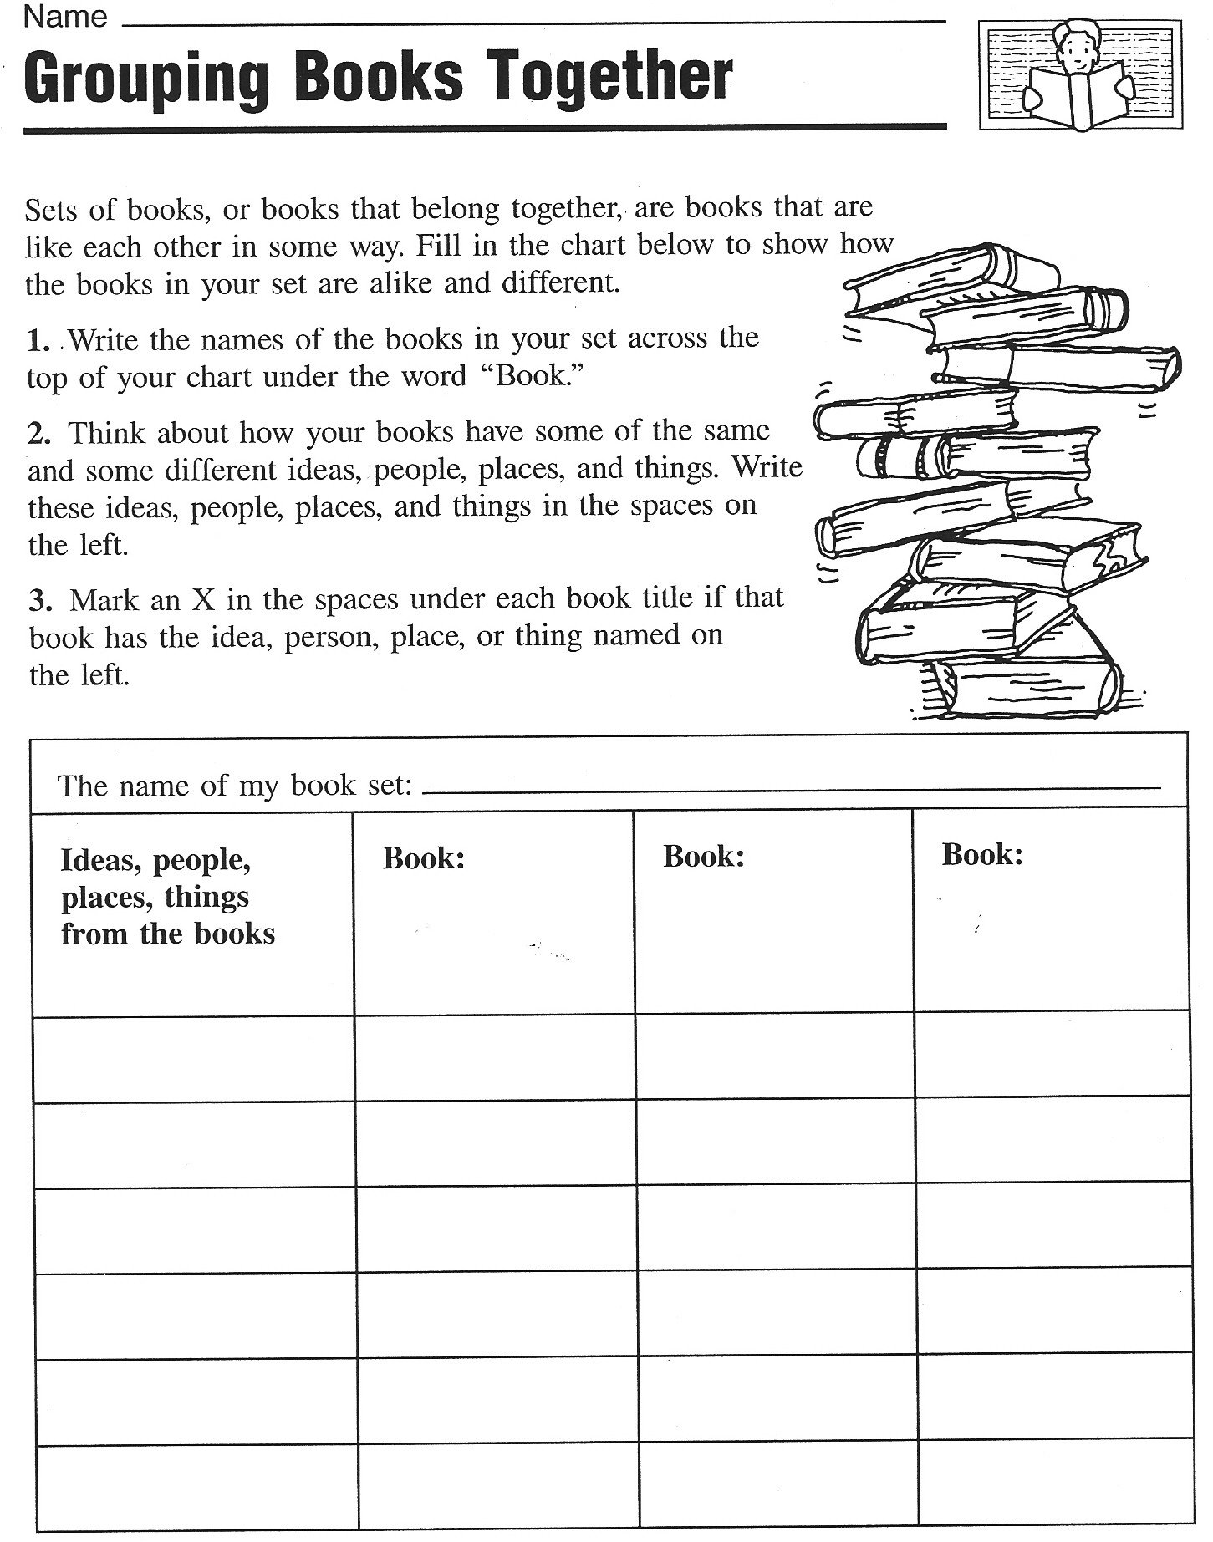
From: Christine Boardman Moen, Better Than Book Reports, Scholastic, 1992

5. Creative Catalogues: Design three A5 catalogue pages.
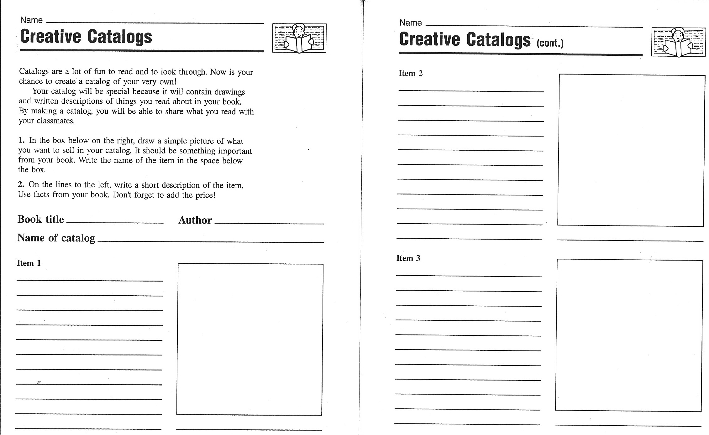
From: Christine Boardman Moen, Better Than Book Reports, Scholastic, 1992

6. Vocabulary Quilt
Choose one of your favorite new expressions from your book and write it on a piece of colored paper. Write a short, typical sentence and decorate the paper in a suitable way. Your paper must include:
- the new word written in big letters
- a typical sentence
- a drawing that will help you remember the new phrase.
We will put all our word cards together to make a Vocabulary Quilt. Please design your cards nicely.
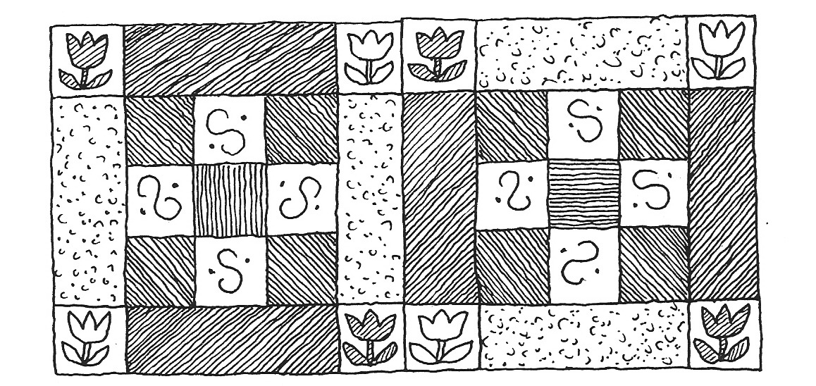

Book sharing

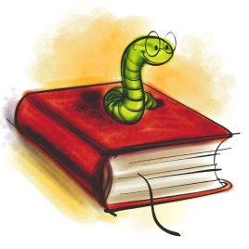
Prepare the following things for the book you have read:
5 nouns (things, objects…) | Choose 5 things that play an important role in your book and write them on the cards provided. (Example: broom, hour glass, magic potion, train, … for a Harry Potter book)
Big trouble | Choose a passage in your book where one of the main characters is in trouble, has a problem or is very sad. Practice reading this passage so you can later read it out to your group.
Happy moments | Choose a passage in your book where one of the main characters is happy. Practice reading the passage.
Important adjectives | Find three adjectives in your book that are somehow important for the story. Choose new and interesting adjectives – not words we all know. Copy the adjective on a card and write the sentence you found in the book on the BACK of the card.

Group Phase
Work in groups of 4 with classmates who have read books you do not know yet.
Guess what… | Show your noun cards and adjective cards to your friends and have them guess what the book might be about.  Ask lots of questions about your friends’ books and try to find out as much as possible about the main characters, their problems, their wishes and hopes.  Do not give away the endings and solutions of your book.
Big trouble and  Happy moments | Read the passages that you have chosen to your friends and explain why your characters feel so happy or so sad.
Important adjectives | Put all the adjective cards on the desk (only show the adjectives, not the sentences)  Copy all the adjectives on the back of this sheet and guess what the words might mean. Discuss your ideas in the group.  Then turn over the cards and look at the sentences. How can these sentences help you guess the correct meaning of the adjectives?  Now ask the students who have written the cards to explain the meaning of the word and record it in the table.
Homework | Copy the new adjectives and sentences on vocab cards and add a second sentence where you use the new adjective in a TRUE sentence.

This is what your vocab cards should look like:
Use ONE card for ONE vocab item.
Word: | Dreadful
Sentence from the book: | Their dreadful voices sounded like dentists’ drills all grinding away together.
My true sentence: | My neighbor Rosalinde has a dreadful, whiny voice.
On the back write a translation of the main parts of the sentences. Example:
Ihre schrecklichen Stimmen klangen wie Zahnarzt Bohrer…
Rosalinde hat eine schreckliche, weinerliche Stimme.
Adjective | Sentence from the book:
1
2
3
4
5
6
7
8
9
10
11
12

Reading Project

1. Choosing a book:
Look at all the books in the selection. Read the blurb (back cover) and then read the first two or three pages of each book. How many unknown words are there on each page? Can you guess the meanings? What else do you notice about the book?
- What kind of book do you think this will be? Do you think it will be science fiction, fantasy, realistic fiction, historical fiction, mystery, a crime story?
- What do you think the plot will be about? Make a one-sentence prediction for each book.
- What kinds of characters do you expect to meet in each book?
- What will the settings be like?
Write your findings in the table on the next page.

Which of the books would you like to read? Award 1 – 3 stars to the books, depending how interesting they look. Mark the stars in the first column. Then decide which book you would like to read. Write down your fist, second and third choices on a sheet of paper and stick your paper up on the book poster under the title of your first choice. As far as possible you will be given your first choice.

2. Getting ready for the book: Making predictions
While you wait for your chosen book to arrive imagine what might happen in your book. We will try a 10-minute free-writing activity in class. Write down what you expect from the book. Use the following expressions and the "will" future. Use your reading diary for all the tasks.

I hope that......
I wonder if ....
I bet that... .... will ...
I'm afraid that...
I (don't) think that...

3. The books have arrived!!! Let's start reading
Get together with your friends who have chosen the same book (3-4 students). Read quietly for 20 minutes. Read slowly and imagine the scenes and characters as vividly as possible. After 20 minutes meet to discuss your reading. Distribute the task cards in your group. Each of you is responsible for a different task. Read your task card carefully, then guide your group through the activity. Write all the questions and answers into your reading diary.

4. Homework:
Read chapters ........................................ by ...........................................................
Read slowly and carefully and mark any interesting passages in your text. Choose 3 phrases or expressions that you would like to remember and write them on vocab. cards. Then write a five minute entry (non-stop writing) into your reading diary.

Book title and | New words per page | Other comments about the book:
Type of book:
Plot prediction:

Characters:
Settings:
Type of book:
Plot prediction:

Characters:
Settings:
Type of book:
Plot prediction:

Characters:
Settings:
Type of book:
Plot prediction:

Characters:
Settings:
Type of book:
Plot prediction:

Characters:
Settings:
Type of book:
Plot prediction:

Characters:
Settings:
Task 1: Language Police  English please!!!  In this activity you are responsible for reminding your group to speak only English. Whenever you catch somebody using German show them this card. |  |  | Task 3: Character Detective  List all the characters that you have met so far. What do you know about them? Who are they? What is their role in the story? What mood are they in? Do you like/dislike them? Do you trust/mistrust them?
Task 2: New Expressions Expert  Ask each of your friends to find one new phrase or expression that they would like to remember. Highlight these phrases in your book and write them on vocab. cards. |  |  | Task 4: Where and When?  Where and when does your story play? Find a passage in your text where the setting (place and time) is described. Highlight it and copy a few important details into your reading diary.
Task 5: Asking questions

Ask each of your friends to write down one question that they have in mind now. What is it they would like to know about the book?
Share your questions and write them into your reading diary. Maybe you can answer them later or ask your teacher.

5. Reading Circle Activities

- Get together in your reading group and decide who is going to be the Language Police and Group Leader today? Remind your friends to use English only in their discussions and to stay on track ( = not digress from the topic). In case of disagreements make sure that your friends argue their point politely.

- Sharing Reading Diaries: Read each others' reading diaries and discuss your reactions to the story.

- Work with the small Discussion Prompt Cards. Sort the cards by color and put the piles face down on your desk. Take a card from the top of a pile and read it out to your classmates. If the card doesn't apply to your book at all, put it back and take a new one. Do the task carefully in your group. Write all your answers into your reading diary. When you have completed a task, take a new card from a different pile. Take turns reading the tasks out and leading the discussion. Do as many tasks as you can but do them carefully and thoroughly.

- Workshop and Homework Tasks: On the following pages you will find 13 tasks. You have one double period in class to do them. You may work alone or in a small group. Do the other activities at home. Write all your answers into your reading diary. Always write clear headings (number and name of activity).

- Reading on: Read chapter(s) ........................................... by .......................................... and write a 5-minute non-stop entry into your reading diary.

- Vocabulary Work: Collect good phrases and write 20 new vocab cards for the whole book. Hand them in with your reading diary.

Useful materials and ideas

Find more ideas on epep.at

50 Fabulours Discussion Prompt Cards: downloadable PDF
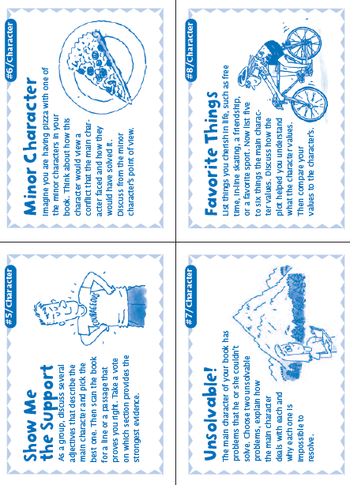
Can be used again and again. For lower intermediate speakers you might want to adapt the language a bit.

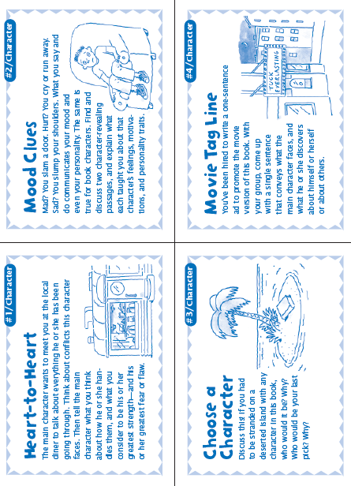
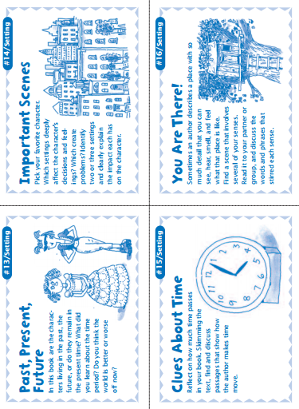

Booklets for all ages: The pedagogy of the blank sheet
These booklets are my favorite projects. The idea is based on Hannelore and Helmut Zehnpfennig’s concept of the “Didaktik des weißen Blatts” (see below). This idea can be used at all levels, from beginners to advanced learners. The results are always stunning and much more interesting than answers to teacher-created questions and tasks. They really show how students have understood a novel or a topic in general.
Didaktik des Weißen Blattes
Hannelore Zehnpfennig (Grundschullehrerin) - Helmut Zehnpfennig (Soziologe)
Im Offenen Unterricht von Hannelore Zehnpfennig werden alle Fächer zum freien
Arbeiten angeboten. Ausnahme: Sport, Musik, Religion und Kunst. Die herkömmliche
Zeit-, Raum- und Stoffstruktur wird aufgelöst. Das heißt: Raum ist individuell nutzbar,
Zeit ist individuell nutzbar für die Fächer, Stoff wird selbständig ausgesucht
Didaktik des Weißen Blattes
Der Sitzkreis zu Beginn und am Ende des Unterrichts ist freiwillig. Zehnpfenning wählt den
Weg der drastischen Einschränkung des Materials. Sie fordert eine kleine Handbibliothek
mit Nachschlagewerken und Fachbüchern zu vielen Themen, Schulbücher sind nicht
dabei. Sie können höchstens als Angebot in der Klasse aufliegen. Heute ist auch der PC
wichtige Infoquelle.
„Unser wichtigstes Arbeitsmaterial ist das weiße Blatt Papier, unseres Erachtens das
kreativste Material, das es gibt. Es stellt "wahrscheinlich die größte Herausforderung
an die Imagination der Kinder dar" stellt Peschel (1996, S.38) fest, nachdem er unsere
"Pädagogik des weißen Blattes" kennengelernt hatte. Das leere Blatt fordert oder
provoziert geradezu die kindliche Phantasie es zu füllen. Wie, das sagt ihm weder das
leere Blatt, noch sagen wir´s. Das Kind muss selber entscheiden und gestalten. Ein
Arbeitsergebnis ist zu dokumentieren, ein Sachthema zusammengefasst
darzustellen, um in ein gemeinsames Buch zu kommen. Welche Informationsquellen
benutzt werden und wie, überlassen wir vollständig dem Kind. (Zehnpfennig/Zehnpfennig
1992)“
Für die Eigenproduktion von Arbeitsblättern spricht ein gewichtiger Grund:
„Selbsterstellte Arbeitsblätter sind immer auch aktive, individuelle und 'originelle'
Lösungen von Problemen" (Zehnpfennig/ Zehnpfennig 1995c, S. 7). Und darauf legt
Zehnpfennig in ihrem Offenen Unterricht viel mehr Wert als auf die noch so korrekte
Ausfüllung eines vorgegebenen Arbeitsblatts. Weniger wichtig ist uns, ob Arbeitsblätter
ästhetisch oder didaktisch perfekt sind. Wichtig ist vor allem, dass sie von den
Kindern selbst und für andere verständlich sind. Diese Fülle an Arbeitsblättern wird
dann thematisch zu "Büchern" versammelt, wie z.B.: "Kniffelbücher" (Mathematik) oder
"Rumänien" (fächerübergreifend) und präsentiert.
gop
http://www.zeugner.at/files/nachlese/010909/Go_OffUnt_Didaktik_des_weissen_Blattes.pdf
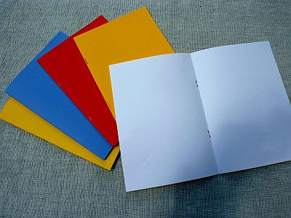
The preparations and instructions are VERY simple:
Step one: Each student receives a blank booklet consisting of 3 white A4 sheets folded and stapled together like an A5 booklet. I usually use a colored sheet on the outside but this is not really necessary. In some cases I copy the title page of their book on the cover to get them started. You’ll need a long-arm stapler to produce these booklets.

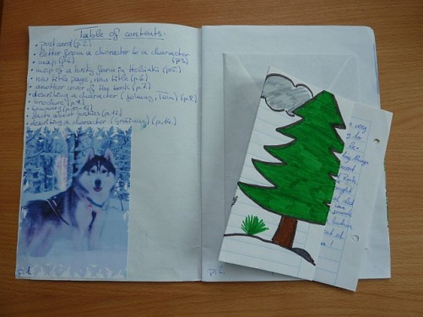
Step two: Ask the learners to fill the booklet with anything that shows their understanding and reaction to the book they have read.
Do a short brainstorming with the class what this might mean. Students come up with many of the ideas they know from their reading diaries and presentations such as:
- Letters or postcards (from the point of view of the characters or to one of the characters), Maps showing the settings of the story,
- Travel brochures advertising the places,
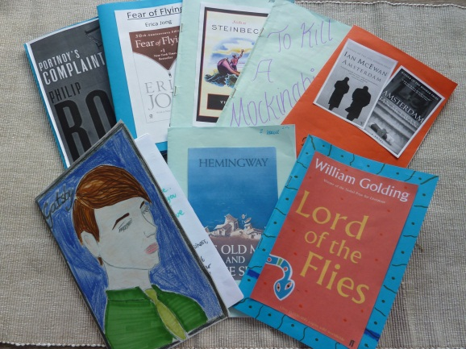
- Diary pages,
- Sociograms,
- Plot diagrams,
- Reviews for Amazon etc.
- Newspaper articles
- Creating their own title page …

Step three: When the booklets are finished the students meet in their groups and share their products. This step can be very interesting and learners see different interpretations of the task and different reactions to the books.
Step four: Optional
Sometimes, if there is not enough time for a round of book presentations ask students to meet with 3 classmates who have read different books and find the similarities and differences of their novels.

Sample pages from such booklets

Letters and Postcards
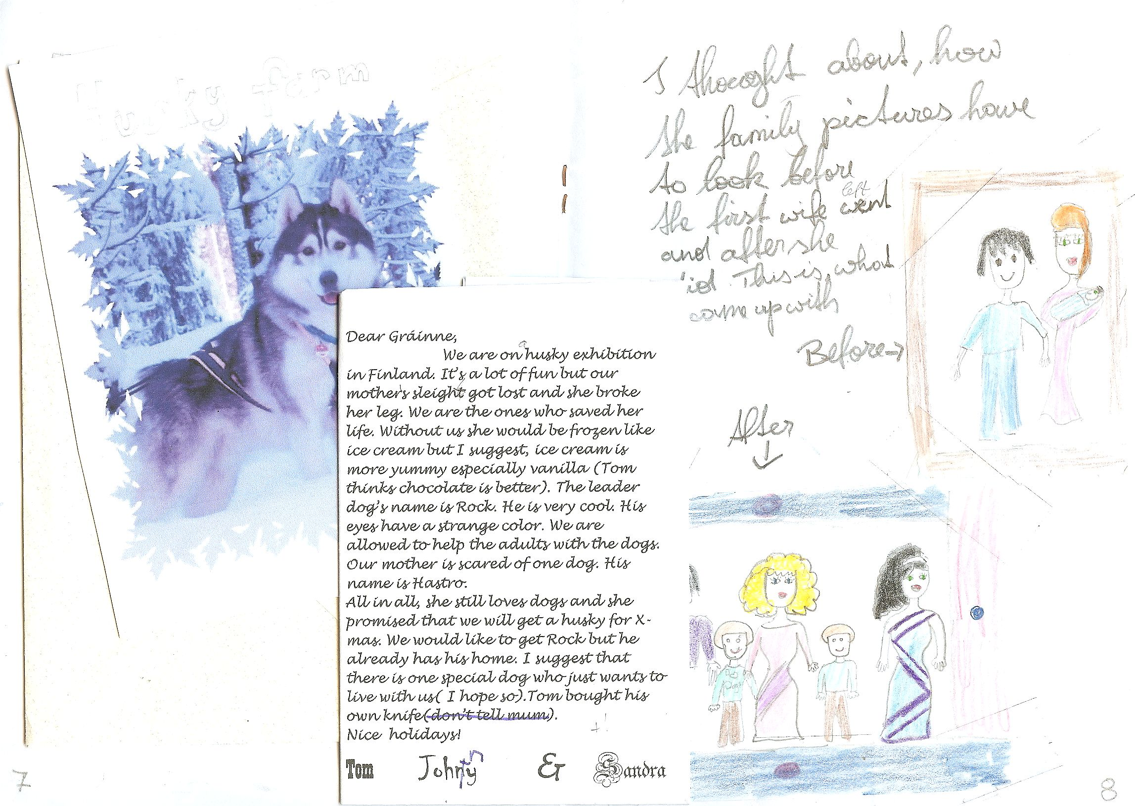
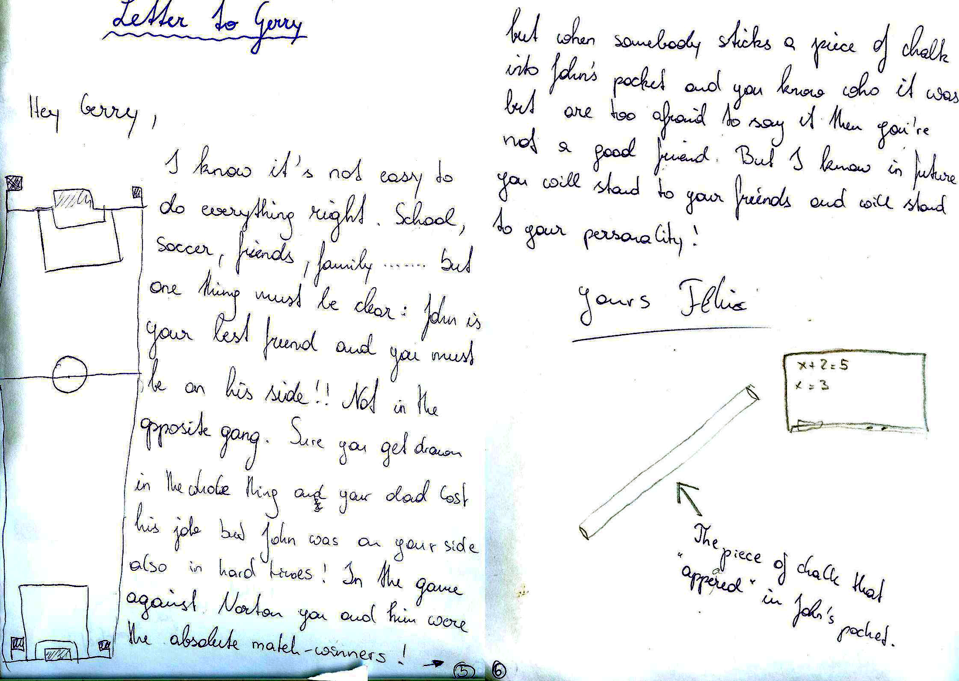

Brochures
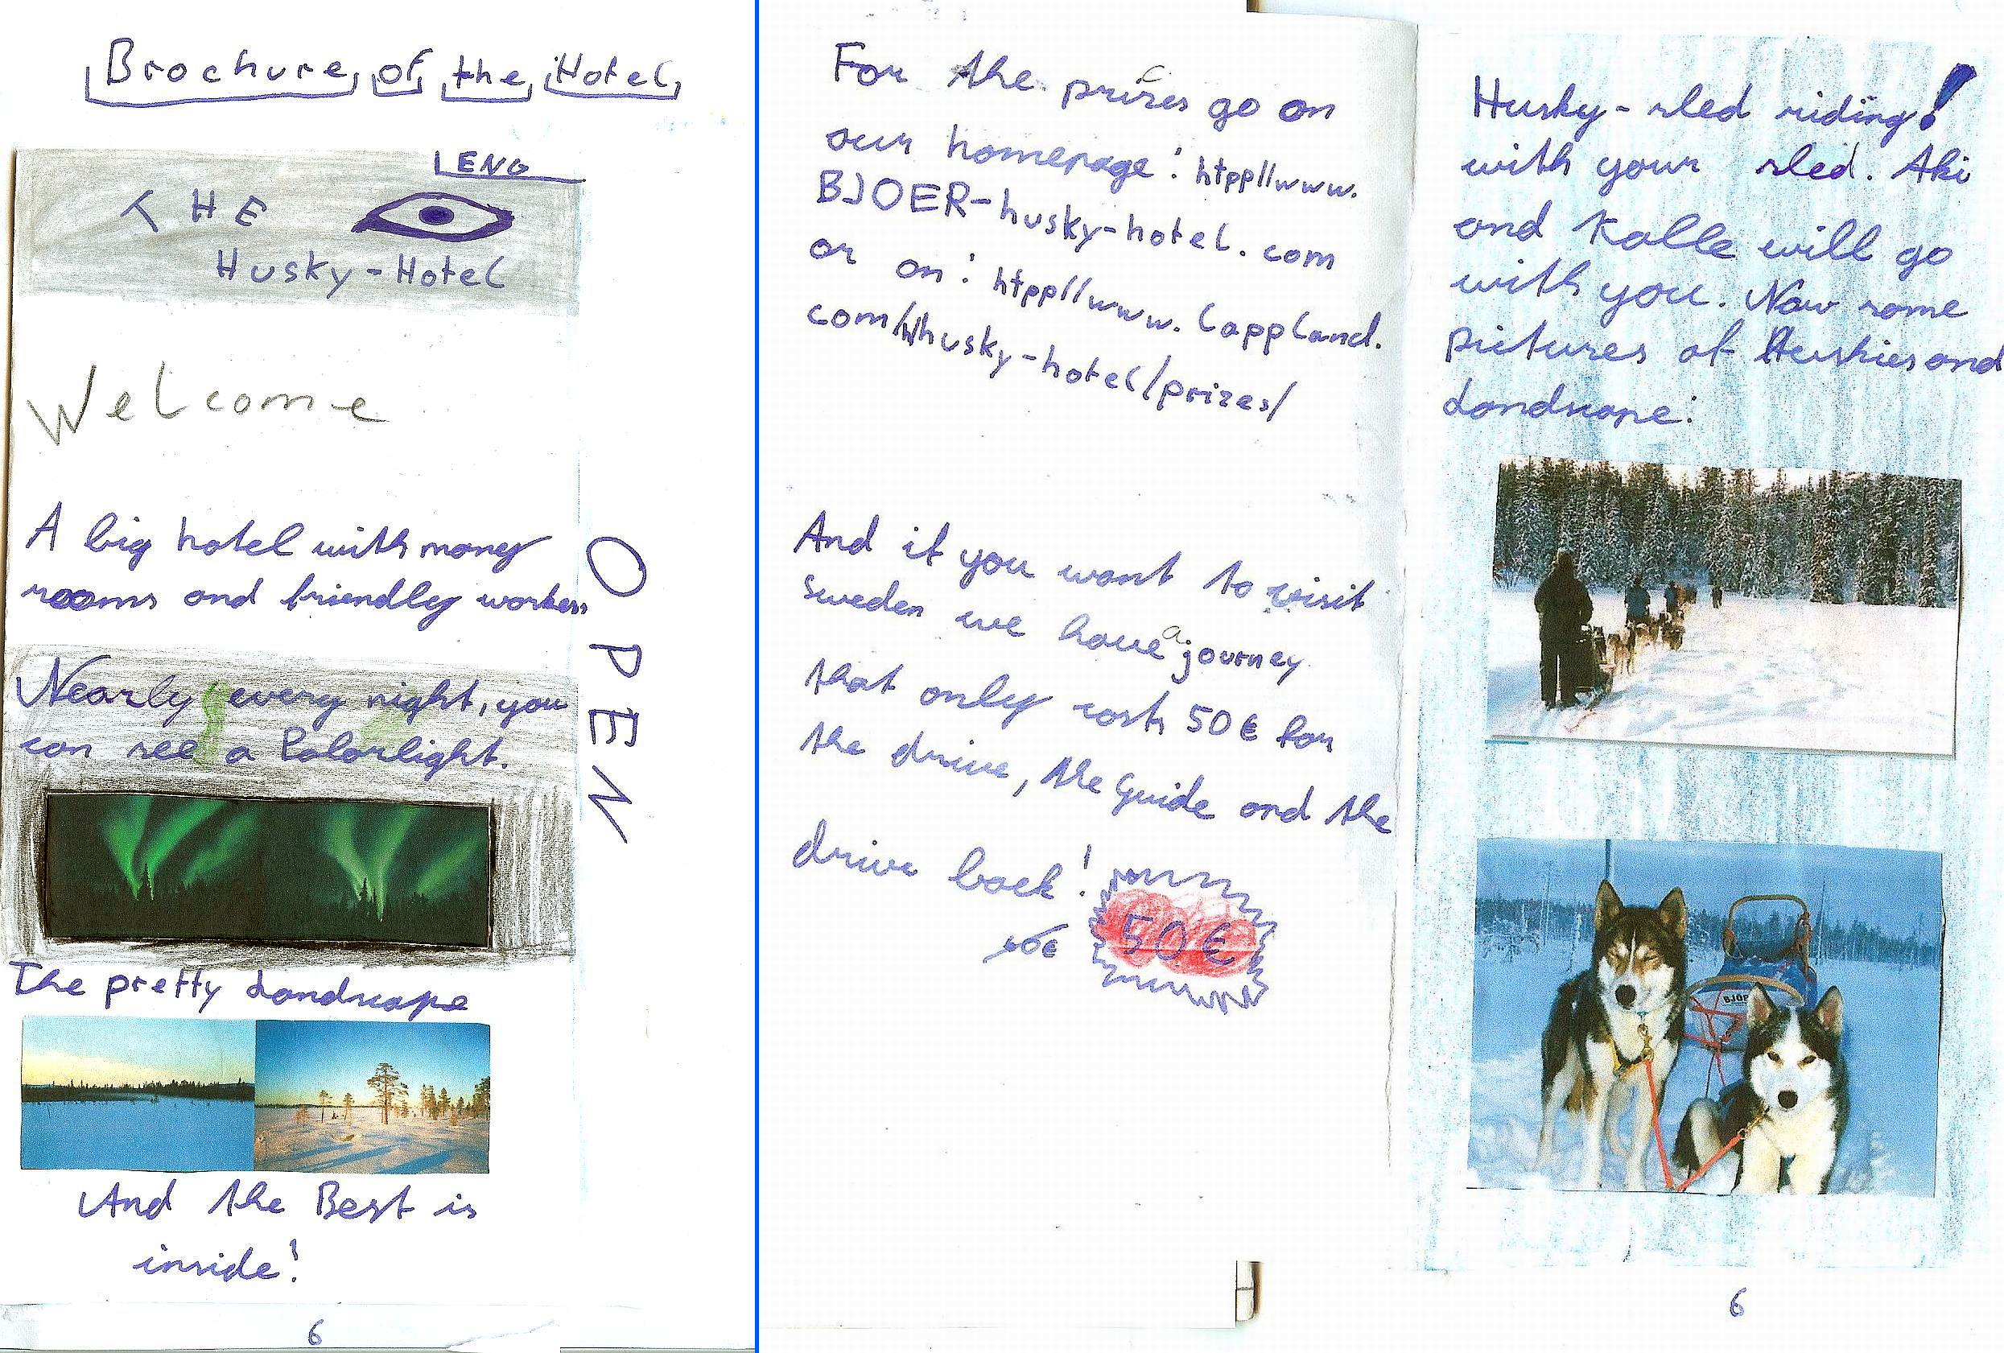

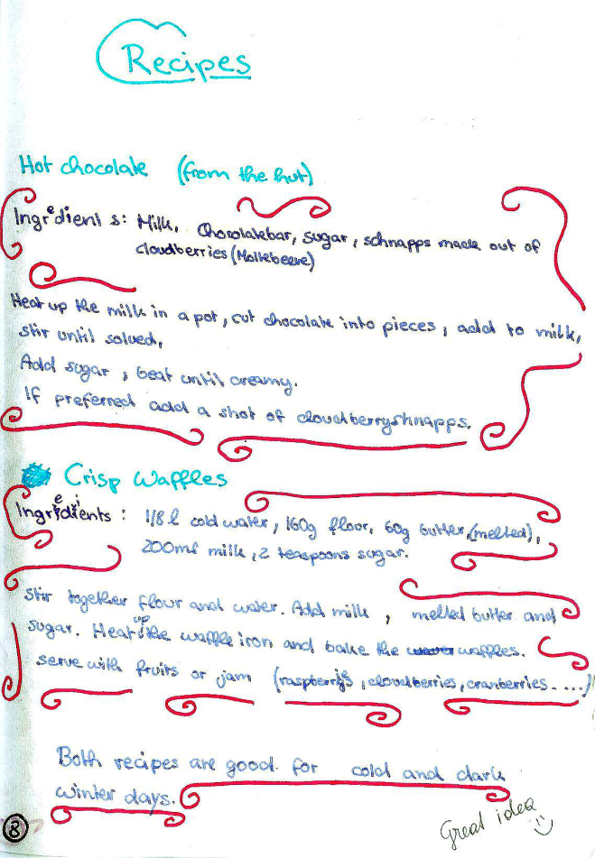
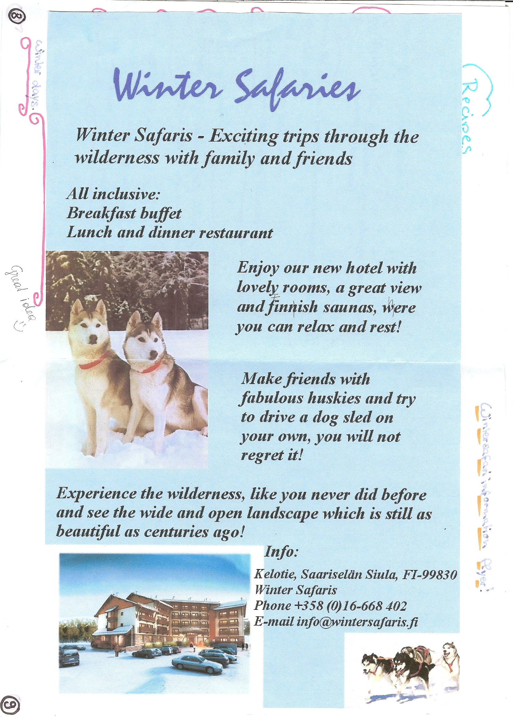

Other ideas: Recipes, Travel info,
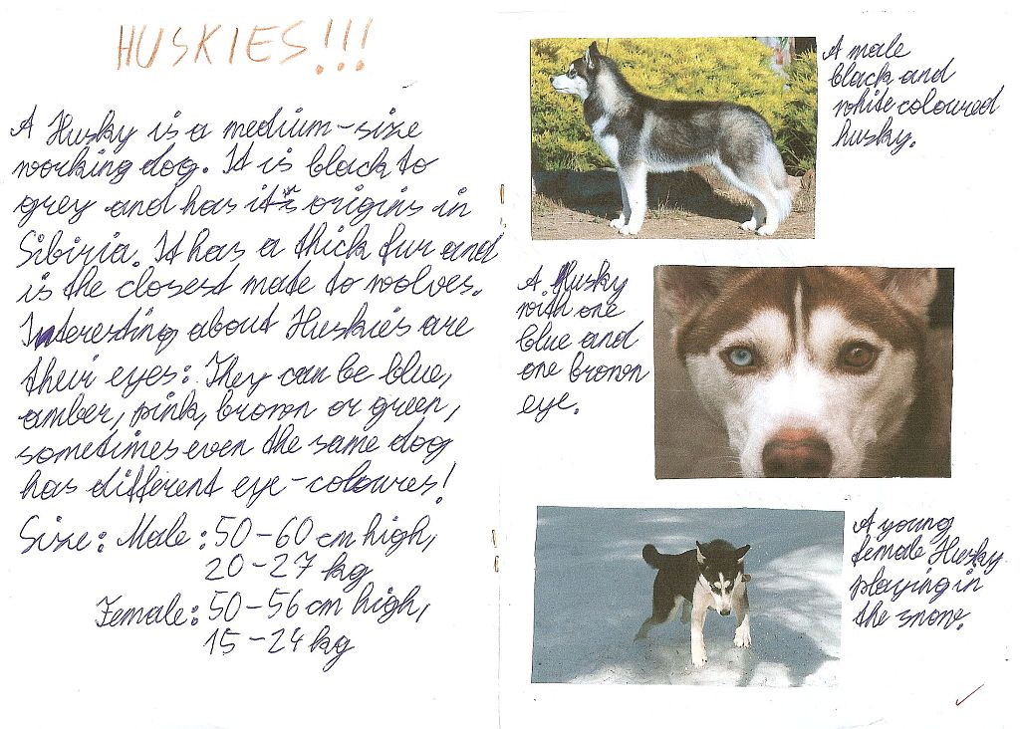

If I was…
Example from Lord of the Flies
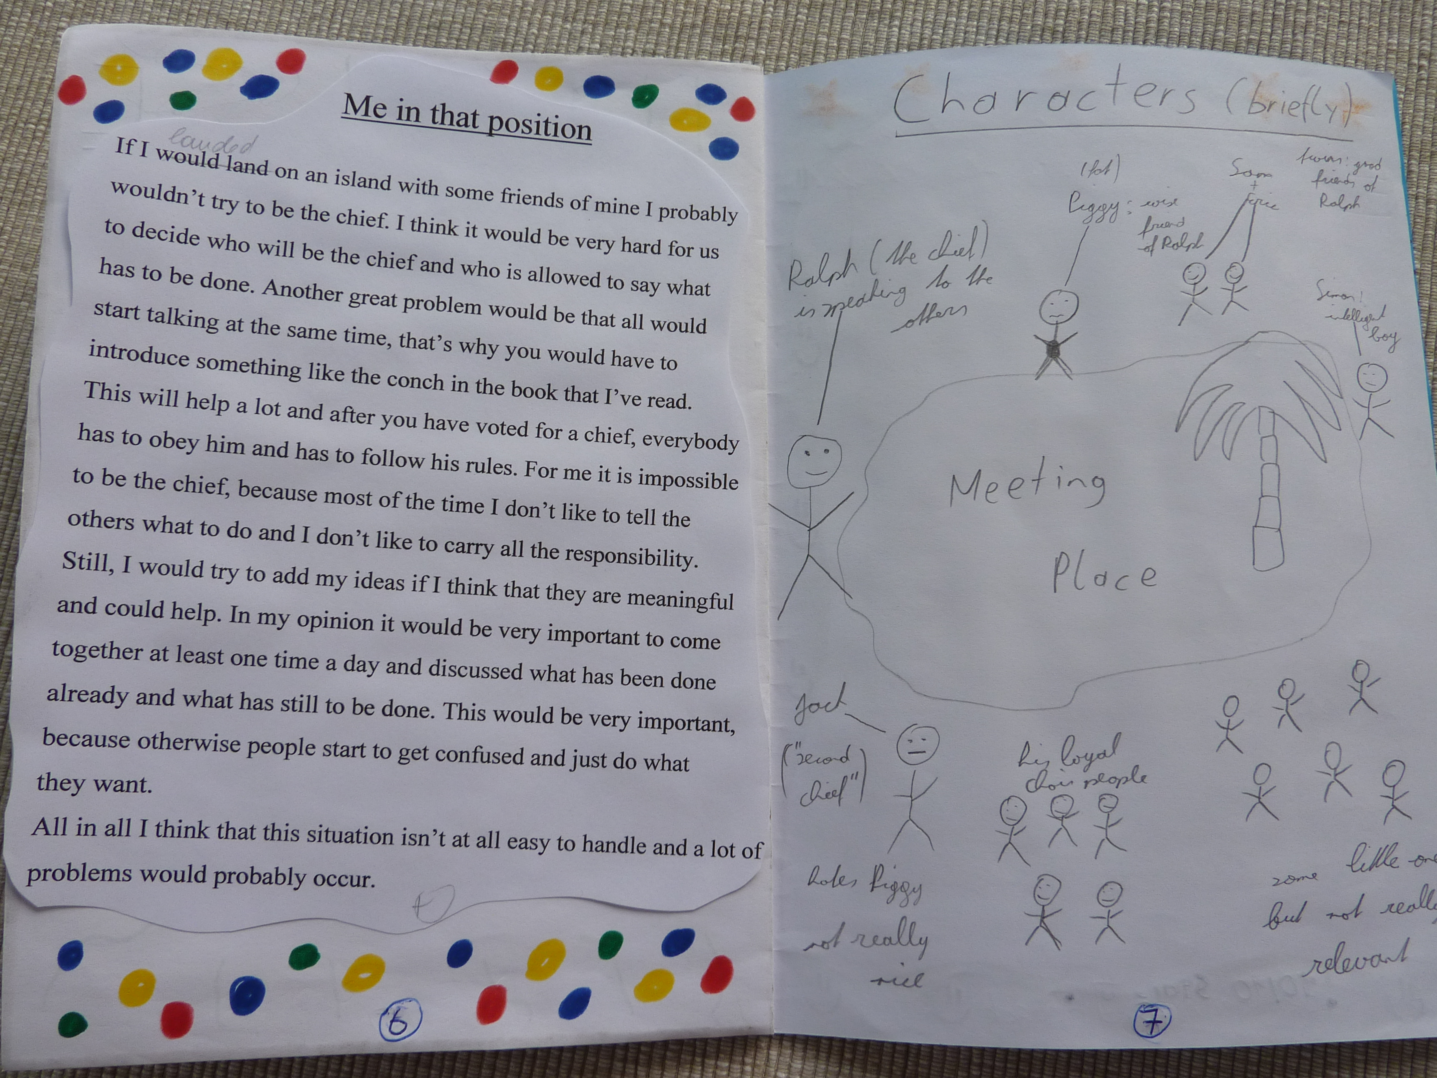

Creative Catalogues
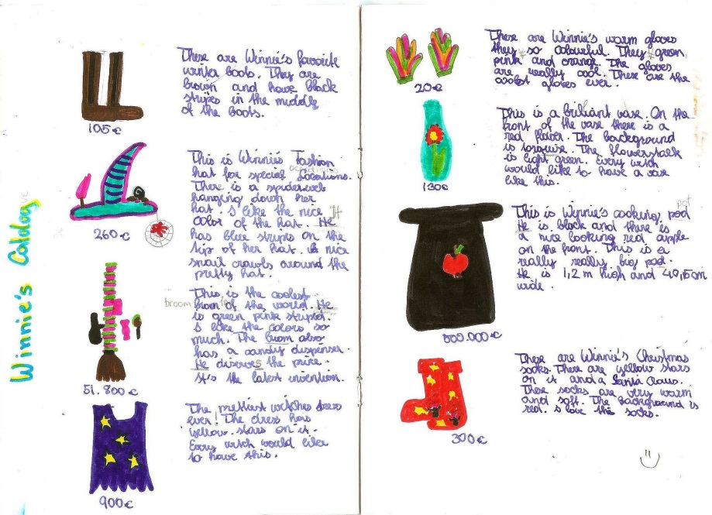

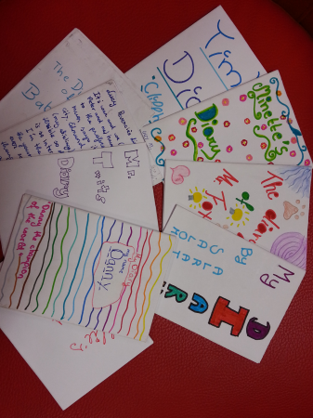
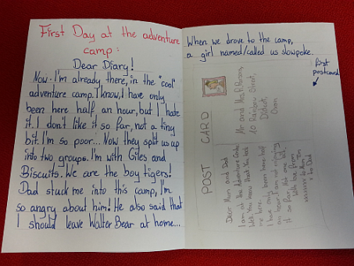
Origami books or Diaries

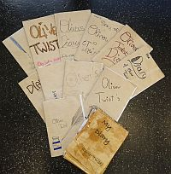

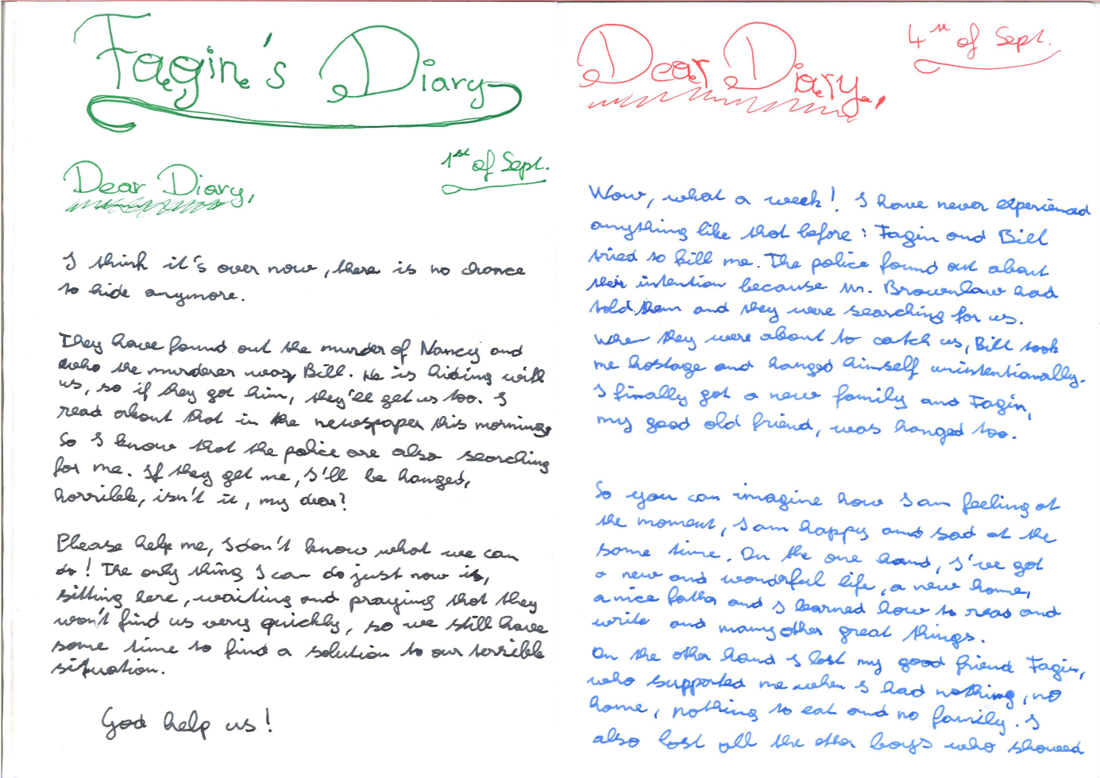

-Oliver Twist: Fagin’s diary entry and a newspaper article about the same events.
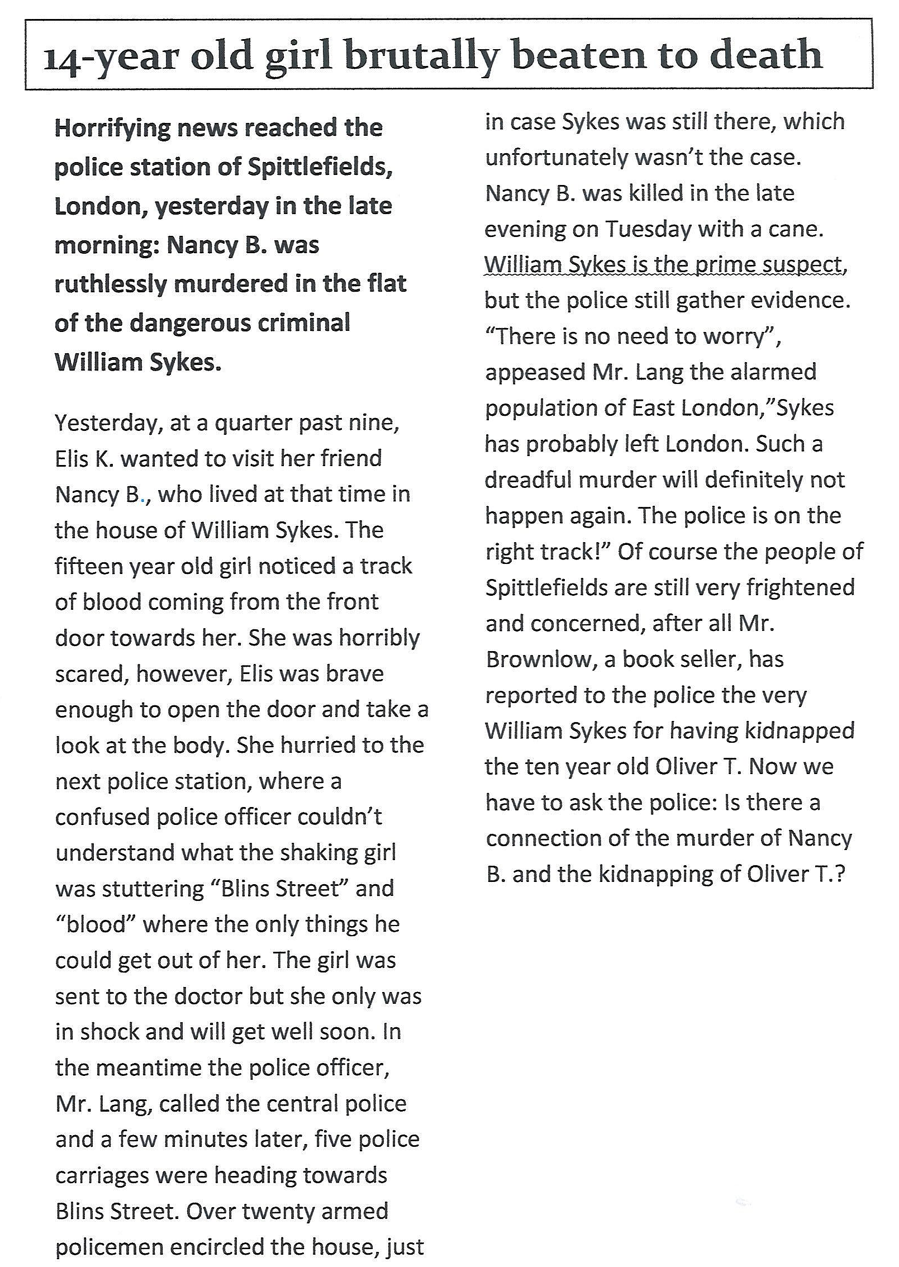

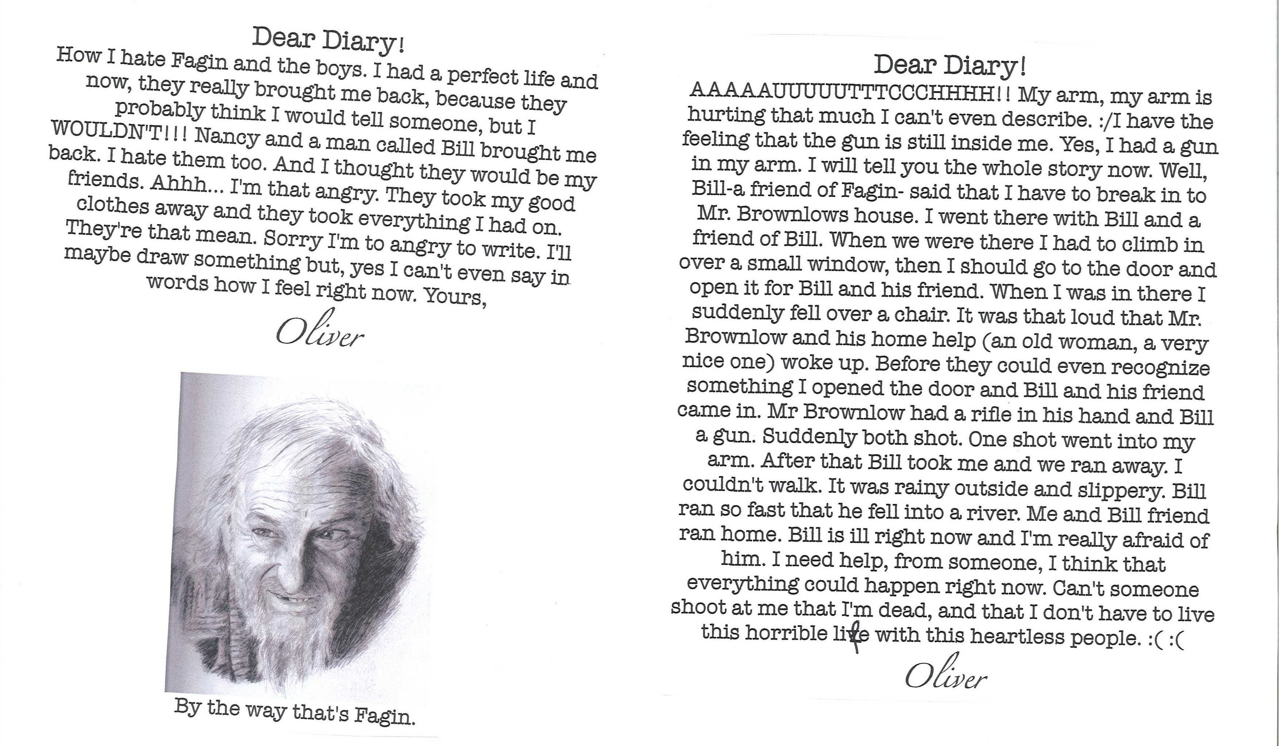

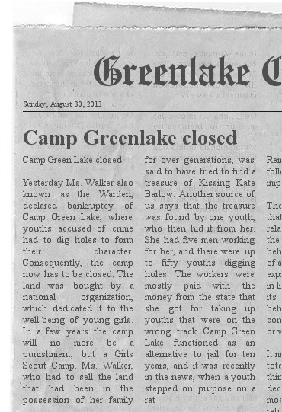
Newspaper Articles
Instructions: Choose an important moment in your book and write an article about this event for a local newspaper.
Remember: The journalist does not know everything; focus on one event – do not tell the whole story or include the characters’ private thoughts and feelings. What would the readers of the local newspaper want to know?
Tip: for the layout of a newspaper article use the online Newspaper Clippings editor : http://www.fodey.com/generators/newspaper

Plot Diagrams
Example from The Great Gatsby
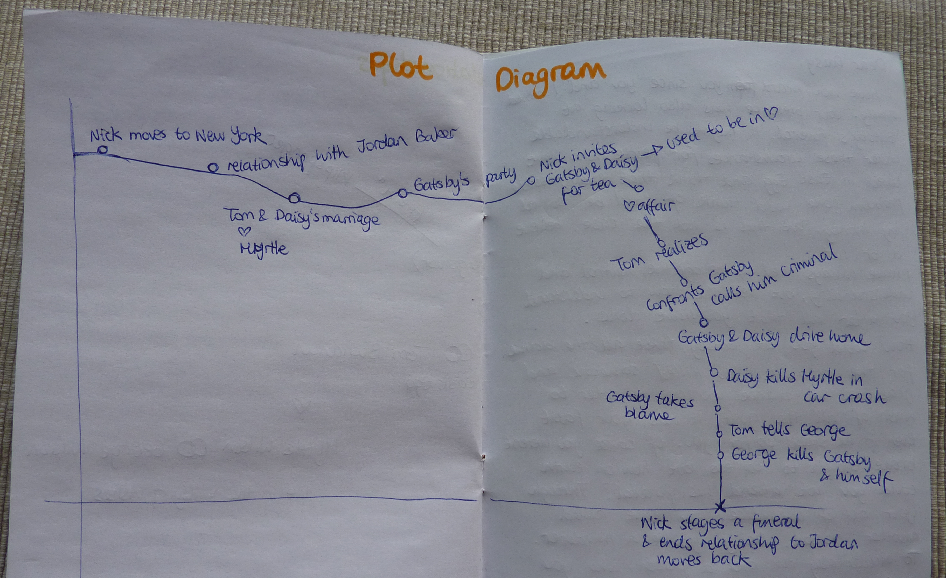

Letters to the Author
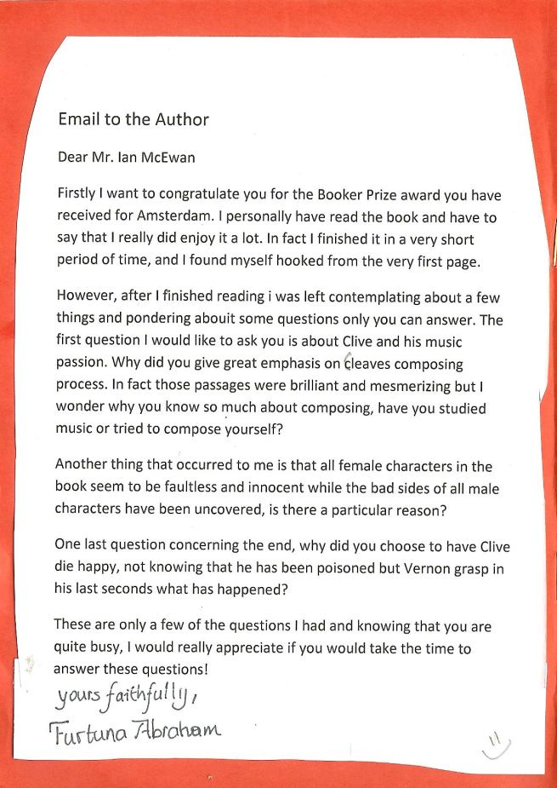

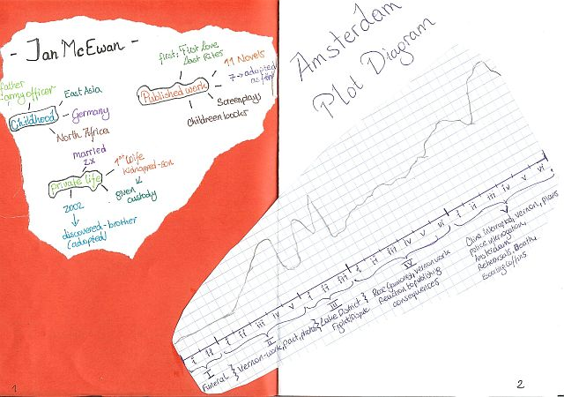
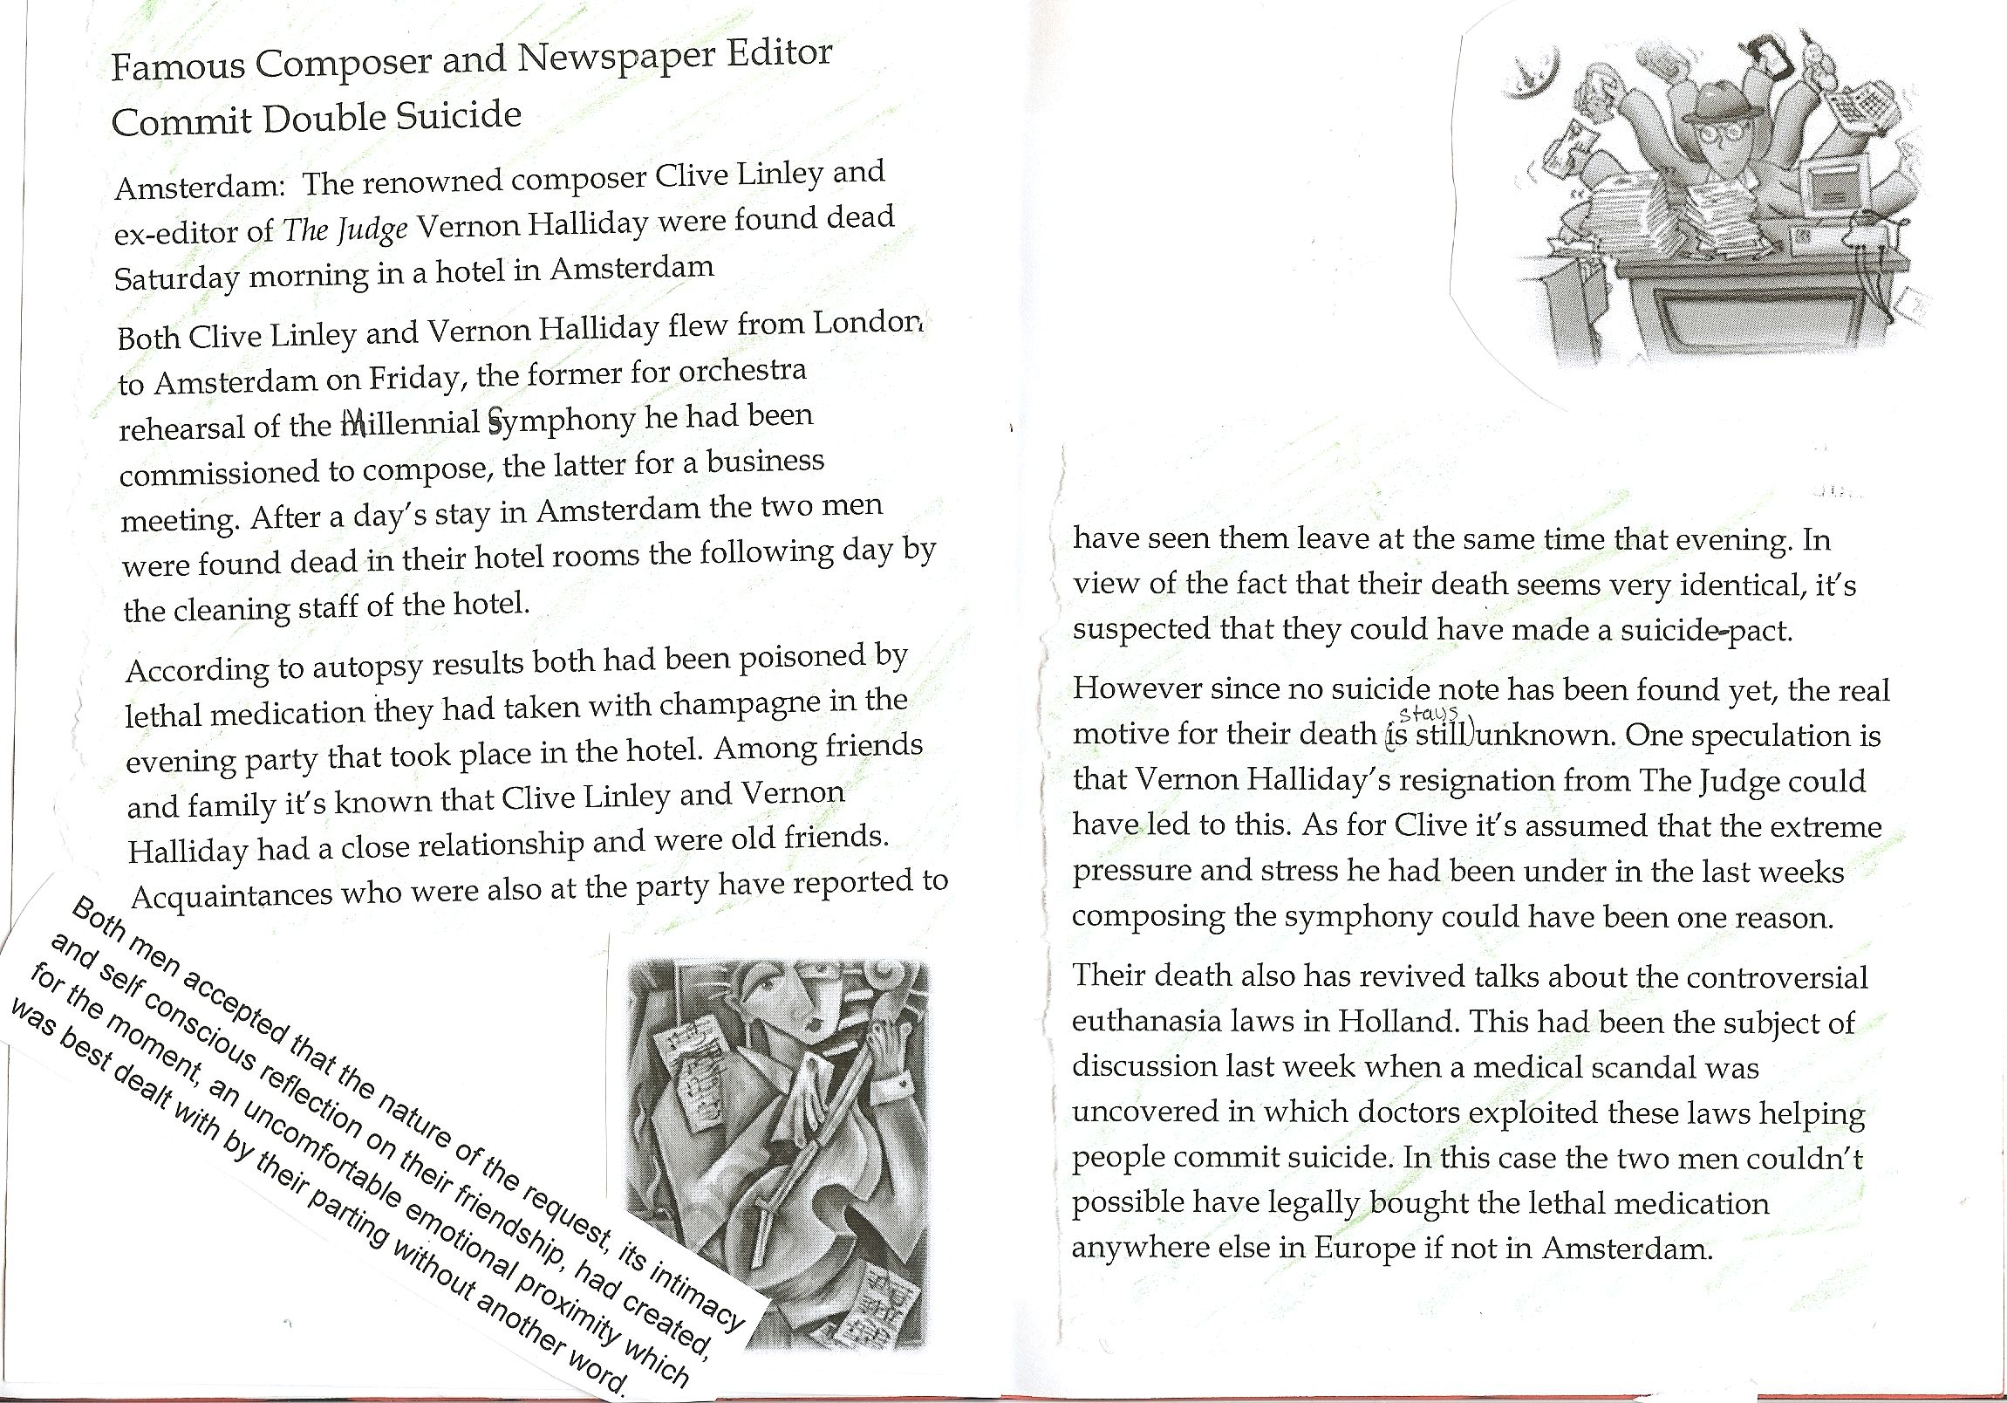
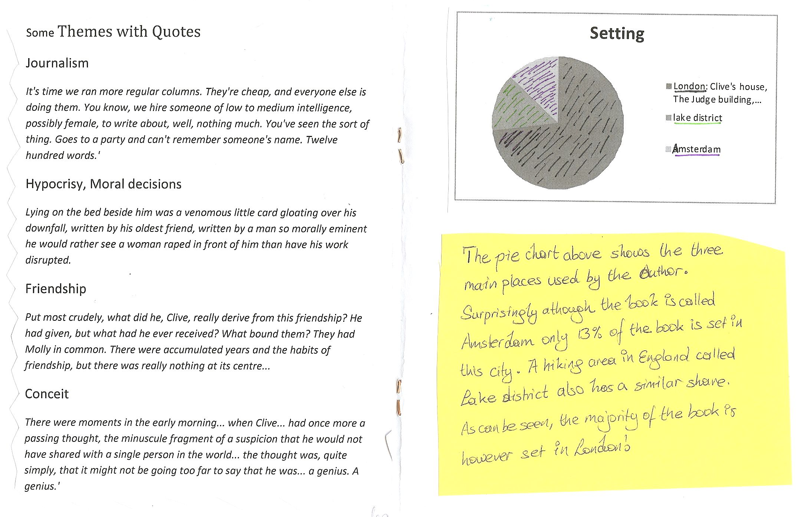
For more examples from upper-school visit the page “creative booklets” on epep.at

Laura Robb and Rick Brown, 50 Fabulous Discussion Prompt Cards

