Ideas for Book Presentations
Presentations are the final and culminating point of every book project. Many of the presentation activities described in this section can be used at any level. What they all have in common is “activity”. The main goals of these presentations are
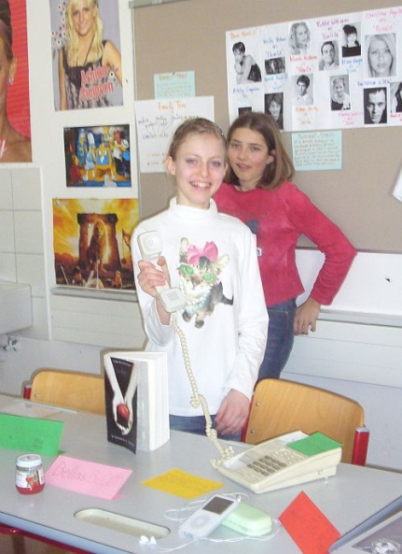
- to make the other learners interested in reading some of the books as well
- to practice presentation skills and oral skills and
- to motivate the learners to dig a bit deeper and understand more than just the plot level of a story.
What we don’t want in these presentations are learners
- reading long summaries from their sheets
- confusing the class with all the minor characters
- boring the audience with unimportant details of the author’s biography

Year 1:
From year 1 on my students present books regularly. The first presentations are no more than 2-3 minutes long and absolutely harmless. Avoid any stress and formality in these presentations and encourage the kids to do as many of them as possible. Invite the learners to present a book at the beginning of your lessons. The whole idea of these mini-presentations is to show the class that WE ALL READ and that reading books is actually fun and not hard work at all. Moreover these mini-presentations give even young learners a chance to speak in front of the whole class regularly and thus lose their fear of presenting. Reward the learners and “pay” them for each of these presentations. Everybody will get a +
After these little presentations the kids pass on the books and thus the whole process of reading starts rolling….
In a typical presentation in year one the learners
- show the book they have read (usually one of the picture books) and they
- say 5 to 7 sentences about the plot and characters in the book. If they have done one of the simple reading diary tasks, they can easily use these sentences again in the presentation. They
- tell us how they liked the book and finally,they
- write one “cool phrase” that they have learned from the book on the board and the class copies the new phrase into their vocab files.

Years 2-8 and beyond
In the course of year 2 or 3, when students do their first real book-projects, the presentations become more varied and creative. The following list of possible activities can be used at any level, up to adult literature. The depth and complexity of the results will of course depend on the age and the level of maturity of the learners.
Most of these presentations are done in groups and every student is responsible for a different activity or aspect of the book. Being responsible for it means that the student plans and prepares this part of the presentation. In some cases they will then need other members of the group to do it with them (act out a scene, take turns speaking, bring some of the props….) The presentation should be as colorful and interesting as possible and will often be assessed by the class according to a list of criteria that the class has agreed upon before.
The best and most interesting book presentations will result from intensive group-discussions with the help of Laura Robb’s discussion prompt cards and similar tasks based on ideas from the books below. Every group-member chooses a different task, possibly from a different area (plot, setting, character...) To make this easier for the students, the tasks are copied on colored cards, one color for each area. The students choose different colors and thus cover all the important aspects of their books.
A wonderful collection of tasks can be found in the following books, all available at Amazon.com
Christine Boardman Moen, Better Than Book Reports, Scholastic Teaching Resources, 2009
Laura Robb, 52 Fabulous Discussion-Prompt Cards for Reading Groups, Scholastic, 2000
Janice Szabos, Reading- A Novel Approach, Good Apple Inc. 1984.
Susan Van Zile, Awesome, Hands-on Activities for Teaching Literary Elements, Scholastic, 2001.

Sample Ideas that have worked very well:

Plot
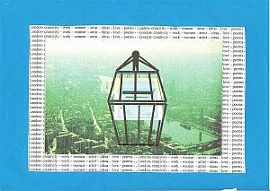
Present an alternative book cover and blurb: Be sure the illustration relates to an important aspect of the book. Use appropriate colors to evoke the atmosphere created by the book. (Older Ss can also be asked to print out different book covers from the internet. Amazon.com usually has different editions. Ss then present the different cover designs and their own version. The class chooses their favorite one. This is a very good way to discover underlying themes and the tone of a novel.
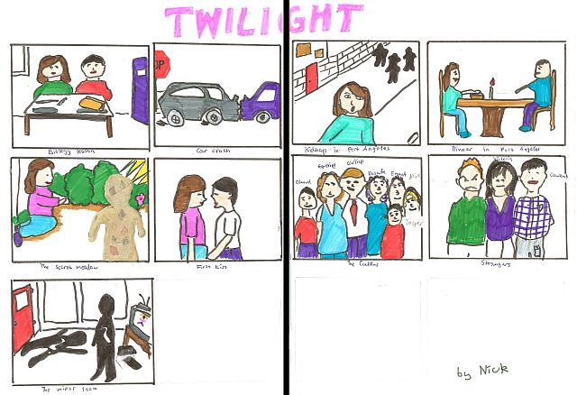
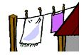
Plot on the line or Storyboard: Write seven to ten main events on separate sheets. Add simple drawings and illustrations. In your presentation hang up one picture after the other using clothes-pegs and a string or stick your pictures on the board with magnets or blue-tack. Talk about each picture using your own words. Don't give away the ending.
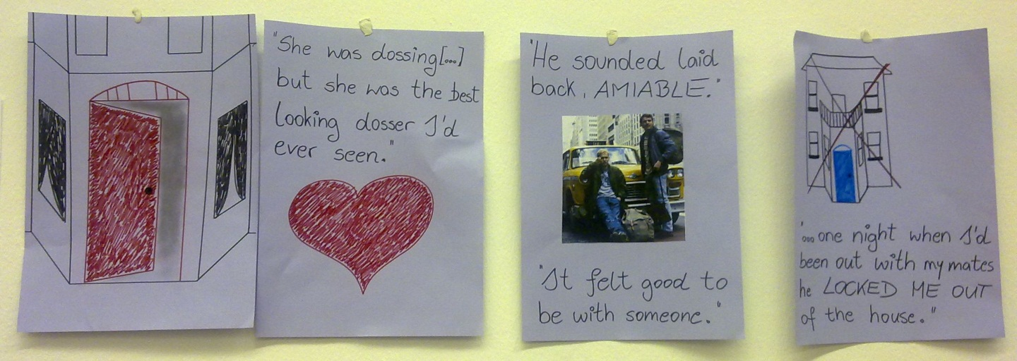
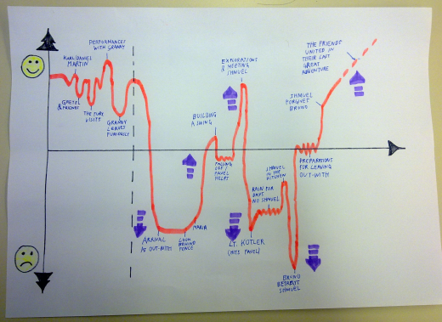
Plot diagram/ Plot mountain: Draw a “fever curve” of the ups and downs in the novel. Peaks of suspense or conflict…., label the curve. In your presentation use your own words to explain each of the events briefly.

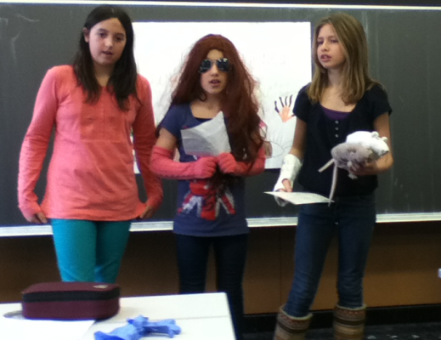
Act out a scene of your choice. Use simple props and costumes.
This activity works best in combination with the “plot on the line” or the “plot mountain” activities. The learners act out one or two important scenes and explain at what point in the novel these scenes happen.

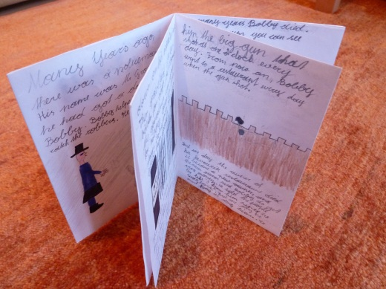
Make a plot mini-book (concertina or origami)
This activity works well for picture books or short stories that the teacher has read to the class. After listening to the story the learners design their own mini-books. They write their own version of the story and add illustrations on each page.
Variation: The learners might also write a follow-up story rather than a summary of the original story.
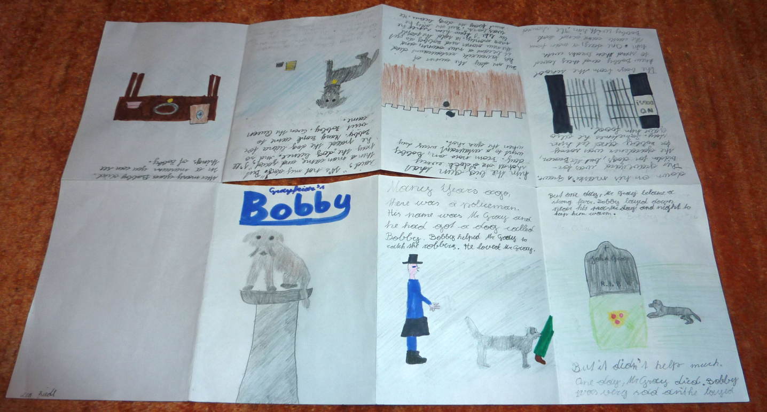

Setting
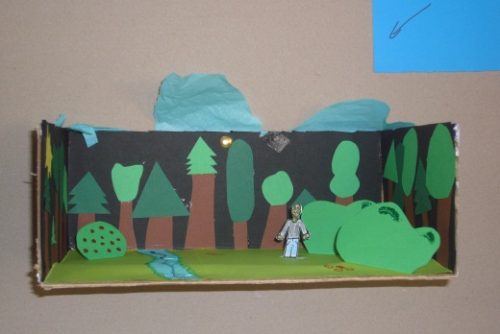
Make a setting pop-up or a painting that shows the most important place(s) in the book.
Setting murals: several paintings glued together
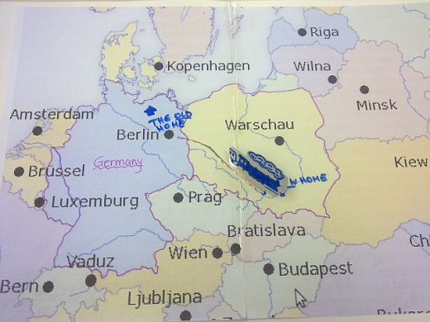
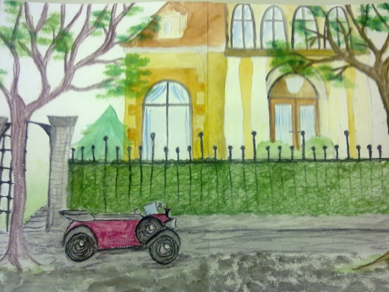
Draw a simple map of the locations in your novel. Make sure the map is large enough so your classmates can read it clearly. Attach a legend to your map. Write a paragraph that explains the importance of each location indicated on your map.

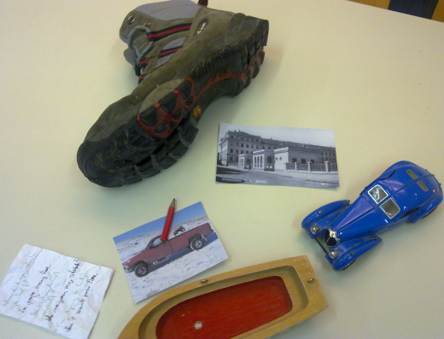
Characters
Identity bags/ character suitcase: Bring a bag full of objects that are somehow important to the main character of your book. Show them and explain their relevance.
Character T-shirts: Design a T-shirt (picture and slogan) for one of your book's characters. Show what is important to them.
Character collage: Find fitting pictures and words from magazines and present (one of) the main character(s) in a collage.
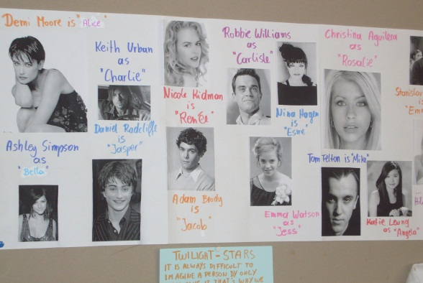
Movie Casting: Imagine that your book will be made into a movie. Choose suitable actors and actresses for each of the main characters and present them to the class. Explain why you think these actors/actresses would be ideal for these roles. What characteristics and qualities will they have to show in order to portray the characters well.

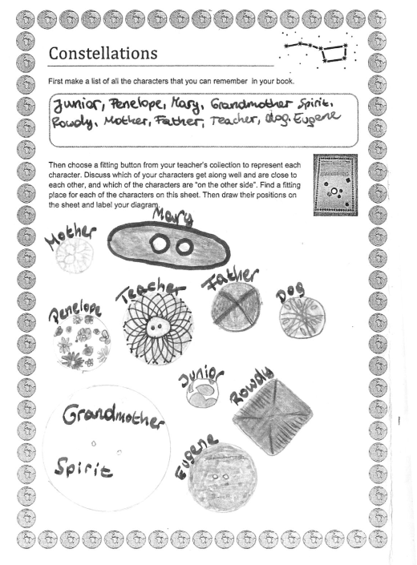
Prepare a "bubble sheet" (A3 poster) where you collect important quotes from your book. In your presentation explain who said these words and why they are important.
Sociogram: Choose suitable buttons to represent the main characters of the book. Then make a sociogram showing the relations between the characters. Show (close) friendships, rivals and enemies, good and bad characters. Compare your version with other students.
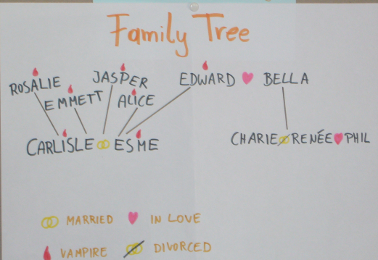
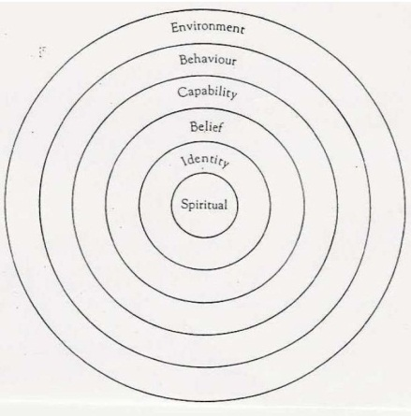
Character profiles: Look at the different levels of a main character’s personality and complete the profile circles. (Find the detailed description on epep.at)

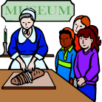
Other

Novel Museums
For the Novel Museum imagine that the characters in your book were REAL people. Our town wants to make their stories public and has, therefore, dedicated a whole room in the museum to these people and their stories. There they show real artefacts from your characters’ lives. These objects are presented nicely in showcases and on tables around the room. Each of the objects has a label explaining the importance of the item, where it is from and what role it played.
In your museum display you might show some of the following things:
Maps, short newspaper articles about what happened to your characters, diary pages, letters, objects they used during their adventures, photos, clothes they were wearing, favorite items of your characters….. or any other things that play an important role.

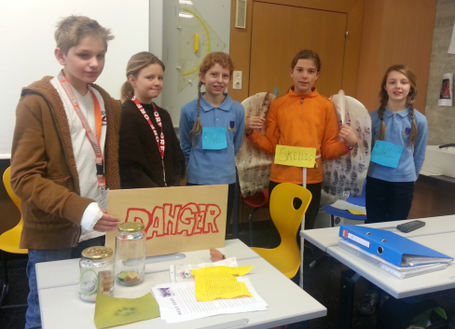
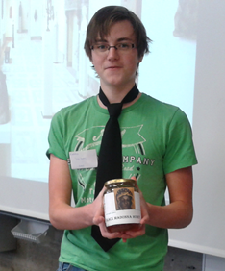
A Novel Museum: display 10 to 15 items that play a role in the book. Act like tour-guides and present the artifacts to the class. Explain the significance of each item. See detailed instructions on the right.

Write a poem or song-lyrics that might be used in a film or radio-play of your book. Present your poem (show it on the projector while you read it) or sing your song. Maybe other classmates can sing along or accompany you on a guitar. You can also use a karaoke CD for background music.

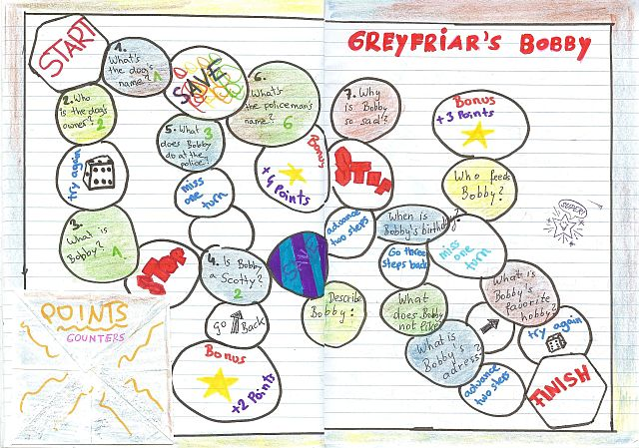
Make a board game: Design a board (use settings, plot line and events… task cards or fields… you might even make Fimo character-counters…

Timesaver Idea: If class time is limited or if students are to present their private reading use the following activity:
Non-stop talking: Ss stand in two concentric circles or parallel rows. The Ss in the outer circle or row talk non-stop for 1 minute (more advanced Ss can do 2-3 minutes) about the novel they have read. Ss in the inner circle/row listen. After 1 minute Ss change roles. Then the students in the outer circle move one person to the left. Do this with 3-4 partners. This activity works well for independent reading where Ss talk about different books. If they have all read the same book give out sub-tasks for each round: e.g: favorite character, least favorite character, setting(s), ending, …

Acrostic poem: Write the title of the novel downwards on a page. Then use each letter as an initial for a line about the book.
Alternative idea: If you have an idea of your own contact your teacher about it.

Older students
Older students who read modern or contemporary literature in their reading groups might also be asked to present some of the following aspects:
Short information about the author: main focus should be on typical themes or characteristic topics, style, other books… Biographical information only if relevant (e.g.: personal experiences that are reflected in the books…)
Historical or cultural background of the novel.
Make connections to the modern world: Depending on the topics and themes of the book Ss might do tasks such as the following (designed for Brave New World or Animal Farm):
- Present the basic principals of propaganda and advertising (do an internet search)
- Give a propaganda speech about any topic of your choice. Then explain the methods you have used.
- Present the pros and cons of genetic engineering
Encourage students to prepare attractive, attention grabbing visuals for their presentations. Do not allow text on powerpoint slides. Allow only pictures or keywords and make sure the students use their own words rather than reading off prepared texts.

