Ideas for Using Poetry in Upper School

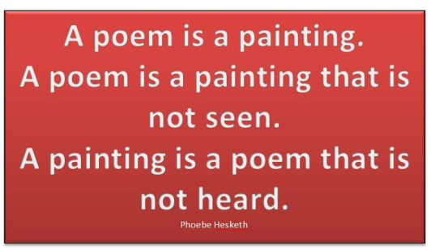

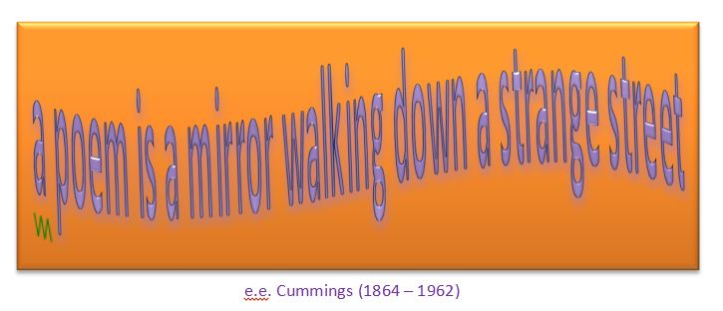

- Pick a poem: hang lots of poems up on a clothes line (use pegs). Students walk around, read lots of poems and pick one they like.

- Painting a poem: Students choose a poem (e.g. in the activity “pick a poem”) and try to express the same idea in a painting. Bring watercolors, water soluble wax crayons, paper, brushes, cups and a rag to clean up the mess.
Example:
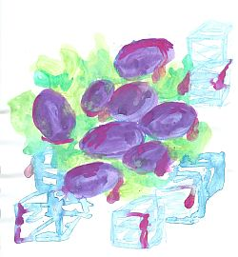
Langston Hughes
Harlem
What happens to a dream deferred?
Does it dry up
like a raisin in the sun?
Or fester like a sore--
And then run?
Does it stink like rotten meat?
Or crust and sugar over--
like a syrupy sweet?
Maybe it just sags
like a heavy load.
Or does it explode?

William Carlos Williams
This Is Just to Say
I have eaten
the plums
that were in
the icebox
and which
you were probably
saving
for breakfast
Forgive me
they were delicious
so sweet and
so cold

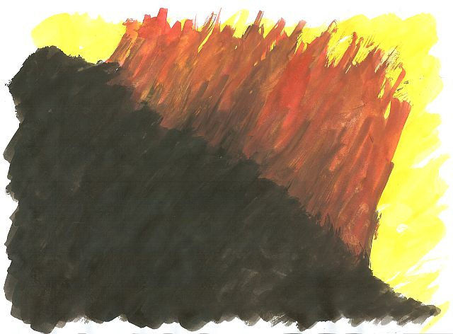

- Writing poems: students choose an object (sea-shell, stone, plastic toys, postcard….) and collect ideas on a sheet. Only single words are allowed. (10min) Then write a poem using (only) the words they have collected. Give a choice of formats e.g.: recipe poem, haiku, acrostic poem, limerick, visual poem…(see previous section)

- Line-breaking: Type a poem as run-on text. Ask students to rearrange the lines in form of a poem and decide where to break the lines. Compare different student versions, then show original and discuss the effects of the different versions.

- Sonnets: Teach typical rhyme and rhythm of sonnets, then cut up a sonnet – students reassemble it correctly.

- Working with parodies: Show students some parodies of famous poems (e.g. Roger Tagholm, Poems not on the Underground (Tagholm 2001)). Students choose a famous poem and write their own parody. Students may use internet poetry pages to find famous poems and parodies.

- Poem into short story: Find 3-4 poems where the speaker has a clearly identifiable problem. Students choose one poem and write a short story based upon it. The speaker of the poem becomes the protagonist of their short story.

- Themes in Poetry: Collect several poems around a theme (war poems, love and lust poems, dreams and nightmares, civil rights, growing up, family, …) Do some of the above tasks.

- Poems and Paintings: Find famous poems that have inspired artists to paintings and vice versa. E.g: Icarus poems and paintings: Students read and discuss the myth, read different poems and discuss the different interpretations of the myth, then match poems with fitting paintings or paint their own. The following website is a great source of Icarus paintings: (http://www.island-ikaria.com/multimedia/ikarosart.asp)

- Use a painting (arts postcards or images of artwork on projector), students interpret the scene (collect ideas….) then write a poem or a short story about it. Hopper paintings work very well for this task (e.g.: The Automat...)

- Found poems: Hand out a recent newspaper article, advertisement or other prose text. Students highlight words they like and then use some of these words to make a poem. No extra words must be used. (The topic can be kept or changed, e.g. using a tourist brochure to praise or criticize tourism or a place…) See examples on page 5.

Examples of short poetry projects

Writing Haikus: Snapshots of America

After our trip to America we will produce a collection of our memories in the form of haikus.
A haiku is a minimalist form of poetry. The writer has 17 syllables through which to convey an experience.
A haiku is like a written snapshot. It recreates the atmosphere of a moment in 3 lines (5 syllables, 7 syllables, 5 syllables). Modern English haikus do not always follow this rule very strictly.
The content of a haiku is typically, but not always, focused on a small but important moment in a person’s everyday life. Part of writing a haiku is finding the ‘awe’ that is usually passed by without notice – the act of creating a haiku is the act of focusing our attention more closely than we might otherwise do. It is like a picture in close-up.
Sometimes haikus deal with important realizations (epiphanies) in a person’s life. Read the following examples and try to visualize the scenes and take in the atmosphere or understand the important realization.
Midday hush  the rasp of a mallard  calling his mate  Ray Rasmussen | on every icicle’s tip  a drop  of sunlight  Alexey Andreyev
street musicians resting –  red maple leaf  lands on the keyboard | second husband  painting the fence  the same green  Carol Montgomery p.
Tompkins Square –  an old man teaches Tai-Chi  to a crowd of pigeons  Paul Mena | a supermarket  in someone’s cart – beef, beer,  flowers and a child  Alexey Andreyev
what is that building?  cobble-stoned streets, glass canyons.  I’m tired. My feet hurt.  Margaret Hinchcliffe | with a flourish  the waitress leaves behind  rearranged smears  Dee Evetts
sunrise  I forget my side  of the argument  George Swede | thundering surf  seagull cries on the  bitter winds  Stonecrow

During our trip: Walk around with open eyes and take in all the little things that contribute to the atmosphere of a place or situation. Take mental snapshots as well as pictures of little things with your camera.

After the trip, go through your pictures and memories and choose one specific moment. Capture your impression in a haiku. Layout your haiku nicely and add your picture.
All your haikus will be collected in our book “Snapshots of America” and the best ones will be published in the GIBS yearbook.

More examples of haikus

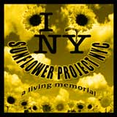
What it’s about
The Sunflower Project NYC started in the Spring of 2002 as a living memorial planting project to remember the people lost on September 11th, to honor their families, to thank the people everywhere who contributed to the recovery, and to make our world better, one patch at a time.
The idea is for individuals, groups and communities to create their own sunflower memorials everywhere—to remember and honor life with living, growing symbols of renewal and hope.

A fork in my bag.  Next to my comb some wet seeds.  Armed and dangerous. | Armed with black seeds  I glance around furtively  then complete my task
Dig hole with chopstick  Make sure seed goes into hole  Mission accomplished | Look at me strangely  Wonder why I'’ poking dirt  Doesn'’ everyone?
Watering something?  Not me, I just spilled water...  for the seventh time | Planting sunflowers.  Large Federal Agent says  "“et'’ see some ID"”
In New York, Cher can  strut nude-—o notice. Plant seeds?  People stop. What'’ that? | Small dog and small mind  in tow, local Tree Lady  watches me closely.
online: site no longer available

Found Poetry

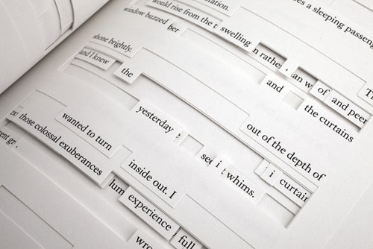
Found poetry is the rearrangement of words or phrases taken randomly from other sources (such as clipped newspaper headlines, bits of advertising, handwritten cards …) in a manner that gives the rearranged words a completely new meaning.
A famous example of found poetry – or “found writing” is Jonathan Safran Foer’s book Tree of Codes, which is based on The Street of Crocodiles by Bruno Schulz. Foer has used it as a canvas, cutting into and out of the pages, to arrive at an original new story.
The following examples written by GIBS students of year 7 are based on two letters to the editor of Newsweek.

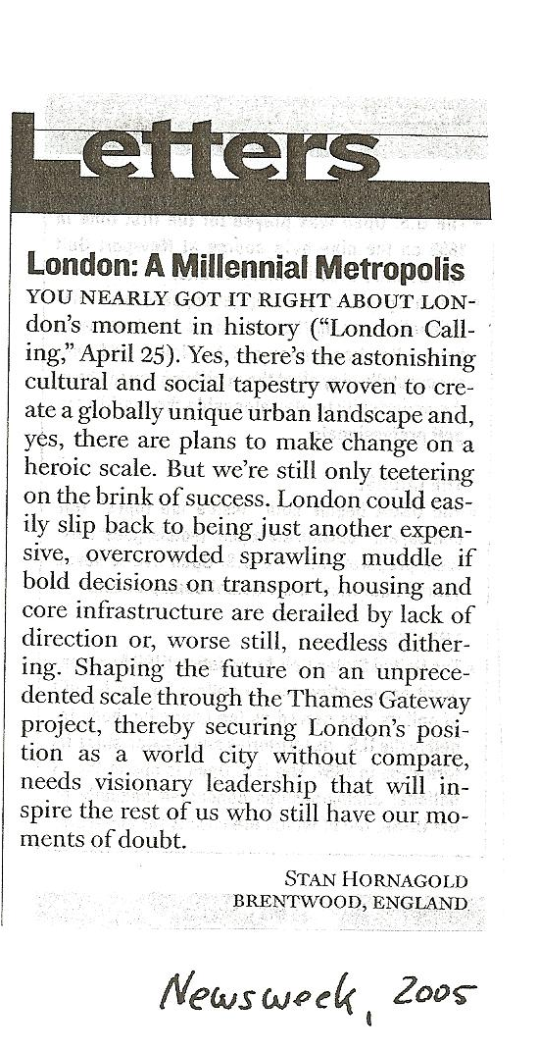

London
Inspiring world city without compare
Globally unique urban landscape
Cultural tapestry woven to create
Change on a heroic scale

But we are still only teetering on the brink
derailed by lack of direction
another expensive,
overcrowded muddle,
full of doubt.

Bombay Dreams of Urbanization
on the backs of
men
women
and
children
displace
and
homeless.
Who is to blame?

Let’s LOOK at Imagist Poetry

Imagism was a brief, complex yet influential poetic movement of the early 1900s, a time of reaction against late nineteenth-century styles in poetry as well as painting and architecture which was flowery and ornate.
In contrast, imagist poems are very short and describe one pure image or emotion. Imagist poets avoid any superfluous word. The image itself is the meaning.
- Read the following Imagist poems and try to imagine the scenes in detail. Share your mental images with a partner or small group.
- Choose your favorite poem and do the task “art beyond sight” on the next page.

In a Station of the Metro

The apparition of these faces in the crowd;
Petals on a wet, black bough.

Ezra Pound
The Red Wheelbarrow

so much depends
upon

a red wheel
barrow

glazed with rain
water

beside the white
chickens.

William Carlos Williams

The City

In the morning the city
Spreads its wings
Making a song
In stone that sings.

In the evening the city
Goes to bed
Hanging lights
Above its head.

Langston Hughes

The Toaster

A silver-scaled dragon with jaws flaming red
Sits at my elbow and toasts my bread.
I hand him fat slices, and then, one by one,
He hands them back when he sees they are done.

William Jay Smith

Apartment House

A filing cabinet of human lives
Where people swarm like bees in tunnelled hives,
Each to his own cell in the covered comb,
Identical and cramped -- we call it home.

Gerald Raftery

Describing a picture: Art beyond sight

Go to the website “Art Beyond Sight”

http://www.artbeyondsight.org/handbook/acs-verbalsamples.shtml

and choose three paintings that you find interesting. Read and listen to the descriptions and collect some useful phrases.

Useful phrases:



Then choose one of the imagist poems on the previous page and paint, find or imagine a painting or photo that might have inspired the poet. What do you see? Describe your painting / photo in detail.

Famous Sonnets and their Parodies
Read the following famous sonnets and their parodies. Then choose a sonnet (online) and write your own parody.
Sonnet at Journey’s End
Shall I compare thee to a ticket collector?
Thou art more lovely and more even tempered
(‘T would not be hard!)
Rough hands do take the darling tickets of May
And one’s yearly Season hath all to short a date.
Sometimes my photocard is checked
Other times I am waved through at the gate:
This inconsistency doth leave me perplex’d
But ‘tis not the traveller’s place to question why,
For I know that at my journey’s end –
(Despite snow that doth have some error and
Leaves that lieth where they shouldst not) –
I shall find thee waiting by our fire’s grate,
And thy eternal summer shall never fade
Even though Knapp’s boys often make me late.
(Tagholm 2001, 49)
William Shakespeare, SONNET 18
Shall I compare thee to a summer's day?
Thou art more lovely and more temperate:
Rough winds do shake the darling buds of May,
And summer's lease hath all too short a date:
Sometime too hot the eye of heaven shines,
And often is his gold complexion dimm'd;
And every fair from fair sometime declines,
By chance or nature's changing course untrimm'd;
But thy eternal summer shall not fade
Nor lose possession of that fair thou owest;
Nor shall Death brag thou wander'st in his shade,
When in eternal lines to time thou growest:
So long as men can breathe or eyes can see,
So long lives this and this gives life to thee.
Composed Upon Westminster Bridge,
September 3, 1802
William Wordsworth
Earth has not anything to show more fair:
Dull would he be of soul who could pass by
A sight so touching in its majesty:
This City now doth, like a garment, wear
The beauty of the morning; silent, bare,
Ships, towers, domes, theatres, and temples lie
Open unto the fields, and to the sky;
All bright and glittering in the smokeless air.
Never did sun more beautifully steep
In his first splendour, valley, rock, or hill;
Ne'er saw I, never felt, a calm so deep!
The river glideth at his own sweet will:
Dear God! the very houses seem asleep;
And all that mighty heart is lying still!
-- William Wordsworth

Composed upon Oxford Street
Earth has plenty to show more fair:
Dull would he be of soul who could enjoy
Sights so grating in their commerciality:
This Street now doth, like an old rag, defile
The beauty of the morning; noisy, full,
Shops, department stores, burger bars and boutiques lie
Open unto the pavement, and to the sky;
All tacky and glittering in the fume-filled air.
Often did sun more beautifully bless
In his first splendour valley, rock or hill;
Ne’er saw I, and felt, a cacophony so deep!
The buses do charge at their own sweet will:
Dear God! The very pigeons seem tawdry and cheap;
And beneath the Street Londoners on the Central feel ill!
(Tagholm 2001, 17)

Sonnet XLIII
By Edna St Vincent Millay,
1923
What lips my lips have kissed, and where, and why,
I have forgotten, and what arms have lain
Under my head till morning; but the rain
Is full of ghosts tonight, that tap and sigh
Upon the glass and listen for reply,
And in my heart there stirs a quiet pain
For unremembered lads that not again
Will turn to me at midnight with a cry.
Thus in winter stands the lonely tree,
Nor knows what birds have vanished one by one,
Yet knows its boughs more silent than before:
I cannot say what loves have come and gone,
I only know that summer sang in me
A little while, that in me sings no more.
Tube Sonnet
What seats my trousers have kissed, and where, and shy,
I have forgotten, and what arm rests have lain
Under my elbow till Holborn; but the tunnel
Is full of ghosts tonight, that tap and sigh
Uponthe glass and listen for reply.
What shall I tell them as we rattle along,
Through Bank and Chancery and Tottenham Court?
That the journey is tiresome more often than not?
That the commuter’s lot is a sorry one, not worth a jot?
No, I shall tell them the rails sing with joy,
That the air is like wine and the staff deserve a clap.
Then I’ll point to my head and say ‘Mind the gap’.

(Tagholm 2001, 36)

