Short Literature Unit – „All Summer in a Day” by Ray Bradbury
Age of the learners | 15/16 years
Language level (CEF) | A2-B1
Topic | nature, future, bullying
Main teaching objectives | - understand the key points of the story  - be able to find specific important information in the story  - express their opinions and thoughts about the text / a key element of the text  - learn new vocabulary and use it in the productive skills (speaking, writing)  - be able to identify causes and effects of bullying  - be able to adopt the perspective of a person who is bullying or who is being bullied  - develop hypothesis about life and nature in the future
Reference to the curriculum | - konkrete, unkomplizierte Texte, auch Zeitungsartikel und einfache literarische Texte über vertraute Themen mit befriedigendem Verständnis lesen können, die wesentlichen Punkte erfassen und wichtige Informationen auffinden können  - Wortschatz, grammatische Strukturen und Idiomatik sind in allen Fertigkeitsbereichen situationsorientiert, unter funktionalem Aspekt, im Kontext und systematisch zu erweitern  - die eigene Meinung und Gefühle sowie Träume, Hoffnungen und Ziele ausdrücken und darauf reagieren können  - für Ansichten, Pläne oder Handlungen Begründungen oder Erklärungen geben können  - eine Beschreibung eines Ereignisses oder einer kürzlich unternommenen Reise verfassen können
Important tips for the teacher | During the pair discussions walk around and listen, check if students understood the story, maybe ask some questions for clarification, write down anything that needs clearing up and do that after the discussions.

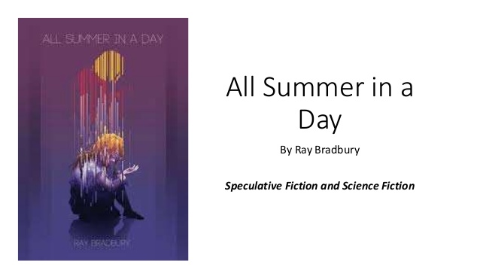
source: https://image.slidesharecdn.com/allsummerinaday-151015231042-lva1-app6892/95/all-summer-in-a-day-ray-bradbury-speculative-fiction-and-science-fiction-1-638.jpg?cb=1444950768
Before reading the text
1. The text you are going to read is called “All Summer in a Day”. What does summer mean to you? Write down your top 5 most important things that are part of a summer day:
1
2
3
4
5

Now turn to your neighbour and compare – but without showing them your paper! Find out if you have anything in common. If so, mark the item by circling it in your list.

2. Here are 5 words/phrases from the story. Look at them and think about what the story might be about. Exchange ideas with your neighbour. Then finish the sentence below.
rocket men and women schoolroom
rain windows Venus
I think the story is about _____________________________________________________
________________________________________________________________________________.


While reading the text

3. While reading the text, underline important information about Margot in orange and important information about the nature/weather on the planet Venus in blue. Then fill the shapes with words/phrases or short sentences.
Margot: Nature/Weather:

After reading the text
4. Complete the SWBS plot chart below to sum up the story.

Somebody (S)
Who is the story about?

Wanted (W)
What did the person want?

But (B)
What prevented the person from getting what they wanted?

So (S)
How did the story end?

5. Pick one of the groups of questions below that you think is interesting. Then find 2-4 other students that picked the same questions. Discuss them and take notes. Every person should be prepared to share the group’s ideas with someone else.

Group Closet: How did the other children treat Margot?
How do you think did the other children feel when Margot told them about the sun? And why did they lock her into the closet?

Group Margot: How was Margot different from the other children?
How do you think did Margot feel and what did she think about when she was in the closet?

Group Sun: Why are all the children waiting for the sun to come out?
Why is Margot especially passionate about this?
How would you feel if you knew you would not see the sun for many years, and what would you do on the day it came out again?

Group Venus: Where do the people in the story live? What does it look like (school and outside)?
Do you think something like this could actually happen in the future? Why/why not?

6. Discussion time! Your teacher will set a timer for 5 minutes. Find a student who was not in your group and exchange your ideas and opinions until the timer rings.

Repeat 2 more times – you should have talked to someone from each group.

7. To prepare yourself for task 8, do an acrostic puzzle: The title of the story is written on the page vertically () - find one or two fitting words or phrases/short sentences for each letter. Your words/phrases should have something to do with the story.

A  L  L  S  U  M  M  E  R | I  N  A  D  A  Y  Other words/phrases I want to remember:

8. Choose one of the tasks. Write ½-1 page and use some of the words/phrases from exercise 7.
a) Write a different ending for the story. Consider why the children bullied Margot and how else they could have reacted. Choose either the perspective of Margot or the perspective of one of the other children. Use the first person singular (“I”).

b) Continue the story to show what Margot and the children do after they let her out of the closet. Consider how Margot felt in the closet and how this experience affected her. Choose either the perspective of Margot or the perspective of one of the other children. Use the first person singular (“I”).


