All Summer in a Day
By Ray Bradbury
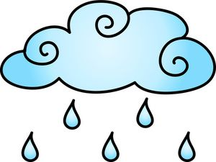
Pre-reading:
Free-flow writing: Write down everything that comes to your mind while listening to the sound of rain and thunderstorm. What mood does it create? What do you imagine seeing, feeling, smelling, tasting, hearing? _____________________________________________________
_____________________________________________________
___________________________________________________________________________
__________________________________________________________________________
____________________________________________________________________________________________________________________________________________________________________________________________________________________________________________________________________________________________________________
Talk to your partner:
-Do you prefer sunny or rainy days? And why? Do you think weather can influence people’s moods?

-Predict: Based on these words, what do you think the story is about? What kind of genre could it be?
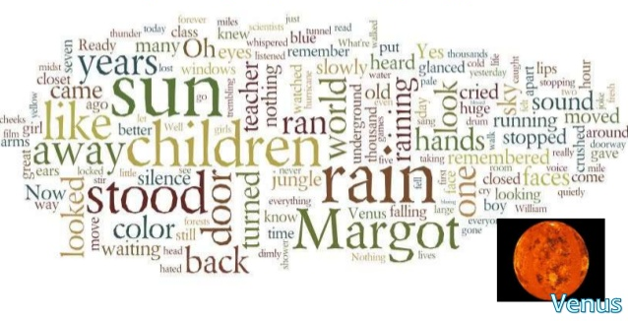
“It rained. It had been raining for seven years; thousands upon thousands of days compounded and filled from one end to the other with rain, with the drum and gush of water, with the sweet crystal fall of showers and the concussion of storms so heavy they were tidal waves come over the islands. A thousand forests had been crushed under the rain and grown up a thousand times to be crushed again. And this was the way life was forever on the planet Venus, and this was the schoolroom of the children of the rocket men and women who had come to a raining world to set up civilization and live out their lives.”

How would your daily life change if it rained nonstop for seven years? (sports, activities, travel, school, appearance) Write your ideas down and then share them with the whole class!
____________________________________________________________________________________________________________________________________________________________________________________________________________________________________________________________________________________________________________
While reading: Read the story until the end of page 2!
“Margot stood apart”.
-What do we learn about Margot’s character? Why do you think Margot does not fit in?
-Why do you think did it seem “vital” to Margot to return to Earth at one point?
_______________________________________________________________________________________________________________________________________________________________________________________________________________________________________________________________________________________________________________________________________________________________________________________
- Based on the description in the text, sketch a picture of Margot!
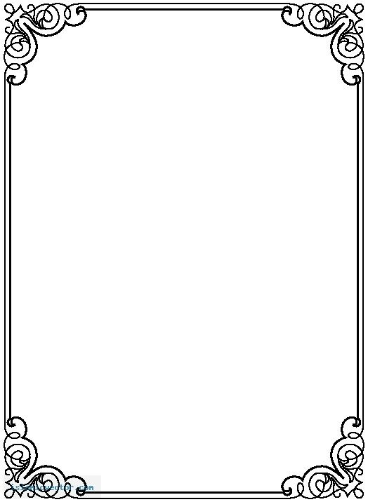

Continue to read the whole story!
Get together in groups of 3-4 and discuss the following questions:
- Do you think it is harder to stand up for what you know is right when you are in a group? Why or why not?
- Think of a time in your life when you were in a situation where you made a choice based on a peer pressure. What happened?
- Compare how the children walk away from the door when they push Margot into the closet with how the children walk back to the closet to let her out at the end. Why are the children able to empathize with Margot at the end of the story?
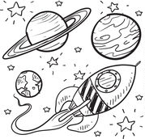
- Try to come up with ideas for possible effective interventions in bullying situations!

Post reading:
Tick off the elements of Science Fiction you encountered in this story!
What is Science Fiction?
- It may be set in the future and may make predictions about life in the future □
- There may be much travelling and journeys □
- It may have new or imagined technology and science □
- It may be set in an alternative world/ another planet □
- It could have other creatures/robots or other non-human characters □
- Science fiction can comment on important issues in society □

Write an ending for the story in which you describe what happens when Margot is released from the closet.
-Consider what Margot might do when the closet door opens? What are possible consequences? How might the children/ Margot feel?

Vocabulary:
The author has used descriptive language and comparisons to explain the concept of “sun”. Find 5 different phrases! Then try to come up with one on your own!

1.
2.
3.
4.
5.

The sun = __________________________________________________________________
Notes:
The short story by Ray Bradbury is set in a school and shows the group dynamics between pupils, which is a perspective all students can relate to. The genre of Science Fiction is explored in connection with the important topics of bullying, peer pressure, and anxiety, as the main character is affected and suffers from these issues. Undoubtedly, readers feel empathy for Margot, thereby allowing students to understand how actions can affect others. If they have been bullied or have bullied in the past, they will come to understand through texts like this, that it has severely negative consequences.

This worksheet is designed for Year 11 learners (7. Klasse AHS). The aim of the lessons is to introduce the genre Science Fiction, focus on descriptive language (similes, metaphors), spark their creativity and tap into issues in society. It would nicely fill two lessons, as there are many discussion questions that deal with sensitive issues and one should take the time to let the pupils share their experiences and opinions. Additionally, there is also a 30 min film version on YouTube (https://www.youtube.com/watch?v=iz05RhA9Cyw) that could be watched together in class. The film has an added ending, in which the Margot’s classmates give her all their collected flowers as apology. I would stop the video at min 22 and then let the students share their own written creative endings. To conclude, it could be nice to watch the other film option.

During the first pre-reading exercise, the sound of thunderstorms and heavy rain should be played to set the mood. In the best case, the short story might be read during a particularly rainy and gloomy time in autumn.

