Teacher’s sheet: “Wonderful Christmas Gift”

Topic (keywords): Christmas and traditions, presents, wishes, reward for help, social differences
Level: A2 (3rd grade)
Source: http://www.english-for-students.com/Wonderful-Christmas-Gift.html
Aims of the lesson :
- Students can ask each other questions about themselves/ a drawing they see.
- Students can use an input text in order to talk about their wishes.
- Students understand that getting a present is a privilege and that not everybody is lucky to get one. They can feel empathetic about that fact. They can talk/write about similarities and differences between the situation in the text and their lives.
Advise:
Before starting with the tasks of the short story, you might want to talk about the differences between Christmas in Austria and the USA/ UK. Being aware of these differences is not the aim of this lesson, but a general knowledge will help students to understand the text better (Santa Claus, night, the morning of the 25th, cookies,…. also: people get/ give each other presents for Christmas maybe not all students celebrate Christmas).
Therefor you could for example:
- do a brainstorming activity (on the board or online)
- talk to the entire class and use a PPP.
- let students discuss what they already know (think-pair-share=


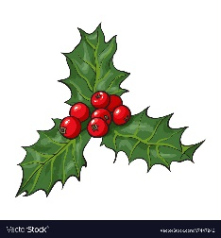
Worksheet “Wonderful Christmas Gift”

1. Before reading
a. What is the story about?
Take a look at the title of the story: “Wonderful Christmas Gift”. Guess what the story could be about and write down some notes. Think about where and when the story might take place, the character(s), what might happen and how the story might end …
Where? | When? | Character(s) | What happens? | The ending

b. Now ask your partner what he/she thinks. Which ideas are similar and which are different?
____________________________________________________________________________________________________________________________________________________________________
2. While reading
a. Read the story and write down 5 words or phrases you want to remember from the text. Also write down why you want to remember them

b: Now read the story a second time and focus on Ann’s feelings about Christmas. Draw symbols next to the passages in the text, e.g.: for happy, for sad, etc.

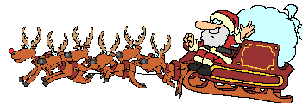
3. After reading
a. Have you been in a similar situation?
Think about a perfect Christmas/ birthday/ Chanukah/ Eid ul-Adha (Opferfest) present for you. What is the present? Draw a picture or write a short paragraph about it.


b. Talk to a partner
Show him/her the present hope to get or let him/her read through your text. Ask each other questions about the topic and find out:
- what the present is
- why it is the perfect present for you
- how your partner would feel if he didn’t get the present he wants to/ a present at all


c. Group work
Now find another pair and form a group of four. Share with the others what your partner told you about the present. Do not talk about your own present, but about your partner’s! Then talk about what is different and what is similar between your and Ann’s situation.

Homework
Imagine that Ann is your friend and that she told you before Christmas that she won’t get a present. Now you have just found out that she had a dress and you want to write an email to her. Write about 100-120 words. In your email:
- tell her how you felt for her before and how you feel now.
- tell her whether you have already been in a similar situation.
- tell her about your perfect gift.

