Death By Scrabble – Charlie Fish
Age of Learners | 15-16
CEFR level | B1-B2
teaching objectives | - The students should be able to follow a complex train of thought.  - The students should be able to understand expressions that describe emotions towards a different person. (hatred in that case)

Just for me:
Great story, but change the tasks. some won’t work
  - Pre-reading activities
While-reading activities
Post reading activities

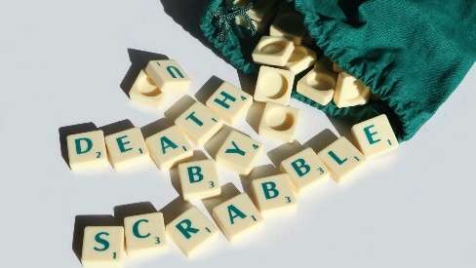

Death by Scrabble

  - Charlie Fish
Task 1: Get together with a partner and brainstorm what you think is going to happen in “Death by Scrabble”.


Something is missing here. I guess they will read a part of the story. Please say this.
Task 2: How did this situation came about? Write down 2-3 sentences about what could have happened before this part of the story.
“The rage gets to my fingertips and passes. My heart is beating. I'm sweating. I think my face actually twitches.”


Task 3: Which expressions does the narrator of the story use to express his feelings towards his wife?


Task 4: What are the differences between your predictions of the story and the actual story. Were some elements similar?
similarities | differences

Task 5: Do you think that the wife also noticed that the scrabble game was “jinxed”, what could have been her intentions with her words? Note down your ideas


Task 6: Work in pairs! Rewrite the story in a different genre. The key elements stay the same (jinxed board, etc.) e.g. Love by Scrabble

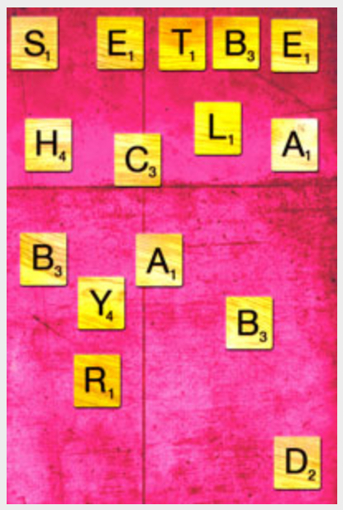
Death By Scrabble
It's a hot day and I hate my wife.
We're playing Scrabble. That's how bad it is. I'm 42 years old, it's a blistering hot Sunday afternoon and all I can think of to do with my life is to play Scrabble.
I should be out, doing exercise, spending money, meeting people. I don't think I've spoken to anyone except my wife since Thursday morning. On Thursday morning I spoke to the milkman.
My letters are crap.
I play, appropriately, BEGIN. With the N on the little pink star. Twenty-two points.
I watch my wife's smug expression as she rearranges her letters. Clack, clack, clack. I hate her. If she wasn't around, I'd be doing something interesting right now. I'd be climbing Mount Kilimanjaro. I'd be starring in the latest Hollywood blockbuster. I'd be sailing the Vendee Globe on a 60-foot clipper called the New Horizons - I don't know, but I'd be doing something.
She plays JINXED, with the J on a double-letter score. 30 points. She's beating me already. Maybe I should kill her.
If only I had a D, then I could play MURDER. That would be a sign. That would be permission.
I start chewing on my U. It's a bad habit, I know. All the letters are frayed. I play WARMER for 22 points, mainly so I can keep chewing on my U.
As I'm picking new letters from the bag, I find myself thinking - the letters will tell me what to do. If they spell out KILL, or STAB, or her name, or anything, I'll do it right now. I'll finish her off.
My rack spells MIHZPA. Plus the U in my mouth. Damn.
The heat of the sun is pushing at me through the window. I can hear buzzing insects outside. I hope they're not bees. My cousin Harold swallowed a bee when he was nine, his throat swelled up and he died. I hope that if they are bees, they fly into my wife's throat.mspytrack
She plays SWEATIER, using all her letters. 24 points plus a 50 point bonus. If it wasn't too hot to move I would strangle her right now.
I am getting sweatier. It needs to rain, to clear the air. As soon as that thought crosses my mind, I find a good word. HUMID on a double-word score, using the D of JINXED. The U makes a little splash of saliva when I put it down. Another 22 points. I hope she has lousy letters.
She tells me she has lousy letters. For some reason, I hate her more.
She plays FAN, with the F on a double-letter, and gets up to fill the kettle and turn on the air conditioning.
It's the hottest day for ten years and my wife is turning on the kettle. This is why I hate my wife. I play ZAPS, with the Z doubled, and she gets a static shock off the air conditioning unit. I find this remarkably satisfying.
She sits back down with a heavy sigh and starts fiddling with her letters again. Clack clack. Clack clack. I feel a terrible rage build up inside me. Some inner poison slowly spreading through my limbs, and when it gets to my fingertips I am going to jump out of my chair, spilling the Scrabble tiles over the floor, and I am going to start hitting her again and again and again.
The rage gets to my fingertips and passes. My heart is beating. I'm sweating. I think my face actually twitches. Then I sigh, deeply, and sit back into my chair. The kettle starts whistling. As the whistle builds it makes me feel hotter.
She plays READY on a double-word for 18 points, then goes to pour herself a cup of tea. No I do not want one.
I steal a blank tile from the letter bag when she's not looking, and throw back a V from my rack. She gives me a suspicious look. She sits back down with her cup of tea, making a cup-ring on the table, as I play an 8-letter word: CHEATING, using the A of READY. 64 points, including the 50-point bonus, which means I'm beating her now.
She asks me if I cheated.
I really, really hate her.
She plays IGNORE on the triple-word for 21 points. The score is 153 to her, 155 to me.
The steam rising from her cup of tea makes me feel hotter. I try to make murderous words with the letters on my rack, but the best I can do is SLEEP.
My wife sleeps all the time. She slept through an argument our next-door neighbours had that resulted in a broken door, a smashed TV and a Teletubby Lala doll with all the stuffing coming out. And then she bitched at me for being moody the next day from lack of sleep.
If only there was some way for me to get rid of her.
I spot a chance to use all my letters. EXPLODES, using the X of JINXED. 72 points. That'll show her.
As I put the last letter down, there is a deafening bang and the air conditioning unit fails.
My heart is racing, but not from the shock of the bang. I don't believe it - but it can't be a coincidence. The letters made it happen. I played the word EXPLODES, and it happened - the air conditioning unit exploded. And before, I played the word CHEATING when I cheated. And ZAP when my wife got the electric shock. The words are coming true. The letters are choosing their future. The whole game is - JINXED.
My wife plays SIGN, with the N on a triple-letter, for 10 points.
I have to test this.
I have to play something and see if it happens. Something unlikely, to prove that the letters are making it happen. My rack is ABQYFWE. That doesn't leave me with a lot of options. I start frantically chewing on the B.
I play FLY, using the L of EXPLODES. I sit back in my chair and close my eyes, waiting for the sensation of rising up from my chair. Waiting to fly.
Stupid. I open my eyes, and there's a fly. An insect, buzzing around above the Scrabble board, surfing the thermals from the tepid cup of tea. That proves nothing. The fly could have been there anyway.
I need to play something unambiguous. Something that cannot be misinterpreted. Something absolute and final. Something terminal. Something murderous.
My wife plays CAUTION, using a blank tile for the N. 18 points.
My rack is AQWEUK, plus the B in my mouth. I am awed by the power of the letters, and frustrated that I cannot wield it. Maybe I should cheat again, and pick out the letters I need to spell SLASH or SLAY.
Then it hits me. The perfect word. A powerful, dangerous, terrible word.
I play QUAKE for 19 points.
I wonder if the strength of the quake will be proportionate to how many points it scored. I can feel the trembling energy of potential in my veins. I am commanding fate. I am manipulating destiny.
My wife plays DEATH for 34 points, just as the room starts to shake.
I gasp with surprise and vindication - and the B that I was chewing on gets lodged in my throat. I try to cough. My face goes red, then blue. My throat swells. I draw blood clawing at my neck. The earthquake builds to a climax.
I fall to the floor. My wife just sits there, watching.

