Teacher Instructions

The following reading activities are designed for a 6th grade, but can be done in higher classes as well, depending on the level of the learners and their interests.
I chose the text because of the content. It is a story about a fictive country where everybody is equal and those who are above the average get handicaps to take him or her to the same level as the others are. There are very famous books that deal with the topic like “Brave New World” or “1984” and this story covers the same topic in a few pages. It is a nice text, because it leads the students to critically think about surveillance and control and about the beauty of everybody being different and having different interests, thoughts and abilities.

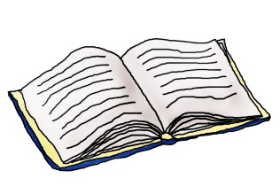
Reading activities

This is a very good story – highly appropriate and certainly interesting for the kids. I have cleaned up your instructions and language a bit. Otherwise this is very good.
Great ideas – just work on your language skills to say things more clearly and more idiomatically.
8/10

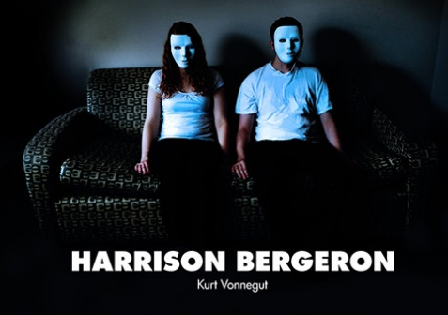
Title: Harrison Bergeron
Author: Kurt Vonnegut
Year: 1961
Type: Short Story
Topic: ??? – you will find out

You are going to read a short story entitled “Harrison Bergeron” written by Kurt Vonnegut in 1961. On the following pages, you will find three tasks in relation to the story. Please do them and afterwards write a little comment on how you liked the story into your reading diary.

- Before reading – What’s the story about?
Before you start reading the story get together in groups of three. Look at the picture and try to assume what this story could be about. Is it funny, sad or maybe dramatic? …
What kind of persons could play a role in the story? What could be the main topic?
Here are some keywords that might help you and give you hints into the right direction. Make some notes on your discussion.
Surveillance and control
equality
Year 2081

My notes:


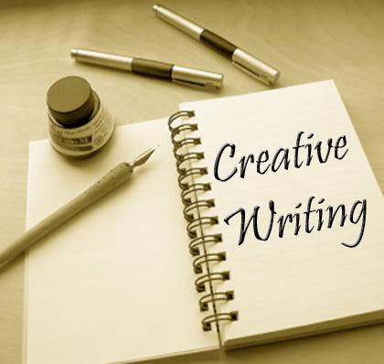
- While reading – How might the story continue?
Read the story until you see the stop sign in the text.
Write a short text about how you think the story might go on.
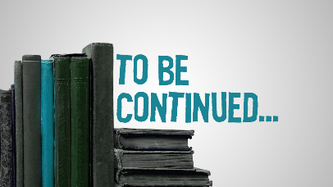
What would you expect? A sad ending or rather a happy ending? What will happen (prediction) happens to the main characters in the story?

Continue reading afterwards and compare your ending to the one of the author. Did you expect the “real” ending?

- After reading – What do you think on the main topic?
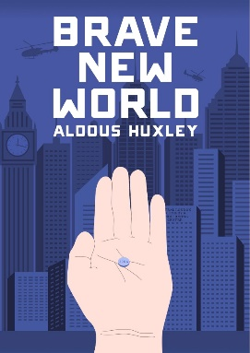
Have you heard of books that deal with a similar topic as the story you have just read? Maybe you know Aldous Huxley – “Brave New World” or “1984” by George Orwell. The authors describe a social dystopia and tell us what they expect the world to be like in a few years’ time. Do you agree with them? Are we heading in the wrong direction? “Harrison Bergeron” was written in 1961. Is this text still up to date?
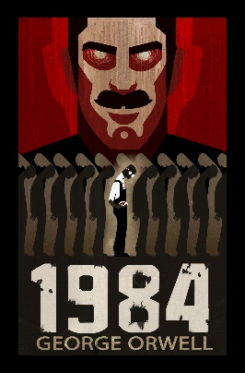
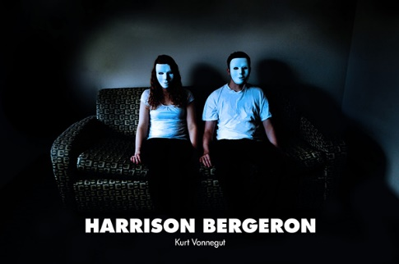

Write a comment on the main topic of the story. How far can we go? Is our need for equality, surveillance and control really taking us into the direction of what the text proposes?

