Literary Unit – Re-Interpretation of Traditional Fairy Tales

Little Red Riding Hood and the Wolf, by Roald Dahl

As soon as Wolf began to feel
That he would like a decent meal,
He went and knocked on Grandma's door.
When Grandma opened it, she saw
The sharp white teeth, the horrid grin,
And Wolfie said, ``May I come in?''
Poor Grandmamma was terrified,
``He's going to eat me up!'' she cried.

And she was absolutely right.
He ate her up in one big bite.
But Grandmamma was small and tough,
And Wolfie wailed, ``That's not enough!
I haven't yet begun to feel
That I have had a decent meal!''
He ran around the kitchen yelping,
``I've got to have a second helping!''
Then added with a frightful leer,
``I'm therefore going to wait right here
Till Little Miss Red Riding Hood
Comes home from walking in the wood.''
He quickly put on Grandma's clothes,
(Of course he hadn't eaten those).
He dressed himself in coat and hat.
He put on shoes, and after that
He even brushed and curled his hair,
Then sat himself in Grandma's chair.
In came the little girl in red.
She stopped. She stared. And then she said,

``What great big ears you have, Grandma.''
``All the better to hear you with,'' the Wolf replied.
``What great big eyes you have, Grandma.''
said Little Red Riding Hood.
``All the better to see you with,'' the Wolf replied.

He sat there watching her and smiled.
He thought, I'm going to eat this child.
Compared with her old Grandmamma
She's going to taste like caviar.

Then Little Red Riding Hood said, ``But Grandma,
what a lovely great big furry coat you have on.''

``That's wrong!'' cried Wolf. ``Have you forgot
To tell me what BIG TEETH I've got?
Ah well, no matter what you say,
I'm going to eat you anyway.''
The small girl smiles. One eyelid flickers.
She whips a pistol from her knickers.
She aims it at the creature's head
And bang bang bang, she shoots him dead.
A few weeks later, in the wood,
I came across Miss Riding Hood.
But what a change! No cloak of red,
No silly hood upon her head.
She said, ``Hello, and do please note
My lovely furry wolfskin coat.''

Source: https://ace.home.xs4all.nl/Literaria/Txt-Dahl.html

Little Red Riding Hood and the Wolf, by Roald Dahl
Notes for the teacher
Level of students: 4th grade Gymnasium
Appropriateness of text: Roald Dahl’s Revolting Rhymes have often been criticised for being too brutal for young children. Students of a 3rd or 4th grade should not be considered to be too young. Nevertheless, when explaining step II. on the handout, the teacher should make it very clear that Dahl uses shocking language at times and that the stories can be quite brutal. In step IV. on the handout, the students are also given the opportunity to reflect the text and discuss which elements they liked or disliked and share their opinions in a classroom discussion.
Student-focus: The handout was designed to ensure a high level of learner-centeredness. In almost all of the steps, the teacher simply functions as a mentor and helps out whenever questions arise.
Integration of different skills:
I: partner discussion and brainstorming – speaking, listening and writing
II: individual work and partner comparison – speaking and listening
III: individual work – reading
IV: group discussion / classroom discussion – speaking and listening
V: individual work – reading and writing
Purpose of activities: 1. Re-introduction of traditional story elements of fairy tales as a starting point. 2. Sparking interest concerning ways of re-writing traditional stories. 3. Introduction of Roald Dahl as one of Britain’s most acclaimed writers of children’s books and poems. 4. Demonstrating how poems are a creative way of ‘playing’ with language. 4. Encouragement of creative and innovative writing while taking learners’ different language levels into consideration (important information: If some students do not feel confident enough to write a poem in the style of Roald Dahl the teacher should tell them that they can also write a short story).
Notes concerning step I: Before the students start to work on step I, the teacher should ask who knows the fairy tale “Little Red Riding Hood”. Students should work in pairs (or if need be in groups) where at least one person knows the story. After this activity, the teacher should encourage a short classroom discussion to make sure that all students are familiar with the main events in the fairy tale “Little Red Riding Hood”.
Little Red Riding Hood and the Wolf, by Roald Dahl (in Revolting Rhymes)

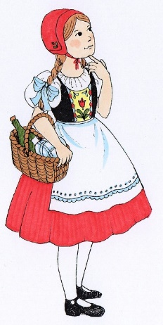
Brainstorm with a partner:
Think of the fairy tale “Little Red Riding Hood”. What do you know about the story? How does the fairy tale begin and how does it end? Who saves Little Red Riding Hood? Summarise the main events in bullet points.

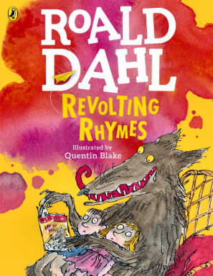
You are going to read the poem “Little Red Riding Hood and the Wolf” by Roald Dahl. It is one of six poems in his book “Revolting Rhymes” (empörende Gedichte). In these poems, Roald Dahl re-wrote fairy tales that give surprising and sometimes shocking endings.
How could the poem “Little Red Riding Hood and the Wolf” end in Dahl’s version? What would surprise you?
Step 1: Write down your ideas and guesses.
Step 2: Compare your notes with your partner.

III.
Read the poem. Highlight the passages that are in line with the traditional fairy tale. With another colour, highlight any passages that are new to the story.

Vocabulary: decent = anständig; frightful leer = beängstigender Blick; flicker = flimmern; knickers = Unterhose

IV.
Get together in groups of four.
What is new in Dahl’s version of “Little Red Riding Hood”? What do / don’t you like about his story and what shocked you the most? Be prepared to talk about your group’s opinions in a classroom discussion.

V.
Now it’s your turn!
Step 1: Choose a traditional fairy tale or folk story you know well. If you need help, you can choose from a wide selection of stories on the following homepage: https://www.worldoftales.com/fairy_tales.html.
Step 2: Write your own version of your chosen story and include traditional story elements as well as new and surprising twists. Write a poem in the style of Roald Dahl. Make sure to write a title that refers to the original tale.
Step 3: Print out your story and be prepared to read it out loud.
Step 4: Hand in your story.

