Nya’s Long Walk
A Step at a Time

Lead-in questions:
- What does the title Nya's Long Walk make you think about?
- Where could this long walk lead her to?

Task 1
In pairs, discuss the cover of Nya's Long Walk. What is Nya doing? Where is she? What surrounds her? What is she thinking about? Together, think about words that could best describe her.

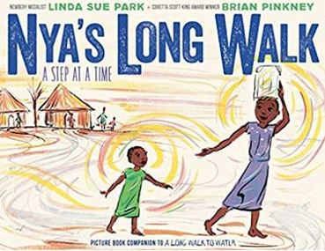
__________________________________________________________________________________________________________________________________________________________________________________________

Task 2
Listen to the story. Look at the comic strip. Who are the characters and what are they saying?

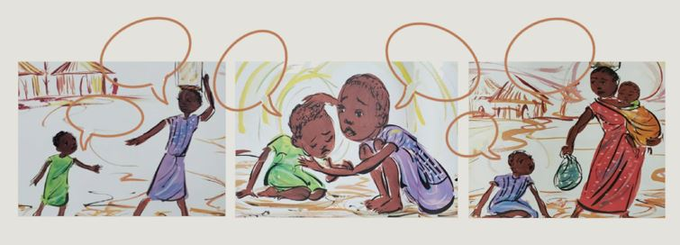

Task 3: Listen to the story again. Answer the following questions with your neighbour:
- Why do Nya and Akeer have to walk so far to get water? ____________________________________________________________________________
- What made Akeer sick? ____________________________________________________________________________
- How long do you have to walk for water? ____________________________________________________________________________
- Does the water in your home make you sick? Why do you think that is? ____________________________________________________________________________
- What do you use water for during the day? ____________________________________________________________________________



Task 4: Look at Nya’s can. How much water can it hold? What would she and her family be able to do with only this little amount of water?

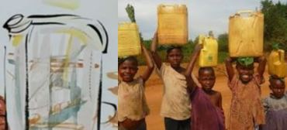
____________________________________________________________________________________________________________________________________________________________________________________________________________________________________________________

picture: https://watercrisisinafrica.wordpress.com/2016/11/30/the-water-crisis-in-africa/
Task 5: How does Nya feel on her way home? Circle the words you associate with her feelings:
happy angry exhausted tired worried

furious glad sad energised
Task 6: How would you feel in this situation? What does Nya do to make it all the way home?
_____________________________________________________________
_____________________________________________________________
Task 7: What do you think Nya and Akeer saw on their way to get water?
____________________________________________________________
____________________________________________________________

Task 8: Create your story pyramid!

_________________
Main character’s name
______________ ______________
Two words describing this person
____________ ____________ ______________
Three words describing the setting or place
___________ ___________ ____________ ___________
Four words describing an important event
__________ __________ __________ __________ __________
Five words describing the importance of this event

Task 9: Write a summary of the story into your notebook. Use your story pyramid as help. Please include a few sentences of how you liked the book. What did you really like? Is there anything you did not like at all?

Task 10: Akeer was sick. Nya and her mum had to walk two days to get to a doctor. How do you feel when you are sick? How long does it take you to go to a doctor? Can you imagine how Nya and her family must have felt? Write a few sentences about how this part of the story made you feel. How would you feel if you had to walk for such a long time? You can also talk to your neighbour about it.
____________________________________________________________
____________________________________________________________
____________________________________________________________
____________________________________________________________
____________________________________________________________
____________________________________________________________
____________________________________________________________
____________________________________________________________
____________________________________________________________
____________________________________________________________
____________________________________________________________
____________________________________________________________
____________________________________________________________
____________________________________________________________
____________________________________________________________
____________________________________________________________

Water for South Sudan – KWL-CHART
- What do you know about this topic?
- What do you want to know about this topic?
- After listening to the last part of the book, what have you learned?

Learned
__________________
__________________
__________________
__________________
__________________
__________________
__________________
__________________
Want to Know
__________________
__________________
__________________
__________________
__________________
__________________
__________________
__________________
Know
__________________
__________________
__________________
__________________
__________________
__________________
__________________
__________________

Salva Dut
Water for South Sudan

Class Discussion:
1. Who is Salva Dut?
2. What does he do to help South Sudan?
3. What does this mean for the villages?
4. How does he get the money for his project?
5. What is his project called?
6. What is clean water needed for?
picture: https://www.waterforsouthsudan.org/


Practice your vocabulary – work in pairs
Write down what the pictures suggest about sounds, smells, tastes and textures:

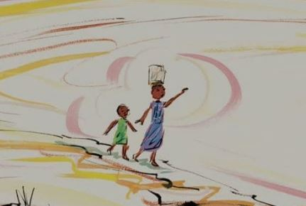
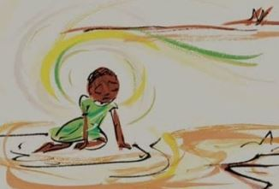
_____________________________________________________________________________________

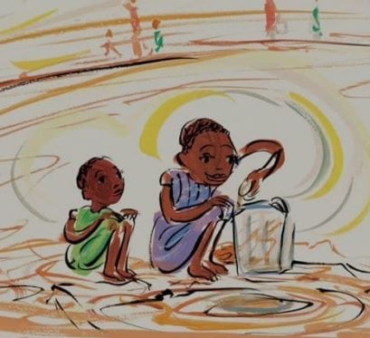
________________________________________________________________________________________

_____________________________________________________________________________________

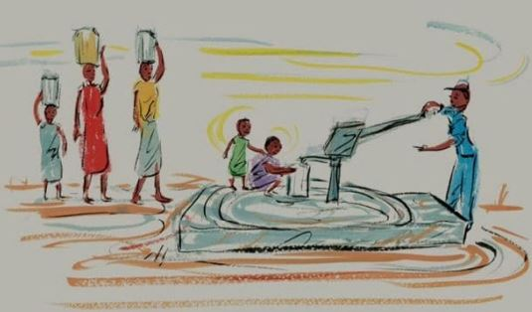
____________________________________________________________________________________________

Vocabulary Work
After listening to the story can you guess the meaning?
being trouble ______________________________________
a rare sight _______________________________________
to drag your feet ___________________________________
to snuffle and hiccup ________________________________
to chatter like a starling ______________________________
to feel worry swelling inside __________________________
to slump _________________________________________

Nya’s Long Walk
A Step at a Time
Teacher Instructions

This literature unit is aimed at A2 level students, maybe 2nd or 3rd grade depending on the English level of the class.
The objective of this session is to make the students aware of how people in other countries live and give an insight into the topic of water resources in general.
- Write the title on the board. Ask the students what they think of the title, what it could mean and where Nya’s walk might lead her to.
- Show the students the book cover. In pairs, have them discuss the cover. What is Nya doing? Where is she? What surrounds her? What is she thinking about? Together, they should think about words that best describe her.
- Tell your students to do task 2 while you start reading the story. Read slowly and take breaks to discuss the individual pages and vocabulary. Always show the pictures as well.
- Read the story again until page 14. The students should do tasks 3 and 4 in pairs. Afterwards discuss their findings with them.
- Have them do tasks 5 to 8. The story pyramid is needed for their writing task (write a summary of the book and also write two sentences on how you liked the story = feedback).
- For task 9 the students should write a summary of the story using their pyramid as scaffolding. They should also include a few sentences as feedback (how they liked the story, what they liked/didn’t like). Maybe play them some traditional African music while they are doing this task. This might have a positive influence on their creativity.
- Task 10 should help them revise one part of the story. They should also include how it made the feel.
- Water for South Sudan: KWL-Chart: Asl them what they already know about the water situation in South Sudan after listening to the story. Have them fill in column K. Then ask them what they would like to know about it. Have them fill in column W. Then read pages 15 and 16 to them. Tell them a bit about Salva Dut and his organisation. Now they should fill out column L. Depending on the class you could also watch this UNICEF video on YouTube:
https://www.youtube.com/watch?v=Y5P5h9TBwTQ
- Go through the class discussion questions with them.
- The vocabulary task can be done in pairs or as homework.
Have the book ready for students to look at during the session(s).

