TEACHER´S NOTE The Disintegration Machine
Age of the learners | 14- 15
Language level (CEF) | B1
Topic | Inventions
Main teaching objectives | - S can express their thoughts clearly and support their arguments  - S can lead a discussion and follow discussion rules (listen carefully, turn taking)  - S can practice and use correct vocabulary related to the topic “Inventions”
Reference to the curriculum | - The aim of this session is to encourage students to lead discussions, to speak up, to support their arguments and to share thoughts  - Enhance student talking time by integrating talking tasks  - Take students the fear of talking in front of other people and prepare them for the oral exam  - Students should become aware of the fact that there are more literary texts than those in the text book. There are real texts in this world available for them too  - Introduce students to important literary texts by famous American and English authors  - Encourage students to read such literary texts besides those texts that are in the text book  - Make reading fun and interesting for them
Solution Gap Filling Letter from McArdle | - have invented  - disintegrating  - dissolves  - returns  - discovery  - invention  - disintegrate  - invention  - inspect  - discovery

The Disintegration Machine by Sir Arthur Conan Doyle
Inventions and their Inventors
Look at the pictures of crazy inventions and read the texts. Then try to connect one text with the matching picture. Get together into groups of four and discuss. Is this an invention people need? Would you use this invention? What could be the invention´s name?
Enter your findings here.
Invention |  | Inventor |  | Group findings
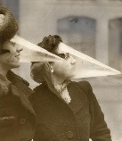 |  | This device was invented in 1876 by a man named Virgil A. Gates. This invention was only used by men. Men put that onto their faces when drinking and eating to keep their facial hair out of the way.
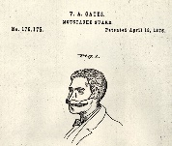 |  | This is a rather new invention, made for women and men. The inventors claim that it reduces stress and reconnects you with nature, “wherever you go”. Developed in the U.S., mainly for people living in the cities.
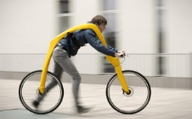 |  | This Canadian invention, invented in 1939, can be used only in one particular season. Women and men use it to keep their faces dry. It may look a bit weird but was considered very helpful.
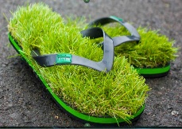 |  | FLIZ is an invention you have never seen before. It was invented by two Germans in the 21st century. This is its description: “The user hangs on a harness in between two____, propelling the _____by running, then resting feet on the back wheel.”
https://bigthink.com/paul-ratner/20-weirdest-inventions-ever
Collect Ideas
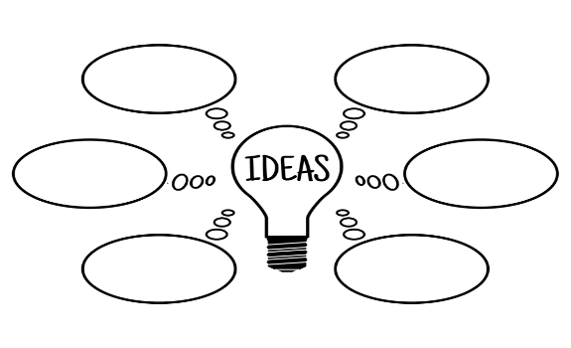
Now that you have seen other crazy inventions, think about following questions: How might the Disintegration machine look like? What color is it? What might be the purpose and function of the Disintegration machine?


Read the story. While reading highlight any references to the Disintegration Machine and to the inventor Dr. Nemor. Use two different colors.

Group discussion
What is special about the Disintegration machine? What is it? How does the author describe this invention? What do we know about Dr. Nemor? What happened to him?
Discuss and compare your highlighted words and phrases with a partner.

Vocabulary Task
Read the letter from R. McArdle to Professor Challenger again and fill in the gaps
“Please call upon our esteemed friend, Professor Challenger, and ask for his co-operation in the following circumstances. There is a Latvian gentleman named Theodore Nemor living at White Friars Mansions, Hampstead, who claims to (1) ________________ a machine of a most extraordinary character which is capable of (2)_____________any object placed within its sphere of influence. Matter (3)___________ and (4)_____________to its molecular or atomic condition. By reversing the process it can be reassembled. The claim seems to be an extravagant one, and yet there is solid evidence that there is some basis for it and that the man has stumbled upon some remarkable (5)____________.
“I need not enlarge upon the revolutionary character of such an (6)___________, nor of its extreme importance as a potential weapon of war. A force which could (7)_____________a battleship, or turn a battalion, if it were only for a time, into a collection of atoms, would dominate the world. For social and for political reasons not an instant is to be lost in getting to the bottom of the affair. The man courts publicity as he is anxious to sell his (8)______________, so that there is no difficulty in approaching him. The enclosed card will open his doors. What I desire is that you and Professor Challenger shall call upon him, (9)______________his invention, and write for the Gazette a considered report upon the value of the (10)______________. I expect to hear from you to-night.
R. McArdle.”

Writing
The Inventor Dr. Nemor disappeared into another universe. Professor Challenger and Malone have done their job and went off to another investigation. Now come up with a different ending for that short story. Therefore, read page 12 and 13 again.

Group A: Come up with a different ending that, fortunately, ends in a positive way for Dr. Nemor the inventor. Try to imagine what could have happened to Dr. Nemor.

Group B: Come up with a different ending for this story that, unfortunately, ends in a negative way for Professor Challenger. Try to imagine what could have gone wrong for Professor Challenger.
Write about half a page and upload your text to moodle.

