Teaching Activities for Literary Texts
“The Killers” by Ernest Hemingway
Year 6-8
Aims: Students should be able to read and understand a (real) American short story. They should appreciate Hemingway’s individual style of writing. They should also be able to work creatively with the text as a starter for a text, comic, or drama: write, draw, or perform (scenes of) the short story in order to engage in a creative way with English. The products will be presented in class.
Pre-reading:
The title of the short story is “The Killers.” What might the story be about? Discuss and take notes with a partner.

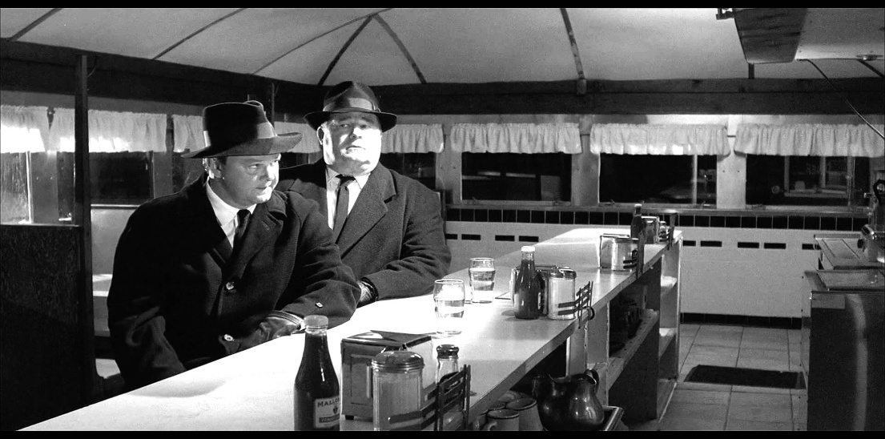
Below you can find a picture from the story. Look at the picture closely and see if your first guess was right/wrong. Can you say where/when the story is set?

While-reading:
Read the story. Pay attention to Hemingway’s sentences. Are they long and complex or short and easy to understand? Give examples from the text.

What do we know about the characters of the story? What are their names? What do they look like? How do they talk? What do they want?
Tip: add a table here with one row for each character. Such a structure will help the learners to collect the info – rather than just chatting about it superficially.
Who is/are the hero/s in the story? Nick Adams or the killers? Explain your decision.
Again – if you provide some space for the explanation, they will produce a meaningful paragraph. Otherwise they might take this easy.
After-reading:
Pick one of the three options below as homework, which will be presented next time.
Option 1: Are you content with the ending? If not, you may want to write your own ending to the story. Try using Hemingway’s special style of writing. On www.hemingwayapp.com/ you can check how Hemingway your ending sounds.

Option 2: What are the major events of the story? Write them down (e.g. the hitmen enter the restaurant) and sketch them in order to create a comic. Add speech bubbles.

Option 3: The short story consists of long passages of dialogue between the characters. Choose one scene that seems most important to you and try to perform it with 2-3 colleagues in class.next time.

Vocabulary:
The author has used lots of good collocations in the story. Find 5 phrases that stand out most to you and write them into your vocabulary book.

YES!!! This is a great project. What a pity I do not have a class to try it out right away.
Congratulations. Clean up the tiny flaws – this is really good.
Pö
10pts

