Short literary Unit

The Monkey's Paw by W.W. Jacobs
https://www.kyrene.org/cms/lib/AZ01001083/Centricity/Domain/2259/The%20Monkeys%20Paw%20-%20text.pdf

Teachers note:
Age of the learners | 16 and up
Language level (CEF) | B2
Topic | superstition and expressing wishes  (good Halloween topic)
Main teaching objectives | Wish + If (Second Conditional)  - The students can express their own wishes  - The students can use the second conditional correctly  - The students can discuss about fate and consequences
Reference to the curriculum | Linguistische Kompetenzen: Wortschatz, grammatische Strukturen und Idiomatik sind in allen Fertigkeitsbereichen situationsorientiert, unter funktionalem Aspekt, im Kontext und systematisch zu erweitern. Komplexität und Vielfalt der sprachlichen Mittel zur Bewältigung kommunikativer Aufgaben sind im Laufe der Oberstufe stetig zu intensivieren. Die entsprechenden Strukturen sind begleitend dazu in zyklischer Progression zu erarbeiten. Dabei ist insgesamt zu beachten, dass das rezeptive Sprachvermögen der Schülerinnen und Schüler das produktive Sprachvermögen übertrifft.

Important tips for the teacher
- The first three questions are to introduce the topic of the story.
- After the discussion, the students read the first part of the story.
- The 3rd and 4th question should also be discussed with the whole class.
- Afterwards the students finish reading the story.
- The teacher can also briefly discuss the story with the students after they have read it.
- Before doing this lesson, you should have taught the students the second conditional. This worksheet can then be used as an exercise so students can apply their knowledge.

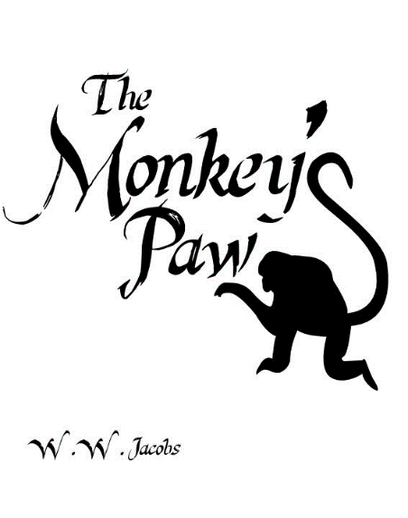

1. What do you think the most common wishes of people
are? Would your wishes be the same? Take some notes
and discuss them with your partner.


2. Can you think of some objects that are considered good luck or bad luck in your culture? Write down your answers and discuss your answers with your partner.

3. Think about the following questions:
- Do you believe all wishes are as good as they seem?
- How much control do you have over making your wishes come true?
- What is fate?
- Should we mess with it by making these wishes?


4. Read the first 6 pages: What do you think happens next? Does the family get the money? Could there be any negative consequences? Write down your ideas.

5. Finish reading the story.
Post-reading exercises
Imagine you have found a genie’s lamp and are now granted three wishes. What would your three wishes be? Write down your wishes.
For example: I wish I were rich.


Be careful what you wish for!
Build groups of 3 or 4. One of you tells the others what one of your wishes would be and why. Afterwards the others have to come up with some negative consequences that could happen with your wish. (Don’t forget to use the second conditional.)
For example: I wish I were taller because then I would be able to reach the top shelf.
If you were taller, then you would hit your head on many things.


Finish the story: Do you think Mr. White's second wish came true? We never see an undead version of Herbert in the story, we only hear someone knocking on the White's door. Can you think of any other explanation for the sound? What do you think Mr. White’s last wish was? Try to make your ending really interesting.

