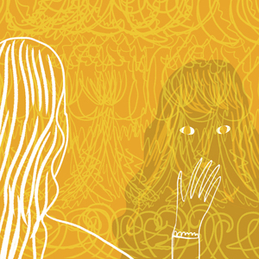
The Yellow Wallpaper –
by Charlotte Perkins Gilman (1860-1935)

You have just seen a trailer of the latest film adaption of Gilman’s
short story “The Yellow Wallpaper”.
1) What do you think might the story be about? Brainstorm with your partner and write down your ideas.

2) Start reading the story and stop at the end of page 653.

What is going on? What or who does the narrator believe to see behind the wallpaper? Can you come up with a possible explanation?


Vocabulary exercise:

The narrator has described the bedroom in much detail. Sketch her room – including the wallpaper – and list the phrases and words she uses to inform her readers about the nature of her room.

3) Finish reading the story.

4) By now, you will have noticed that the story is a collection of journal entries written by a woman who went through a mental breakdown and used writing to describe her feelings. Now, it is time to switch perspectives.

Describe what the time in the mansion might have been like for her husband and if he really thought that she was recovering or if he noticed her decline. Write a diary entry of approximately 350 words.

Teacher guide: (not visible for students)
target group: year 7 students (original text possesses lots of difficult vocabulary which might be challenging for younger students )

link for movie trailer:
https://www.youtube.com/watch?v=TZpoxNr-yWE (Short Film Trailer 2012)

main aims:
- expanding students’ knowledge of literary classics
- providing students with an example of feminist literature and making them aware of attitudes towards women and their health – (discussion on that theme not included in this outline)
- expansion of vocabulary – providing students with new vocabulary
- improving students’ reading comprehension

YES; this is EXCELLENT! You can use it as it is, without any changes.
Congratulations,
10pts
Pö

