The horrible Dib Dib
Online available:
https://idriesshahfoundation.org/read-online/the-horrible-dib-dib
Target Group: Beginners in year 1-2 / 2 lessons á 50min
Pre reading:  Teacher tells the name of the book; students get exercise sheet 1.  Students should draw their own “horrible Dib Dib”, there are no specific points given- they should draw what they think of!  The teacher explains the task and mentions that afterwards the students need to describe their dib dibs to the class(in short!)  Students give their “Dib Dibs” features to answer the question- “Why is the Dib Dib horrible?” | Learning objectives  - the students can name different colours  - the students can explain 3 features of their DibDibs  - the students can present a few sentences in front of the class | Time  1 whole lesson
Reading  While reading  Arriving on page 32-33 the students will stop reading. The teacher hands out sheet 2. The students have to think of how the story continues and write a few short sentences about it. The teacher supports them with questions.  Afterwards a class discussion starts. Students tell how they would continue the story. The teacher collects the ideas on the board. Students are allowed to vote for their favourite idea, but they need to tell why they like it  Teacher explains Homework to the students | - Students can understand the story  - The students can write simple sentences in the present tense and will future  - The students can write meaningful sentences  - The Students can explain preferences | 5min-10min  10 min-15min  Rest of the lesson
Post reading – Follow up  -Finishing the story at home  -Homework sheet | - The students can read independently  - The students can answer text-based questions | At home (no longer than one-hour max!)

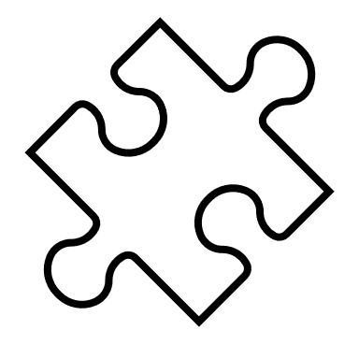
Pre Reading activities:
- What could a “horrible Dib Dib” be?
Draw your own Dib Dib, please use colours and any other material you need.
My own DibDib:
- Why is it called a horrible Dib Dib? Think of three features that make your DibDib horrible and explain it in short:
Example: My Dib Dib is horrible because it has a bad mouth smell.
1
2
3
While reading activity
Stop on Page 32-33 write a few short sentences answering the questions:
- What do you think happens with the old women when the doctor arrives?
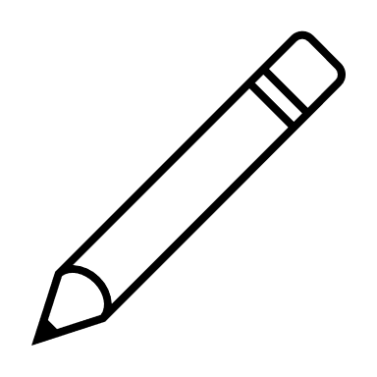
- Do you think the thief will be healed?
- How will the story end?
(be careful which tense you use)
____________________________________________________________________________________________________________________________________________________________________________________________________________________________________________________________________________________________________________________________________________________________________________________________________________________________________________________________________________________________________________________________________________________________________________________

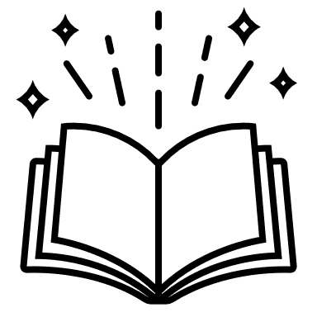

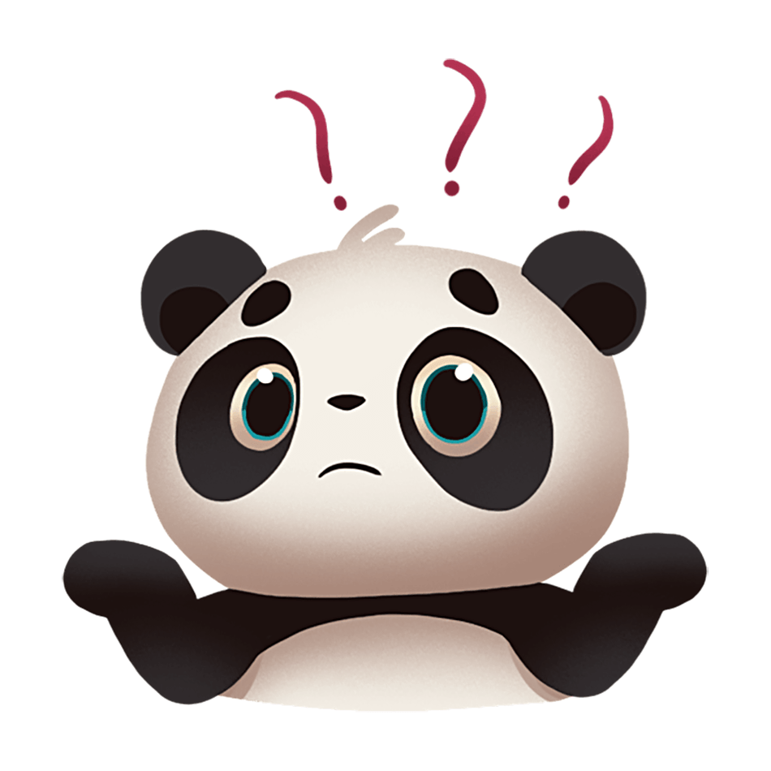
Follow Up: Homework
- Read the rest of the story at home

Answer the questions in whole sentences:
- What is the “horrible Dib Dib”?
- Why is the Dib Dib horrible in the story?
- Do you like the story? Explain your answer.

Story Pie for The Horrible Dib Dib
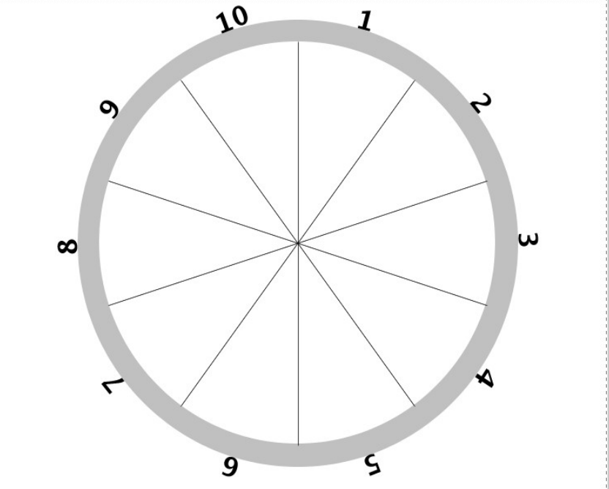
On scrap paper, write down the 10 most important events in your story. Put the main events in the correct order and write them into the story pie below.

Well done! You finished reading the story The horrible Dib-Dib. You are now an expert about horrible dib-dibs, do you think your parents know what a horrible Dib-Dib is?

