About Time!

This booklet belongs to________________________________________
General Information & Instructions
Read this carefully before starting!
Work on the tasks in this booklet before, during, and after reading the book of your choice. Make sure you know which tasks to do when by reading through the tasks beforehand. On some tasks you will have to work continuously while reading the book (e.g. when collecting words).

Each task has a symbol that tells you where it should be done:

 | At school / fixed time
 | At home or during free-project-time

Make this booklet look awesome!
- Create a cover for your booklet. Make sure the illustration is somehow relevant to the content of the book! Use colours and shapes that fit the mood of your book as well!
- Make sure each page looks interesting and is well structured.
- If you don’t like the basic design of a page, you can do the task on an extra sheet and glue it on top of the page later.
- To make sure the texts in your booklet are free of mistakes and look orderly, hand the text in on a loose sheet of paper first and then write the corrected version into this booklet.
- Drawings, stickers, foldable element or collages will make your booklet even greater!

Due Date:_________________

 Book Choosing
Book Title & | Unknown words per page | Comments/First impression
Characters:

Setting:

Mood:

Plot:

Characters:

Setting:

Mood:

Plot:

Characters:

Setting:

Mood:

Plot:

Characters:

Setting:

Mood:

Plot:

Task 1 – Prediction

 Task 2 – Creative Catalogue
Everyone likes flipping through catalogues – the texts are short and the pictures look colourful and interesting. Create your own catalogue page for one interesting or helpful item in your book!
You can use the template below or glue your very own design on this page. In order to look nice and appealing, your catalogue page needs:
- A beautiful picture of the item.
- A short text, explaining what it is and why it is a must-have.
- A price tag.

Task 3 – Quotes
This page provides you with space to write down the best quotes from your book! They can be funny, thoughtful, serious, or strange, as long as you think they are interesting and/or express an important idea in the book!
Write down the page number next to the quote, so you can find it again later!
As a plus, you can also draw little illustrations or symbols next to your quotes.

Task 4 - Summary
Write a very short summary of the book in the box below (5-10 sentences) – it should include 1) the names of the main characters as well as 2) the main quest/problem that they have to conquer/solve.


Task 5 - My thoughts on the book
Write down your personal opinion of the book on the next page! You can write down whatever came to your mind when reading the book. You can describe your favourite scenes, complain about a part you hated with passion, or write about which character you can relate to best– just make it personal!

6a) Words n’ Phrases
Use this page to remember useful, interesting or amusing phrases and words that you want to remember.
- Do not write down words/phrases you already know!
- Write down an example sentence for each word/phrase.
- Fill this page completely!
 | Example: to peer (= to look narrowly or searchingly)
 | In Use: “She hummed, peering down one of the corridors.”

6 b) - Words n’ Phrases

Task 7 - Plot
Choose one of the two following tasks! (A or B)
- Clock Plot
Use this clock to give an overview of the most important events in your book: Find 12 central events in your book, explain them in 2-3 words, and then put them in chronological order (=in the order they actually happen) on the lines on the clock.
Start with 1 o’clock and end with 12 o’clock .

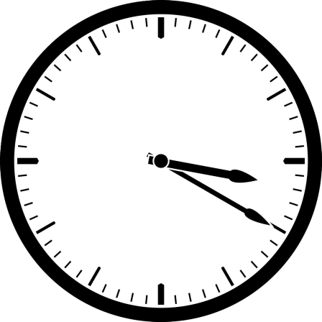

- Cogs & Gears
Like cogs and gears are driving mechanisms of a clock, and are needed to make it work, each story has important events that drive it onwards. Think of the most important events in your book and describe them in 2-3 words. Put these words into the cogs in the right chronological order (=in the order they actually happen), starting from the top! Feel free to add as many cogs as you need.

Task 8: Book-specific tasks
Glue in the book-specific task you have chosen and use the following space for your task!

Extra Space
Use the last pages to present your book and/or the topic “Time” in any way you want. For example, you can …
- …draw your favourite scenes from the book.
- …write a book review for a school paper.
- …create more catalogue pages.
- …draw a map of the most important locations your protagonists visit.
- …write a letter to the author from the perspective of one of the characters.
- …choose actors to play in a movie version of the book and describe why you would choose them (& add pictures of them!)
- …or think of something completely different that fits the topic!

Do not be afraid to try out new things & use this opportunity to show what you can do!

