152 M  BOYS AND GIRLS ARE VICTIMS OF CHILD LABOR. GLOBALLY.    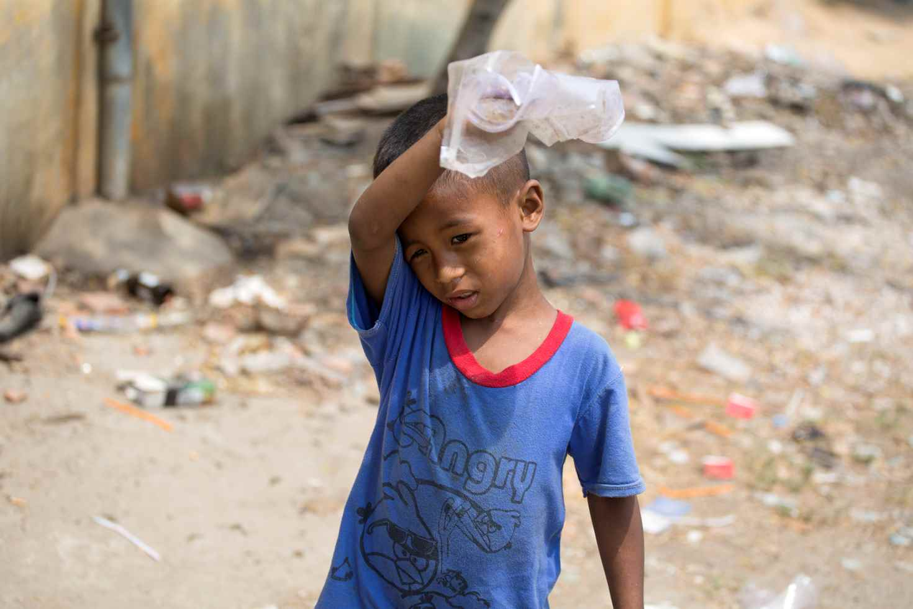  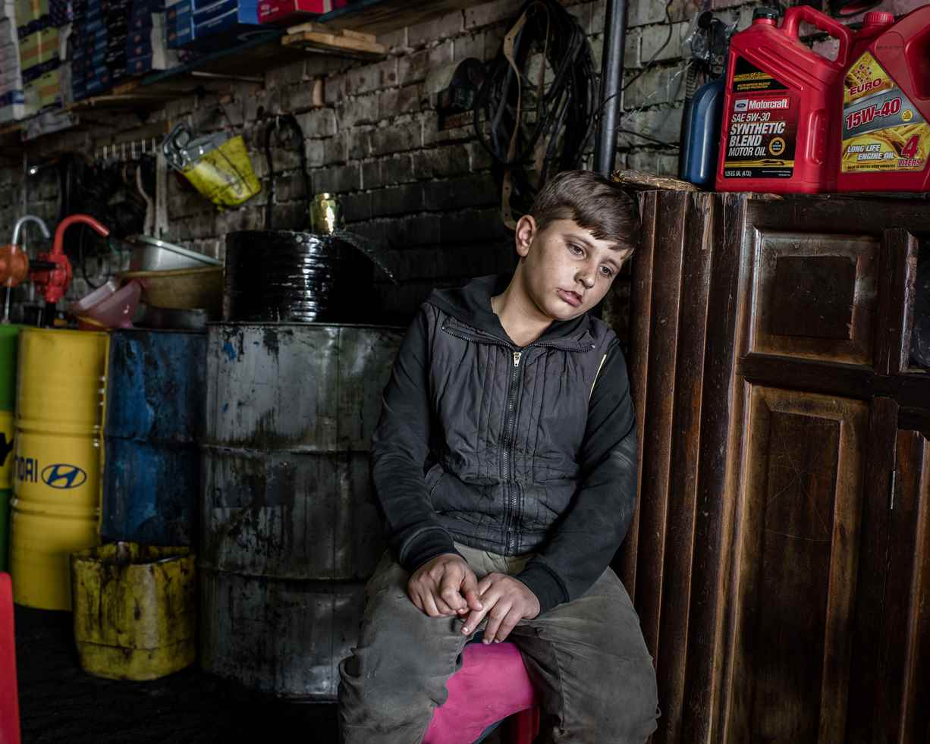  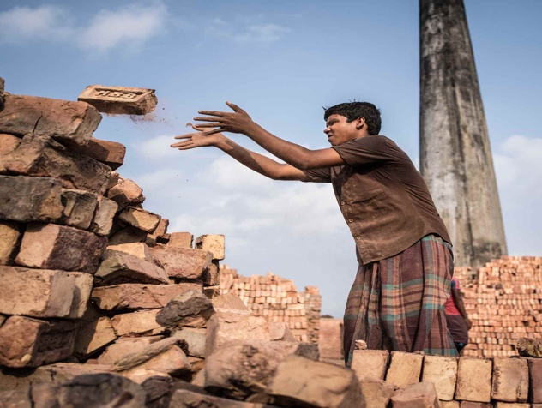  Rashini Suriyaarachchi is a UNICEF reporter and shares the stories of working children from around the world. | Every day, millions of children go to work.  Many work to help their families in ways that are neither harmful nor exploitative but millions more are put to work which drains their childhood of all joy - and crushes their right to normal physical and mental development.  Learn about some of the aspects of child labor and meet the children whose first jobs will impact their lives forever.  6-year-Old Chamroeun  Most mornings, Chamroeun and his mother Sareth head to the streets of Phnom Penh in Cambodia to work, collecting old cans and plastic bottles from the street to sell. At lunchtime, Sareth counts her money. If they’ve made enough, she can afford to feed her three children well.  “If I don’t have enough money after I’ve sold the cans and bottles, I buy each of them an egg,” she says, smiling. “That’s what we’re having today.”  14-year-old Mohammed  “We used to live on a farm in Kobani. My father had a truck and worked on the farm and we went to school. I miss my school in Syria. I miss my pens and books and I’d like to have them back.”  Mohammed is only 15 years old but school is a distant memory. He and his five siblings haven’t been in a classroom since they fled Syria and came to the Kurdistan region of Iraq. Instead of studying, Mohammed works full-time changing oil and fixing axles.  13-year-old Arieful  Arieful doesn’t know what he wants to be when he grows up. After dropping out of school in the first grade, not only are his opportunities limited - so are his dreams.  After a day of strenuous labor in a brick factory, Arieful can contribute less than four Australian dollars to his family’s income. His family borrows money from the factory owner in the off-season and just manages to pay their loan when they return to work.


1.
First, listen carefully to what your teacher has to say about the books. Then, discuss with a partner what you would do in each of the cases below.
Finally, choose the book you would like to read during our project.

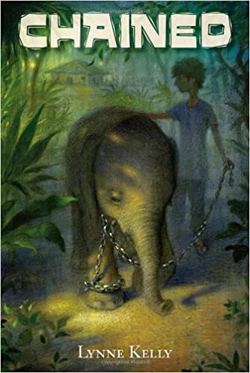 | Your little sister is seriously ill and gets treatment in hospital; however, your mother cannot pay the bills. How far would you go in order to support your family? Would you trust total strangers and take on a job offer for which you have to give up your childhood?
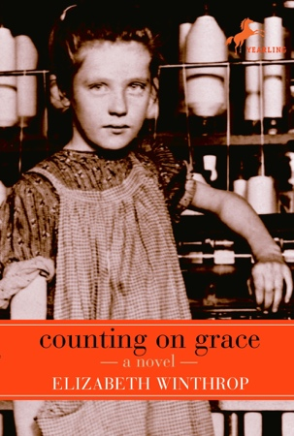 | Would you keep on working in a job you hate just because you want to satisfy your parents, keep your family as a whole and help them pay off their debts? Or would you rather be responsible for yourself and break out from your family’s pathway and try to pursue your own dreams? If only it was that easy…
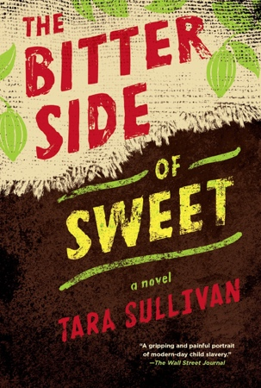 | Among other children you have to work the whole day under horrific circumstances and get locked up in a hut over night. One night you have the chance of a lifetime to flee with your wounded brother. Would you seize this opportunity and run or put yourself in danger of getting caught in order to hopefully liberate your fellows too?
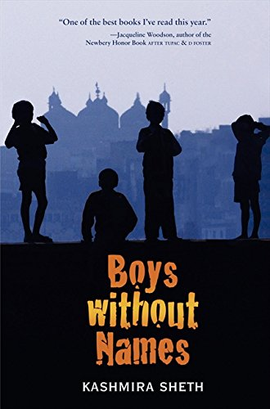 | Your new home is as tricky as promising. But instead of holding a better life for you, the new city life turns out to be even worse than before. Escaping from the sweatshop you and five other boys are trapped in is your only wish. Would you really take any opportunity to get back to your beloved family or would you stay and help the other kids as well?
While waiting for our books to come …



2.
Your task now is to write down your personal expectations of your choice of novel. Use the information you have so far and let your creativity run wild.

I’ve chosen ....... because… I hope that… I wonder if… I bet… I (don’t) think that…

___________________________________________________________________________________________________________________________________________________________________________________________________________________________________________________________________________________________________________________________________________________________________________________________________________________________________________________________________________________________________________________________________________________________________________________________________________________________________________________

… while reading …

3.
While enjoying the book you chose, highlight the passages you find particularly important. For future tasks in class, please look for two types of passages specifically:

A) Highlight passages that describe your protagonist’s personal life.
For example, where does your protagonist live? What do they eat? What is their goal in life? What is their daily routine? Do they have a hobby? With whom do they socialize with? Whom do they trust? What are their strengths and weaknesses? How do they cope with difficult situations?

B) Highlight passages that describe your protagonist’s labor.
For example, what is your protagonist’s job? What do they do exactly? What are the working conditions? Why do they have to work? How long do they have to work?

4.
Find five good expressions that you would like to remember and fill in vocab-cards from them. There will be time in class for sharing them with your class-mates.

Phrase: | Memory hook:
Sentence I found in my reading:

Second example sentence from my dictionary:

Useful collocations:

… after reading.

5.
Look for a partner who read a different novel and compare your protagonists’ personal lives and find the common core as well as the differences. Enter your findings into a Venn diagram. Please use a separate sheet to draw a full-page diagram.

6.
Look for a partner who read the same novel and create a job advertisement that describes your protagonist’s field of work and the working conditions.


We are hiring! Join our team!

7.
Do a bit of research and create one fact sheet about child labor in the country where your novel is set. Add a definition of child labor that you find accurate. (Work in groups of three.)

Tips: The fact sheet “Introducing the Problem: Child Labor” which we read in class can serve as an inspiration. Scan the following QR code for useful links.


8.
Choose one of the following writing tasks. Your text should consist of approximately 350 words.

A) Write a newspaper article about an event in your novel! You can find a guidance and useful tips for writing a professional article in the writing section of your textbook.

B) Be creative and re-write the ending! Indicate in which line on which page your alternative ending begins.


9.
Do you think that you possess products or objects which were produced by child labor?
At home, browse through your stuff and if you find a thing which could be produced by child labor bring it to class or show us a picture of it.


