Reading project
Diversity – Interpersonal Differences
Books
The Absolutely True Diary of a Part-Time Indian – Sherman Alexie
Perks of Being a Wallflower - Stephen Chbosky
Wonder - R.J. Palacio
Felix Ever After – Kacen Callender
Pertl David
david.pertl@edu.uni-graz.at
11823878

Pickl Georg
georg.pickl@edu.uni-graz.at
11813758
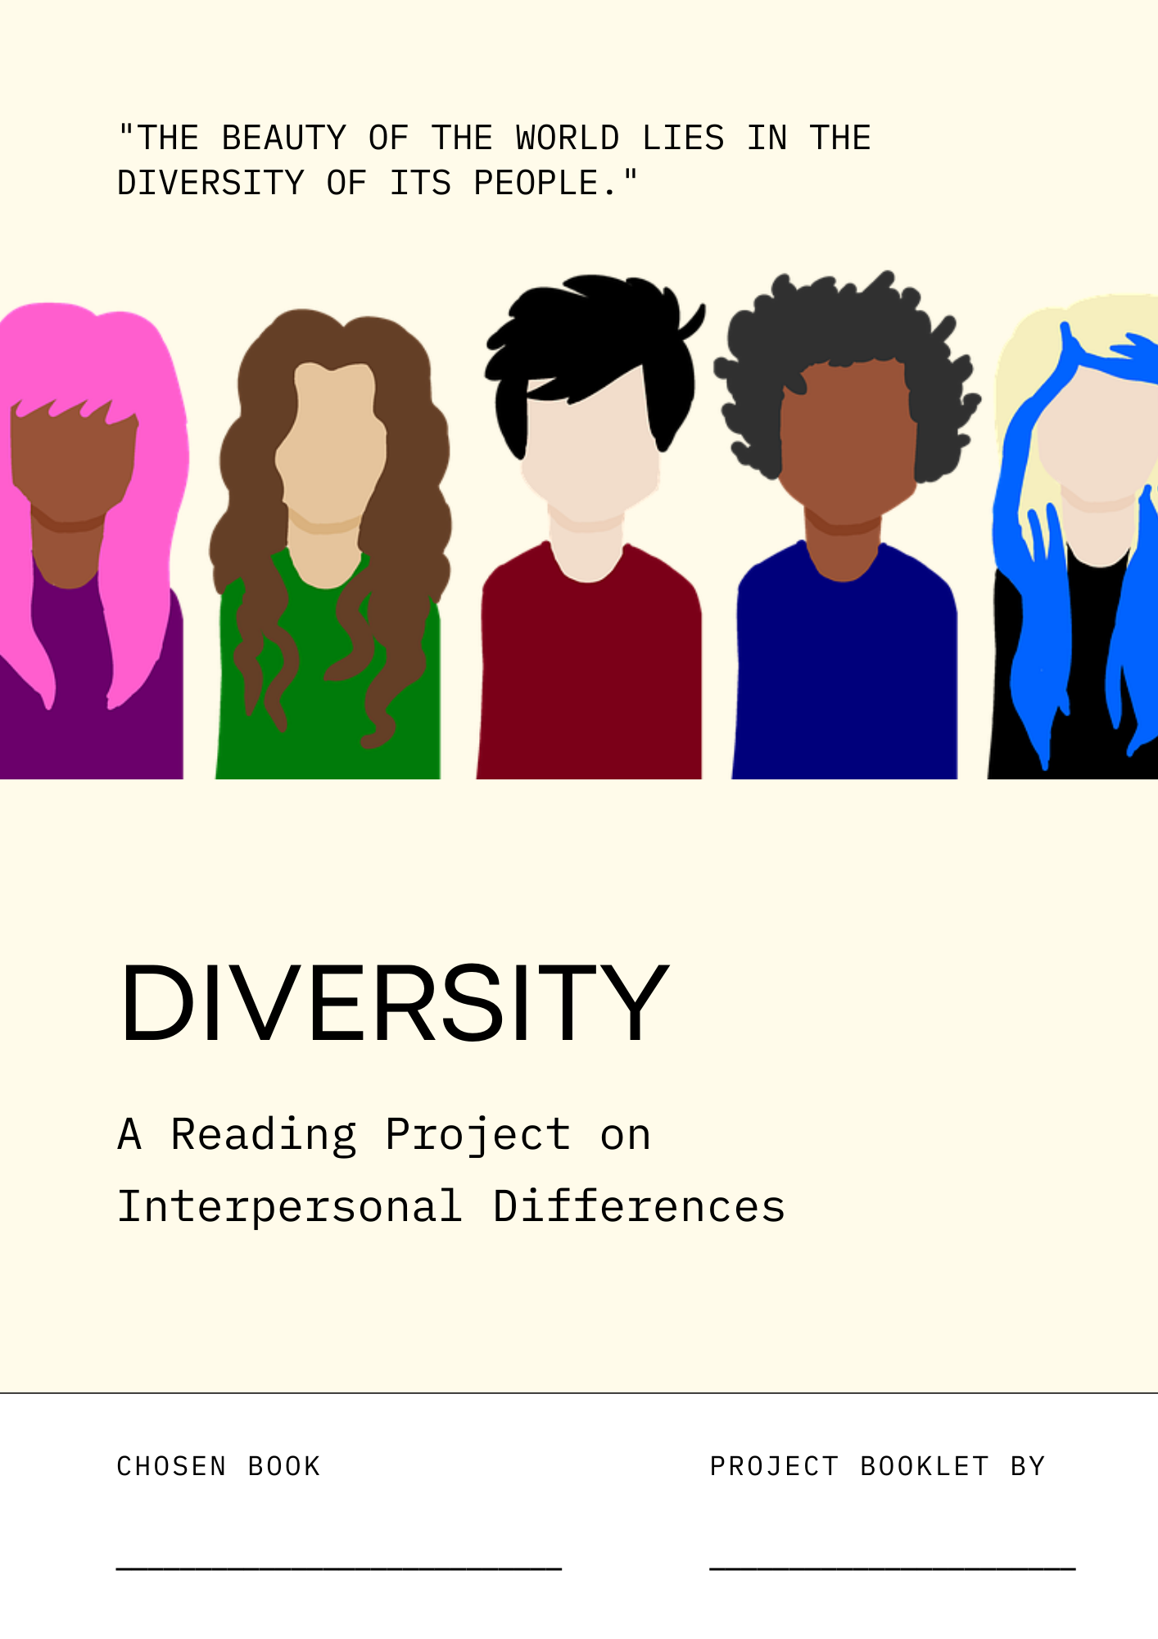

TEACHER’S PAGE

DELETE THIS PAGE BEFORE PRINTING THE BOOKLET

Topic | Diversity – Interpersonal Differences
Books | The Absolutely True Diary of a Part-Time Indian – Sherman Alexie  Perks of Being a Wallflower - Stephen Chbosky  Wonder - R.J. Palacio  Felix Ever After – Kacen Callender
CEFR Level | B1
Recommended Grades | 9th-10th
Further Information | Wonder and The Absolutely True Diary of a Part-Time Indian are simpler and could also be done in an 8th grade class, while Felix Ever After and Perks of Being a Wallflower are a little more challenging.  In case some students are uncomfortable with certain topics, all books and respective warnings can be found on https://www.doesthedogdie.com/
Copyright | Unless specified otherwise, all pictures used have been taken from Pixabay and are therefore in the public domain.

Contents
TEACHER’S PAGE 2
BOOK CHOOSING 3
10-MINUTE FREE-WRITING ACTIVITY 5
ALL THAT WE SHARE 6
HOMEWORK: 5-MINUTE FREE-WRITING 7
DIVERSITY 8
DIFFERENT BUT THE SAME 9
TEXT MESSAGES: SPECIAL MOMENTS 10
CASTING: SPECIAL PEOPLE 11
PUTTING PEOPLE INTO BOXES 12
THE JINGLE TO YOUR LIFE 13
DIARY ENTRY: STUDENT EXCHANGE 15
STYLISTIC CHOICES 16
TURNING POINTS: WHAT IF …? 17
YOUTUBE VIDEO: 5 THINGS I’VE LEARNED … 19

ALL THAT WE SHARE

Before you start reading your book, we are going to watch the TV ad “All that we share”.
Then write the following letter:

Letter to a friend: Putting people into boxes
https://youtu.be/jD8tjhVO1Tc
Write a letter to one of your friends about a time you were put into a box.
- Explain what kind of ‘box’ it was.
- Describe how it made you feel.
- Reflect if putting people into boxes is a good thing.
Write 250-300 words.

DIVERSITY

Take out your phone and find what the term ‘diversity’ stands for. Choose information that you think is important and relevant.

Write down your findings on this page. You’ll be later put into groups with your classmates to discuss your findings.

In your groups, come up with a one-sentence definition of diversity and write it down below. Your definition should include as much relevant information as possible.

BOOK CHOOSING

Choose a book
Look at the available books. Read the back cover and the first two to three pages of each book. Count the number of words you don’t know on each page. Can you guess their meanings? Is there anything else you notice about the book?
Use the questions below and write your findings down in the table on the next page.

- What type of book do you think it is? Is it romance, fantasy, mystery, science fiction or something else entirely?
- What do you think the book is about?
- What is the setting of the book like?
- Which characters will you meet in the book?

Which of the books would you like to read? Give each book a rating from 1-3 stars ★★★, depending on how interesting they seem. Then, decide which book you want to read. Write your first, second, and third choice on a piece of paper and give it to your teacher.

Get ready: Make predictions
While you wait for your book to arrive, think about what might happen in your book. We will do a 10-minute free-writing activity. Write down what you expect from the book into your reading diary. Use the will-future. The following expressions are there to help you.

I expect that…
I fear that…
I (don’t) think that… …will…
I bet that…
I suspect that…

Homework

Read chapters ……………………………………… by ………………………………………
Read slowly and carefully and mark interesting passages. Choose 3 phrases that you want to remember and write them on vocabulary cards. Then, write a 5-minute entry (non-stop writing) about what you’ve read into your reading booklet.

Book title and  ★★★ | New words per page | Comments about the book
Type of book:

Plot prediction:

Setting:

Characters:

Type of book:

Plot prediction:

Setting:

Characters:

Type of book:

Plot prediction:

Setting:

Characters:

Type of book:

Plot prediction:

Setting:

Characters:

10-MINUTE FREE-WRITING ACTIVITY

What do you expect from your book? For 10 minutes, write down everything that comes to your mind. Don’t stop writing during these 10 minutes!

HOMEWORK: 5-MINUTE FREE-WRITING

What did you read in your homework chapters? For 5 minutes, write down everything that comes into your mind about these chapters. Don’t stop writing during these 5 minutes!

DIFFERENT BUT THE SAME

Your character is different from others in some respects, but they also have a lot of things in common with others. Complete the following Venn diagram with information about a) the differences between the protagonist and other characters and b) the things they have in common.
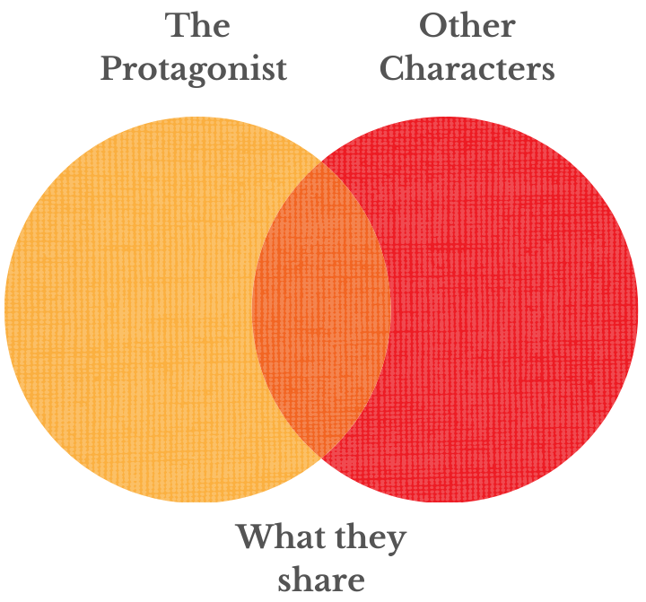

In case you have difficulties coming up with ideas, look at the ‘diversity wheel’ on the back cover of your booklet. It shows you categories that you can use for your comparison.

TEXT MESSAGES: SPECIAL MOMENTS

At first, your character doesn’t always feel like they fit in. However, they live through special moments that make them feel like they belong. Pick one such moment from your book. Imagine your character texts one of their friends, telling them everything about this moment. Come up with a text-message conversation between them and write it down below.

(Add more text bubbles.)

CASTING: SPECIAL PEOPLE

Your character interacts with a lot of different people who play an important (positive or negative) role in their life.

Imagine there was a film about your book, and you got to pick the actors playing the most important characters. Add photos/drawings of the actors you would cast for the different roles. Then explain why you would choose these actors in a few sentences below the photos/drawings.

THE JINGLE TO YOUR LIFE

We often relate music to special events in our life.

Create a playlist for your character that includes 8 songs you think fit in well with what your character has lived through. List the songs you’d choose below (artist + title) and explain (in a short paragraph) why you’ve chosen them.



PUTTING PEOPLE INTO BOXES

The TV ad you dealt with in the first task of this project showed us that we share a lot of things even though we might often be put into different boxes.

Think of 8 inclusive ‘boxes’ that you could put many different characters from your book in. Choose boxes that bring together characters that seem very different at first. Name the boxes and add the names of the characters that fit into this box.

DIARY ENTRY: STUDENT EXCHANGE

Imagine that your main character takes part in an exchange project and comes to your school.

Write a short diary entry from your character’s perspective in which they reflect on this first day at your school. Think about the following questions:
How did they feel when entering the school? How were they introduced? How did other people/the teachers treat them? What classes did they have? What was new/interesting/weird/exciting? What did they notice about the teachers?

TURNING POINTS: WHAT IF …?

Every life - and every story - has its ups and downs. Your character goes through easier as well as tougher times. There are a couple of ‘turning points’ in your story, i.e. points in the book that change the course of the story and help your character get to where they finally are.

Think of 5 such turning points in your story. Then imagine what would have been different if your character hadn’t gone through these turning points.

Write short paragraphs about these turning points that follow this model:

EXAMPLE (CINDERELLA)
Turning Point: Cinderella loses her shoe at the ball and the prince finds it.
What if…?: If Cinderella hadn’t lost her shoe at the ball and the prince hadn’t found it, he would have probably had a professional artist draw a picture of her. He would have described all the details he remembered to the artist. The ‘wanted’ picture would have been put up everywhere in town and the prince would have given a lot of money to the person who found Cinderella.

1
2
3
4
5

STYLISTIC CHOICES

Your book is full of new and interesting language. Some of the language can be characteristic of a certain author.

Now you’re the style critic:
- Pick 10 words from the book that are new to you and that you really want to learn. Add these words below and to your vocab journal.
- Then pick 5 words or phrases you think are special to your author. For each of those, write 1-2 sentences and explain why you think your book’s author might use them. How did they make you feel? Did they give the text a certain quality?

YOUTUBE VIDEO: 5 THINGS I’VE LEARNED …

Your character has gone through a lot throughout the whole book, but they’ve also grown a lot as a person.

Imagine they have decided to start a YouTube channel to share their experience with the world. Put on your character’s role and record a video (on Flipgrid) in which you tell your audience about the 5 main things you’ve learnt through everything that’s happened to you. Your video should be around 3-5 mins in length.

You can use this page to take notes on what you want to say.

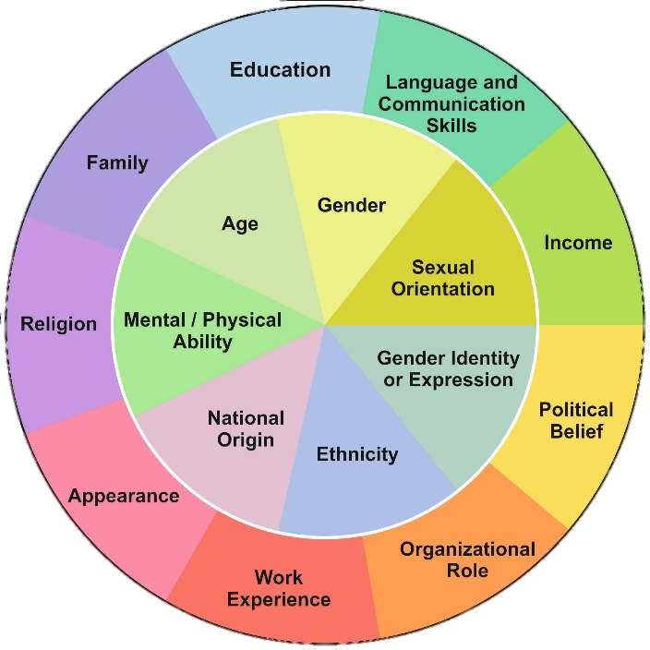
Picture: https://www.ejmste.com/download/learning-to-teach-at-heterogeneous-and-diverse-chemistry-classes-methods-for-university-chemistry-5552.pdf

