Four Books to choose from
The chosen book covers are only one version of many different designs.
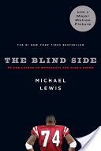
Blind Side: Evolution of a Game by Michael Lewis
Published in 2006
Movie: Blind Side, published in 2009

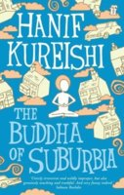
The Buddha of Suburbia by Hanif Kureishi
Published in 1990
Movie: The Buddha of Suburbia, published in 1993

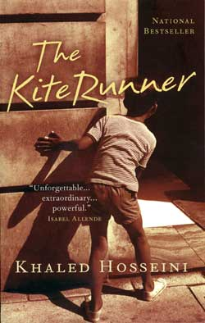
The Kite Runner by Khaled Hosseini
Published in 2003
Movie: The Kite Runner, published in 2007

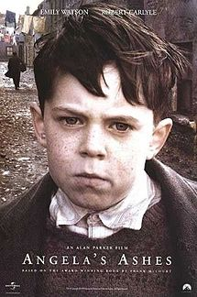
Angela’s Ashes by Frank McCourt
Published in 1996
Movie: Angela’s Ashes, published in 1999

Pre-Reading Activities

Brainstorming – Different Types of Migration
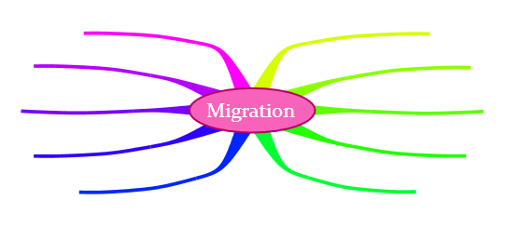
Go together with a partner and think about different types of migration that you might have heard in your geography classes. Create a mind map to illustrate your ideas. Then present it in class. The following mind map is an example you could use.

Why did you choose this book?
Choose one of the offered books on page 2 and then fill in the following figure. Think about the reasons why you chose your book and write the title into the middle box.
- The orange box: expectations about the book
- The grey box: issues and aspects you do not want to read about
- The yellow box: reasons why you have chosen your book
- The blue box: how would you change the cover of the book so that it is more appealing to you

Cultural Differences and Expectations

Task a)
Go together with the people who have chosen the same book. After reading the plot summary on the back of your book make a list of cultural aspects. Search the web for cultural values, traditions etc. (e.g. country – country, social class – social class). You can also add your personal knowledge.

Task b)
Use the list to consider your expectations concerning the main character and the cultural differences the protagonist might struggle with. Write a short text (max. 200 words) about the main character. You could consider the following questions:
- What problems might the main character have?
- Which cultural values might be different to the main character’s origin?
- …

While-Reading

Unfamiliar Vocabulary
While reading the book you might come across a lot of unfamiliar words and phrases. Fill in the words in the following chart and also include the sentence in which you found the word. Do not forget to find a translation in a dictionary. You have to complete this page, if necessary, please, extend it.

Unknown Word | Example Sentence from the Book | Translation

Timeline of the Protagonist
Here you can see the process of growing (up) of your protagonist. Growing up does not only mean age wise, but also mentally and socially. While reading your book, divide this timeline into stages, which are important for the protagonist’s development. Include important situations and events and mention the page number in brackets.



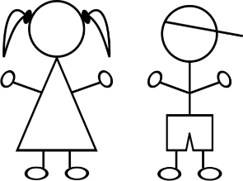

Chapter Summary Pie
After finishing a chapter, summarize this part of the book with such a “Chapter Summary Pie”. Include the five most important events that you helps you remember the story. Create a pie for each chapter and add it to your reading diary.

Post-Reading Activities


Letter to the Editor
Imagine you are the book’s protagonist who criticizes the recent issues in the European migration politics. Refer to at least one newspaper article about refugees in Europe which was published lately. Write a letter to the editor and state your situation and what you have experienced. Further, include your own ideas which might help European countries to handle the actual situation more efficiently. Do not forget the formal criteria of a letter to the editor! Use a separate sheet for this task. (Maximum 400 words)

Collage
After having read your book, go together in your book groups and design a collage that represents the storyline of your book. The aim is that the people who have not read the book can imagine what the book is about. You can use newspapers, pictures from the internet, magazines and other sorts of material. Present your creative work to the class.
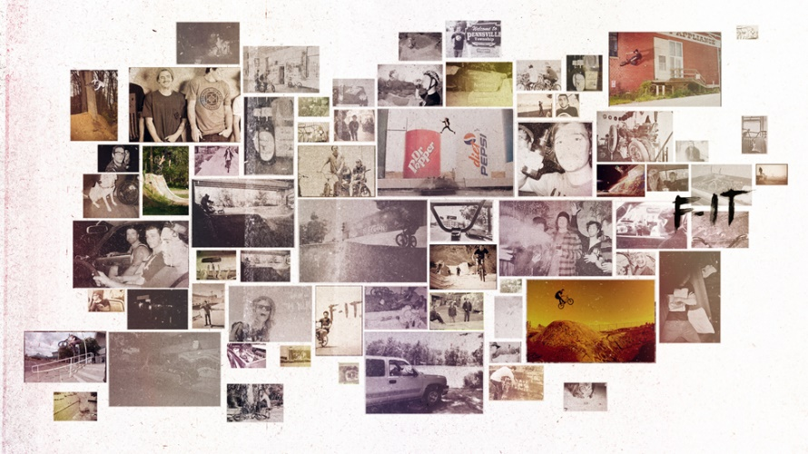

Reviews
Watch the movie of your book and come up with some differences or similarities between your book and your movie. Include these aspects into a written review where you also mention a recommendation. Give reasons for your argumentation and do not forget the formal guidelines for a review. Evaluate the movie and the book separately and give them a maximum of five start:

Book

poor excellent

Movie

poor excellent

Review:

