READING PROJECT - OUTSIDERS
  - PS 4 Teaching Culture and Literature/ WS 2015/16/ Anja Behofsits and Heike Holli
Table of Contents
Teacher’s Notes 1
1. Pre-Reading 3
1.1 Identity – What makes you special? 3
1.1. Identity – What makes you special? 4
1.2. Being Unique 5
2. Book choosing 6
3. While-Reading Activities 8
3.1. Vocabulary 8
Category 8
4. Post-Reading Activities 9
4.2. Being Different 9
4.3. Big Trouble, Sad Experience and Happy Moment. 11
4.4. Help me! 12
4.5. Main characters 13
4.6. Supporter and opponent 14
4.7. New student 15
4.8. Time Travel 16
5. Presentations 17
Tasks: 17

Teacher’s Notes
This reading project should teach students the concept of identity and raise awareness of how it feels to be an “outsider” in a community. The books provide insights into the minds of the “outsiders” themselves but also from outer points of view. The outcome should be that students rethink the way they treat people they see as special and that they understand that everybody is unique in their own way.
Age Group/Level: 5th grade (15-16 years), Level B1-/++
Books:
- Butter - Erik Lange (main theme: obesity; level: relatively easy to read)
- Looking for Alaska - John Green (main theme: coming of age; level: for advanced readers)
- Stargirl - Jerry Spinelli (main theme: popularity, level: easy to read and short)
- The Perks of Being a Wallflower - Stephen Chbosky (main theme: uniqueness, l: advanced)
- Wonder - R.J. Palacio (main theme: outer vs. inner values; level: relatively easy to read)
READING PROJECT: OUTSIDERS



- Butter - Erik Lange
- Looking for Alaska - John Green
- Stargirl - Jerry Spinelli
- The Perks of Being a Wallflower - Stephen Chbosky
- Wonder - R.J. Palacio

This booklet belongs to:
The book I chose:

Pre-Reading

Identity – What makes you special?
Describe yourself and your personality by drawing or writing into the silhouette below. Try to answer the following questions:
- Who am I? (Character, look, hobbies, interests …)
- What makes me special?


Discuss with a partner:
- What do you have in common?
- How do you differ?
- What makes you special?

Identity – What makes you special?
Describe yourself and your personality by drawing or writing into the silhouette below. Try to answer the following questions:
- Who am I? (Character, look, hobbies, interests …)
- What makes me special?


Discuss with a partner:
- What do you have in common?
- How do you differ?
- What makes each of you special?

1.2. Being Unique

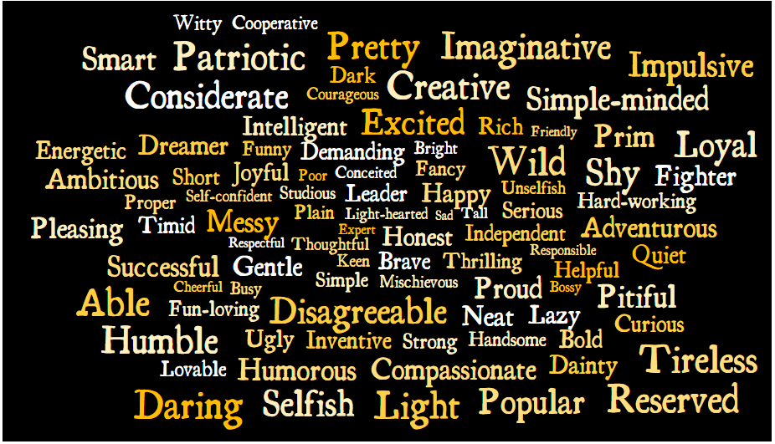
Make Top-Five Lists: What are the most important and what are the least important traits you value on a person? Use words of the picture or come up with your own:
Most Important: |  | Least Important:
1. | Category: | 1. | Category:
2. | Category: | 2. | Category:
3. | Category: | 3. | Category:
4. | Category: | 4. | Category:
5. | Category: | 5. | Category:

- Get together in groups of four and compare your lists. Try to categorize the chosen words: do they describe a person’s character or look? Which category occurs more often?

- Together decide on one word which describes yourself the best:

Book choosing
You are handed out the cover and the first two pages of four different books. Read through them to get an impression of what the book will be about. How many new words are there on each page? Can you guess their meanings? What else do you notice?
- What type of book is it and what do you think the plot will be about? Make a one-sentence prediction for each book.
- Who do you think are the important characters? What makes them special?
- Where do you think the story takes place?
Book title and author | ☺☺☺ | Other comments about the book
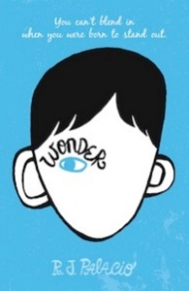  Wonder  R.J. Palacio |  | Type of book:  Plot prediction:  Characters:  Settings:
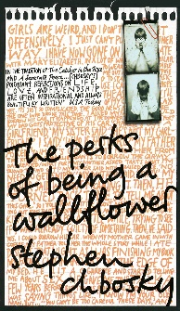  The Perks of Being a Wallflower  Stephen Chbosky |  | Type of book:  Plot prediction:  Characters:  Settings:
  Looking for Alaska  John Green |  | Type of book:  Plot prediction:  Characters:  Settings:
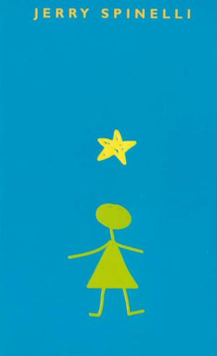  Stargirl  Jerry Spinelli |  | Type of book:  Plot prediction:  Characters:  Settings:
  Butter  Erik Lange |  | Type of book:  Plot prediction:  Characters:  Settings:

While-Reading Activities

3.1. Vocabulary
Write down the letters of the title of your book vertically. While reading, you will come across new vocabulary and expressions. Pick one word or expression for each letter of your title which sounds interesting and that you think will be useful to you. Write down the vocabulary item you want to remember and give an explanation of the new expression in English. (Note: for Perks of Being a Wallflower may either choose Perks or Wallflower)

Category
Try to fit your chosen words into categories you select. Use a variety of categories and try to be unique!
Category | Words, Phrases

Post-Reading Activities

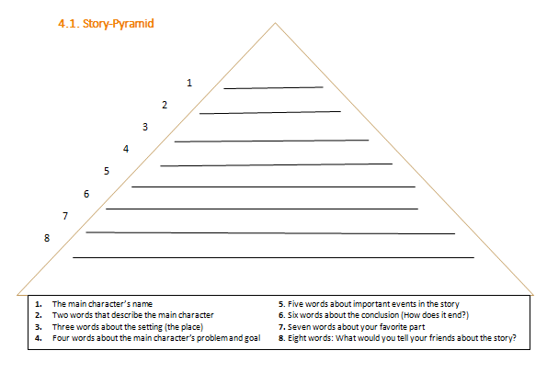

4.2. Being Different

Actions and Reactions.
Get together in your book group. The main character of your book is different and he/she sticks out of the mass.
- Try to point out what it is that makes him/her unique.
- How does the social environment react towards the main character? Are there positive or negative reactions? Do the reactions change?
- How does the main character react towards the social environment? Does he/she seal themselves off or do they try to fit in?

Main Character

Actions Reactions

Social Environment

4.3. Big Trouble, Sad Experience and Happy Moment.
Feelings and Reading.
Prepare the following tasks carefully. Choose two out of three scenes from your book:
- Big trouble: Find one scene in which the main character or one of the main characters gets into trouble
- Sad experience: Find one scene in which the main character or one of the main characters experiences a very sad moment.
- Happy moment: Choose one scene in which the main character or one of the main characters is experiencing something happy.
Practice reading these two passages using the fitting intonation and emotions. Get together into your reading group and read out your passages to one another.

4.4. Help me!

Email writing.
Your character is in a desperate situation. That’s why he/she has written to ‘Teen Line’. As he/she cannot cope with the situation by themselves anymore they decided to seek help and advice of professionals. Go to https://teenlineonline.org/talk-now/ and familiarize yourself with the homepage and find out how they might be able to help you.
Write an email or letter from your character’s point of view. Make sure to include the following information:
- Explain your current situation. What is your problem and how did you get into this mess?
- Why have you decided to contact them now? Have you already talked to someone else about the situation?
- Ask for advice and support in order to improve the situation.
Write an email of about 250 words.
_____________________________________________________________________________________________________________________________________________________________________________________________________________________________________________________________________________________________________________________________________________________________________________________________________________________________________________________________________________________________________________________________________________________________________________________________________________________________________________________________________________________________________________________________________________________________________________________________________________________________________________________________________________________________________________________________________________________________________________________________________________________________________________________________________________________________________________________________________________________________________________________________________________________________________________________________________________________________________________________________________________________________________________________________________________________

4.5. Main characters
Venn Diagram.
Get together with a person who read a different book as you. Compare the situation of the main characters of your books – what do they have in common and how do they differ?

My book: ____________

Book 2: __________

4.6. Supporter and opponent
Sociogram.
In the course of the novel your main character meets a lot of different people. Some of them support him/her, some don’t. Some help to build him /her up while others bring him/her down.
Give examples of supporters and opponents and create a sociogram of these characters. Additionally, find some characteristics and information in the book that describes those characters and their behavior.

4.7. New student
Diary writing.
Imagine that the main character of your book comes to your school.
Write a diary entry of your first impressions and thoughts of the person. Describe what you noticed about him/her in the first place. Do you think your main character is a nice person who could possibly become your friend? Why/Why not? Did you talk to him/her? What were the other students’ reactions to the boy/girl?
To make you diary sound authentic you may include names and places known to the whole class: E.g. …. When I came into our class room Kevin, Drago and Julian, were already in a vivid discussion about something.
____________________________________________________________________________________________________________________________________________________________________________________________________________________________________________________________________________________________________________________________________________________________________________________________________________________________________________________________________________________________________________________________________________________________________________________________________________________________________________________________________________________________________________________________________________________________________________________________________________________________________________________________________________________________________________________________________________________________________________________________________________________________________________________________________________________________________________________________________________________________________________________________________________________________________________________________________________________________________________________________________________________

4.8. Time Travel
Reflecting.
Think about one of the main characters in the novel you have just read. Think of their actions, decisions and opinions. Do you disagree with any of them? Fill in the following diagram and explain what you would have done differently and how this would have influenced the story.
My point of view:
What I would have done:
Character’s name:
Actions/decisions:

If ………….. had ………………….

Presentations
For your final presentations of the reading projects choose one of the following tasks out of each category. Each student of your group must do a different task and category. Discuss which of these tasks are the most meaningful in connection with your book. Try to choose tasks which complement each other so that the presentation gives a full overview of the book that you have read. (Main themes, characters, background, style of the novel)

Tasks:
Plot:
- Plot Diagram: Draw a “fever curve” of the ups and downs in the noveland label the curve. In the presentation use your own words to explain each of the events briefly.
- Plot on the Line: Split up the story into 7 – 10 main events and write or draw them onto separate sheets. or your presentation hang up one picture after the other using clothes pegs and a string or stick them on the board. Talk about each picture but don’t give away the ending!
- Present an alternative book cover: be sure the illustration relates to an important aspect of the book and explain why it is fitting for the book.
- Act out a scene: Use simple props and costumes to act out an important scene of the novel. (Best combined with Plot Diagram or Plot on the Line!)
Characters:
- Character profiles: Look at the different levels of the main characters’ personality and complete the profile circles. (attached below)
- Sociogram: Choose a symbol representing each of the main characters of the book and draw a sociogram showing the relations between the characters. (close friends, rivals, family members, enemies …)
- Identity Bags: Bring a bag full of objects which are important for the main character of your book. Show them and explain their relevance.
Setting:
- Draw a map: Collect the locations in your novel to draw a map for the setting of your book. Attach a legend and explain the importance of each of the places mentioned on the map.
- Create a pop-up or a painting: These should show the most important locations of the book. Explain their relevance for your novel.
Additional ideas:
- Design a board game: Make a board using the setting, plot line and events of the novel and design task cards or fields.
- Make a novel museum: Display 10-15 items that play a role in the book. Act like tour-guides and present the artifacts to the class. Explain the relevance of each item.
- Come up with your own ideas and talk to your teacher about them (:

Attachment:
Character profile
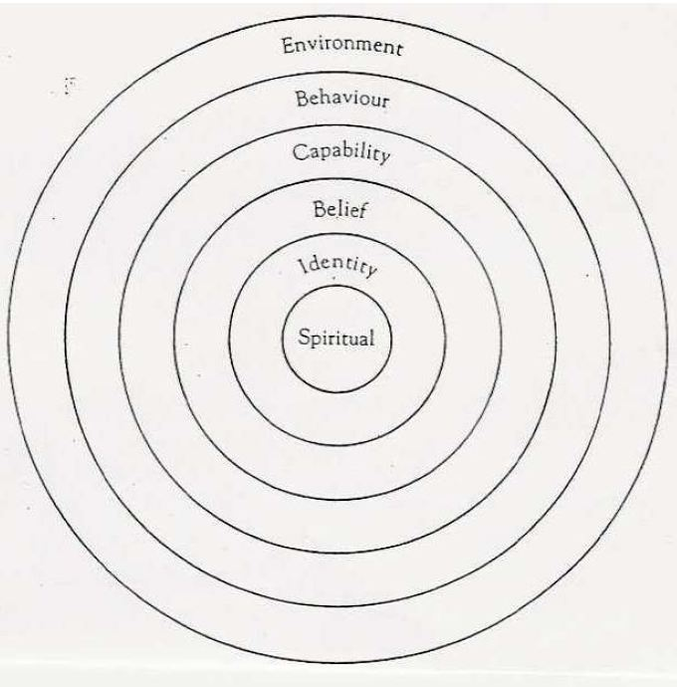

All activities in Chapter 5 are taken from the course handout of PS4 Teaching Literature and Culture by Elisabeth Pölzleitner and were slightly adapted (p.64-68)

