

Dear student,
I am your reading booklet and I am looking forward to being your guide on this reading journey.
I am full of fun pages that are waiting to be completed with your help. Read through my instructions carefully and try to do the exercises to the best of your abilities.
After you have read your book, please design a new cover for me. Feel free to be as creative as you want by using drawings, photos or quotes from the book. I love colour!
If you need any help, you can always ask your teacher.

Best wishes and good luck,
Your Booklet

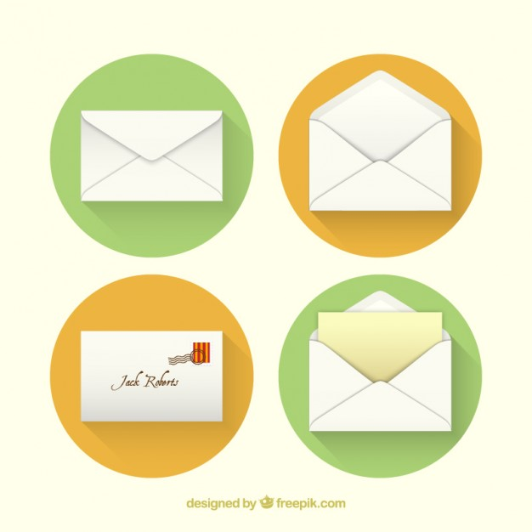
Envelope – content clues:
Get together with the other students who have chosen the same book as you and open the envelope. Look at the seemingly random pictures and discuss what meaning they could have in the book. Note down your predictions! Get creative!
1.………………………………………………………………………………….…………………………………………………………..……………….………………………………………………………………………….………………………….……………………………………………………………………………………………………………………………………..……………………………………….……………………………………… ………………………………………………..…………………………………………………….…………
2…….……………………………………………………………………………….………………………………………………………………………….……..….....………………………………………………………………….………………………………………………….………………………….…………………………………………………………………………………………….……………………………..……………………………………….………………………………………………….………………………………………………………..
3.…………………………………………………………………………….………………………………………………………………………….………………………..………………………………….....……………….…………………….……………………………………………..……………………………………….…………………………………..………………….………………………………….……………………………………………………………………………………………………………………………………………….………………
4.……………………………………………………………………………….………………………………………………………………………….………………………………………………………..………………….………………………………….……………………..…………………………………………………………………………………………………………………………………….……………………………………….………….………………………………………………….………………………………………..………………………..
5.………………………………………………………………………………………………….………………………………………………………………………….………………………………………………………………………….……………………………………..………………………………………………………………………………………………………………...…………………….………………………………………………….………………………………………………………………………..……….……………………………………
After reading the book, read through the predictions you have made again and write down what the actual meaning of the pictures/items is in the book and what significance they have for the story.
1.………………………………………………………………………………….…………………………………………………………..……………….………………………………………………………………………….………………………….……………………………………………………………………………………………………………………………………..……………………………………….……………………………………… ………………………………………………..…………………………………………………….…………
2…….……………………………………………………………………………….………………………………………………………………………….……..….....………………………………………………………………….………………………………………………….………………………….…………………………………………………………………………………………….……………………………..……………………………………….………………………………………………….………………………………………………………..
3.…………………………………………………………………………….………………………………………………………………………….………………………..………………………………….....……………….…………………….……………………………………………..……………………………………….…………………………………..………………….………………………………….……………………………………………………………………………………………………………………………………………….………………
4.……………………………………………………………………………….………………………………………………………………………….………………………………………………………..………………….………………………………….……………………..…………………………………………………………………………………………………………………………………….……………………………………….………….………………………………………………….………………………………………..………………………..
5.………………………………………………………………………………………………….………………………………………………………………………….………………………………………………………………………….……………………………………..………………………………………………………………………………………………………………...…………………….………………………………………………….………………………………………………………………………..……….……………………………………


My Views – Their Views
friendship | school | family
hopes | support | self-confidence
Each of the following key words has a special meaning for the main protagonist of your book. Before you start reading, write down what they mean to you, give an example from your life or say how they make you feel in the first row. Once you have read your book, you can write down what these things mean to the main character(s) of the story in the second row.
Speech-Bubbles
While reading, collect interesting quotes and fill the speech bubbles with them!


Vocabulary
While reading, note down at least 20 new cool words or phrases
you come across and explain what they mean!
Facebook page
Design a facebook page for one of the characters in your book! Try to include information about them from the book. Use your imagination for things that were not mentioned in the book!
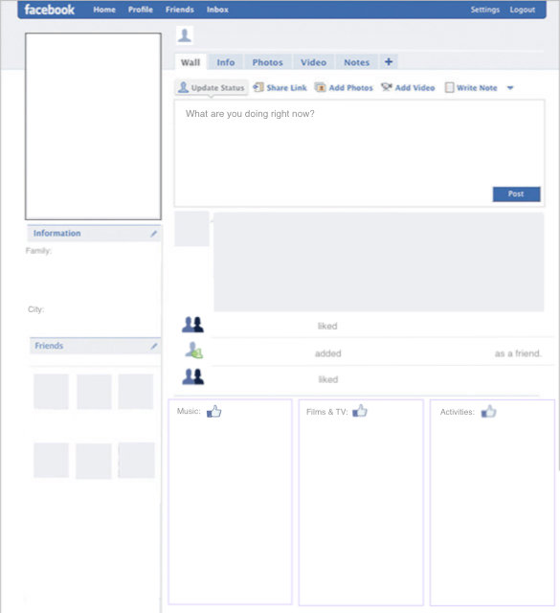

Story Pyramid

Fill in the story pyramid by answering the questions below.

1. _____________________________
2. ___________________________________
3. _______________________________________
4. ____________________________________________
5. ________________________________________________
6. _____________________________________________________
7. __________________________________________________________
8. ______________________________________________________________

1. Who is writing the letters?
2. What is the most important event in the story?
3. Which three words would you use to describe the setting?
4. Which four words would you use to describe the main character(s)?
5. What is the main characters'/character’s problem/goal? Find four words.
6. What are six words to describe the ending of the story?
7. What was your favourite part? Use seven words.
8. What eight words would you tell your friends about the book?
Adapted from: http://fall10edu404a.providence.wikispaces.net/Post+Reading-Story+Pyramids-Gilchrest [05.06.2018]
Postcard

Write a postcard to the book’s author(s) and tell them your honest opinion and give a short review of the book. What did you like most? What did you not enjoy? And why? Tell them about the impact their story might have had on you. In addition, create a suitable and creative design on the front of your postcard!
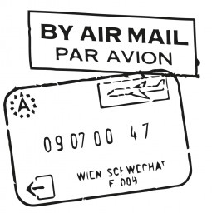
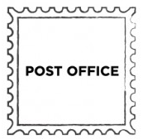


Venn Diagram
Get together with a partner who has read a different book. Give your partner a quick plot overview of your book and then let your partner explain the plot of their book to you!

Discuss and find out what the two books have in common and in what way the stories differ. Possible discussion questions: To whom are they writing letters? Do they have the same reasons to write them? What role does friendship play in the novel? Collect your answers in the Venn diagram on the next page and don’t forget to write the titles of the books on top.
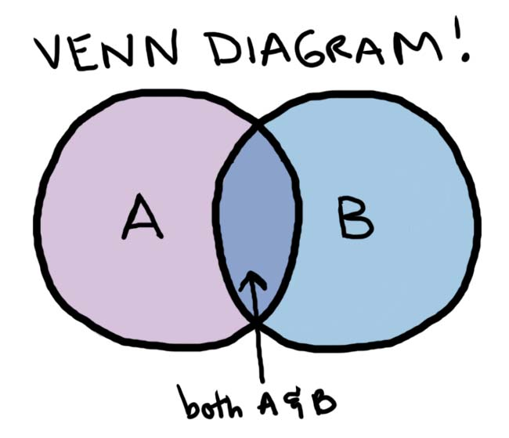

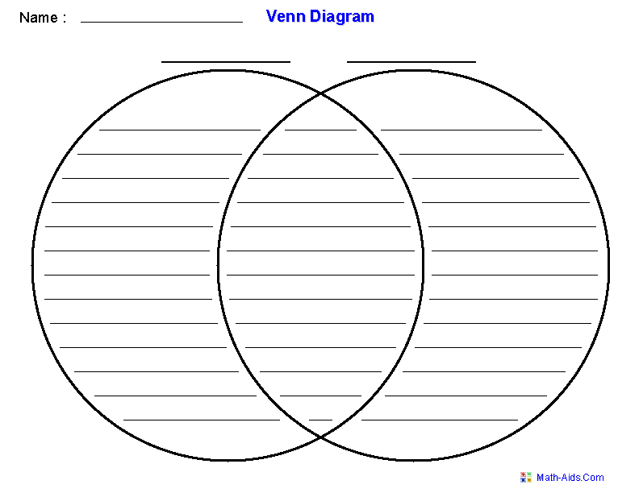


Writing letters
Choose one of the following tasks:
Letter of advice (300-350 words): Think of a point in the book in which the protagonist or one of the protagonists were in a very complicated situation and felt hopeless. Imagine you are writing a letter or email to them to give them advice!
Refer to some of the highs and lows of the character’s story and make some suggestions what they could do. Think about how you could cheer them up and give valuable solutions to their issues!

or
Future Letter (300-350 words): Imagine you are one of the pen pals in the book and you have not been in contact with your friend for 5 years. A long time has passed since you last wrote each other and you want to reach out again to your former dear friend. Explain why you think the respondence declined, tell your pen pal what has changed in the meantime and what your life looks like now. Don’t forget to ask questions about what you would like to know and refer to the memories you share!

Book presentations
Get together with the people who have read the same book as you and prepare a 10-15 minute long presentation about your book for the rest of your classmates.
Some things you could include in your presentation are…
plot diagram maps alternative book covers acting videos plot on the line identity bags music
Source: Pölzleitner, Elisabeth (2017). Teaching Literature and Promoting Intercultural Competence. Course Handout, p. 61-68.
Feel free to include any of your own ideas as well!
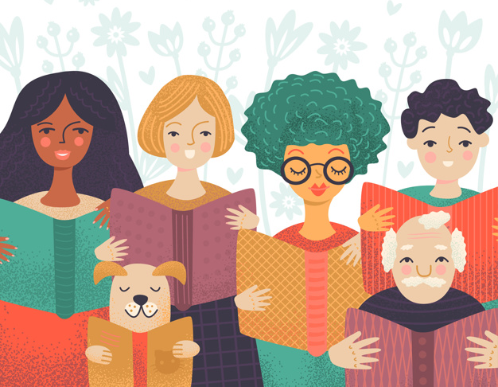

Presentation checklist:

- Plot – You explained the plot of the book but avoided spoilers.
- Characters – You introduced the main characters.
- Themes – You discussed the main themes of the book.
- Author – You briefly (!) introduced the author of the book.
- Personal Opinion – You stated your personal opinion on the book and what you liked/disliked/found special about it.
- Creativity – You used different tools and methods to make your presentation interesting.
- Fairness- You distributed the workload equally and everyone had a chance to speak.

(All pictures are from freepik.com)

