511.440 Fachdidaktisches PS 4:
Methodology of Teaching Literature and Culture
SS 2013
Dr.phil. Elisabeth Pölzleitner

READING PROJECT
‘MINORITIES’

handed in by:

Jelena Begenisic  1212384 | Bernadette Kurz  0312859  bernadette.kurz@edu.uni-graz.at
  jelena.begenisic@edu.uni-graz.at

June 10, 2013

Contents

Books for the ‘Minorities’ reading project
- The Absolutely True Diary of a Part-Time Indian by Sherman Alexie
- The House on Mango Street by Sandra Cisneros
- Black Boy by Richard Wright

Activities
Pre-reading:
- Choosing a Book
- My Cultural Autobiography

While-reading:
- Journal Entry
- Online Research

After-reading:
- In-Class Workshop Activities:
- Stereotype Detectives
- Differences and Similarities
- Character Profile
- Group Discussions
- Put Yourself in Someone Else’s Shoes
- Creative Booklets
- Presentations and Peer Assessment

Teachers’ Page

This project has been designed for students in year 5 or 6. It deals with three books whose protagonists are representatives of a minority group in the United States of America. Black Boy addresses the problems of the African-American population in the US during the 20th century while The House on Mango Street and The Absolutely True Diary of a Part-time Indian deal with contemporary problems of Hispano and Indian population respectively. Black Boy comes under the domain of adult literature while the other two books can be read as young adults novels, which make them appropriate for all age groups from 13 up. All three books feature a single protagonist and a multitude of minor characters, which gives prominence to only one perspective.
The aim of this project is that students become familiar with the problems of minorities in a society and think about the ways of solving racial conflicts and promoting tolerance. Since this is a project for mature students, it can be approached seriously and be dealt with cross-referentially in relation to students’ history or geography classes’ curriculum.

Choosing a Book
When it comes to choosing a book, your task as a teacher is to make copies of each of the books (approximately the number of 1/3 of the class number.). The copies should include the book cover, the first one to three pages and the blurb of the book from the last page, if there is one. In class, you should place the copies in three different piles and give your students about 5 minutes time to take a look at each of the books and decide which one they want to read. The groups formed around books will also be used for following activities. In case groups are too uneven in number, split the biggest group into 2 or 3 so that all of the groups count more or less same number of students. Once the students have chosen and ordered the book, you give them 2-3 weeks time to read it (two weekends). While the students are waiting for the books to arrive, they should write their cultural autobiographies (‘My Cultural Autobiography’).

Making sure everyone has got the book
For the class that precedes the book project start, assign the writing task ‘Journal Entry’ for homework in order to make sure everyone has got a copy of their book. You can discuss problems they have discovered in the book, but make sure you do not reveal too much of the book’s action. You can use the ‘What might happen’ sheet (see Appendix) for keeping them interested in the book
After the reading deadline has finished, get the students together in their groups. What follows are the ‘Workshop Activities and Discussions’, 2-3 classes should be dedicated to this.

Creative Booklets
For this activity, the teacher is supposed to create booklets out of blank paper (colorful paper can be used for some pages as well), size A5, with approximately 10 pages, that he/she is to hand out to the students and ask them to make their own booklet related to the book they read. If materials like newspapers, crayons, scissors and other creative tools are available in class, this task should be done as a block class and group work, i.e. in two hours. If this is not possible, the booklet should be created individually, started at school and finished as homework.
The teacher should also provide the students with ideas about what they could fill their booklets with. Our suggestion is that students choose as many activities as they could manage to do in the course of the class, for example:
- Alternative cover and the blurb
- E-mail to the author
- Newspaper article
- Plot diagram
- Other

Presentations
In the second or third class after everyone has finished reading the book, get the students back in their groups and discuss the ‘Presentations’ sheet with them. Explain how every presentation idea works and what it should include, what the advantages of that type of presentation are and what the disadvantages are. Give clear instructions about the length of the presentation and other requirements. The presentation should not be longer than 15 minutes and they should make sure that all group members are involved. Show them the ‘Peer Assessment’ sheet so they can see the criteria according to which they will be assessed.

Appendix: What Might Happen?

1st Chapter Summary

Scenario 1 | Scenario 2 | Scenario 3

Minorities: Reading Project

The Absolutely True Diary of a Part-Time Indian
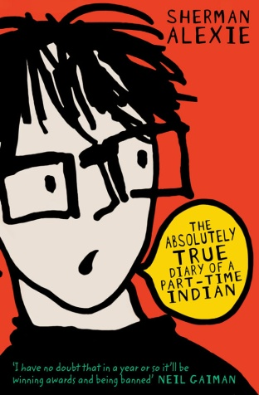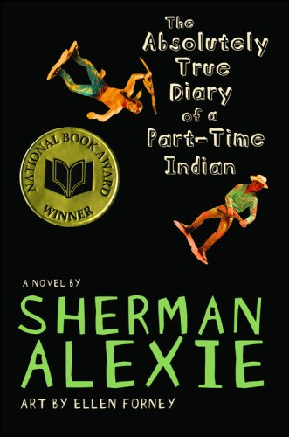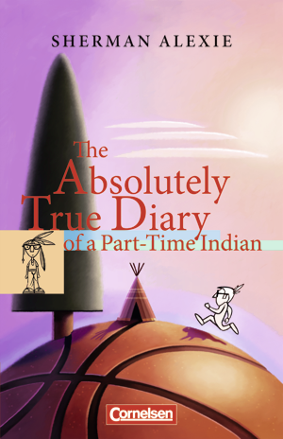

The House On Mango Street
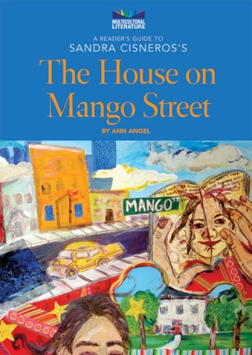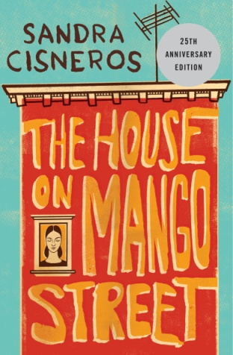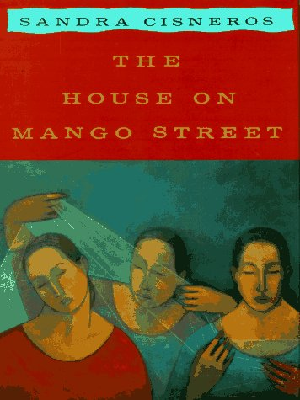

Black Boy
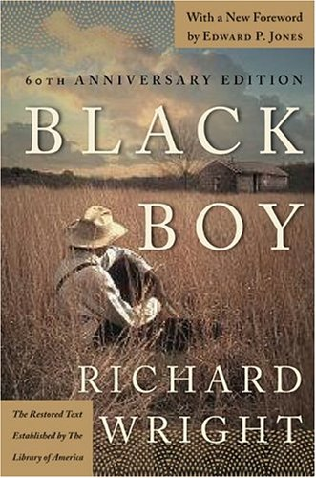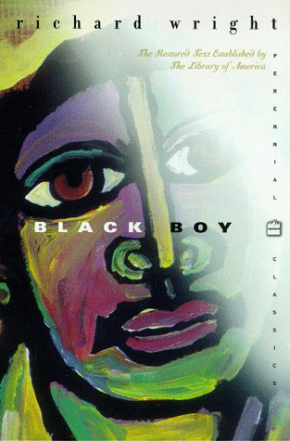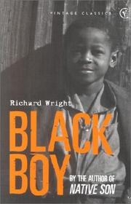

Choosing a Book

Take a look at each of the book copies provided. Read the blurb and the first couple of pages. Do you think the language of this book will be appropriate for you? What kind of book do you think this will be? Does it make you curious to continue reading? Make two or three predictions about the book:
- What kind of characters do you expect to meet?
- What will the setting be like?
- What kind of events will it present: fantastic, realistic, historical?
Write your findings in the table below. Then rate the books with one, two or three stars depending on how interesting they look. The book you would like to read the most, rate with . As far it is possible, you will be given your first choice.

Book title and | Other comments about the book
Type of book:
Plot prediction:
Characters:
Settings:
Additional notes:
Type of book:
Plot prediction:
Characters:
Settings:
Additional notes:
Type of book:
Plot prediction:
Characters:
Settings:
Additional notes:

My Cultural Autobiography

How would you define yourself? Think about things that are especially important to you in how you think about yourself and how you like others to see you. Think of your family background, your country, community, language(s), groups you belong to, activities that are important to you and so on. Use the table on the next page to see universally recognized criteria that determine someone’s cultural biography. Before you start writing, take a minute and have a look at new or unknown vocabulary from the list. Can you guess the meaning out of context? If you have problems look them up in an English-English dictionary and write down some typical collocations for these words or expressions. Then, use some of the keywords from the table to help you and write a text about yourself.

- Class  - Underclass  below poverty level, homeless  - Working class  lower middle class, blue collar  - Middle class  white collar and low-level managerial / administrative  - Upper middle class  professionals, high-level managerial / administrative  - Upper class  professionals, top-level managerial / administrative, inherited wealth and social status | - Race  - Caucasian (Whites)  - African American (Blacks)  - American Indian, Eskimo  - Asian / Pacific Islander  - Hispanic  - Other | - Ethnicity  - Western European  - Central / Eastern European  - Asian  - African  - Latino  - Other
- Gender / sexual orientation  - Male  - Female  - Heterosexual  - Homosexual  - Bisexual  - Transgender | - Language  - Monolingual  English / German … only  - Bilingual  English / German … as a primary language  - ESL  English as a second language  - Multilingual  fluent in more than two languages | - Religion  - Christianity – Protestantism  - Christianity – Catholicism  - Christianity – Other (e.g. Mormon, Jehovah’s Witness, Christian Scientist)  - Eastern Orthodox  - Judaism  - Islam  - Buddhism  - Hindu  - Other
- Exceptionality  - Non-disabled  - Physically disabled  - Mentally retarded  - Learning disabled  - Gifted / talented / precocity | - Age  - Infancy  - Youth  - Adolescence  - Young adulthood  - Middle age  - Aged (elderly) | - Geography  - Regional (e.g. Midwest, New England, Southwest etc.)  - Location (e.g. urban, suburban, rural)  - Environmental (e.g. mountains, desert, coastal)
(http://www.marietta.edu/~peeblesm/452%20Microcultures.htm)
Journal Entry

Write a 10-minute journal entry after you have finished reading the first chapter of your book. Identify different problems you have come across. Mark these sentences and passages in the book. Make predictions of how you think the story will develop. Bring the book and the journal entry to class and be prepared to discuss it with your classmates.

Online Research

After you have finished reading the first half of the book, do some research online about the main character’s ethnic group and its position within the United States of America. Does your character’s behavior match the information you found on the Internet? Collect the most interesting facts and use some of them in your presentation.

Stereotype Detectives

Every culture creates stereotypes about other cultures. The books you have read contain many examples of both positive and negative stereotypes. Chart the stereotypes that you find throughout the book. Try to find both positive and negative ones for each topic. Don’t forget to write down where you found the examples.

Topic | Chapter/Page | Negative stereotype | Positive stereotype
dwelling (where and how they live)

language (how do they communicate with others – both in their group and outside)

physical appearance (generic look, clothes, exaggerated features, how they move, sit, stand …)

compared to other Americans, minority members in your book are … (smarter, more athletic, lazy …)

Differences and Similarities

Think of the main character of your book. What’s his/her life like? Does he/she live in very different culture or place from yours? How does it compare to your own life? Are there any things you have in common or do you differ in most parts? Fill in the following Venn-diagram. In one circle you write important things about your own life, in the other circle you write important things about your character’s life. Use the overlapping parts for the things you have in common, for your similarities.

Character Profile

Choose one interesting character of the book you are reading and take a closer look at his/her personality. Who is he/she really? Look at the different levels of his/her personality, starting with the environment (setting) he/she lives in and move in towards the spiritual center. Use the circle diagram on the following page and write a few keywords or sentences of the character’s personality into each layer.
Slip into the character’s mind and consider the following questions:
- Environment
Where does your character live/work? What is this place like? How does it affect him/her? Who else is there? How do these other people influence him/her? How does your character get along with them?
- Behavior
What does your character do? List a few important or typical actions or activities of your character.
- Capability
What is your character good at? What strategies does he/she use in the story? Does he/she use them openly and consciously? What skills does he/she have?
- Beliefs
What are your character’s basic beliefs? Think of the various ideas that he/she thinks are true, and that your character uses as a basis of daily action. Beliefs can be both permissions and limitations. (e.g.: “I am strong! The positive forces will always win!” or “I am afraid of my stronger enemy, he will certainly kill me.” or “I don’t do this or that because I think it’s wrong.”).
- Identity
What are your character’s core values and his/her mission in life? What does your character want to achieve?
- Spiritual
This is the deepest level of any character or person. Here we consider such metaphysical questions as “Why are we here? What is our purpose?” These questions are hardly ever asked or answered openly. Try to slip into your character’s mind and answer these questions for him/her. What would he/she say?

Title of Book/Story:
Author:
Character's name:
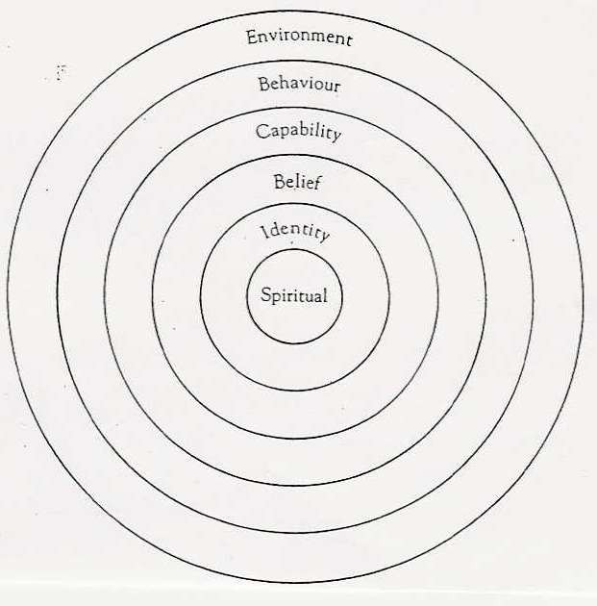

Group Discussions

Agree on a person who will be the language police for this activity. Make sure you use ENGLISH ONLY in your discussions. Work with the discussion cards provided below and discuss each topic in detail. Write down a few notes about your results and be ready to share them in class.

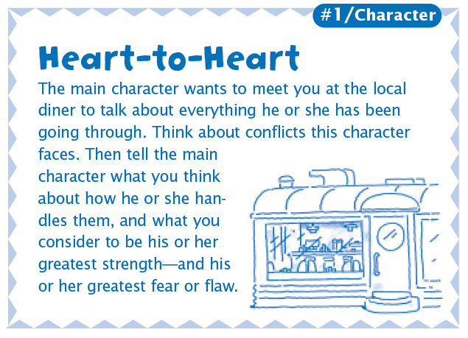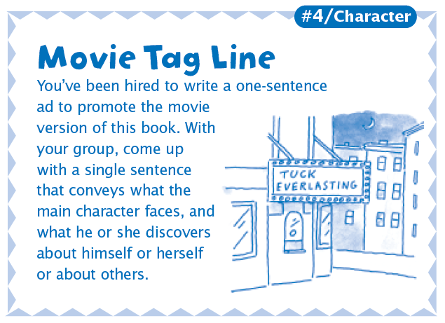

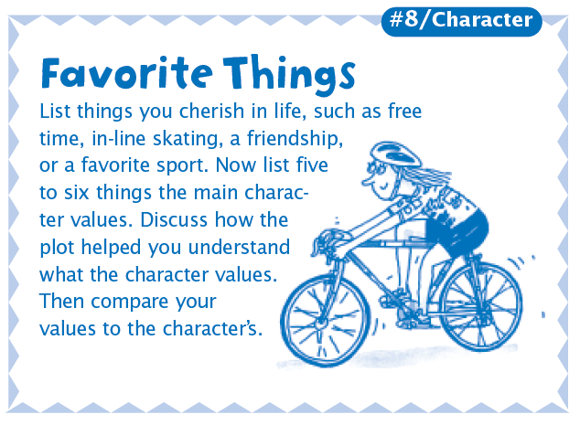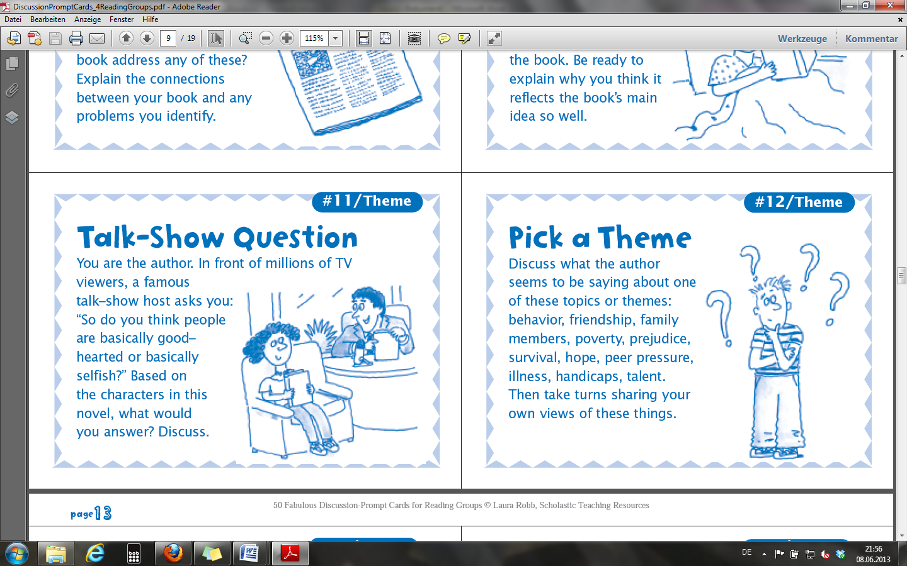

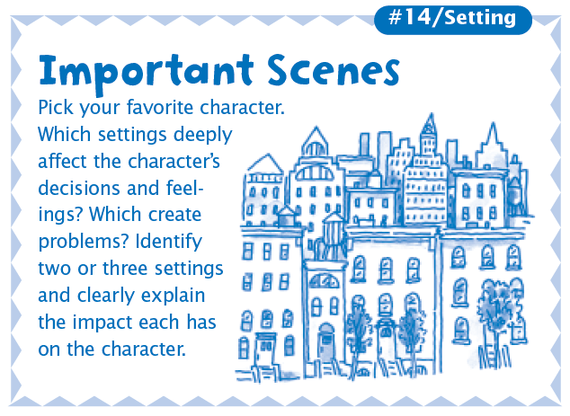
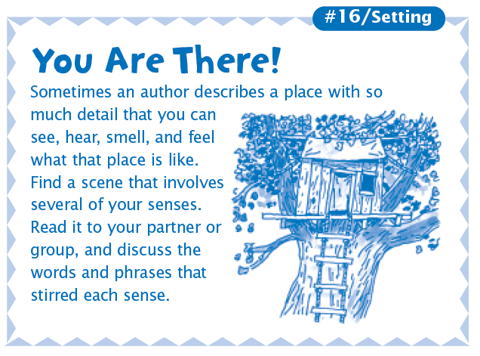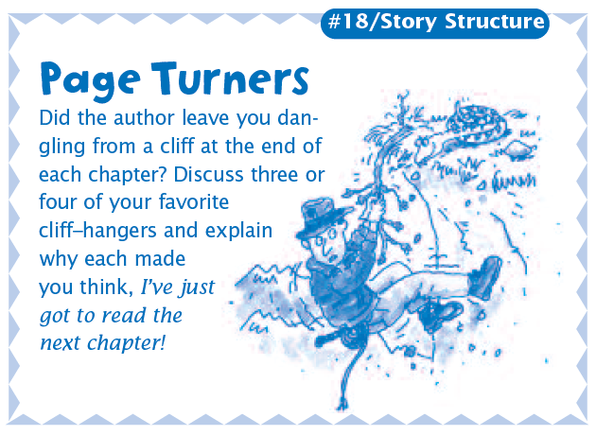

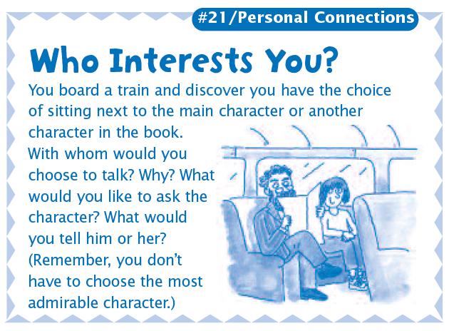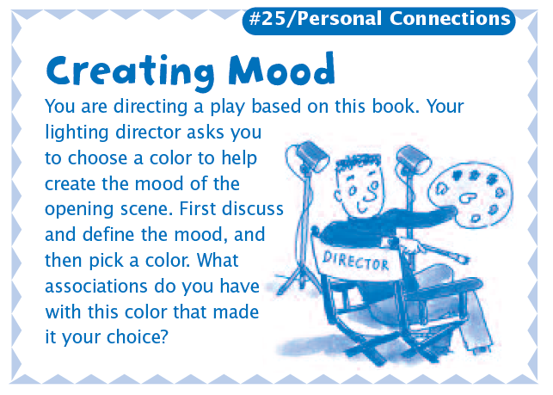

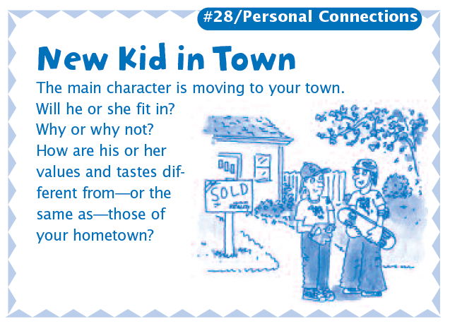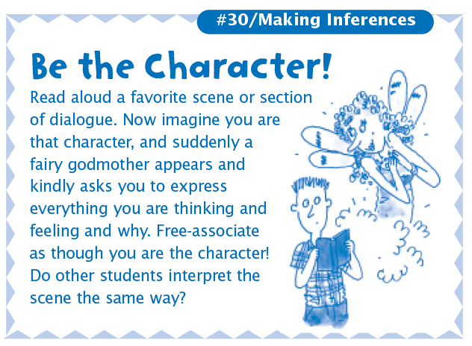

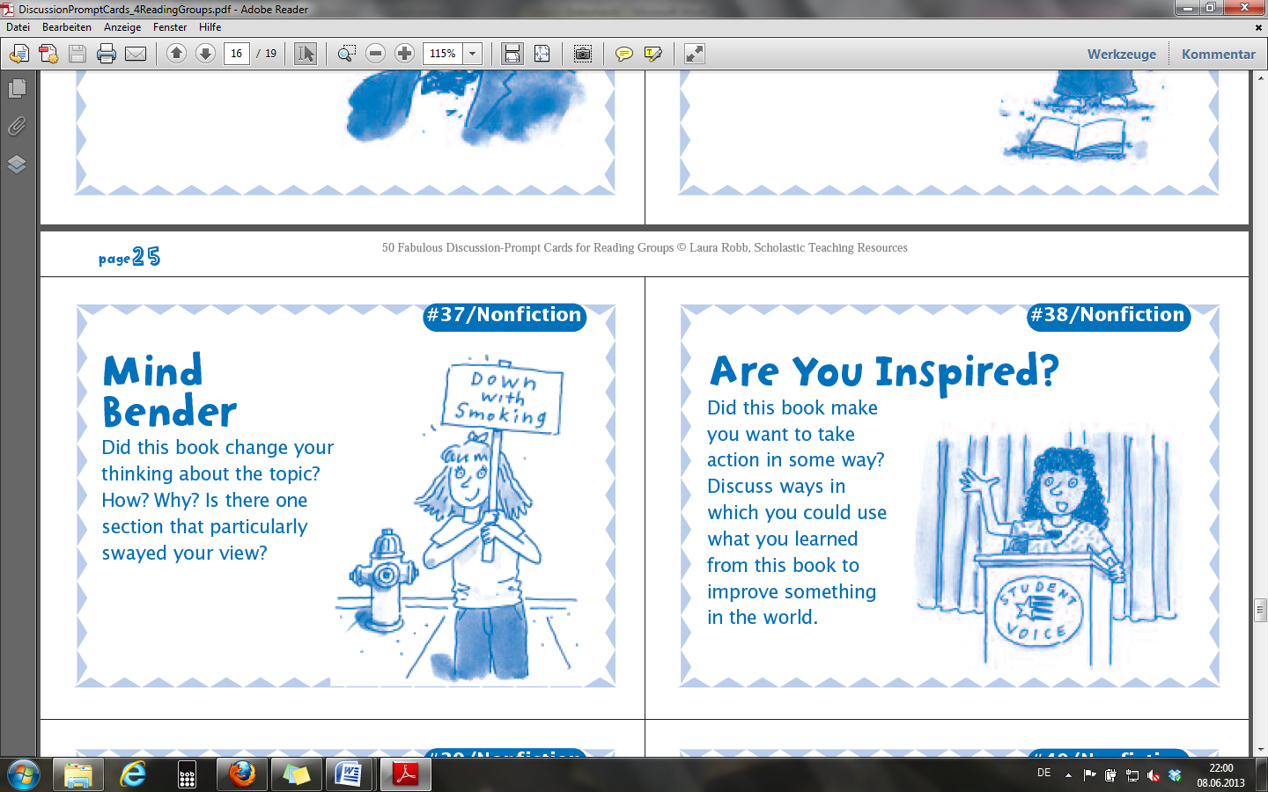

Put Yourself in Someone Else’s Shoes

Do you always agree with the decisions made or actions taken by the characters in your book? Think of a time you did not agree with a character. In the shoe on the left, write about the situation and what the character did. In the shoe on the right, write about what you would have done if you were the character. Why would you have done things another way? Share your results with your neighbor.

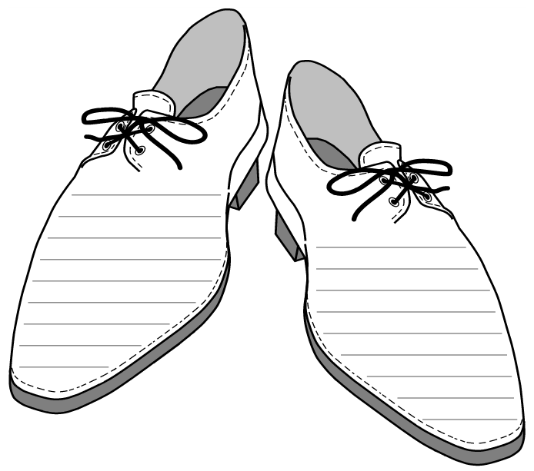

Creative Booklets

In this activity you are going to create your own booklet that presents the book that you have read. You can use some of the following ideas for the booklet:
- Design an alternative cover and blurb for the book.
- Write an e-mail to the author of the book: What would you like to ask him/her if you had the chance?
- Write a fake newspaper article about an interesting scene in the book, how it would be seen from a neutral, journalistic perspective.
- Make a plot diagram that shows the important events in the book and their connection. Draw a curve of ups and downs in the novel, where for example peaks represent the suspense or the conflicts or moments of happiness for the protagonist. Label the curve.
- Use any other text types and ideas: Songs, poems, drawings, cartoons …
Your teacher will provide you with a blank booklet consisting of 3 white A4 sheets folded and stapled together like and A5 booklet. Fill the booklet with your reactions, ideas etc. to the book. You can be as creative as possible!

Presentations

For your presentations plan several interesting and creative activities. Each group should present one of the following:

- Short information about the author: The main focus should be on his/her biography and how it relates to this book, but you can also mention typical topics, style and other books.
- Historical or cultural background of the novel: What important historical or cultural events have to be mentioned in connection with the book? In which way does the novel depict the historical or cultural circumstances of that time?
- Instances of similar problems in your country or environment: Which ethnic groups are minorities in your environment? How are they treated? What are some of the stereotypes connected to them?

Furthermore, your presentation should have the following parts:
Museum: Display 10-15 items that play a role in the book. Guide the tour through the artifacts. Make sure the layout is clear and creative, do not throw everything on a small space.
Map: Make a setting pop-up or a poster that shows the most important places in the book or draw a simple map of the locations in your novel. Make sure the map is large enough that everyone can read it clearly.
- The Absolutely True Diary of a Part-Time Indian: The world of the reservation and the world outside the reservation (conditions, circumstances, peoples’ attitudes).
- The House on Mango Street: Moving within Chicago (the areas available to the minorities and the conditions in them, deterioration factor).
- Black Boy: Moving across the USA (nomadic life of African American population in search of tolerance and sustenance).
Act out a scene from the book
‘Bubble sheet’: Prepare a ‘bubble sheet’ (A3 poster) where you collect important quotes from your book.

Peer Assessment

When watching your classmates’ book presentations you will be asked to give feedback to them. After each presentation, fill in the assessment sheet. Put an X under the assessment you think is right for each of the aspects of the presentation. You can write extra comments if you feel like there is something that should be included into the evaluation. Tell your classmates what you especially liked in their presentation and if there was anything you would have changed. Your teacher will use the same evaluation form to assess you presentation.

 | Very good | Good | Could have been better
How informative was the presentation?
Was the information presented in a clear an interesting way?
Did they present information about the plot, characters, setting and theme?
How good was the presentation at making us want to read the book?

 | Very good | Good | Could have been better
How informative was the presentation?
Was the information presented in a clear an interesting way?
Did they present information about the plot, characters, setting and theme?
How good was the presentation at making us want to read the book?

