Fachdidaktik PS4: Teaching Literature and Culture

Term Paper

Reading Project: Life Lessons

Name: Richard Bartle-Tubbs
Student ID Number: 0914265
Study Code: 511.440
Email Address: richard.bartle-tubbs@edu.uni-graz.at

Date of Submission: 10^{h} June 2013

Life Lessons

You will never truly understand something until you go through it yourself….

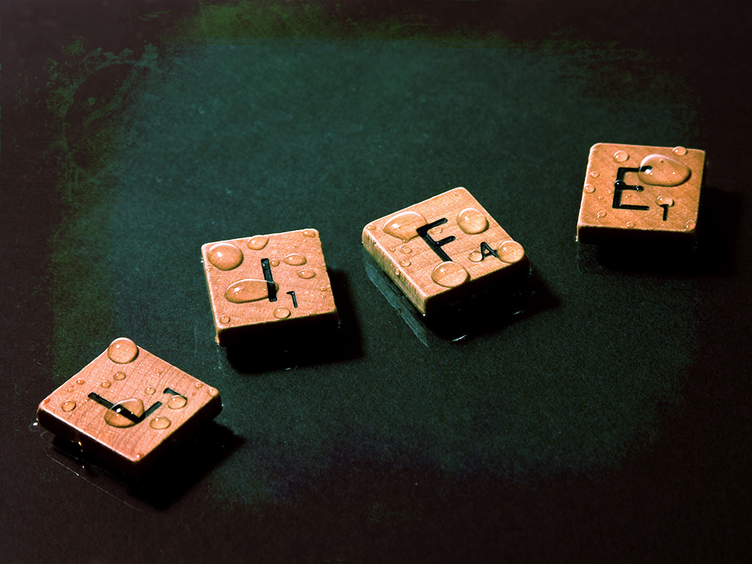

Name:

Class:

Book:

Life Lessons: Reading Project

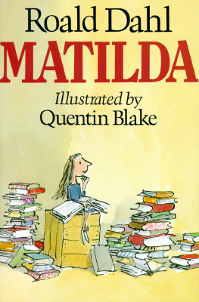 | Hi, my name is:  I like:  I think school is:  My home life is:  I would rather:
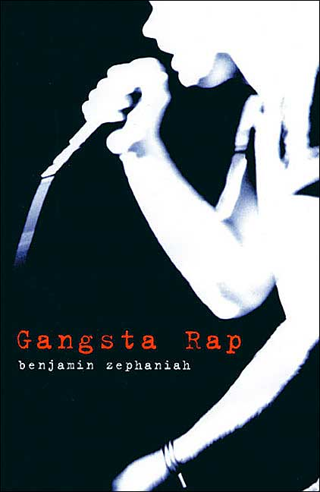 | Hi, my name is:  I like:  I think school is:  My home life is:  I would rather:
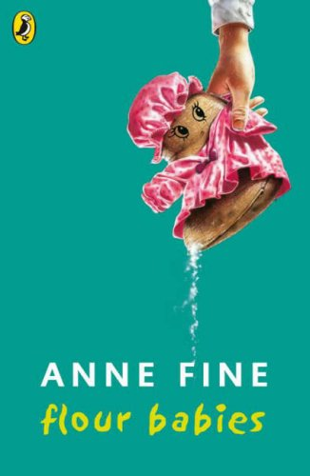 | Hi, my name is:  I like:  I think school is:  My home life is:  I would rather:
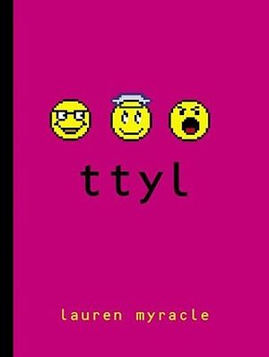 | Hi, my name is:  I like:  I think school is:  My home life is:  I would rather:

What do I think about?

What things do you think about the most? Think about the issues, topics and problems that you are confronted with everyday. Think about your family and school life – do the two things connect in any way? Do you enjoy how you spend your time? Do you sometimes spend your time wishing you were doing other things, and if so, what? Note down the first things that pop into your head when you consider your everyday life and what you think about:

With these things in mind, draw 2 pie charts. The first shows how much time you spend doing things during a typical week. The second shows what you think about during this time: (Are you honestly always concentrating on schoolwork at school?)

My Complicated Life

Life is full of relationships and is all about balance. If things are balanced, then it can be easy to be happy. However, finding this balance is often a very tricky thing. On this line put the 3 headings School, Family, and Friends in terms of how close they are to you. Put those things that are closely connected to you closer to your name, those disconnected further away.
ME

Use this space to draw a web diagram of the relationships within your life. Put your name in the middle, use the 3 main headings from the line diagram (and any others you need, such as Sports, Music etc.) and show how your life connects. Use colours and explanations to show good and bad relationships:

Reading the Books: School Experience

The experience that we have at school depends on many things. The school itself and the teachers that work within it, your life at home during your school time, and also your relationships with your fellow students. These can be both positive and negative and, in the books that have been chosen for this project, the characters have many different experiences at school that may mirror your own. Use the table below to show what you have found:

School Experience  (Praise, detention, punishment….) | How does the character feel because of this?  Has this happened to you:  yes – how did you feel?  no – how would you feel?  Does he/she still like the teacher, does he/she understood what has happened and why? Is it fair? | Evidence in the book/Page number


Authority Figures: Part One

What does the word ‘authority’ mean to you? Are there any particular nouns, verbs or adjectives that you associate with authority? Use this space to jot down your ideas:

AUTHORITY

What positive and/or negative experiences have you had so far in your life with authority figures? Write about them here:

Authority Figures: Part Two

Now do the same for your main character. What dealings have they had with authority figures in their life and how have they dealt with them? Do they have any respect for the “typical” authority figures that you named on the previous page? Or do they distrust them due to previous experience? Make sure to find both positive and negative examples!

My character’s experiences of and feelings towards authority figures:

Life Lessons

School can teach you many things but it cannot prepare you for everything that life will throw at you. What are the five most important things that you have learned in life, and where/how did you learn them?

# | What? | Where/how?
1
2
3
4
5

Now make the same list for your character. What lessons do they learn throughout the book and where, how and from whom do they learn them?

# | What? | Where/how?
1
2
3
4
5

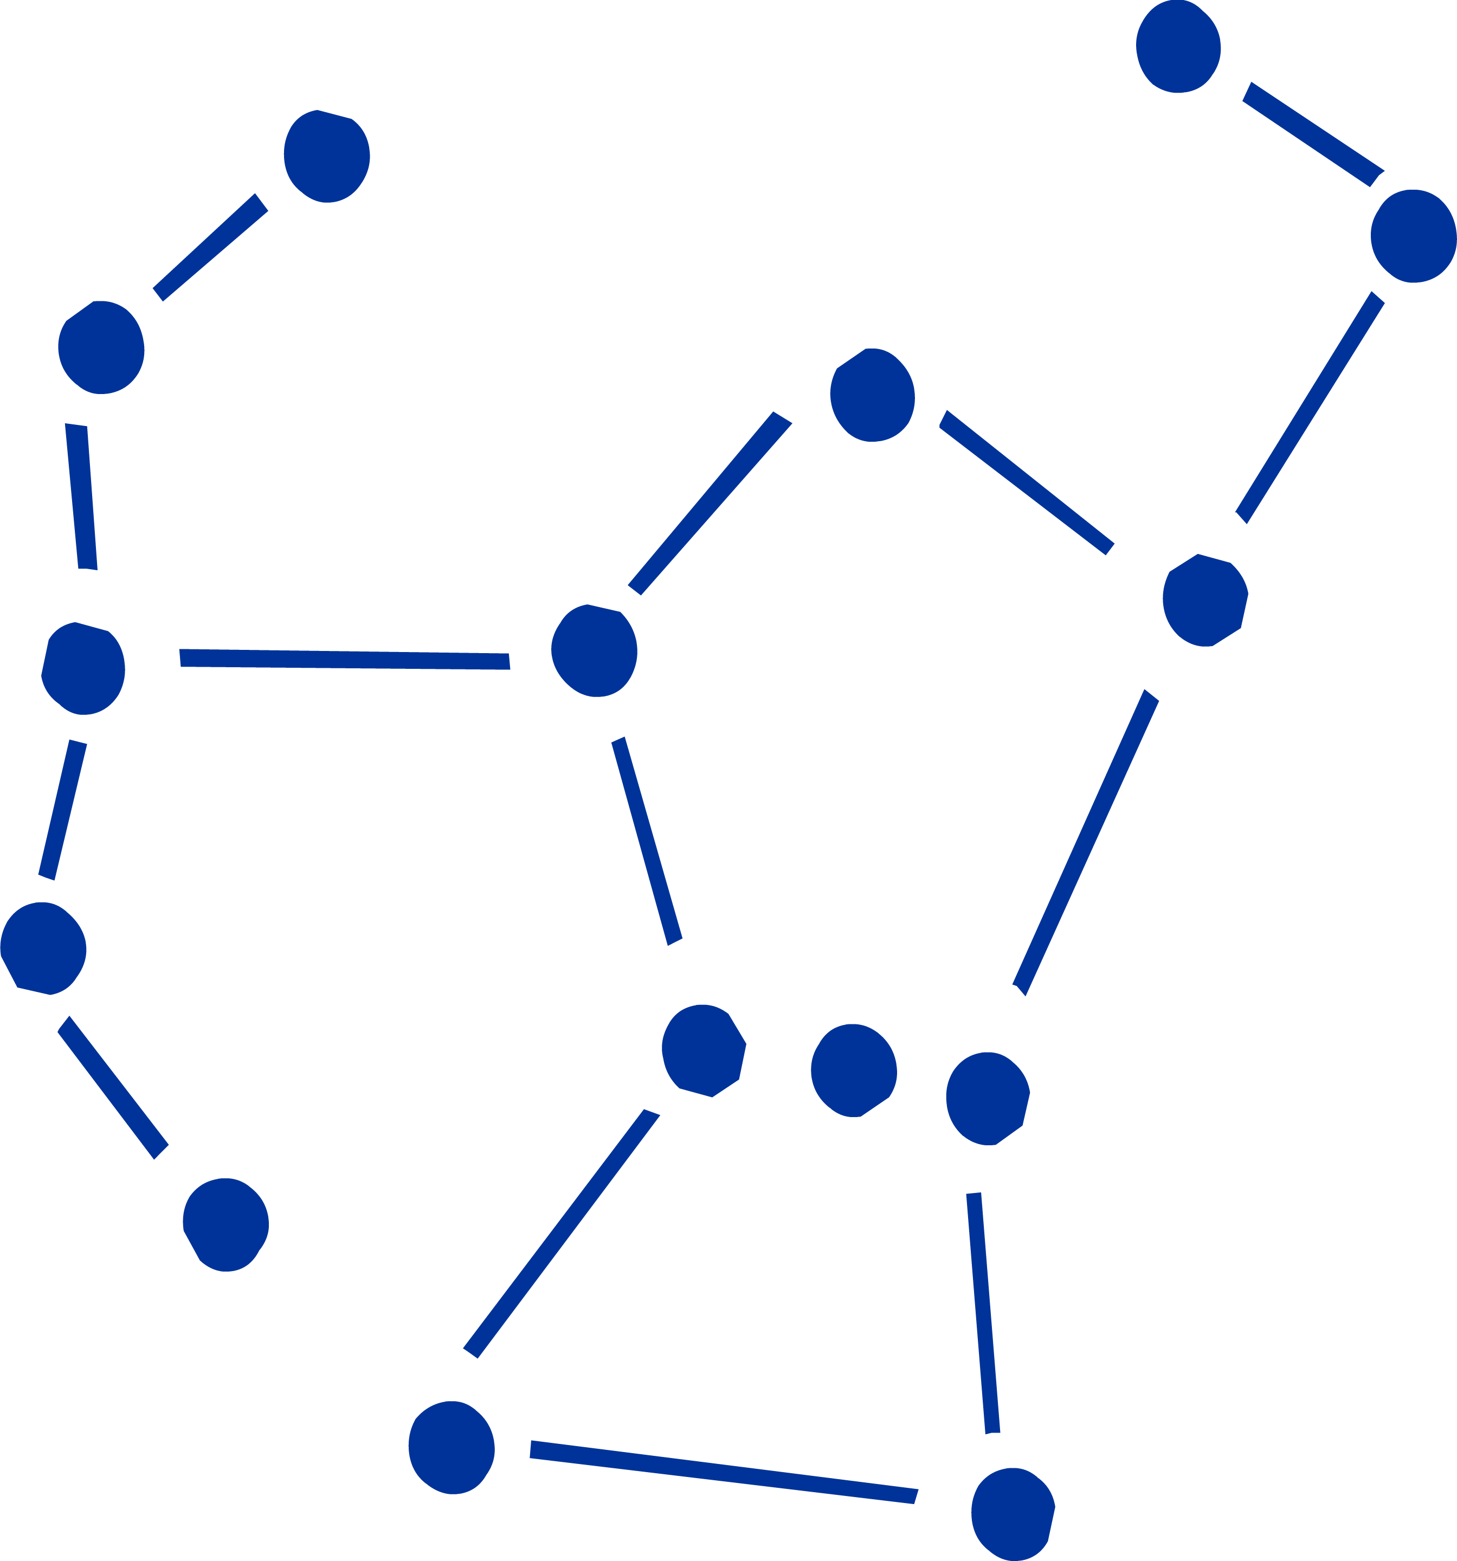
Character Constellations

First of all, who are the most important characters in your book? Write them down here:

Using the work you have done on your own life with your web diagram, your analysis of authority figures, and your interpretation of important life lessons, create a constellation of characters from your book. How do the characters relate to one another and what influence do they have on each other?

Fever Curve

Drawing the plot arc as a line on a graph, with the peaks of suspense and rise of conflict, is a very good way of giving an overview of the story. Turn this page landscape and sketch the ups and downs of the novel. Collect a few ideas first on a scrap piece of paper before you start here. Don’t forget to label the key rises and falls!
Positive
Negative
Plot

Helping Out

Take another look at the fever curve you have drawn. Reflect upon the moments you have depicted as being the absolute lows in the book. With these feelings in mind, write a letter to the character(s) involved offering some help or useful advice. Use your own experience of life to really try and better the character’s situation.

To School or Not To School: Part One

In your groups, discuss how important school is in your book characters’ lives in comparison to your own lives. Make sure you cover the following points

- What does your character think about school?
- Has school helped them in any way?
- Would you be friends with your character if they were in your class?
- Are there any advantages to be had in not going to school?
- How would your life be if you hadn’t gone to school this year?

Make some rough notes afterwards in the space below:

To School or Not To School: Part Two

Use the information you shared and found out from the group discussion and also the notes you took to complete the diagram below. Use arrows to link the ideas. What experiences do some (or maybe all) of the characters have in common, and what are the differences?

Matilda
Gangsta Rap
Flour Babies
TTYL

Book Presentations

Now is the time to present your books in front of the class. Find others who have read the same book and compare your work so far on this project: compare the fever curves, the character constellations and the life lessons. You can use these in your group presentation.

Make sure that your presentation is made up of interesting activities and that you can present the work you have done already. Remember that your audience needs to know the following things:

- The main characters in the story
  - You can use role-play acting, profiles, a chat show or talent show format, etc….

- Where the story is set
  - Maps (either self-drawn or real maps if the story is set in a real-world location), background information, pictures…

- Important features of the story
  - “Actual” objects from the story, plot development, newspaper articles, letters written between characters in the book.

- Your personal opinion and reading recommendation

If you need any help, feel free to ask other members of the class or your teacher. The presentation should not last longer than 15 minutes and with all the work you have already done, filling the time should be no problem

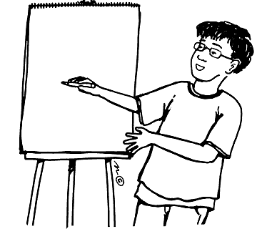

Teacher’s Notes

Age Group:

This project has been conceived for typical AHS students in the 5th or 6th classes, age range 14-16. A reasonable amount of school and life experience is needed for the project and pupils need to be mature enough to reflect upon their own experiences in an objective manner.

Books:

The books are page-turners and are full of relevant modern UK/US youth language. Matilda and Flour Babies are older books but the stories and situations are nevertheless gripping for all class members. Gangsta Rap is probably more appealing to boys in the class, whereas TTYL is certainly more of a girls’ novel.

Duration:

The project should last 3-4 lessons worth of time. This does not include preparation work done at home in terms of any homework set, nor does it include the actual reading of the book.

Notes to the Exercises:

“Reading Project”
Here the pupils are free to browse through the 4 books for about 10 minutes each. They shouldn’t start reading the books in depth, instead they should flick through, read the blurb and get a gist of whether they are interested in the book or not. The question prompts are designed to be answered from the main character’s perspective.

“What do I think about?” and “My Complicated Life”
Perhaps the concepts of the Pie Chart and Web Diagram/Constellation need to be introduced. Refer to the appendix for examples, if need be.

“To School or Not to School: Part Two”
These circles represent a rough Venn diagram where the pupils should show the links between the books. The circle in the middle is for ideas that are present in all 4 novels. They should draw arrows between the other circles linking ideas.

Appendix

Pie Chart
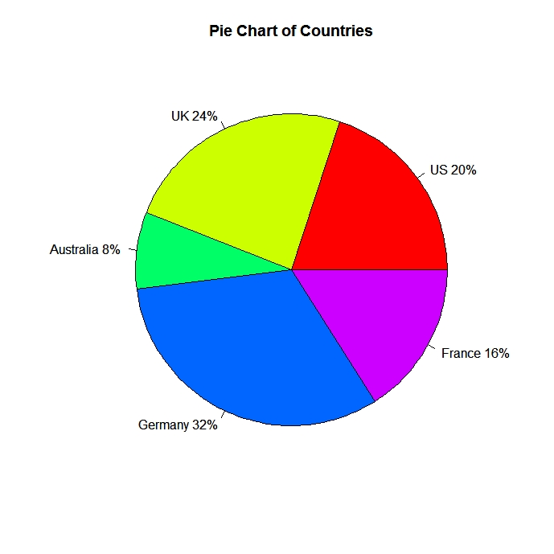

Source: http://www.statmethods.net/graphs/pie.html
Accessed: 7th June 2013

Web Diagram/Constellation

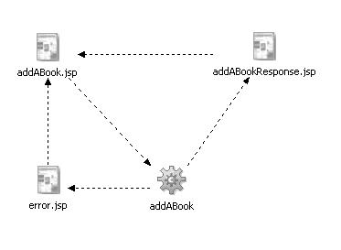

Source: www.ibm.com
Accessed: 7th June 2013

