Methodology of Teaching Literature and Culture
(Fachdidaktisches Proseminar 4)
SS 2011
Dr. Elisabeth Pölzleitner

Project 1
Teaching unit for lower school

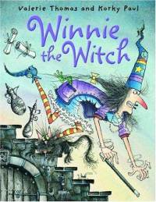

(Winnie the Witch, 6-in-1 collection by Valerie Thomas and Korky Paul, Oxford University Press.)

Author: Sabrina Rathausky
0512263

Graz, June 15th 2011
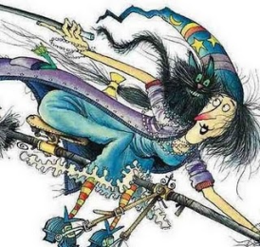

1. Pre-reading activities:

a) Which rooms does your house have? Which furniture do you have at home?
Collect some ideas and then write them on the blackboard.
___________________________________________________________________________

___________________________________________________________________________

___________________________________________________________________________

b) Together with a partner, play the memory game handed out by your teacher!

c) There is someone who also has a living room, a bathroom, a bedroom and a kitchen and even a room for her broomstick and her boiling pot. Her name is Winnie. Who do you think is Winnie?
Again, collect ideas and present them to your classmates and teacher.
___________________________________________________________________________

___________________________________________________________________________

___________________________________________________________________________

d) Listen to your teacher’s description of Winnie and try to draw her on a separate sheet of paper. Afterwards compare your drawing to your neighbor’s and the true Winnie.

2. While reading activities:

a) Now listen to your teacher who reads out the story of Winnie the Witch and shows you the pictures of her house and story.
Kim’s game: Try to answer these questions after looking at the picture at p. 1-2 for one minute.

• How many windows does the house have?

___________________________________________________________________________
• How many rooms does the house have?

___________________________________________________________________________
• How many floors does the house have?

___________________________________________________________________________
• Where is Winnie’s bedroom?

___________________________________________________________________________
• Where is Winnie?

___________________________________________________________________________
• Where is she storing her tank and broomstick?

___________________________________________________________________________
• Where is Wilbur the cat?

___________________________________________________________________________
• What furniture could you identify on the picture? Where is it placed?

___________________________________________________________________________
• What color is the house?

___________________________________________________________________________

b) Go on listening to your teacher. What do you think is the big problem Winnie has? Collect ideas.
___________________________________________________________________________

___________________________________________________________________________

___________________________________________________________________________

c) What do you think is going to happen now? Again collect ideas.
___________________________________________________________________________

___________________________________________________________________________

___________________________________________________________________________

d) How do you think does Wilbur feel now? Is he happy? Is the problem now solved? Again collect ideas.
___________________________________________________________________________

___________________________________________________________________________

___________________________________________________________________________

Then discuss with your classmates and your teacher how you would feel if you were Wilbur.

e) Now you have 10 min. to write your own ending of the story. Afterwards compare your ending to your neighbor’s. Then listen to your teacher reading out the real ending and compare it with your own ending.
___________________________________________________________________________

___________________________________________________________________________

___________________________________________________________________________

___________________________________________________________________________

___________________________________________________________________________

___________________________________________________________________________

___________________________________________________________________________

___________________________________________________________________________

___________________________________________________________________________

3. Post-reading activities:

a) Fill in the story pyramid and put it in your reading diary.

Story Pyramid

1._____________
2.________________________
3.__________________________________
4.________________________________________
5.____________________________________________
6.______________________________________________
7._______________________________________________
8_________________________________________________

1. The main character's name
2. Two words that describe the main character
3. Three words about the setting (the places)
4. Four words about the main character's problem and goal
5. Five words about important events in the story
6. Six words about the conclusion (How does it end?)
7. Seven words about your favorite part
8. Eight words: What would you tell your friends about the story?
©Elisabeth Pölzleitner: www.epep.at

b) Posting Postcards: For homework, make a postcard by yourself. It must have a front side where you draw a picture which should show a place from the book. Then, on the back of the postcard, on the upper left-hand side, tell a little bit about the picture you have drawn. Beyond this description write a little message pretending you are one of the characters from the book. Then write an address on the right-hand side of the back of the card. To finish your postcard, draw a stamp in the space where the stamp should go.
When you finished your postcard, you can put it in your reading diary just as you have done with the story pyramid.

Front side:

Back side:

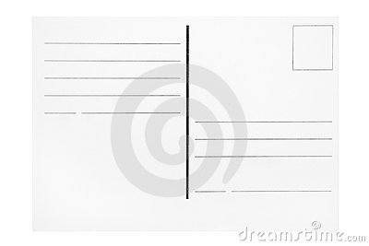

©dreamstime.com

Appendix Project 1:
The Memory Game
dishwasher | couch (sofa)
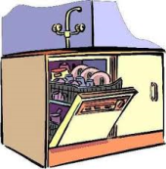 | 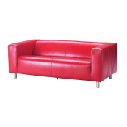
table | chair
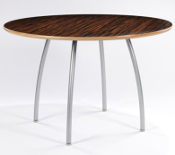 | 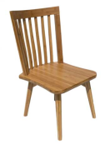
recliner | loveseat
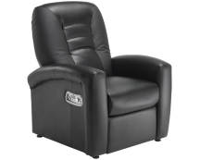 | 
coffee table | end table
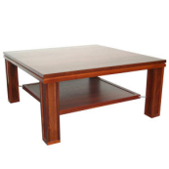 | 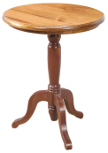
lamp | light switch
 | 
bed | stove
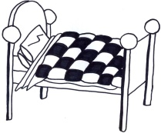 | 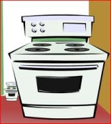
oven | refrigerator
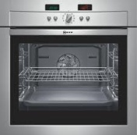 | 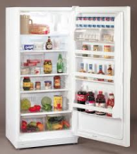
freezer | sink
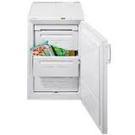 | 
dresser | closet
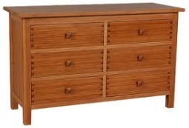 | 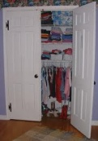
bookcase | shelves
 | 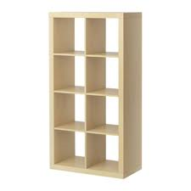
carpet | curtains
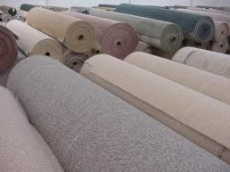 | 
sheets and blankets | bathtub
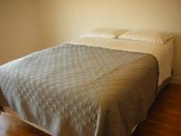 | 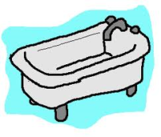
shower | toilet
 | 
living room | bathroom
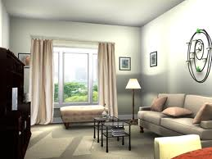 | 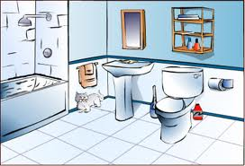
kitchen | broomstick
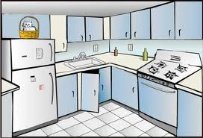 | 
magic wand | bedroom
 | 

