Appearance vs. Reality
This is an excellent project that will lead to really important, interesting discussions in class. I am truly impressed by your excellent mix of activities.
Clean up the tiny flaws – it’s just a few minutes – and turn this into a 100% perfect package.
Pö
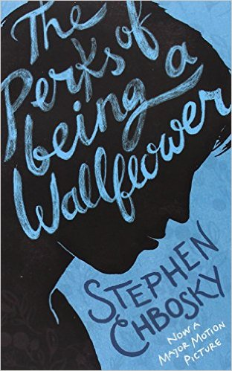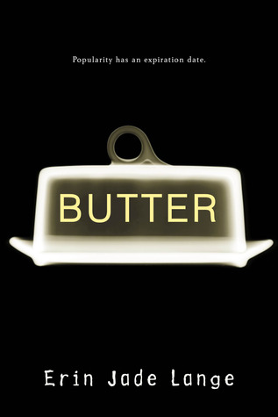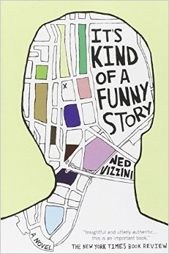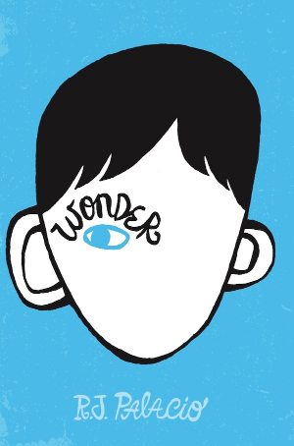

It is only with the heart that one can see rightly; what is essential is invisible to the eye. [Antoine de Saint-Exupery]
Table of Content
- Book Choosing
- Butter
  - Getting Started
  - Activities Throughout the Reading Process
for your Reading Diary
  - After Reading Activities
- Perks of Being a Wallflower
  - Getting Started
  - Activities Throughout the Reading Process
for your Reading Diary
  - After Reading Activities
- Wonder
  - Getting Started
  - Activities Throughout the Reading Process
for your Reading Diary
  - After Reading Activities
- It´s Kind of a Funny Story
  - Getting Started
  - Activities Throughout the Reading Process
for your Reading Diary
  - After Reading Activities
- Presentations – The Literature Café
- For Teachers

Book Choosing Activity
Getting started
- Read through the copies of the books presented to you. Use the grid below as a guideline for your book choosing. Take your time when browsing through the books. Pay particular attention to what effect the cover illustration in combination of what you´ve just read has on you.

Book Title | My first thoughts when reading the title and looking at the cover illustrations | What challenges might the protagonist of the book run into?

- Choose the book that attracts you the most and get into a group with classmates who have chosen the same book. This will be your discussion group throughout your reading process.

- Reading Diary
Throughout the reading process, you will be asked to do some activities. Collect all the pieces you´ve created in the form of a booklet. Use formatting and illustrations in order to add extra information to your booklet and make it look nice.
The booklets will be collected and graded (focus on effort and creativity, not on language proficiency) .

BUTTER by Erin Jade Lange
Getting started
- EATING HABITS:
Not eating right can make you sick. But not eating right does not always mean eating too much, it can also mean eating too little. Obesity and anorexia are both eating disorders that can seriously harm your health.
- Freewriting: Think about factors that influence your eating behaviour. Have you ever felt the urge to skip meals in order to look like a person on a photo you found on the internet? Or did you ever find comfort in binge eating sweets or fatty food? Write down your personal experiences on eating habits. You don´t have to share them in class if you don´t feel like it.
- Partner activity: Together with a partner, write down a list of 5 factors that you think are the most influential factors regarding eating habits.
- Group activity: As soon as all of you are finished present your list to your group and compare your findings to the ones of your classmates.

- OUTWARD APPEARANCCE:
Think of a fat person. Which character traits do you associate with them? Write down at least 3. Afterwards do the same thinking about a skinny person. What have you come up with?
Save your notes and compare them to the character in the book. Do your descriptions fit the character’s description?

Activities throughout the reading process for your reading diary
- EMOTIOGRAM:
When reading the book you join the protagonist on a rollercoaster ride of emotions. Cut out the diagram below and use it as a bookmark. Mark every carving experience that causes a change of how the character feels (on a scale from 0-10, where 0 means very bad and 10 very good). Step by step map the rich world of emotions the character wanders through. Add the page number of the carving experience and a short note that reminds you of what caused the experience. You can also use the back of the bookmark for notes.

0
- VOCAB CARDS or VOCAB BOOK ENTRY:
While reading the book, write down 20 interesting phrases or vocabulary from the book. You can either make entries in your vocab book or design vocab cards. Make sure you include the following elements:
Word
Sentence from the book
My true sentence
On the back of your vocab card or just include this in your vocab book entry:
Translation
Definition
Translation of the sentences

Post-reading activities
- REASONS FOR OVEREATING
Throughout the story, “Butter” mentions several reasons that influence his eating behaviour. Add the factors that he mentions in the book to the picture below. Differentiate between internal factors and external factors that influence his behaviour and arrange them accordingly.



- APPEARANCE VS REALITY
Create a book cover that represents both outward appearance and character traits or innermost thoughts of the main character.
- APPEARANCE ON THE INTERNET
- Read the story about the 18-year-old Instagram model Essena O´Neil:
https://www.theguardian.com/media/2015/nov/03/instagram-star-essena-oneill-quits-2d-life-to-reveal-true-story-behind-images
- Discuss with a partner:
Do you think her story is an exception or is this what the life of an Instagram model actually looks like?
What are possible consequences for people looking at her profile before she edited it? Would you feel jealous of her lifestyle or do you know that all of this is acted out?
- Come up with one person you regularly follow on the internet and review their online appearance critically.
Write a short text (~250 words) about the findings you´ve made. Write about the experiences they represent online and which ones they leave out. Maybe you suddenly realize that they represent specific brands. (For example: If it is a travel blog where only beautiful beaches are shown and the arduous process of travelling and being a stranger in a country is completely left out write about the information that is left out.)

THE PERKS OF BEING A WALLFLOWER by Stephen Chbosky
Getting started
- WALLFLOWER:
Where do you think does the term of a wallflower come from? At first guess. After you have written down your explanation of the term do some research and find out about the meaning of the word. Have you guessed right, or did you come up with a brilliant explanation that wasn´t true at all? Share your explanation with a partner.
Activities throughout the reading process for your reading diary
- VOCAB CARDS or VOCAB BOOK ENTRY:
While reading the book, write down 20 interesting phrases or vocabulary from the book. You can either make entries in your vocab book or design vocab cards. Make sure you include the following elements:
Word
Sentence from the book
My true sentence
On the back of your vocab card or just include this in your vocab book entry:
Translation
Definition
Translation of the sentences

- SOCIOGRAM
Choose symbols representing the main characters of this book. Then make a sociogram showing the relationships (friends, enemies, love, good or bad people etc.) between these.
Post-reading activities
- DIARY WRITING
Freewriting:
- Who do you think was the addressee of Charlie’s letters?
- Why do you think did Charlie write letters to a stranger?
- Do you have a diary? Why/Why not?
- A LETTER TO CHARLIE
Choose one of Charlie’s letters and imagine you were the unknown addressee. Write a letter to Charlie as a reply to the one you´ve chosen. Give advice or express empathy in your letter. You could write about your own experiences that are like the ones Charlie wrote about in his letter to you. Minimum length of the letter: 250 words.



WONDER by R.J. Palacio
Getting started
From our book choosing activity, you have already an idea of the main character, the theme of the book. In a 10-minute free-writing activity, write down what you expect from the book and from the characters – and what do you think the book title entails?
You can use the following phrases (and the “will-future”):
I think that….
I hope that…
I am afraid that…
Activities throughout the reading process for your reading diary
- VOCAB CARDS or VOCAB BOOK ENTRY:
Throughout reading the book, write down 20 interesting phrases or vocabulary from the book. You can either make entries in your vocab book or design vocab cards. Make sure you include the following elements:
Word
Sentence from the book
My true sentence
On the back of your vocab card or just include this in your vocab book entry:
Translation
Definition
Translation of the sentences

- SOCIOGRAM
Choose symbols representing the main characters of this book. Then make a sociogram showing the relationships (friends, enemies, love, good or bad people etc.) between these.
- CHARACTER PROFILE
Take a close look at 2 characters of the book, get into their perspectives and fill out their character profiles (See HO “Character Profiles).
- FREEWRITING 1: BEING STARED AT
At school, August feels excluded and isolated; he is being stared at, people are whispering behind his back and even avoid him at lunch. (See book p. 66) Slide into the perspective of one of the kids avoiding August. Why do you think he/she is avoiding August? How would you react? What would be the right way to approach August?
- FREEWRITING 2: “I mean, the thing is: he always follows me around. What am I supposed to do?”
On Halloween, Jack denies being friends with August (See book p. 96). Slide into Jack’s mind in this situation and write a diary entry or an inner monologue capturing his thoughts in this very moment. What could be his motivation to act this way and deny his friendship with August?
Post-reading activities
- THE FUTURE
In a 10-minute free-writing, imagine August’s future starting after high school graduation. What will he accomplish in his life? What is college going to be like? Where will he work? Compare your ideas with your group.
- INSPIRATION
Watch the video clips below and take notes. Your focus should be on the following two questions: How do people with disabilities want to be approached? What can we learn from people with disabilities?
- Lizzie Velasquez: https://www.youtube.com/watch?v=sohGDfNQV7M&t=149s
- Soulpancake –“How you see me”: https://www.youtube.com/watch?v=bwW6mYdJ7Xc
Get together in groups and design two posters:
- 5 Advices on how to approach people with disabilities with respect
- What can we learn from people with disabilities?

IT’S KIND OF A FUNNY STORY by Ned Vizzini
Getting started
What is depression? Watch the video (link below) on depression. Take notes and answer the following questions:
- What is the difference between depression and feeling depressed?
- Which symptoms do people suffering from depression usually show?
- What does the video suggest we should do if we know someone with depression?
https://www.youtube.com/watch?v=z-IR48Mb3W0
Now discuss your answers with your group partners and compare them.

Activities throughout the reading process for your reading diary
- VOCAB CARDS or VOCAB BOOK ENTRY:
Throughout reading the book, write down 20 interesting phrases or vocabulary from the book. You can either make entries in your vocab book or design vocab cards. Make sure you include the following elements:

Word
Sentence from the book
My true sentence
On the back of your vocab card or just include this in your vocab book entry:
Translation
Definition
Translation of the sentences

- POINT OF VIEW: after chapter 10 (p.89)
- Slip into Aaron’s perspective and in a 10-minute free-writing write down what you think his thoughts were when Craig walked out over the trussing of the Brooklyn Bridge (chapter 10).
- Now think about what you would do if a friend of yours acted the way Craig does and discuss your ideas with your group mates.

- PLOT-DIAGRAM
Slip into the Craig’s perspective, and draw a “fever curve” of the ups and downs in the novel. When does Craig feel most contend and when does he feel devastated? What triggers his emotions? Label the peaks of your plot-diagram with the emotional highs and lows.

- VENN DIAGRAM (towards the end of the book) – private activity

Compare your life with Craig’s life. Do not only take obvious circumstances such as family, friends and school life into consideration, but also think about your emotional challenges, feelings and plans for your future. (Use a separate sheet to draw a half-page diagram)

Post-reading activities
- INTERVIEW WITH CRAIG
Get together in pairs. Imagine Craig as an up-and-coming artist 10 years from now. You are reporters of an artsy magazine (of your choice) and are going to interview Craig about his work, his inspiration for it and especially how and why he has become an artist. Think of at least 5 question you would like to ask the grown-up Craig. Write down the interview (and Craig’s answers, record it with your smartphone and upload it to Moodle– one is the reporter, the other one is Craig.

- THINKING BEYOND:
Choose one of the two activities:
- BEING SCREWED UP:
“I met this girl in here--… (…) and she’s really screwed up, as screwed up as me, but I don’t look at that as an insult. I look at that as a chance to connect. (…) People are screwed up in this world. I’d rather be with someone screwed up and open about it than somebody perfect and…you know…ready to explode.” (p. 397)
- Freewriting and group discussion: What does Craig mean? In a 10-minute free-writing, write down your associations, thoughts and feelings that came into your mind when reading this quote. Share your conclusions with your group.

- FUTURE PLANS:
p. 50 – Craig: “I’ll admit it: I kind of want to be President.”
p. 415 – Craig: “This is something different. This is something I love. So I’d better do it.”
- Freewriting and group discussion: Why has Craig’s change of heart concerning his future had such an impact on his mental health?
- Draw a sketch: What are your goals in life? Which people, things, values and achievements are important for you to live a happy life?

Presentations – The Literature Café
Let’s share our book experiences and stories with a cup of coffee:
The idea is that you get together in groups consisting of one member of each book group and tell the others everything you want them to know about your book. Prepare the materials from your book diary and group activities.
- Make sure you only give away bits and pieces and not the whole story – you want to make your colleagues want to read the book themselves!
- Go beyond your book and challenge your colleagues with questions concerning the topic of your book.
- You can use your book diary or flash cards, but make sure you speak freely and involve your colleagues in the conversation.
- Prepare some snacks and grab a cup of coffee or tea or hot chocolate from the cafeteria – let’s start!
For Teachers
This reading project can be used for more advanced learners of English (6th or 7th grade).
The project focuses on the topic of appearance vs. reality with different focal points. The two books “The Perks of being a Wallflower” and “It´s Kind of a Funny Story” deal with the topic depression. “Butter” approaches the topic with an emphasis on eating disorders and “Wonder” is a heart-warming book on a boy who was born with a genetic disorder known as Treacher Collins syndrome, which caused a deformation of the protagonist’s face.
Working on these books in combination with the exercises, requires a good teacher-student relationship. Many of these exercises motivate students to think and talk about personal experiences and therefore need to be approached with sensitivity. Nevertheless, don´t be afraid about working on this topic. The two aspects of appearance and reality do play a big role in pupils´ lives. From early on, they are trained by social media websites to create digital avatars which focus on their appearance and superficial character traits, neglecting their true selves and struggles. Creating a place for students to share more profound thoughts and talk about fears creates a strong feeling of cohesion within a group.

Preparation
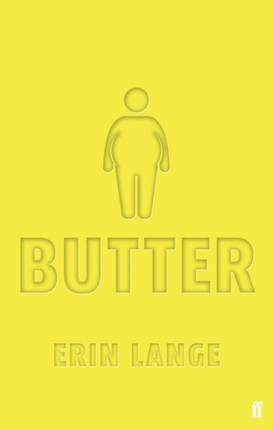Organise print versions of all four books that have an appealing cover illustration you like to work with. Good examples would be the following. They all focus their depiction on human bodies and the appearance of human bodies. The two books that focus on depression both show silhouettes of heads and a somehow abstract interpretation of thoughts. The two other books that focus more on the outward appearance of bodies symbolically represent the problems the protagonists have to deal with.

Furthermore copy the first 20 pages of the each book in order to provide your students with reading extracts they can browse through.

