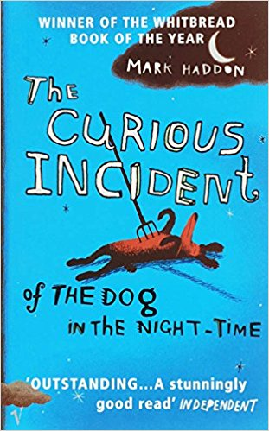
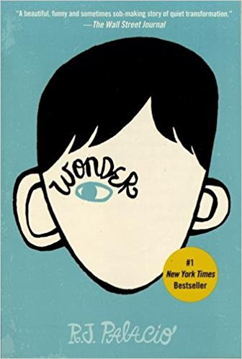
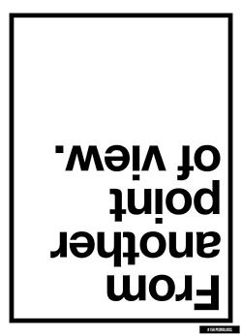
BOOK PROJECT:
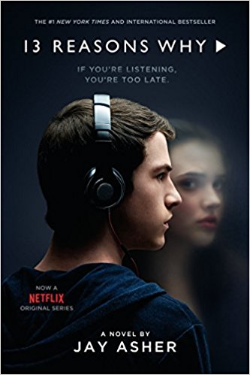
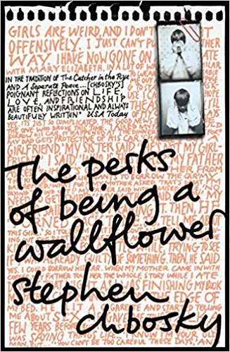
BEING DIFFERENT
This is an absolutely awesome project. WOW!!
I have made two tiny comments inside. It’ll take less than 5 min to polish it to perfection.
pö
Table of Contents

Checklist 3
Room for thoughts 4
Book Choosing 5
1. Matching activity 5
2. Book reviews 6
Pre-Reading 7
3. Survey about ourselves 7
4. Discussion questions on personality 7
5. Blog comment 8
While-Reading 10
6. About us 10
7. Venn diagram 11
8. Favorite quotes 11
Post-Reading 12
9. How did it make you feel? 12
10. Acrostic poem 12
11. Time travel 13
12. Discussions 14
13. Share your favorites 15
14. A song for you 15
15. Generation Snowflake 16
Book presentations 17
References 18

Checklist

 | Name of activity | Done? | I liked the task/rating
 | Room for thoughts
 | Time to choose a book:
1 | Matching activity
2 | Book reviews
 | Pre-Reading:
3 | Survey about ourselves
4 | Discussion questions on personality
5 | Blog comment
 | Let’s get ready to read!
6 | About us
7 | Venn diagram
8 | Favorite quotes
 | Post-Reading:
9 | How did it make you feel?
10 | Acrostic poem
11 | Time travel
12 | Discussion
13 | Share your favorites
14 | A song for you
15 | Generation Snowflake
 | Presentation
 | Great job! Reading is cool, isn’t it?

My book is:
These are my group members:
The presentation will take place on:

Room for thoughts

Here is a whole blank page for your book project.
Fill it with whatever you want (questions, pictures, notes, interesting facts, drawings,..).
Get creative!

Book Choosing

Matching activity
In order to get to know a little more about the books for this project, take a closer look at the book cover and match it with the right summary.

The Curious Incident of the Dog in the Night-Time | Thirteen Reasons Why | The Perks of Being a Wallflower | Wonder
by Mark Haddon | by Jay Asher | by Stephen Chbosky | by R. J. Palacio

1 | I know I’m not an ordinary ten-year-old kid. I mean, sure, I do ordinary things. I eat ice cream. I ride my bike. I play ball. I have an XBox. Stuff like that makes me ordinary. I guess. And I feel ordinary. Inside. But I know ordinary kids don’t make other ordinary kids run away screaming in playgrounds. I know ordinary kids don’t get stared at wherever they go.  If I found a magic lamp and I could have one wish, I would wish that I had a normal face that no one ever noticed at all. I would wish that I could walk down the street without people seeing me and then doing that look-away thing. Here’s what I think: the only reason I’m not ordinary is that no one else sees me that way.
2 | It was 7 minutes after midnight. The dog was lying on the grass in the middle of the lawn in front of Mrs. Shears’s house. Its eyes were closed. It looked as if it was running on its side, the way dogs run when they think they are chasing a cat in a dream. But the dog was not running or asleep. The dog was dead. There was a garden fork sticking out of the dog. The points of the fork must have gone all the way through the dog and into the ground because the fork had not fallen over. I decided that the dog was probably killed with the fork because I could not see any other wounds in the dog and I do not think you would stick a garden fork into a dog after it had died for some other reason, like cancer, for example, or a road accident. But I could not be certain about this.
3 | Hello, boys and girls. Hannah Baker here. Live and in stereo. I don’t believe it. No return engagements. No encore. And this time, absolutely no requests. No, I can’t believe it. Hannah Baker killed herself. I hope you’re ready, because I’m about to tell you the story of my life. More specifically, why my life ended. And if you’re listening to these tapes, you’re one of the reasons why.  What? No!  I’m not saying which tape brings you into the story. But fear not, if you received this lovely little box, your name will pop up…I promise. Now, why would a dead girl lie? Hey! That sounds like a joke. Why would a dead girl lie? Answer: Because she can’t stand up.  Is this some kind of twisted suicide note?  Go ahead. Laugh. Oh well. I thought it was funny.  Before Hannah died, she recorded a bunch of tapes.  Why? The rules are pretty simple. There are only two. Rule number one: You listen. Number two: You pass it on. Hopefully, neither one will be easy for you.
4 | August 25, 1991  Dear friend,  I am writing to you because she said you listen and understand and didn’t try to sleep with that person at that party even though you could have. Please don’t try to figure out who she is because then you might figure out who I am, and I really don’t want you to do that. I will call people by different names or generic names because I don’t want you to find me. I didn’t enclose a return address for the same reason. I mean nothing bad by this. Honest.

Book reviews
Now that you are more familiar with the books, watch these book reviews. Then, choose one of the books you want to read for your project. Note down its name as well as the name of your group members and the date of the presentation on page 3.
 The Curious Incident of the Dog in the Night-Time, by Mark Haddon:
https://www.youtube.com/watch?v=AYjtv1md3-8

The Perks of Being a Wallflower, by Stephen Chbosky:
https://www.youtube.com/watch?v=uJHYocKEoKw

Thirteen Reasons Why, by Jay Asher:
https://www.youtube.com/watch?v=J7Yp4o5yh9A

Wonder, by R. J. Palacio:
https://www.youtube.com/watch?v=oFMcAbf8f0Q

Pre-Reading
Before we start reading, we are going to do a little warm up for our topic. Let’s dive right in!

Survey about ourselves
In order to get to know a little more about ourselves, we are going to do a survey on character traits. In this survey, go through the 16 statements and tick whether they are "Always me", "Sometimes me" or "Never me". Don't linger on a question for too long, just go with your gut. Let's get started!
Take out your phone and go to this link: https://docs.google.com/forms/d/e/1FAIpQLSdgWqzRwKX_7ckBx6GNqB62imIx8CyYLShLWucZW1e4Es6adw/viewform?usp=sf_link
When you are finished, write down your “Always me” statements below. Once everyone is finished we are going to look at the class responses and compare traits!
“Always Me” statements:

Discussion questions on personality
Now, we are going to discuss in small groups the following questions:
Do you think that your personality will significantly change over time? Why? Name a few examples.
Are there personality traits you would like to have or change? Which are they and why did you decide on exactly those?

How much do you think that society is changing our personalities? Which influences can you name? Which changes can you see?
Would you try to change someone’s personality? Under which circumstances?

Which personality traits are important to you in a partner/friend? Which should he/she not have? Are those the same you treasure in your friends as well? Why?

Blog comment
You have just come across this quote on a blog entry. Write a blog comment where you discuss your reaction to it.
You can use these questions for help:
- How important is it for you to be kind?
- Is kindness always the best choice? What is more important, being right or being kind? Why?
- Have you ever had an experience when you realized after a while that someone was going through something tough but they did not show it at all?
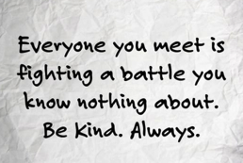
JULIE’S BOOK BLOG
8th May 2018, by Julie

I recently saw this quote on Twitter and felt compelled to share it. On more than one occasion I’ve judged someone’s actions before realizing they were going through something difficult in their life, causing them enough pain to affect their behavior. How do you interpret this quote? What do you think about it? I would love to hear your opinions.

Love, Julie

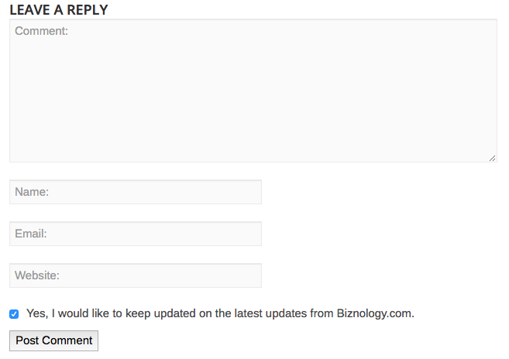

While-Reading

About us
While you read the book, take notes on these aspects:
Name of the main character: __________________________

What’s special about the main character?
What’s weird about him/her?
What’s annoying about him/her?
What makes him/her angry?
What makes him/her really happy?
What makes him/her fearful?
What makes him/her worried?
What’s his/her best quality?
What’s his/her favorite thing?

And now answer the same questions about yourself:

What’s special about you?
What’s weird about you?
What’s annoying about you?
What makes you angry?
What makes you really happy?
What makes you fearful?
What makes you worried?
What’s your best quality?
What’s your favorite thing?

Venn diagram
What do you have in common with that character? Write down key words.
main character
you
Things in common

Favorite quotes

As you read the text, make sure to note down your favorite quotes and/or passages. Think about why you chose them. You will need these later on in task number 13! You can do this in whatever way you find the easiest (page numbers, post-its, highlighting, copying them…)

Post-Reading

How did it make you feel?
Now that you have read the book, look at the faces below and tick how you feel about this book. You can also tick more than one.
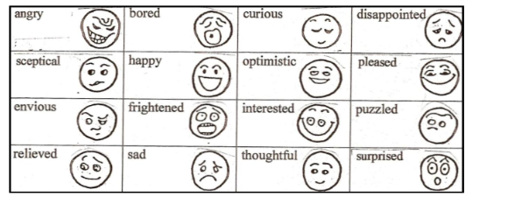

Acrostic poem
You are a poet and decided to write an acrostic poem with the first name of a character in your book. In an acrostic poem, the first letters of the first name of a character spell out a word or phrase that describe him or her. You can find an example below. If you want to, you can use the information you have collected in the activity number 6.

An acrostic poem
Can be about anything
Really.
Of course, some people like to
Start each line as a sentence,
Though
I prefer weaving words into a
Creation that is more freeform.

Time travel

You are your favorite character from the book and it is 2030. Write a journal entry of the day of your birthday. How are you doing? What are you up to? How do you feel? What have you done today? Have you celebrated? How? With whom?

Discussions
Choose a few of these prompt cards and discuss them with your group. Note down a few keywords about what you have talked about.
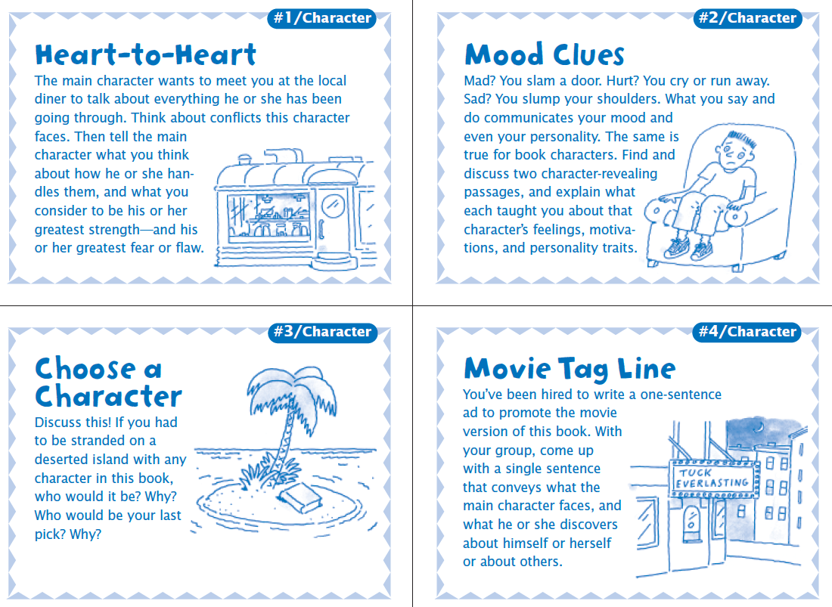
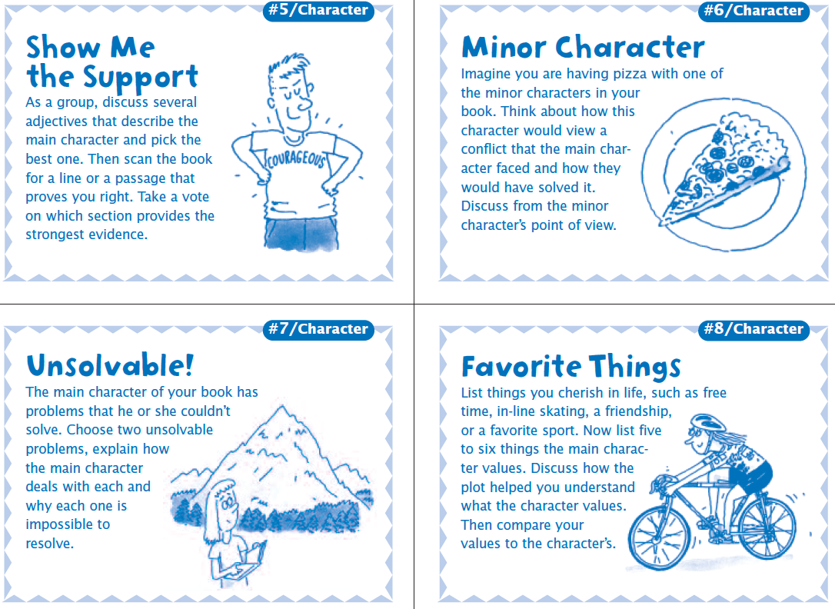
Just add the cource at the bottom.
Here is some space for your notes:

Share your favorites
Get together in groups and share your favorite passages and /or quotes you noted down in activity number 8. At first, read them out aloud and then explain why you chose these ones in particular. What are they about? Why are they important? Do they reveal anything about the character? Are they important for the development of the story? What do they make you feel?
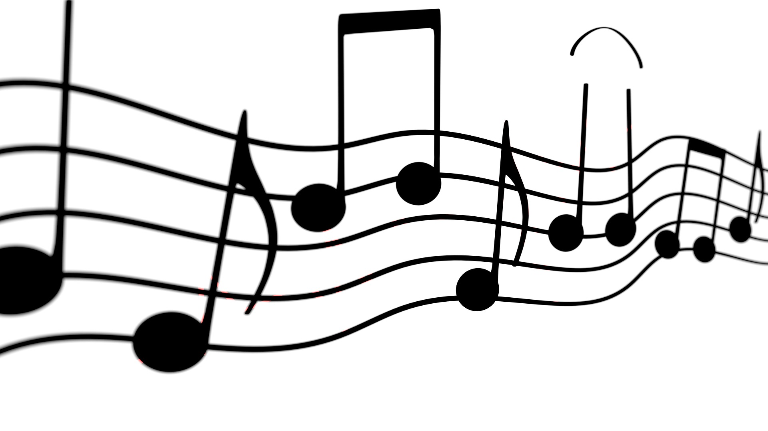

A song for you
“Beautiful” by Christina Aguilera
- Make yourself familiar with this song. If you want to, consult this website and play one round: https://lyricstraining.com/en/play/christina-aguilera/beautiful/H0ZDLkEHb0

- The song emphasizes the message that “words can’t bring you down”. Write down at least three tips for someone who struggles to stay positive when other people say mean things to them.

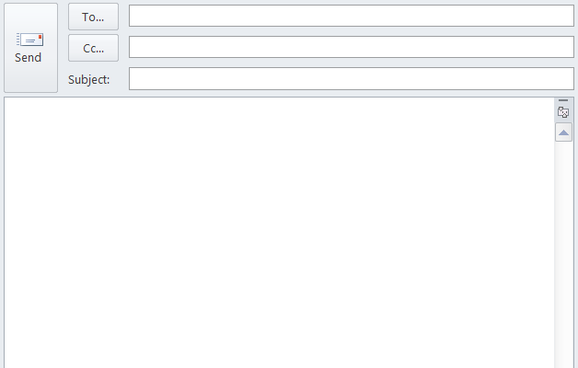
- Would you recommend this or another empowering song to the main character of your book? Write him/her an E-Mail and explain why.

Generation Snowflake
The media has been suggesting that the millennial generation are snowflakes, as they are too sensitive to the world around them. They would get offended and upset by things that have nothing to do with them directly, but might offend and upset someone else.
Is this negative as it means we are less emotionally resilient, or does it mean we are getting closer to a peaceful world if everyone can understand why something upsets someone else? Take notes about your thoughts and be ready to discuss it. Then, share your opinion with others and answer this question in the group.

Is the sensitive nature of the 'snowflake' generation a positive?
The suggestion is that, like snowflakes, these people are that they are delicate individuals and a slight increase in temperature will see them melt, often resulting in a high emotional response.

a) Yes
b) No
c) Not Sure
If you want to, here’s an interesting video about this topic: https://www.youtube.com/watch?v=iKcWu0tsiZM

Book presentations

Now that you have finished reading your book, it is time to get creative! In pairs or small groups, record a book review on Flipgrid.
Use the code ____________________
This is going to be your book presentation. As a homework, watch some other videos and leave a comment.
A few tips for you:
- pick out what is important about your book
- be structured and concise so that others understand
- make it appealing for others
- no spoilers
- don’t read but really speak!
If you need inspiration, you can consult this website:
http://www.readingiscool.xyz/.

Reading is cool, right?

References

Pölzleitner, Elisabeth (2018). “Teaching Literature and Culture.” Unpublished course handout. Summer term 2018. English Department, KFU Graz.
http://www.teacherpage.com/engage/docs/50_Fabulous_Discussion_Prompt_Cards_for_Stories.pdf
https://metro.co.uk/2018/01/10/what-is-the-snowflake-generation-7218112/?ito=cbshare

Pictures:
https://www.amazon.de/Perks-Being-Wallflower-Stephen-Chbosky/dp/1847394078
https://www.amazon.de/Curious-Incident-Dog-Night-time/dp/0099470438
https://www.amazon.de/13-Reasons-Why-Jay-Asher/dp/0451478290/ref=sr_1_1?s=books-intl-de&ie=UTF8&qid=1528615784&sr=1-1&keywords=thirteen+reasons+whyhttps://www.amazon.de/Thirteen-Reasons-Why-Jay-Asher/dp/159514188X
https://www.amazon.de/Wonder-R-J-Palacio/dp/0553509977/ref=sr_1_1?s=books-intl-de&ie=UTF8&qid=1528616255&sr=1-1&keywords=wonder
https://tex.stackexchange.com/questions/229919/background-notebook-template-with-spiral
http://bonafideconsulting.co.nz/2016/05/25/just-be-kind/

