Being Special –
Reading Project


Book choosing

Read through the various extracts and fill out the table. Award and find your favourite book:
Book title and   | New words per page | Other comments about the book:
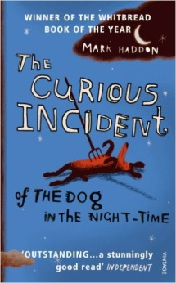 |  | Type of book:  Plot prediction:  Characters:  Settings:
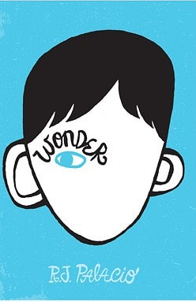 |  | Type of book:  Plot prediction:  Characters:  Settings:
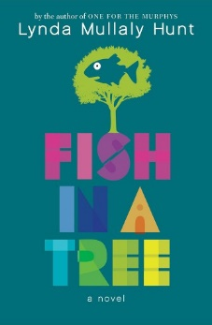 |  | Type of book:  Plot prediction:  Characters:  Settings:
 |  | Type of book:  Plot prediction:  Characters:  Settings:

Activities:
Write everything into your reading booklet.
Pre- reading activities:
  on your own | Getting ready | Imagine what might happen in your book. For this task you have to write down what you expect from the book in a 7-minute free-writing activity. Use the following expressions and the “will” future.  - I hope that …  - I wonder if …  … will …  - I bet that …  - I’m afraid that …  - I (don’t) think that …

  on your own | Research | Before reading the book, do some online research about your main character’s disability. Also consider the problems of children who are of school age with that disability.  Take notes of the most important information.

book | main character’s disability
The Curious Incident of the Dog in The Night-Time | Asperger’ Syndrome
Wonder | Mandibulofacial Dysostosis
Fish in a Tree | Dyslexia
Out of My Mind | Celebral Palsy

Name of the character’s disability:
What it means to have this disability:

Let’s start reading!
While Reading:
Start reading!
  on your own | Get together with your classmates who have chosen the same book (3-4 students) and start reading. Read quietly for 20 minutes.  Read slowly and imagine the scenes and characters as vividly as possible.
After 20 minutes, meet to discuss your reading. Write down some notes to the questions below.
  in your group | Setting | Where and when does your story play? Find a passage in the text where the setting (place and time) is described. Highlight it and copy a few important details.

in your group | Characters | List all the characters that you have met so far. What do you know about them? Who are they? What is their role in the story? What mood are they in? Do you like/dislike them? Do you trust/ mistrust them?

  in your group | Finding new phrases and expressions | Each of you should find one new phrase or expression that you would like to remember. Highlight these phrases in your book and write them on the front of a vocab card.  Draw something or write down a sample sentence to help you remember the meaning of your phrase/expression.

  in your group | Questions I have about the book | Each one of you writes down one question that you have in mind now. What is it that you would like to know about the book? Share your questions and write all of them into this reading booklet.

in your group | Being special and its problems | In your reading group discuss the book you are reading. Focus on the main character’s experience of being special. Take down some notes.  - How does he/she see the world?  - What are his/her problems and obstacles?  - What are his/her strengths?  - What are his/her dreams, hopes and wishes?  - What does your main character have in common with his/her friends and peers?  - Does your character’s behaviour match the information about the disability you found on the internet in the Pre-reading activity?

After Reading:
  in pairs | Walking in someone else’s shoes | In pairs, prepare a 5 minute show of the world seen through your main character’s eyes. Upload your power-point presentation on knovio.com and record your voice commentary. Think of your character’s world, his/her environment, things that are important to him/her. The title of your presentation will be: “Walking in someone else’s shoes” (use your character’s name: “Walking in …………’s shoes”)  Share your talking time equally.

in pairs | Being special in school | Talk about the following questions:  - How does your character feel about school?  - How does he/she fit in with his/her classmates and what makes him/her different from the rest of the children in their class?  - What would be your main characters’ ideal school situation?

on your own | Dear Diary, … | Write a diary entry about an event happening in your book from the perspective of a friend, a neighbour, a sibling or a teacher of your books’ hero. Your main character should also be included in this event.  Put yourself in the characters’ shoes:  - What would they see?  - What would they hear?  - What would they feel?

on your own | Letter to the editor | Write a letter to the author of your book.  You can …  - tell the author what you liked and disliked about the book  - tell the author what you would like him/her to know  - ask the author questions you might have  - suggest a different ending

Book sharing
On your own:
Prepare the following things for the book you have read:
 | 5 Nouns  - things, objects, … | Choose 5 things that play an important role in your book and write them on the cards provided.  Example for The Hunger Games: arrow, berries, bread, cave, brooch
 | Big Trouble | Choose a passage in the book where one of the main characters is in trouble, has a problem or is very sad. Practice reading this passage so you can later read it out to your group. ~ 1-2 pages
 | Happy Moments | Choose a passage in our book where your main character is happy. Practice retelling this moment with your own words.
 | Important Adjectives | Find three adjectives in your book that you think are important for the story. Choose new and interesting adjectives – ones not everyone knows.  Write the adjectives on the FRONT of a card and the sentence you found in the book on the BACK.

Group Phase:
Work in groups of 4 with classmates who have read books you do not know yet.
 | Guess what … | your book: Show your noun and adjective cards to your group and have them guess how the words are related to the story.  Do not give away the endings and solutions!!  other books: ask a lot of questions and find out as much as possible about the characters, their problems, their wishes and their hopes.
 | Big Trouble | Read the passage you have chosen to your friends and explain why your character feels sad.
 | Happy Moments | Share the happy story you have been practicing with your group. Answer their questions afterwards.
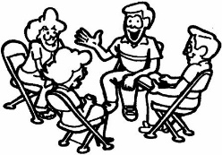 | Important Adjectives | Put the adjective cards of one student on the desk only show the adjectives, not the sentences!  Copy all the adjectives in your reading booklet and guess their meaning. Then discuss your ideas.  Now turn over the cards and look at the sentences. How can they help you guess the correct meaning of the new words?  Now ask the student who has written the cards to explain the meaning and write it into your vocabulary book.

 | Homework | Add a second sentence to the adjectives you have written down. Use the new words in TRUE sentences and write them into your vocabulary book.
in your groups | Presentation | In your reading groups prepare a 10- minute presentation for your classmates. The goal of the presentation is to give your audience a deeper understanding of the book and to make your listeners interested in reading the book. Use different activities we have discussed before e.g.: Plot on the line, Plot diagram, museum, paintings, acting…  Also include some interesting information on the disability of the main character – keep it simple and short.
Group Phase: Important Adjectives

