Reading Project: Friendship in Troubled Times
By Johanna Grünwald and Mirjam Höfler WS 2015/16

TEACHER’S INSTRUCTIONS
Age/level: Year 5 (15 or 16-year old students)
Theme/topics: Importance of friendship, problems and difficulties in teenager’s lives and their effect on friendships, fights and reconciliation in friendships
Books: The Outsiders (1967) by S.E. Hinton → for boys; short and easy to read
Speak (1999) by Laurie Halse Anderson → for girls; short and easy to read
The Kite Runner (2003) by Khaled Hosseini → for advanced readers
It’s Kind of a Funny Story (2006) by Ned Vizzini → easy to read

TABLE OF CONTENTS Page
Pre-reading activities: to be done in class before choosing and reading the book
Asking the Question: What is Friendship? (Individual and pair work) 2
Providing the Answer: Friendship is … (Individual work) 3
Free writing: Struggles in Friendships (Individual work) 4
Book-choosing: to be done in class or at home 6
While-reading activities: to be done at home (in no particular order) while reading the book
Expand your Vocabulary (Individual work) 8
Completing the Circle (Individual work) 9
Find Quotes and Take Notes (Individual work) 10
The Other Side of the Story: Diary Entry from the Friend’s Perspective (Individual work) 11

Post-reading activities: to be done in class or at home (in no particular order) after reading the book
Sum it up (Individual work) 12
Creative Catalog (Individual and pair work) 13
Giving Advice (Individual work) 14
Back to the Future: What WhatsApp Would Have Changed (Group Work) 15
Sharing and Comparing (Group Work) 16
OPTIONAL TASK:
Film Adaptations: Putting a Face to the Name (Individual Work) 17

Presentations 18

Reading Project

FRIENDSHIP IN TROUBLED TIMES

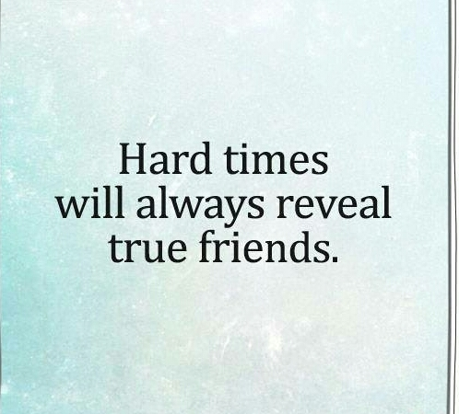

The Outsiders by S.E. Hinton
Speak by Laurie Halse Anderson
The Kite Runner by Khaled Hosseini
It’s Kind of a Funny Story by Ned Vizzini
PRE-READING ACTIVITIES
Asking the Question: What is Friendship?
Read the following quotes about friends and friendship. Pick the two you most agree with and one you disagree with. Then, find a partner and discuss your view on friendship based on the quotes you chose. Consider the following questions:
- What do you expect of a friend?
- What should a friend tolerate?
- How does true friendship look like?
Friends show their love in times of trouble, not in happiness. – Euripides, 5th cent. BC
My best friend is the man who in wishing me well wishes it for my sake. – Aristotle, 350
Friendship needs concrete actions.
My best friend is the one who brings out the best in me. – Henry Ford, mid 19th cent.
Friends share values.
Without friends, no one would want to live, even if he had all the other goods. – Aristotle, 350
Friendship needs generosity.
In true a friendship we can be whoever we want to be.
Because he is himself and I am myself. – Montaigne, 1595
Everybody can be a friend.
The only way to have a friend is to be one. – Ralph Waldo Emerson, 1830s/40s
There is nothing on this earth more to be prized than true friendship. – Thomas Aquinas, mid 13th cent.
Providing the Answer: Friendship is …
As you might have noticed, some of the quotes in the previous activity are definitions of friendship. Many philosophers, among them Aristotle (384-322 BC) and Montaigne (1533-1592), have already thought about how to define friendship. Just like them, you have reflected on what friendship means to you. Now you need to formulate your personal definition of friendship. Use your own ideas to finish the sentences and fill in the boxes below.
Friendship is

Friends should not
A real friend is
Free writing: Struggles in Friendships
In life, certain events might challenge or even threaten friendships. Think about what these events could be and to what consequences they might lead. Start writing and don’t stop for ten minutes. In class, a timer will be set to help you keep track of time. In your writing you can jump from one idea to the next, ask questions or refer to your own experiences, if you want to. Everything is allowed – there is only one rule: YOU MUST NOT STOP WRITING!

BOOK-CHOOSING

Read the short summaries and sneak peeks at the first pages of the books and think about which one you want to read for this project. If you need more information before making a final decision, do some online research about the books.
The Outsiders (1967) by S.E. Hinton
Short summary:
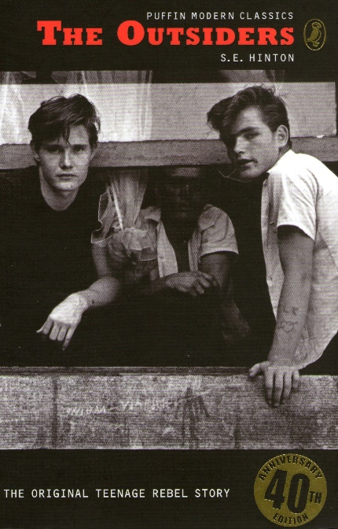
The Socs’ idea of having a good time is beating up Greasers like Ponyboy. Ponyboy knows what to expect and knows he can count on his brothers and friends – until the night someone takes things too far.
Sneak peek at the first page:
When I stepped out into the bright sunlight from the darkness of the movie house, I had only two things on my mind: Paul Newman and a ride home. I was wishing I looked like Paul Newman – he looks tough and I don’t – but I guess my own looks aren’t so bad. I have light-grown, almost-red hair and greenish-gray eyes. I wish they were more gray, because I hate most guys that have green eyes, but I have to be content with what I have. My hair is longer than a lot of boys wear theirs, squared off in back and long at the front and sides, but I am a greaser and most of my neighborhood rarely bothers to get a haircut. Besides, I look better with long hair.
Speak (1999) by Laurie Halse Anderson
Short summary:
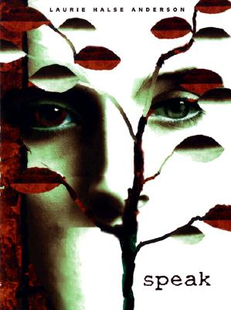
Melinda Sordino busted an end-of-summer party by calling the cops, so her old friends won’t talk to her, and people she doesn’t know hate her from a distance. It’s no use explaining to her parents; they’ve never known what her life is really like. The safest place for Melinda is to be alone, inside her own head. But even that’s not safe. Because there’s something she’s trying not to think about, something about the night of the party that, if she admitted it and let it in, would blow her carefully constructed disguise into smithereens.
Sneak peek at the first page:
It is my first morning of high school. I have seven new notebooks, a skirt I hate, and a stomachache.
The school bus wheezes to my corner. The door opens and I step up. I am the first pickup of the day. The driver pulls away from the curb while I stand in the aisle. Where to sit? I’ve never been a backseat wastecase. If I sit in the middle, a stranger could sit next to me. If I sit in the front, it will make me look like a little kid, but I figure it’s the best chance I have to make eye contact with one of my friends, if any of them have decided to talk to me yet.
The Kite Runner (2003) by Khaled Hosseini
Short summary:
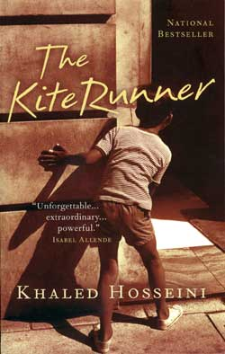
1970s Afghanistan: Twelve-year-old Amir is desperate to win the local kite-fighting tournament and his loyal friend Hassan promises to help him. But neither of the boys can foresee what will happen to Hassan that afternoon, an event that is to shatter their lives.
Sneak peek at the first page:
I became what I am today at the age of twelve, on a frigid overcast day in the winter of 1975. I remember the precise moment, crouching behind a crumbling mud wall, peeking into the alley near the frozen creek. That was a long time ago, but it’s wrong what they say about the past, I’ve learned, about how you can bury it. Because the past claws its way out. Looking back now, I realize I have been peeking into that deserted alley for the last twenty-six years.

It’s Kind of a Funny Story (2006) by Ned Vizzini
Short summary:
Ambitious New York City teenager Craig Gilner is determined to succeed at life – which means getting into the right high school to get into the right college to get the right job. But once Craig aces his way into Manhattan’s Executive Pre-Professional High School, the pressure becomes unbearable. He stops eating and sleeping until, one night, he nearly kills himself. Craig’s suicidal episode gets him checked into a mental hospital, where his new neighbors include a transsexual sex addict, a girl who has scarred her own face with scissors, and the self-elected President Armelio. There, Craig is finally able to confront the sources of his anxiety.
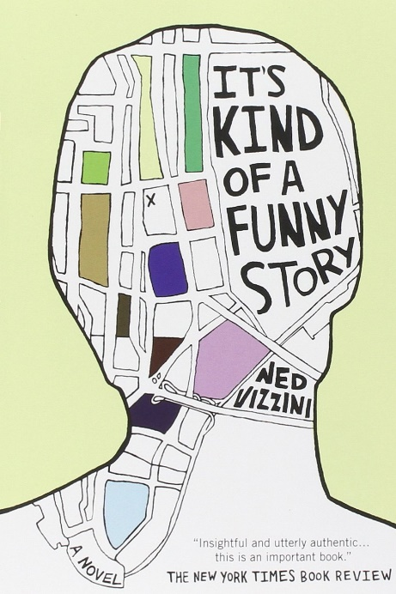
Sneak peek at the first page:
It’s so hard to talk when you want to kill yourself. That’s above and beyond everything else, and it’s not a mental complaint – it’s a physical thing, like it’s physically hard to open your mouth and make the words come out. They don’t come out smooth and in conjunction with your brain the way normal people’s words do; they come out in chunks as if from a crushed-ide dispenser; you stumble on them as they gather behind your lower lip. So you just keep quiet.

WHILE-READING ACTIVITIES
Expand your Vocabulary
Vocabulary work: While reading, you will come across idiomatic language and new expressions. Pick at least ten that sound interesting and that you think will be useful to you. Write down the English vocabulary item you want to remember, the sentence where you found it in the text and a short explanation of the new expression in English.
 | Vocabulary Item/  Expression | Example Sentence | Explanation
1
2
3
4
5
6
7
8
9
10
Completing the Circle
Vocabulary work: Chose one item from your vocabulary list and put it in the top circle. Find another word from the list that is somehow connected to the first word and enter it in the next circle. Explain the connection you see between these words by short notes next to the arrows. Use other words from your list to go on like this until you’ve come full circle.

Find Quotes and Take Notes
One of the topics your book deals with is friendship and the main character’s views on what is important in a friendship might differ from yours. At some point, the protagonist’s friendships will be challenged and they will try to save them. Their problems and choices might be of interest to you, so when you come across a part that contains interesting insights into friendship, write down the corresponding quote in the table below.
While working on the post-reading activities, you can then compare your quotes with a partner and explain why you chose them.
Page | Quote | Reason why I like it

The Other Side of the Story: Diary Entry from the Friend’s Perspective
Writing task: After reading a few chapters, you have learned how the protagonist views the situation they are in, but there are always two sides to every story. Imagine you are the friend of the protagonist, who has done something to make you question your friendship. Write a diary entry explaining your view of the situation. State how you feel about what the protagonist has done, what you think about your friendship and what the protagonist should do to resolve your issues.

POST-READING ACTIVITIES
Sum it up
Visualize the most important events or the most important characters in the story by drawing
- a plot diagram
or
- a sociogram (see explanations below).
This will help you to remember the key scenes when you present your book to others who have read a different book.

Plot Diagram: Draw a “fever curve” of the ups and downs of the novel (peaks of suspense or conflict) and label the curve. You can do it from the main character’s point of view or from your perspective as the reader.
Sociogram¹: Think about the main characters in your book and suitable symbols to represent them. Then create a sociogram showing the relationships between the characters. Show (close) friendships, rivals and enemies, good and bad characters.

Creative Catalog
Imagine the main character in your book has a “treasure box” where they keep personal things that are very important to them and you get to look into this box. Sketch and describe five things the character owns that symbolize their friendship with their best friend (for example objects or photographs of shared memories). After you have created your list, compare your items with those of a partner who has read the same book.
Object 1:

Object 2:

Object 3:

Object 4:

Object 5:

Giving Advice
Writing task: The main character in your book has faced several problems and made some difficult decisions that you may or may not agree with. Put yourself in their shoes and write a letter of advice to your book’s protagonist. In this letter
- Describe how you would have behaved if you had been in their situation
- State your opinion on their most important decisions
- Mention what you might have done differently and explain why you would have acted in this particular way

Back to the Future: What WhatsApp Would Have Changed
Group discussion in your book group: Nowadays, most teenagers use new media, such as Facebook or WhatsApp, to communicate and to cultivate their friendships. In the book you have read, the internet and smartphones do not play a role in the characters’ friendships. However, imagine what effect it would have on the story, if this were the case and discuss the following questions. Take some notes during the discussion.
- What would have happened if the main character in your book had had access to new forms of communication like Facebook or WhatsApp? Would this have solved or complicated their problems?

- What misunderstandings might have been avoided and which additional problems might have been added to their lives and friendships?

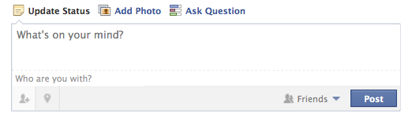
- Pick one particular moment in your book and think of a short Facebook status the main character would have posted:
Sharing and Comparing
Group discussion: Form a group with two other students who have read two different books. Tell each other about your books. Find out what your books have in common and how they differ. Collect similarities and differences in the Venn-Diagram below. Focus on:
- Similarities concerning plot and topics
- The main characters
- The protagonist’s problems
- The protagonist’s way of solving the problems
Book 2:

Book 1:

Book 3:
OPTIONAL TASK
Film Adaptations: Putting a Face to the Name
Writing task: Watch the movie that is based on your book and write a film review for your school’s student magazine. Give a short plot summary and answer the following questions:
- How does the movie differ from the book? Why do you think these changes were made?
- What do you think about the actor who has been cast as the protagonist? Do they fit for the role or would you have imagined the character in a totally different way?
- Which one do you like better, the book or the movie? Why?

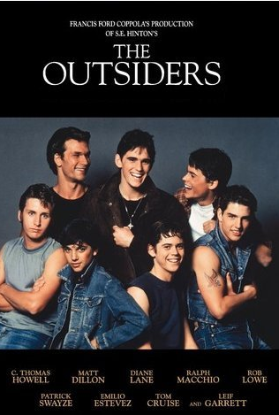




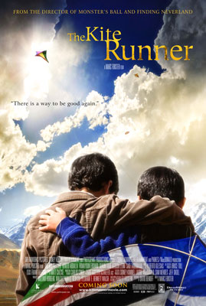



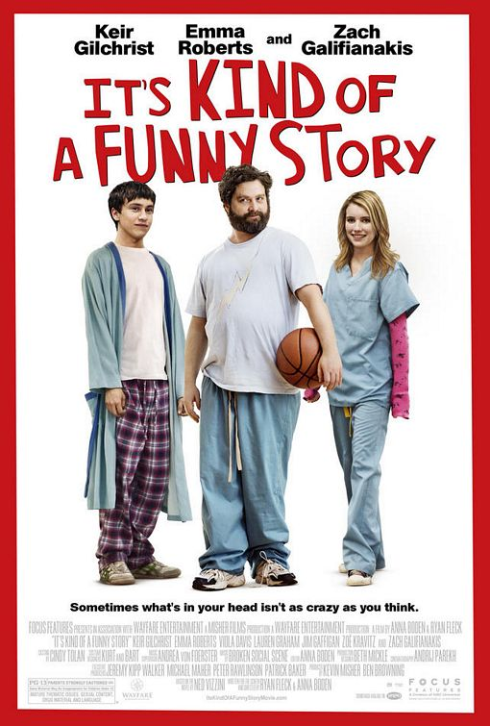

PRESENTATIONS
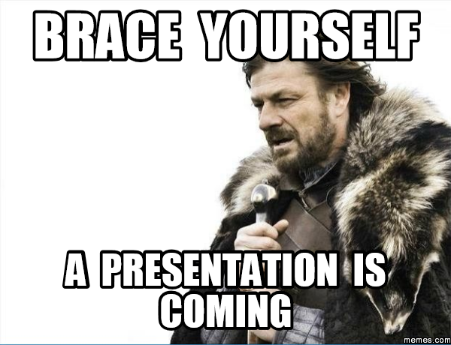
Prepare a presentation to introduce the book you have read to your classmates. Make sure that it is interesting and entertaining – it should motivate the others to read your book!
Group size: Form groups of four or five. All group members must have read the same book.
Length: Make sure your presentation is 15 to 20 minutes long. Think carefully about its content and structure, and make sure that everybody contributes to the presentation.
Activities: It is important that you choose activities that are appropriate and meaningful for your story. Make sure that you include information about the plot, the setting and the characters. Keep in mind that your classmates have not read the book. They want to get a good impression of what your book is about, but don’t bore them with unnecessary details. Read the following sample ideas for your presentations. You can chose some of these activities, but feel free to come up with your own ideas as well!
PLOT
Present an alternative book cover and blurb: Be sure the illustration relates to an important aspect of the book. Use appropriate colors to evoke the atmosphere created by the book.
Plot on a line or Storyboard: Write seven to ten main events on separate sheets. Add simple drawings and illustrations. In your presentation hang up one picture after the other using clothes-pegs and a string or stick your pictures on the board with magnets or blue-tack. Talk about each picture using your own words. Don’t give away the ending.
Act out a scene of your choice: Use simple props and costumes. (This activity works well in combination with the “plot on the line” activity because you can use the “plot on the line” to explain at what point in the story the scenes happen.)

SETTING
Create a setting pop-up or a painting that shows the most important place(s) in the book.
Draw a simple map of the locations in your novel. Make sure the map is large enough so your classmates can read it clearly. Attach a legend to your map. Write a paragraph that explain the importance of each location indicated on your map.

CHARACTERS
Identity bags/ character suitcase: Bring a bag full of objects that are somehow important to the main character of your book. Show them and explain their relevance.
Sociogram: Choose suitable buttons to represent the main characters of the book. Then make a sociogram showing the relations between the characters. Show (close) friendships, rivals and enemies, good and bad characters.

OTHER IDEAS
A Novel Museum: Display 10 to 15 items that play a significant role in the book. Imagine that the characters in your book were REAL people. You want to make their story public and have dedicated a whole room in a museum to these people and their stories. Present the real artefacts from your characters’ lives nicely in showcases on tables around the room. Label each object, explaining the importance of the item, where it is from and what role it played. You might show: maps, short newspaper articles, diary pages, letters, photos, or clothes. Act like tour guides and present the artefacts to the class. Explain the significance of each item.
Write a poem or song lyrics that might be used in a film or radio-play of your book. Present your poem or sing your song. Maybe other classmates can sing along or accompany you on a guitar. You can also use a CD for background music.

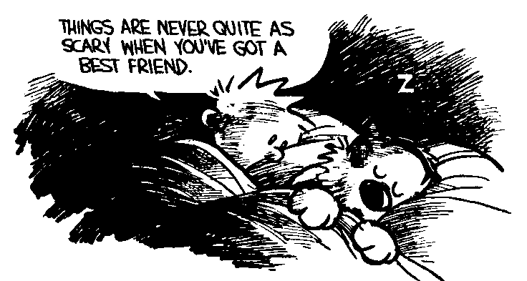

Taken from epep.at
Taken from epep.at
Taken from the course handout for “Teaching Literature and Culture PS4” by Elisabeth Pölzleitner (English Department of the University of Graz)

