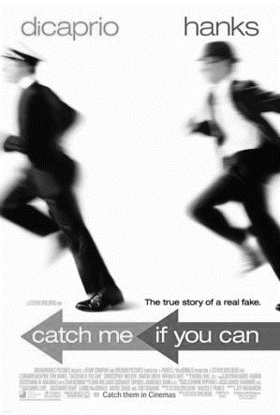
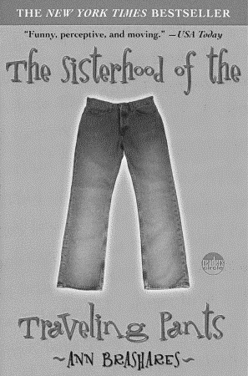

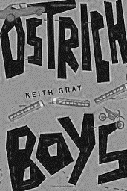
Journeys
Journeys

This booklet belongs to …………………………………………….
The book I have chosen is…………………………………by……………………………

Making predictions
I hope that………………………………………………………………………………………
I wonder if……………………………………………………………………………………....
I bet that………………………………………………………………………………………...
I’m afraid that…………………………………………………………………………………..
I think that………………………………………………………………………………...........
I don’t think that………………………………………………………………………………..

Deadline
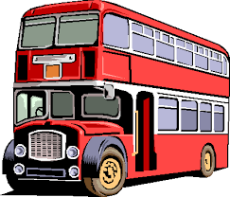
Read your book by……………………………………………



Note:
When you see this symbol next to a task it means this task is conducted in school.

1.Pre- reading activity
A chance of a lifetime!
Win a trip to a destination of your choice by describing your perfect holiday.
Where would you go and why did you choose this destination?
Who would you take with you?
What would you like to see there?

____________________________________________________________________________________________________________________________________________________________________________________________________________________________________________________________________________________________________________________________________________________________________________________________________________________________________________________________________________________________________________________________________________________________________________________________________________________________________________________________________________________________________________________________________________________________________________________________________________________________________________________________________________________________________________________________________________________________________________________________________________________________________________________________________________________________________________________________________
In addition to describing your perfect trip above, also prepare a presentation for the class. Add pictures, videos or anything else that are necessary to present your dream trip to your classmates. The best presentation will win a price!


The 7 Types of Travelers:
Listen to the video and take notes.
After we have listened to it twice you will have time to discuss the different types of travelers in pairs. Maybe you can come up with additional advantages and disadvantages for each travel type.
1.Type of traveler:______________________________________________________________
Characterization: _______________________________________________________________
Advantages:___________________________________________________________________
Disadvantages:_________________________________________________________________

2.Type of traveler:______________________________________________________________
Characterization: _______________________________________________________________
Advantages:___________________________________________________________________
Disadvantages:_________________________________________________________________

3.Type of traveler:______________________________________________________________
Characterization: _______________________________________________________________
Advantages:___________________________________________________________________
Disadvantages:_________________________________________________________________

4.Type of traveler:______________________________________________________________
Characterization: _______________________________________________________________
Advantages:___________________________________________________________________
Disadvantages:_________________________________________________________________

5.Type of traveler:______________________________________________________________
Characterization: _______________________________________________________________
Advantages:___________________________________________________________________
Disadvantages:_________________________________________________________________

6.Type of traveler:______________________________________________________________
Characterization: _______________________________________________________________
Advantages:___________________________________________________________________
Disadvantages:_________________________________________________________________

7.Type of traveler:______________________________________________________________
Characterization: _______________________________________________________________
Advantages:___________________________________________________________________
Disadvantages:_________________________________________________________________

What type of traveler are you??

__________________________________________________________
2.While reading activities
Dear Diary……
Take on the role of one of the characters from your book and write a diary entry about what has happened so far, how you feel and what your next moves will be.

Dear Diary
__________________________________________________________________________________________________________________________________________________________________________________________________________________________________________________________________________________________________________________________________________________________________________________________________________________________________________________________________________________________________________________________________________________________________________________________________________________________________________________________________________________________________________________________________________________________________________________________________________________________________________________________________________________________________________________________________________________________________________________________________________________________________________________________________________________________________________________________________________________________________________________________________________________________________________________________________________________________


Trip essentials vs. the right tunes
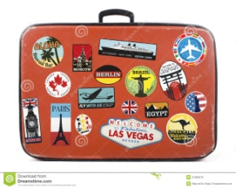
Design either a playlist that matches your characters´ journey or a list of items that you would take with you on their trip. Dare to be creative and explain why you’ve chosen these songs or items.

1.
Reason:
2.
Reason:
3:
Reason.
4:
Reason:
5:
Reason
6:
Reason:

Vocabulary Work
Collect 5 (or more) words or phrases from your book you want to remember.
Use them to complete the table below by writing them down, using them in a sentence and drawing something next to it that makes you remember the term.
Piece of vocabulary | Used in a sentence: | Drawing
to have itchy feet (idiom) | I have itchy feet; I really want to travel again. | 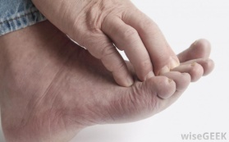

Additional note: Write the new terms also on a separate sheet of paper and bring them to class with you. We will need them later for a little game

3.Post reading activities:
Writing vs. Speaking
Choose one of the two activities below:
- Tell your classmates a story from a trip you have taken. It can be any story, but prepare it well!
- Points of View: What I would have done…
Think of one of the characters in the novel you have just read. Think of their actions, decisions and opinions. Did you disagree with any of them? Fill in the following diagram and explain what you would have done differently and how this would have influenced the story.
Character’s name:
Actions/Decisions

My point of view:

What I would have done:

If…………………………………………………………………………………………………….
had…………………………………………………………………………………………………..

Quotes, Quotes, Quotes, Quotes, …

“To travel is to take a journey into yourself” by Danny Kaye

“All journeys have secret destination of which the traveler is unaware”

Look at the two quotes above and answer the questions in pairs:

- How do these quotes apply to the characters in your book?
- What kind of journey do they take?
- In what ways does the journey alter the characters´ lives?
- Can you relate to the quotes?


Homework Task: Scrapping away
Design a double scrapbook page in your reading diary. Add information about the countries/states your characters have visited on their journeys.

Preparation for your book presentations
Plot diagram
Get together with the people who have read the same book and draw a plot diagram into your booklet. Also design a big one on an A3 sheet for your book presentation later.


Mapping out the world
Pick a suitable map where you can mark the cities/countries/states your main characters have visited on their journeys. Glue it into this booklet. If you want to, you can also include it in your presentation.

Novel Museum + Playlist Concert

In your group choose five from the items from your “Trip Essentials” list that you would like to present in your novel museum. Also pick 3 songs you think are best to represent your novel and play parts of them to your classmates in your presentation.

Checklist for your presentation:
- Present the plot diagram
- Show us the map you have chosen to make the character´s journey more feasible (optional)
- Tell us about the main characters and their character traits
- Prepare the items for the novel museum (these items might be the same as the ones you have chosen for the Trip Essentials task)
- 3 songs

