Teacher notes to reading project „Journeys“+ sources
This book project was designed for a 5th grade.
Catch Me If You Can by Frank W Abagnale
The Sisterhood of the Travelling Pants by Ann Brashares
Ostrich Boys by Keith Gray
Amy and Rodger´s Epic Detour by Morgan Matson
Book choosing in class
We planned to do the activity we did in class where the students read the first couple of pages for each book, have to complete a table to chose their book. (cf Pölzleitner 2015: 9)
Speed- dating: Topic: travelling
Students form two circles facing each other. The teacher provides them with an incentive related to travelling and each student has to talk with the person faces them. After two minutes the teacher tells the outer circle to move 4 spaces to the left and provides a new incentive.
Those incentives can be “All inclusive holiday or backpacking trip- what do you prefer?” or “Beach vs mountains” or “Travelling by plane vs travelling by train- the advantages and disadvantages”
The booklets are distributed and the students can complete the 2nd page in the booklet.
(Making predictions cf Pölzleitner 2015: 47)
Pre-reading activities
A chance of a lifetime!
The price for the best trip can for example be a chocolate bar.
The 7 Types of Travelers
Listening in the classroom.
Play this video twice: https://www.youtube.com/watch?v=3WuPm-VKlyQ
If the teacher feels that the speaker is too fast, they can pause the video after each description of a Type of Traveler (0:51, 1:39, 2:19, 3:06, 3:36, 4:03)

While- reading tasks
Are conducted as homework tasks or the teacher gives the students time to start them in the lesson (depends on the schedule).

Post-reading:
Vocabulary game (not in the booklet)
Tell the students to sit with the students who have read the same book. Tell them all to put their vocabulary slips from the extra sheet in a bowl. The students then quiz each other on the new terms.
Speaking vs writing:
To increase learner autonomy students have a choice between either a speaking tasks (story telling in front of the class) or completing the Points of View: What I would have done task. (cf Pölzleitner 2015: 71)
Plot diagram (cf Pölzleitner 2015: 65)
Novel museum (cf Pölzleitner 2015: 68)
Source: Pölzleitner Elisabeth. Teaching Literature and Culture – PS 4 (2015). English Department Uni- Graz. ELT Research and Methodology.
Maps students can choose from for the Mapping section:
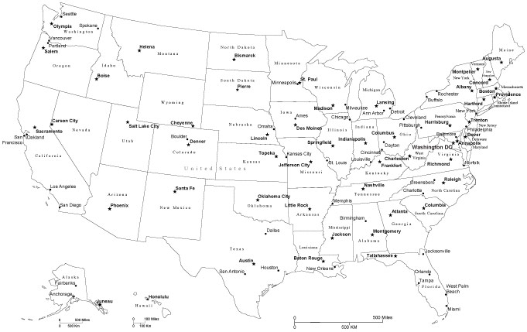
(ideal for Amy and Rodger´s Epic Detour)
http://www.mapresources.com/black-and-white-usa-digital-vector-raster-state-map-usa-xx-113011.html
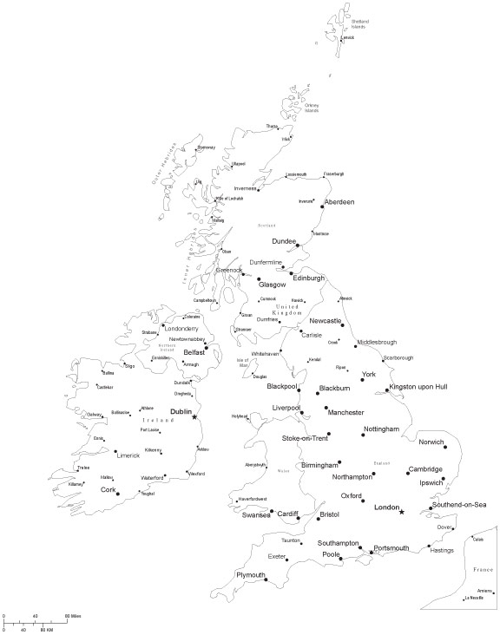
(ideal for Ostrich Boys)
http://www.mapresources.com/black-and-white-united-kingdom-digital-vector-map-gbr-xx-533852.html
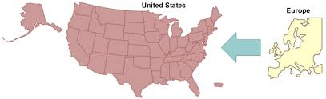
(can be used for both Catch Me If You Can and The Sisterhood of the Travelling Pants) http://efmp.amedd.army.mil/screening/us/location1.html

