Reading Project
Identity Crisis - Life-Changing Experiences

Teaching Literature and Culture, PS 4
Prof. Elisabeth Pölzleitner
SS 2015

Von
Claudia Loidolt &
Theresa Somitsch

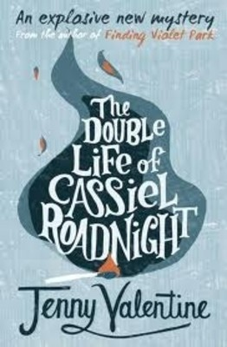
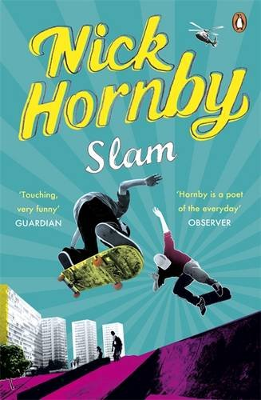
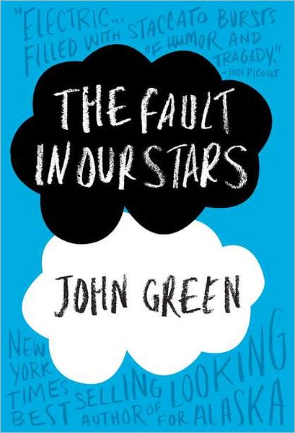
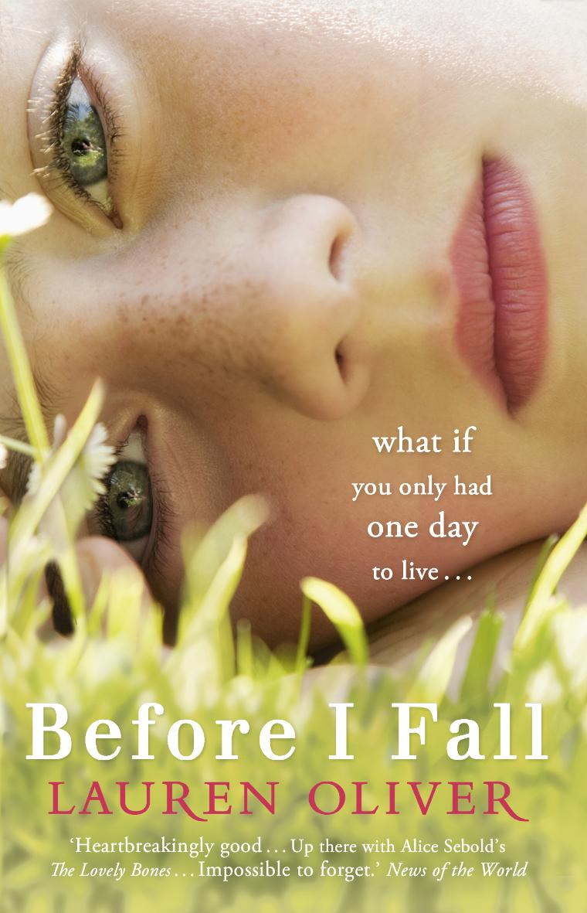
Dear colleagues,
Teenagers go through different phases in their transformation from children to adolescents and, finally, to adults. Most of them do not really know who they are, what they want in life or what their plans for the future are. They are in a state of insecurity which is often reflected in young adult literature. Hence, for teachers it is of great importance to deal with issues of identity crisis in class, being easily achieved by reading selected literature. The overall title of our project is “Identity Crisis – Life-changing Experiences”, subsequently addressing said process of finding oneself during adolescence. This is why we have chosen the following books for our project: SLAM, The Double Life of Cassiel Roadnight, Before I Fall, and The Fault in Our Stars. They all deal in different ways with life-changing experiences during adolescence. Each main character is plagued by the urge to find their true self, what they want to achieve in life, and their expectations of life.
SLAM deals with the life of a teenage boy who unexpectedly becomes a father. The Double Life of Cassie Roadnight is about a homeless teenager who takes on the identity of someone else. Before I Fall considers the life of a teenager who dies in a car accident and gets to relive her last day seven times, every day thinking about what she could have done differently to prevent her own death. The Fault in Our Stars is about a young teenage love and their fight against cancer. Even though the plot lines of the books chosen could not be more diverse, they still have a lot in common in the sense that they all deal with life-changing experiences.
Since most of the characters in the books are about sixteen or seventeen years old, this project is designed for that exact age group. Consequently, we would conduct this book project in seventh grade (level B1+/B2). When creating this project, we had a class size of about twenty students in mind; it should however also work with more or less students. In general the activities serve for each book but some of them vary in their individual instructions (see activity 4, 9 and 10). Part of our project is a final book presentation for which the students may choose from a variety of presentation methods as outlined in the student handout. In addition, you will find templates according to the individual books. In order for you to easily find your way around this paper, we have included an activity overview below.
Best wishes,
Claudia and Theresa
ACTIVITY OVERVIEW

SLAM – Nick Hornby
- Making Predictions ……………………………………………………. page 4
- Book Choosing ………………………………………………………… page 4
- The books have arrived! Let’s start reading ………………………… page 6
- Individual homework ………………………………………………….. page 7
- Character profile ……………………………………………………….. page 7
- Our self within society …………………………………………………. Page 8
- Who are you? …………………………………………………………… page 9
- Making comparisons ………………………………………………….. page 10
- Final Writing Task …………………………………………………….. page 10
- Presentations ………………………………………………………….. page 11

The Double Life of Cassiel Roadnight – Jenny valentine
- Making Predictions ……………………………………………………. page 13
- Book Choosing ………………………………………………………… page 13
- The books have arrived! Let’s start reading ………………………… page 15
- Individual homework ………………………………………………….. page 16
- Character profile ……………………………………………………….. page 16
- Our self within society …………………………………………………. page 17
- Who are you? …………………………………………………………… page 18
- Making comparisons ………………………………………………….. page 19
- Final Writing Task …………………………………………………….. page 19
- Presentations ………………………………………………………….. page 20
Before I Fall – Lauren Oliver
- Making Predictions ……………………………………………………. page 22
- Book Choosing ………………………………………………………… page 22
- The books have arrived! Let’s start reading ………………………… page 24
- Individual homework ………………………………………………….. page 25
- Character profile ……………………………………………………….. page 25
- Our self within society …………………………………………………. page 26
- Who are you? …………………………………………………………… page 27
- Making comparisons ………………………………………………….. page 27
- Final Writing Task …………………………………………………….. page 28
- Presentations ………………………………………………………….. page 29

The Fault in Our Stars – John Green
- Making Predictions ……………………………………………………. page 31
- Book Choosing ………………………………………………………… page 31
- The books have arrived! Let’s start reading ………………………… page 33
- Individual homework ………………………………………………….. page 34
- Character profile ……………………………………………………….. page 34
- Our self within society …………………………………………………. page 35
- Who are you? …………………………………………………………… page 36
- Making comparisons ………………………………………………….. page 37
- Final Writing Task …………………………………………………….. page 37
- Presentations ………………………………………………………….. page 38

SLAM
By nick hornby

- Making Predictions

Find out from your partner what their plans for the next five years are. What are they planning to do after graduation? Do they want to go to university or rather get a job? Are they going to move out from their parents’ house?
Afterwards discuss what could happen differently than expected. Is there something like a worst-case scenario? If so, what is it and how do you think you could prevent it from happening? Have you already had a life-changing experience? Do you believe in destiny?

- Book Choosing
In small groups sit down at one of the arranged tables with a book cover on them. Have a look at the cover and make assumptions about the plot.
- What does the title reveal?
- What do you think might happen to the main protagonist?
- What might the book have to do with destiny?
Answer these questions by filling out the book choosing form! In your groups, write down one question (to be answered with yes or no) about each book which you would like to have answered by the teacher. After five minutes move on to the next table to discuss another book cover!

Book title & author | Rating (1-5) | Other comments
Type of book:

Plot prediction:

Question:

Type of book:

Plot prediction:

Question:

Type of book:

Plot prediction:

Question:

Type of book:

Plot prediction:

Question:

- The books have arrived! Let’s start reading!!!
Get together with your classmates who have chosen the same book as you. Read quietly for about 20 minutes. Afterwards discuss your first impressions of the book in your groups! Answer the following questions:

- What have you gotten to know so far about the main character?

- What is the setting of the book?

- Do you think you could be friends with the main character in real life? If so, why? What do you like or dislike about them?

- 10-minute Free-writing activity (homework)
Read the book until page number 85. The page number marks an important stage in the progress of the book and is striking to one of the main characters’ lives. Write down what you would do if you were in the same situation as this character.

- Character profile
While reading the book highlight passages of the text which describe important aspects of the main character(s) (appearance, character descriptions, values, hopes and wishes, lies, fears,…). Put a sticky note on these pages so that you can find them easily again later on.
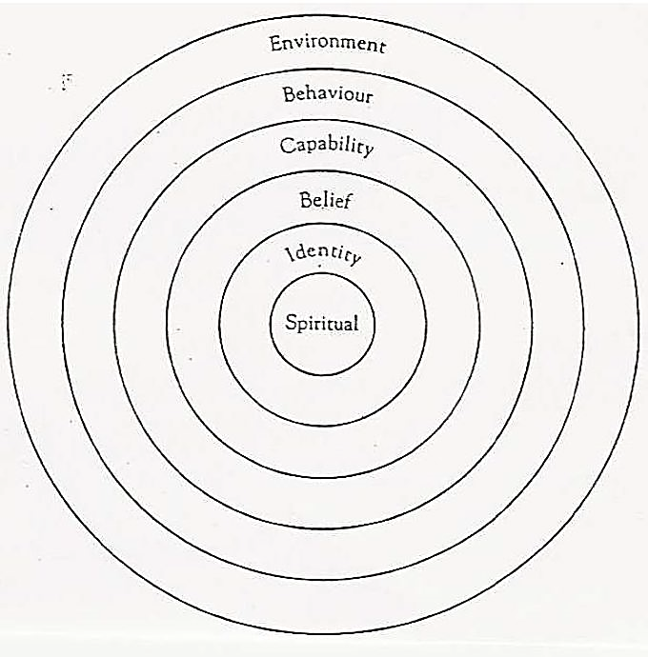
Once you have finished reading the book, fill in the following diagram with the information you have gained about the character.
- Our self within society
https://www.youtube.com/watch?v=ikGVWEvUzNM
You are going to watch a short film about the lack of self-identity due to living in our society. Now go together in your groups. You are going to be handed an A3 poster with a question written on it which you should answer. Write down your ideas on the poster. Once you are done, pass your poster on to the next group until you have discussed all four aspects of the movie. Afterwards your group is going to present one poster and its content to the rest of the class.

What is the moment of self-discovery?
What might the Masks stand for?

Why might the girl feel like an outsider?
What function does the mirror fulfill?

- Who are you?
Fill in the following chart with your own features and characteristics. Think about who you are and what defines you. How have your past decisions shaped who you are now? Also think about events that you did not have any control of yourself?

Spiritual
Identity
Behavior
Capability
Environment
Belief
Who am I?

- Making comparisons
Write a short character description (150 words) in which you describe your identity and compare yourself to the main character in the book. Include YOUR position within society, your interests, your family background, your environment, your hopes and plans, etc.! Make use of the charts you have already completed before!

- Final Writing Task
In order to recap the book, you are going to write a text (~ 300 words) about your book. You can find the instructions below:
SLAM
Imagine you are Sam. Write a letter to your son which you will give to him on his 16th birthday about your youth and give him some advice on growing up.

- Presentations

Prepare a 10-minute presentation with your classmates who have read the same book as you. You can choose from a variety of presentation forms which are listed below. Try to be as creative, entertaining and informative as possible but do not give away the ending of the book!

- Movie trailer
Imagine the book you have read was made into a movie and you were asked to create a movie trailer for it. Design a short screenplay and distribute the roles among your group members. You will show your movie trailer during the final presentation session!

- Plot diagram
Draw a “fever curve” of the novel’s ups and downs on a poster. Make sure to address peaks of suspense or conflict etc. and label the curve. In your presentation use your own words to explain each of the events!

- Act out a scene of your choice
Choose one important or significant scene from the book and write a screenplay for it. You can either act it out in class or film that scene and show the video in class. Make sure every group member is allocated a specific task. Use simple props and costumes!
- Movie casting for main character
Each one of your group members is going to attend a casting for one of the main characters in the book. One of your group members should be the casting director and ask the actors and actresses (the other group members) questions about why they think they would be perfect for the role. The actors and actresses should be able to describe the character which they have decided to audition for in as much detail as possible in order to convince the director of their suitability for the job. Perform the casting in front of the class! You may also let the other class members vote on who should get the role.

- Plot on the line
Write seven to ten main events on separate sheets of paper (format: A4). Add simple drawings or illustrations. In your presentation hang up one picture after another using either clothes-pegs and a string, or stick your pictures on the board using magnets or tape. Talk about each picture in order to give your classmates an overview of the events in the book. BUT don’t give away the ending of the book!!!

- Talk show
Each one of your group members is going to take on the role of one of the main characters in your book. One of you should function as the talk show host. The host has to interview the characters about specific events in the books.
List of possible characters:
SLAM:
Sam, Alicia, parents

The Double life of cassiel roadnight
By jenny valentine

- Making Predictions
Find out from your partner what their plans for the next five years are. What are they planning to do after graduation? Do they want to go to university or rather get a job? Are they going to move out from their parents’ house?
Afterwards discuss what could happen differently than expected. Is there something like a worst-case scenario? If so, what is it and how do you think you could prevent it from happening? Have you already had a life-changing experience? Do you believe in destiny?

- Book Choosing
In small groups sit down at one of the arranged tables with a book cover on them. Have a look at the cover and make assumptions about the plot.
- What does the title reveal?
- What do you think might happen to the main protagonist?
- What might the book have to do with destiny?
Answer these questions by filling out the book choosing form! In your groups, write down one question (to be answered with yes or no) about each book which you would like to have answered by the teacher. After five minutes move on to the next table to discuss another book cover!

Book title & author | Rating (1-5) | Other comments
Type of book:

Plot prediction:

Question:

Type of book:

Plot prediction:

Question:

Type of book:

Plot prediction:

Question:

Type of book:

Plot prediction:

Question:

- The books have arrived! Let’s start reading!!!
Get together with your classmates who have chosen the same book as you. Read quietly for about 20 minutes. Afterwards discuss your first impressions of the book in your groups! Answer the following questions:

- What have you gotten to know so far about the main character?

- What is the setting of the book?

- Do you think you could be friends with the main character in real life? If so, why? What do you like or dislike about them?

- 10-minute Free-writing activity (homework)
Read the book until page number 85. The page number marks an important stage in the progress of the book and is striking to one of the main characters’ lives. Write down what you would do if you were in the same situation as this character.

- Character profile
While reading the book highlight passages of the text which describe important aspects of the main character(s) (appearance, character descriptions, values, hopes and wishes, lies, fears,…). Put a sticky note on these pages so that you can find them easily again later on.
Once you have finished reading the book, fill in the following diagram with the information you have gained about the character.
- Our self within society
https://www.youtube.com/watch?v=ikGVWEvUzNM
You are going to watch a short film about the lack of self-identity due to living in our society. Now go together in your groups. You are going to be handed an A3 poster with a question written on it which you should answer. Write down your ideas on the poster. Once you are done, pass your poster on to the next group until you have discussed all four aspects of the movie. Afterwards your group is going to present one poster and its content to the rest of the class.

What is the moment of self-discovery?
What might the Masks stand for?

Why might the girl feel like an outsider?
What function does the mirror fulfill?

- Who are you?
Fill in the following chart with your own features and characteristics. Think about who you are and what defines you. How have your past decisions shaped who you are now? Also think about events that you did not have any control of yourself?

Spiritual
Identity
Behavior
Capability
Environment
Belief
Who am I?

- Making comparisons
Write a short character description (150 words) in which you describe your identity and compare yourself to the main character in the book. Include YOUR position within society, your interests, your family background, your environment, your hopes and plans, etc.! Make use of the charts you have already completed before!

- Final Writing Task
In order to recap the book, you are going to write a text (~ 300 words) about your book. You can find the instructions below:
The Double Life of Cassiel Roadnight
Write a revealing article for a youth magazine about the fascinating life of Damiel!

- Presentations
Prepare a 10-minute presentation with your classmates who have read the same book as you. You can choose from a variety of presentation forms which are listed below. Try to be as creative, entertaining and informative as possible but do not give away the ending of the book!

- Movie trailer
Imagine the book you have read was made into a movie and you were asked to create a movie trailer for it. Design a short screenplay and distribute the roles among your group members. You will show your movie trailer during the final presentation session!

- Plot diagram
Draw a “fever curve” of the novel’s ups and downs on a poster. Make sure to address peaks of suspense or conflict etc. and label the curve. In your presentation use your own words to explain each of the events!

- Act out a scene of your choice
Choose one important or significant scene from the book and write a screenplay for it. You can either act it out in class or film that scene and show the video in class. Make sure every group member is allocated a specific task. Use simple props and costumes!
- Movie casting for main character
Each one of your group members is going to attend a casting for one of the main characters in the book. One of your group members should be the casting director and ask the actors and actresses (the other group members) questions about why they think they would be perfect for the role. The actors and actresses should be able to describe the character which they have decided to audition for in as much detail as possible in order to convince the director of their suitability for the job. Perform the casting in front of the class! You may also let the other class members vote on who should get the role.

- Plot on the line
Write seven to ten main events on separate sheets of paper (format: A4). Add simple drawings or illustrations. In your presentation hang up one picture after another using either clothes-pegs and a string or stick your pictures on the board using magnets or tape. Talk about each picture in order to give your classmates an overview of the events in the book. BUT don’t give away the ending of the book!!!

- Talk show
Each one of your group members is going to take on the role of one of the main characters in your book. One of you should function as the talk show host. The host has to interview the characters about specific events in the books.
List of possible characters:
The Double Life of Cassiel Roadnight
Chap, Frank, Helen, Edie, Floyd

Before I fall
By Lauren oliver

- Making Predictions
Find out from your partner what their plans for the next five years are. What are they planning to do after graduation? Do they want to go to university or rather get a job? Are they going to move out from their parents’ house?
Afterwards discuss what could happen differently than expected. Is there something like a worst-case scenario? If so, what is it and how do you think you could prevent it from happening? Have you already had a life-changing experience? Do you believe in destiny?

- Book Choosing
In small groups sit down at one of the arranged tables with a book cover on them. Have a look at the cover and make assumptions about the plot.
- What does the title reveal?
- What do you think might happen to the main protagonist?
- What might the book have to do with destiny?
Answer these questions by filling out the book choosing form! In your groups, write down one question (to be answered with yes or no) about each book which you would like to have answered by the teacher. After five minutes move on to the next table to discuss another book cover!

Book title & author | Rating (1-5) | Other comments
Type of book:

Plot prediction:

Question:

Type of book:

Plot prediction:

Question:

Type of book:

Plot prediction:

Question:

Type of book:

Plot prediction:

Question:

- The books have arrived! Let’s start reading!!!
Get together with your classmates who have chosen the same book as you. Read quietly for about 20 minutes. Afterwards discuss your first impressions of the book in your groups! Answer the following questions:

- What have you gotten to know so far about the main character?

- What is the setting of the book?

- Do you think you could be friends with the main character in real life? If so, why? What do you like or dislike about them?

- 10-minute Free-writing activity (homework)
Read the book until page number 56. The page number marks an important stage in the progress of the book and is striking to one of the main characters’ lives. Write down what you would do if you were in the same situation as this character.

- Character profile
While reading the book highlight passages of the text which describe important aspects of the character (appearance, character descriptions, values, hopes and wishes, lies, fears,…). Put a sticky note on these pages so that you can find them easily again later on.
Once you have finished reading the book, fill in the following diagram with the information you have gained about the character.
- Our self within society
https://www.youtube.com/watch?v=ikGVWEvUzNM
You are going to watch a short film about the lack of self-identity due to living in our society. Now go together in your groups. You are going to be handed an A3 poster with a question written on it which you should answer. Write down your ideas on the poster. Once you are done, pass your poster on to the next group until you have discussed all four aspects of the movie. Afterwards your group is going to present one poster and its content to the rest of the class.

What might the Masks stand for?
What is the moment of self-discovery?

Why might the girl feel like an outsider?
What function does the mirror fulfill?

- Who are you?
Fill in the following chart with your own features and characteristics. Think about who you are and what defines you. How have your past decisions shaped who you are now? Also think about events that you did not have any control of yourself?

Spiritual
Identity
Behavior
Capability
Environment
Belief
Who am I?

- Making comparisons
Write a short character description (150 words) in which you describe your identity and compare yourself to the main character in the book. Include YOUR position within society, your interests, your family background, your environment, your hopes and plans, etc.! Make use of the charts you have already completed before!

- Final Writing Task
In order to recap the book, you are going to write a text (~ 300 words) about your book. You can find the instructions below.

Before I Fall
Imagine you are Kent Fuller: After Sam’s death you have decided to write an article on teenage drinking and driving for your school newspaper.

- Presentations
Prepare a 10-minute presentation with your classmates who have read the same book as you. You can choose from a variety of presentation forms which are listed below. Try to be as creative, entertaining and informative as possible but do not give away the ending of the book!

- Movie trailer
Imagine the book you have read was made into a movie and you were asked to create a movie trailer for it. Design a short screenplay and distribute the roles among your group members. You will show your movie trailer during the final presentation session!

- Plot diagram
Draw a “fever curve” of the novel’s ups and downs on a poster. Make sure to address peaks of suspense or conflict etc. and label the curve. In your presentation use your own words to explain each of the events!

- Act out a scene of your choice
Choose one important or significant scene from the book and write a screenplay for it. You can either act it out in class or film that scene and show the video in class. Make sure every group member is allocated a specific task. Use simple props and costumes!
- Movie casting for main character
Each one of your group members is going to attend a casting for one of the main characters in the book. One of your group members should be the casting director and ask the actors and actresses (the other group members) questions about why they think they would be perfect for the role. The actors and actresses should be able to describe the character which they have decided to audition for in as much detail as possible in order to convince the director of their suitability for the job. Perform the casting in front of the class! You may also let the other class members vote on who should get the role.

- Plot on the line
Write seven to ten main events on separate sheets of paper (format: A4). Add simple drawings or illustrations. In your presentation hang up one picture after another using either clothes-pegs and a string, or stick your pictures on the board using magnets or tape. Talk about each picture in order to give your classmates an overview of the events in the book. Don’t give away the ending of the book though!!!

- Talk show
Each one of your group members is going to take on the role of one of the main characters in your book. One of you should function as the talk show host. The host has to interview the characters about specific events in the books.
List of possible characters:
Before I fall:
Sam, Lindsay, Ally, Elody, Julia Sykes, Kent

The fault in our stars
By john green

- Making Predictions
Find out from your partner what their plans for the next five years are. What are they planning to do after graduation? Do they want to go to university or rather get a job? Are they going to move out from their parents’ house?
Afterwards discuss what could happen differently than expected. Is there something like a worst-case scenario? If so, what is it and how do you think you could prevent it from happening? Have you already had a life-changing experience? Do you believe in destiny?

- Book Choosing
In small groups sit down at one of the arranged tables with a book cover on them. Have a look at the cover and make assumptions about the plot.
- What does the title reveal?
- What do you think might happen to the main protagonist?
- What might the book have to do with destiny?
Answer these questions by filling out the book choosing form! In your groups, write down one question (to be answered with yes or no) about each book which you would like to have answered by the teacher. After five minutes move on to the next table to discuss another book cover!

Book title & author | Rating (1-5) | Other comments
Type of book:

Plot prediction:

Question:

Type of book:

Plot prediction:

Question:

Type of book:

Plot prediction:

Question:

Type of book:

Plot prediction:

Question:

- The books have arrived! Let’s start reading!!!
Get together with your classmates who have chosen the same book as you. Read quietly for about 20 minutes. Afterwards discuss your first impressions of the book in your groups! Answer the following questions:

- What have you gotten to know so far about the main character?

- What is the setting of the book?

- Do you think you could be friends with the main character in real life? If so, why? What do you like or dislike about them?

- 10-minute Free-writing activity (homework)
Read the book until page number 63. The page number marks an important stage in the progress of the book and is striking to one of the main characters’ lives. Write down what you would do if you were in the same situation as this character.

- Character profile
While reading the book highlight passages of the text which describe important aspects of the character (appearance, character descriptions, values, hopes and wishes, lies, fears,…). Put a sticky note on these pages so that you can find them easily again later on.
Once you have finished reading the book, fill in the following diagram with the information you have gained about the character.
- Our self within society
https://www.youtube.com/watch?v=ikGVWEvUzNM
You are going to watch a short film about the lack of self-identity due to living in our society. Now go together in your groups. You are going to be handed an A3 poster with a question written on it which you should answer. Write down your ideas on the poster. Once you are done, pass your poster on to the next group until you have discussed all four aspects of the movie. Afterwards your group is going to present one poster and its content to the rest of the class.

What is the moment of self-discovery?
What might the Masks stand for?

What function does the mirror fulfill?
Why might the girl feel like an outsider?

- Who are you?
Fill in the following chart with your own features and characteristics. Think about who you are and what defines you. How have your past decisions shaped who you are now? Also think about events that you did not have any control of yourself?

Spiritual
Identity
Behavior
Capability
Environment
Belief
Who am I?

- Making comparisons
Write a short character description (150 words) in which you describe your identity and compare yourself to the main character in the book. Include YOUR position within society, your interests, your family background, your environment, your hopes and plans, etc.! Make use of the charts you have already completed before!

- Final Writing Task
In order to recap the book, you are going to write a text (~ 300 words) about your book. You can find the instructions below:
The Fault in Our Stars
Imagine you are Peter van Houten and Augustus has asked you to write a eulogy about Hazel. Drawing from all the information you have gained throughout the book write a eulogy for Hazel’s funeral! Make sure to address the love story between Hazel and Augustus.

- Presentations
Prepare a 10-minute presentation with your classmates who have read the same book as you. You can choose from a variety of presentation forms which are listed below. Try to be as creative, entertaining and informative as possible but do not give away the ending of the book!

- Movie trailer
Imagine the book you have read was made into a movie and you were asked to create a movie trailer for it. Design a short screenplay and distribute the roles among your group members. You will show your movie trailer during the final presentation session!

- Plot diagram
Draw a “fever curve” of the novel’s ups and downs on a poster. Make sure to address peaks of suspense or conflict etc. and label the curve. In your presentation use your own words to explain each of the events!

- Act out a scene of your choice
Choose one important or significant scene from the book and write a screenplay for it. You can either act it out in class or film that scene and show the video in class. Make sure every group member is allocated a specific task. Use simple props and costumes!
- Movie casting for main character
Each one of your group members is going to attend a casting for one of the main characters in the book. One of your group members should be the casting director and ask the actors and actresses (the other group members) questions about why they think they would be perfect for the role. The actors and actresses should be able to describe the character which they have decided to audition for in as much detail as possible in order to convince the director of their suitability for the job. Perform the casting in front of the class! You may also let the other class members vote on who should get the role.

- Plot on the line
Write seven to ten main events on separate sheets of paper (format: A4). Add simple drawings or illustrations. In your presentation hang up one picture after another using either clothes-pegs and a string, or stick your pictures on the board using magnets or tape. Talk about each picture in order to give your classmates an overview of the events in the book. BUT don’t give away the ending of the book!!!

- Talk show
Each one of your group members is going to take on the role of one of the main characters in your book. One of you should function as the talk show host. The host has to interview the characters about specific events in the books.
List of possible characters:
The Fault in Our Stars:
Hazel, Augustus, Peter Van Houten, mother

