SS 2010
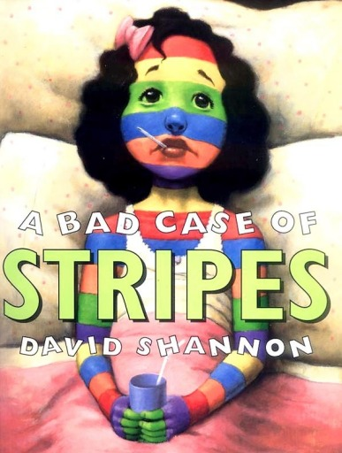
Literature Project: A Bad Case of Stripes
Methodology of Teaching Literature and Culture
Lecturer: Ms. Elisabeth Poelzleitner

designed for an Austrian Lower School by Verena Vorraber

Table of Contents

Student’s Handouts …………………………………………………………………………………2
Teacher Notes …………………………………………………………………………………………6
Literature Project: A Bad Case of Stripes by David Shannon
Part I – not more than 30 minutes
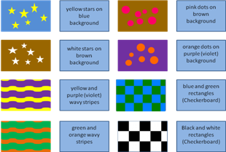
Colors and Shapes Memory Match
Number of Participants: Groups of 4 – 6
Language Sheriff:
The one who finds a match formulates a complete sentence like:
“I have found black circles on white background.”
Instructions:
- All the cards are turned upside down.
- You take turns turning over two cards until you find the matching pairs.
- The one who finds most pairs is the memory match winner.
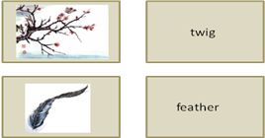
Vocabulary Cards: Test-Yourself
Number of Participants: Groups of 4 – 6
Instructions:
- Try to study the items of vocabulary in 3 minutes.
- Then put the cards on your desk so that you can only see the pictures.
- Take turns turning over the cards you can label.
- If there are pictures left that you cannot label, take 1 minute to study the missing vocabulary and start the game again.
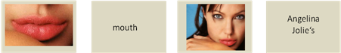
Celebrity Body Part Match
Number of Participants: Groups of 4 – 6
Language Sheriff: Focus on the right use of the possessive forms (Brad’s arm Or: the arm of Brad) and the use of This is … and These are …

Instructions:
- Take turns identifying the body parts of celebrities.
- When it is your turn put the matching cards next to each other and tell your colleagues that:
- “These are Angelina Jolie‘s lips.” Or: “These are the lips of Angelina Jolie.”
- “This is Brad Pitt’s arm.” Or: “This is the arm of Brad Pitt.”
Part II – not more than 35 minutes
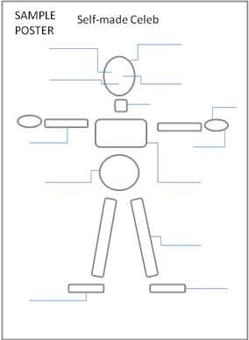
Self-made Celeb
Number of Participants: Groups of 4 – 6
Language Sheriff: Focus on the right use of the possessive forms Brad’s arm Or: the arm of Brad) and the possessive adjectives his and her.

For Example:
A begins with a statement:
A: I like Angelina Jolie’s lips. Or: I like the lips of Angelina Jolie. What do you think B?
B: I agree I also like her lips.
OR: I disagree, I don’t like her lips. I like Kristen Steward’s lips much more. Can we agree on her lips instead?
A: Ok, we can take Kristen Steward’s lips.

Then B goes on with the next body part:
B: I like ……’s (celebrity)………(body part). What do you think C?

Attention! If you talk about a man you use the possessive pronoun his!
Instructions:
- Design your own Celebrity
- Choose the body parts either from “Celebrity Body Part Match” or from the magazines you have brought with you.
- Arrange your body parts on a poster (see SAMPLE POSTER) with glue stripes and label them.

Part III – not more than 15 min
Present your Self-Made Star to the class
Number of Participants: Groups of 4 – 6
Language Sheriff: Everybody presents complete sentences!
Like: Our Self-made Celeb has Christiano Ronaldo’s legs. Or: We have chosen Beckham’s arms for our Self-made celeb.
Instructions: Everybody has to present at least two body part.

AFTER READING THE BOOK – not more than 45 min
- Find Your Camilla Cream Lookalike …

- Little group discussion:
- Why didn't Camilla want to let others know that she liked lima beans?
- How does Camilla feel when the children laugh at her? Did her classmates behave respectfully?
- Why did Camilla get rid of her stripes again?
The following phrases might help you in your discussion:
- to be worried about what other people think of you – she is worried about what other people think of her
- to want to fit – she wants to fit in
- to show respect for someone – her classmates did not show respect for her
- to bully someone – her classmates bullied her
- to admit to like something – she admitted to like lima beans
- to be true to oneself – she is true to herself
- to be proud of oneself – she is proud of herself
- to be proud of one’s uniqueness – she is proud of her uniqueness

- Find someone who ….
… dislikes 3 things you like and someone who likes 3 things you dislike.
Language Tips: You can ask questions like these:
Can you please tell me some things you like! Or: What things do you like?
Can you please tell some things you dislike! Or: What things do you dislike?
Name of my classmate | 3 things he dislikes that I like | 3 things that I dislike and he likes

Find Your Camilla Cream Lookalike …
- Paint and color Camilla according to the info at the bottom of your sheet.
- Cover your sheet or fold it in two. DO NOT SHOW IT to anybody. Walk around and find your Camilla Lookalikes. They will be colored just like your Camilla Cream.
Language Tips: You can ask questions like these:
What color and shape is your Camilla’s left foot?
What color and shape are your Camilla’s lips?

Your Camilla Cream’s face is light pink. Your Camilla Cream’s lips are bright red, the tip of her nose is green and her eyes are blue.
Your Camilla Cream’s neck is orange. Your Camilla Cream’s shoulder is purple with yellow dots, her chest has white, red and blue stripes and the blue stripes contain white stars. So her chest looks like the American flag.
Your Camilla Cream’s belly looks like an orange and green Checkerboard (squares), her legs are yellow with vertical, wavy, purple stripes, her feet are grey and her toes are black.
Your Camilla Cream’s left arm is pink and it is covered with purple circles. Your Camilla Cream’s right arm is green and is covered with brown rectangles. Her fingers are yellow with black, horizontal stripes.
Find Your Camilla Cream Lookalike …
- Paint and color Camilla according to the info at the bottom of your sheet.
- Cover your sheet or fold it in two. DO NOT SHOW IT to anybody. Walk around and find your Camilla Lookalikes. They will be colored just like your Camilla Cream.
Language Tips: You can ask questions like these:
What color and shape is your Camilla’s left foot?
What color and shape are your Camilla’s lips?

Your Camilla Cream’s face is light pink. Your Camilla Cream’s lips are bright red, the tip of her nose is green and her eyes are blue.
Your Camilla Cream’s neck is orange. Your Camilla Cream’s shoulder is pink with yellow dots, her chest has white, red and blue stripes and the blue stripes contain white stars. So her chest looks like the American flag.
Your Camilla Cream’s belly looks like an orange and green Checkerboard (squares), her legs are yellow with vertical, wavy, purple stripes, her feet are grey and her toes are black.
Your Camilla Cream’s left arm is pink and it is covered with purple circles. Your Camilla Cream’s right arm is green and is covered with brown rectangles. Her fingers are yellow with black, horizontal stripes.
Find Your Camilla Cream Lookalike …
- Paint and color Camilla according to the info at the bottom of your sheet.
- Cover your sheet or fold it in two. DO NOT SHOW IT to anybody. Walk around and find your Camilla Lookalikes. They will be colored just like your Camilla Cream.
Language Tips: You can ask questions like these:
What color and shape is your Camilla’s left foot?
What color and shape are your Camilla’s lips?

Your Camilla Cream’s face is light pink. Your Camilla Cream’s lips are bright red, the tip of her nose is green and her eyes are blue.
Your Camilla Cream’s neck is orange. Your Camilla Cream’s shoulder is purple with yellow dots, her chest has white, red and blue stripes and the blue stripes contain white stars. So her chest looks like the American flag.
Your Camilla Cream’s belly looks like an orange and green Checkerboard (squares), her legs are yellow with vertical, wavy, purple stripes, her feet are grey and her toes are black.
Your Camilla Cream’s left arm is red and it is covered with purple circles. Your Camilla Cream’s right arm is green and is covered with brown rectangles. Her fingers are yellow with black, horizontal stripes.
Find Your Camilla Cream Lookalike …
- Paint and Color Camilla according to the info at the bottom of your sheet.
- Cover your sheet or fold it in two. DO NOT SHOW IT to anybody. Walk around and find your Camilla Lookalikes. They will be colored just like your Camilla Cream.
Language Tips: You can ask questions like these:
What color and shape is your Camilla’s left foot?
What color and shape are your Camilla’s lips?

Your Camilla Cream’s face is light pink. Your Camilla Cream’s lips are bright red, the tip of her nose is green and her eyes are blue.
Your Camilla Cream’s neck is orange. Your Camilla Cream’s shoulder is pink with yellow dots, her chest has white, red and blue stripes and the blue stripes contain white stars. So her chest looks like the American flag.
Your Camilla Cream’s belly looks like a red and green Checkerboard (squares), her legs are yellow with vertical, wavy, purple stripes, her feet are grey and her toes are black.
Your Camilla Cream’s left arm is pink and it is covered with purple circles. Your Camilla Cream’s right arm is green and is covered with brown rectangles. Her fingers are yellow with black, horizontal stripes.
Notes for teachers
Level of Proficiency: < A1 (11 year-olds)
Time: 3 x 45 min
Teaching Objectives:
Vocabulary: focus on colors, shapes and body parts.
Grammar: possessive forms (people, possessive adjectives his/her), singular vs. plural (This is/These are …’s arm/s.), forming questions (What color is…/What color are …)
Listening comprehension: If the teacher reads the picture book.
Reading comprehension: If students read the picture book.
I would read the book to the students so that they can lean back and enjoy the literature and in order to support their understanding of the book with the right mimic and gestures. One could also leave out certain passages of the book that appear to be too difficult to understand for the students.
Pre-Reading Activities
Part I – Vocabulary Teaching
For Part I I would divide the class into two groups, namely into girls and boys (later: male body part cards for boys’ and female body part cards for girls’ groups). And divide those groups further into groups of 4 to 6. Then each group has about 30 minutes to do Part I. Memory Match Cards and Vocabulary Cards can be found in an attached Power Point file.
Part II – Self-made Celeb

Students stay in their groups and have 35 minutes to do part II.
Ask students to bring some old magazines. Teacher brings scissors, glue strips, poster paper, text markers and dictionaries.
Part III - Present your Self-Made Celeb to the class
Each group has about 3 minutes to present their work. The posters are put on the classroom walls.
Part IV - Transition to the book
As this is a unit for beginners, I would switch to German where it is needed, but I would always expose them to the English version as well:
In order to trigger students’ interest in the book I would ask some questions like:
- Do you like something that no one else seems to like? Do you sometimes try to pretend you don't like it in order to fit in? (Write down at least three things – use your dictionary)
- Do you dislike something that everyone else seems to like? (Write down at least three things – use your dictionary)
- Are you worried about what other people think of you?
Students write their answers on a piece of paper secretly, fold the paper and put it into their bags. (This will be needed for the last activity again.)
- Transition to the book: There was once a girl called Camilla Cream:
Camilla Cream loved lima beans. But she never ate them. All of her friend hated lima beans, and she wanted to fit in. Camilla was always worried about what other people thought of her.

Do you want to know the story of Camilla Cream?

Part V - Reading of the book
Part VI - Follow-up Activities
- Find Your Camilla Cream Lookalike … (idea and texts copied from The Quibblesnuff by Elisabeth Poelzleitner)
Don’t forget to bring enough colored pencils or ask students to do so!

If students have found their lookalikes they stay together as a group for the following activities:
- Little group discussion
Before that activity I would put some important phrases on the blackboard, discuss them with the students and encourage them to use them in the group discussion. (The phrases are on students’ handouts as well.)

- Find someone who …
Ask students to put out their folded papers with their likes and dislikes again. Ask them if they want to change or add anything.
Now students will have to find someone who dislikes 3 things they like and likes 3 things they dislike.
When wrapping up the unit the teacher should try to put across the idea that we should be proud of our uniqueness rather than being ashamed of it. That we should not try to be someone else – just look at the pictures of the self-made celebs and you can see how terrible the result may be if you corrupt the uniqueness of a person. The message is to be proud of one’s own uniqueness and appreciate others’. The world would be so boring if we all were the same!
If you don’t have the picture book, you can find some info about it on Youtube, like:
http://www.youtube.com/watch?v=F8734VNgX8c – This is a rather bad reading of the book, but is the only full version of the book on the internet.

