Five Minutes’ Peace …
by Jill Murphy

1) What do you think of the title? What could the story be about?

2) Listen to the beginning of the story and write all the words you associate with food on the tray.
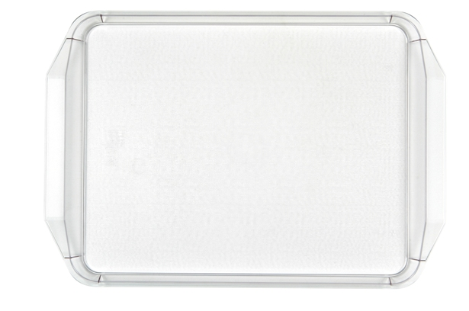

What do you and your family eat for breakfast? Talk with your neighbour about your breakfast at home. Then write down all the words:

3) Listen again to the story. Then draw a picture of Mrs Large in the bathroom.

What do the drawings of your classmates look like?

4) How does Mrs Large feel now? Circle the words you associate with her feelings:

Sad angry happy bored

Would you feel the same?

Which positive and negative feelings do you know?

5) Create your story tree!
(taken from: Christine Boardman Moen, Better Than Book Reports, Scholastic Instructor Books, 1992)

Write:
- the name of the main character
- two words that describe the main character
- three words that describe where the story takes place (setting)
- four words telling what the main character wanted in the story
- five words telling how the main character got what she wanted
- six words telling what happened that stopped the main character from getting what she wanted
- seven words that describe the best part of the book
- eight words telling why you would or would not tell a friend to read this book

6) Vocabulary work

Can you guess the meaning? Work with your partner.

it was heaven _____________________________________________________________
keep an eye on someone ____________________________________________________
to be in a hurry ___________________________________________________________
to beam _________________________________________________________________

Match the following words with the pictures below.

dressing gown bath-hat bath-foam
to run oneself a bath
towels soap




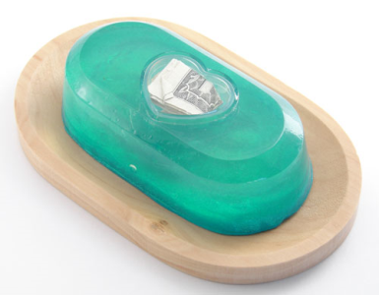

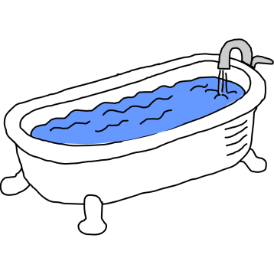

7) Do you remember a situation when you wanted five minutes’ peace?
When? Why? How did you feel? What did you do to get your five minutes’ peace?

→ Write your own story! If you want you can draw a picture.

Teacher instructions for:

Five Minutes’ Peace
by Jill Murphy

- Write the title on the board. Ask your pupils what they think of the title and what they think the story is about.
Then ask them why they think the main character/the mother wants five minutes’ peace.

- Tell your pupils to do task 2 while you read the first two pages to them (until “…she sneaked off towards the door.”) You can also show them the pictures. Then the pupils should talk about their own breakfast. Find out together with the pupils what one can eat and drink for breakfast (collect the words on the board).

- Read the first sentence of page 3 (“Where are you going with that try, Mum? asked Laura.”) Let your pupils guess!
Read on until (“It was heaven.”) and show them the next two pictures (but NOT the picture of the bathroom!)
Read again the scene in the bathroom while the pupils draw the picture of Mrs Large in the bathroom. (on a separate sheet)
Hang up all the drawing on the wall. The pupils can now go around and look at the other drawings. Then show them the picture of Mrs Large in the book.

- Ask the pupils if they think Mrs Large will have her five minutes’ peace now. Read the next six pages and show them the pictures.
Show the pupils the picture of Mrs Large putting on her dressing gown. Ask them to do task 4 (How does Mrs Large feel now?)

- Read the end of the story and show them the pictures. Then the pupils should create their story tree.

- The pupils do task 6. Then compare in class.

- Ask the pupils if they remember a situation when they wanted five minutes’ peace. As a homework the pupils should write their own story.

