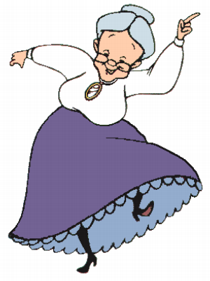
The Trouble with Gran

by Babette Cole

Pre-reading activities

- Talk about the following questions with your partner.

- Do you also sometimes have trouble with your granny?
- If yes, what problems do you have with her?

- Think of a typical grandmother and read the words below. Draw a circle around the words you connect with a grandmother. Look at the transparency to understand all the words.

glasses thin liking adventures grey hair knitting old-fashioned clothes bikini

wrinkles party curly hair playing cards cat plump cooking

travelling well-dressed naughty watching TV reading dyed hair high heels

- Describe a typical grandmother.

- What does she look like?
__________________________________________________________________________
__________________________________________________________________________
__________________________________________________________________________
__________________________________________________________________________

- What does she like doing?
__________________________________________________________________________
__________________________________________________________________________
__________________________________________________________________________


While reading activities

- “The trouble with Gran is...secretly...” Guess why it is a secret!

I think the trouble with Gran is secretly because ___________________________________
_________________________________________________________________________.

- “She's an __________.” Listen to your teacher's explanation and write down what an ___________ is:____________________________________________________________.

- “Wethorp was awful. Gran started to play up!” Listen to your teacher's description of what granny looks like and draw a picture in the box below.

- “And there was a Glamorous Grandma Contest. …Gran cheated of course!” Guess how she cheated!
__________________________________________________________________________
__________________________________________________________________________

- “On the Lunar Landscape Tour Gran met some friends. She took them to the tea rooms!” Look at the picture and think about which of the adjectives below describe the boy's feelings and which of them describe granny's feelings.

happy, good-tempered, miserable, cheerful, bad, sick, good, ashamed, uncomfortable, satisfied, comfortable, embarrassed, confused

The boy feels ______________________________________________________________
_________________________________________________________________________.
His granny feels ____________________________________________________________
_________________________________________________________________________.

Choose five feelings and draw faces that express these feelings.

- “We zoomed towards Gran's planet...” What do you think Gran's planet
looks like? Work together with your partner.

__________________________________________________________________________
__________________________________________________________________________
_________________________________________________________________________.

- Look at the picture “Carnival” for a minute and try to remember as many details as possible. Then answer your teacher's questions.

Post-reading activities

- Role play

Get together in pairs or small groups of three or four and practise acting out your favourite scene. Then act it out in front of the others.

- Writing tasks

- Help granny to promote her unusual journeys. Get together in groups of three and create an interesting advertisement for gran's travel agency.
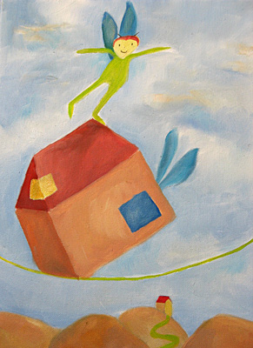

- Imagine you are a student who took part in this very exciting school trip. In your diary you describe what happened and also mention how you felt in certain situations and what you liked or did not like about the trip. Some nice pictures would make your diary entry look much more beautiful!


Teacher Instructions

- Pre-reading activities

Do the three pre-reading activities that are mainly supposed to pre-teach some vocabulary and to give the pupils some idea of what the story is about. Before doing the second task, introduce some new words with the help of the transparency. Make sure the pupils can have a look at the transparency while doing the task. After the pupils have finished an activity, always let them talk about what ideas came to mind.

- While reading activities

“The trouble with Gran is … secretly...” (Do task 1)

“She's an alien!” (Do task 2: Explain what an alien is: a creature from another planet)

“Wethorp was awful. Gran started to play up!” (Do task 3: Do not immediately show the pupils what granny looks like, but read them the following text. By using gestures make sure the pupils understand all the words. The words that are probably unknown are underlined. After the pupils have finished drawing, show them the picture in the book.)

“Granny has a green head and whiskers like a cat. She is smiling. Her nose looks like a shower head. She has little white eyes and very small round ears. Gran wears glasses and a round black cap. She has two antennas and white curly hair. Granny is plump. Her arms are very thin and short. She has only two fingers and they look like half a circle. Granny has a green crocodile tail and hairy green legs. She wears a black coat with a fur collar and fur cuffs. On the coat there are two badges that look like the heads of a cat. Granny wears low- heeled black shoes.“

“And there was a Glamorous Grandma Contest. …Gran cheated of course!” (Do task 4: Do not show the pupils the right page before they have finished the task.)

“On the Lunar Landscape Tour Gran met some friends. She took them to the tea rooms.” (Do task 5: Make sure the pupils understand all the words.)

“We zoomed towards Gran's planet...” (Do task 6)

Task 7: Show the pupils the double page where it can be seen how the people on gran's planet celebrate carnival. After one minute, you ask them questions and check how much they can remember. By asking what the people are doing, the pupils practise the present progressive. Write new words on the board.
- Post-reading activities

As far as the role play is concerned, give the pupils some time to practise acting out their favourite scene. Then let them act it out in front of the others.

The first writing task is thought to be done in groups. After the pupils have created a nice leaflet with a short text, the groups present their leaflets to the others. The second writing task could be done at home. By letting the pupils write about what happened on this school trip, they practise telling the story using their own language and they are also likely to include some new words.

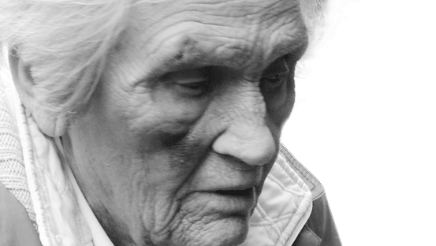
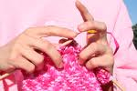
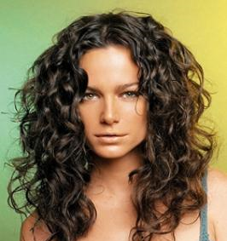

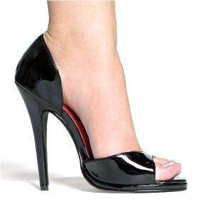
Old people have wrinkles.
She has curly hair.
The woman is plump.
She is knitting a sweater.
She dyed her hair pink.
She always wears high heels.
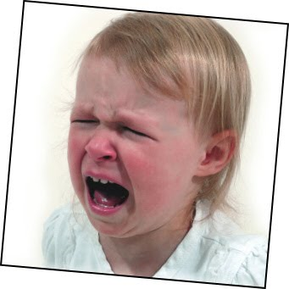

He is a naughty child.
He behaves badly.

