Methodology of Teaching Literature and
Culture
Dr. Elisabeth Pölzleitner

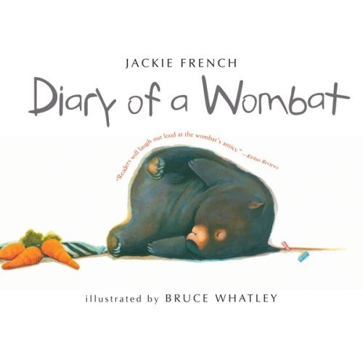

Project handed in by
Sabrina Huber
sabrina.huber@edu.uni-graz.at

Teacher’s notes

Depending on the students’ language proficiency this unit can be done in year 2 or earlier.

Lesson plan:

- Pre-reading task: (5 min)
  - Show the students a picture of a wombat (OHT, poster, PowerPoint etc.) and ask the questions on page four.

- While-reading tasks: (20-25 min)
  - Read the book and explain words like “roots”, “occasional treat” etc. First paraphrase them and let students guess.
  - Read the book up to page 15 (there are no page numbers at the bottom of the book)
    - page 16: Cover the picture and text on the right (“ate carrots”) as well as the text above the bin (“Banged on large metal object till carrots appeared”)
    - Let students guess what the wombat got when it banged on the large metal object
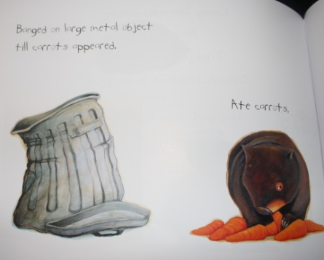
page 16 (no page numbers)
  - Continue reading up to the second last page and cover the last page.
    - “Night: Dug new hole to be closer to them” Let students guess where the wombat dug the hole.
    - Then show them the last picture for 30 seconds and ask them to remember as much as possible.
    - Then ask questions like, “How many people are in the picture?”, “What colors does the blanket have?”, “How many doors could you see?”… etc.
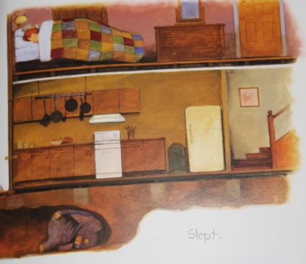

= Kim’s Game:
http://en.wikipedia.org/wiki/Kim%27s_Game

- Post-reading task: (15-20 min)
  - Board game (instructions below) “Hungry Wombat”

Preparation:
- Cut out and glue die together
- Cut out cards
- Cut the wombat into 8 pieces (= puzzle, see instructions)

You need:
- Plastic fruits/vegetables, something similar or just normal pawns in four different colors (6 of every sort); the colored bowls are optional

Instructions:
- Students get together in groups of 3-4
- Their aim is to collect all fruits/vegetables before the hungry wombat eats them
- One after another they roll the die and do the respective task – then they can take the fruit/vegetable displayed on the die
  - If they roll a red tomato they pick up a red card
  - ...
- If they roll the wombat road sign, they have to take one part of the puzzle and put it on the right place
  - if the puzzle is completed before they could collect all fruits/vegetables the hungry wombat wins, otherwise the students will (so no individual can lose/win but they win or lose as a group)
- If they roll the x2 symbol they can pick two cards

Board Game “Hungry Wombat”

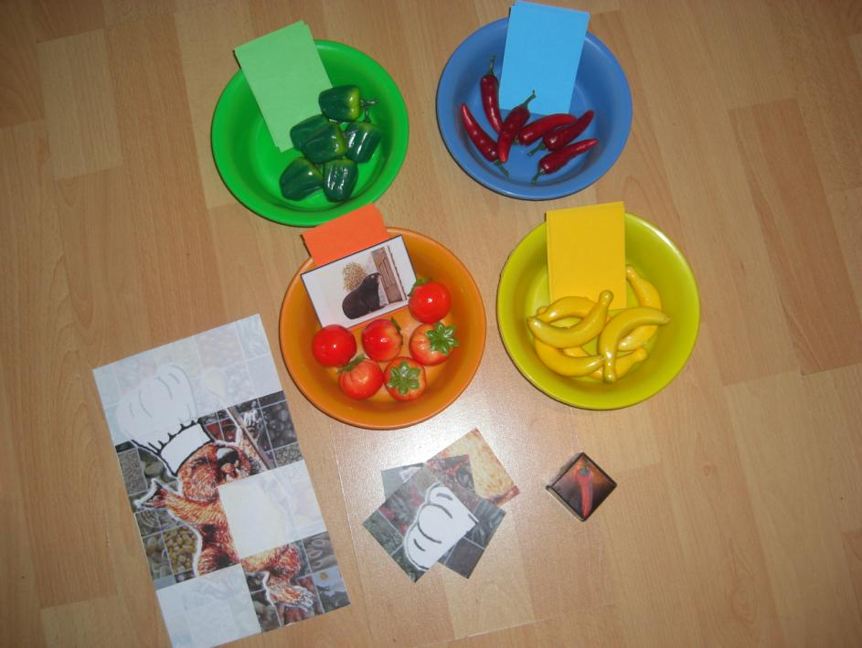
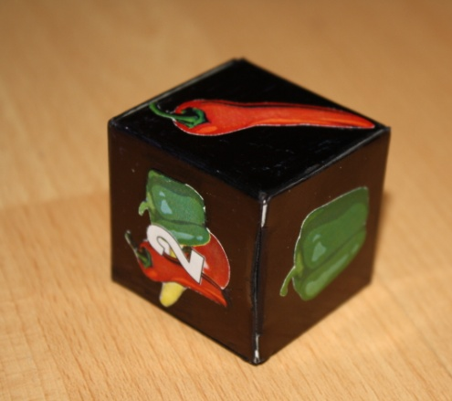
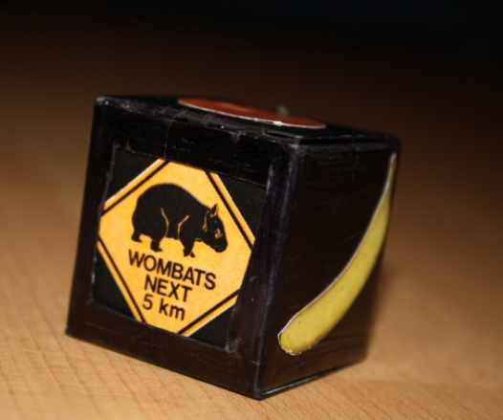
Questions

Do you know the name of this animal?

Where does it live?

What does it eat?

Is it a friendly animal?

How much does it weigh?

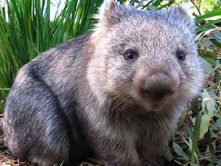
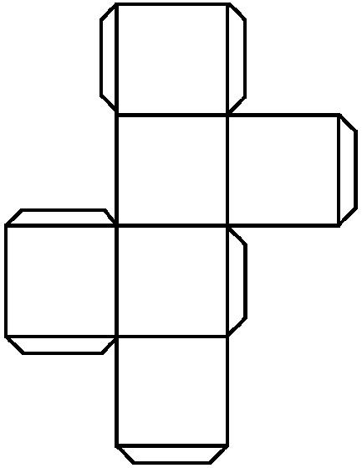
To be cut out and glued together.



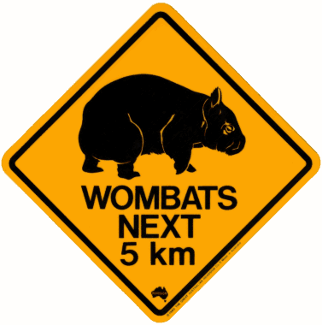
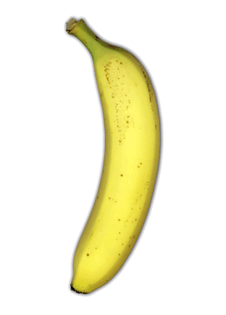
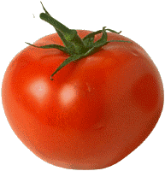


What kind of food do wombats eat? | What do wombats look like?
Where do wombats live?  (In which country? + What kind of home do they have?) | What does the wombat in the book think of humans?
What do wombats do most of the time? | How does the wombat scratch itself?

I come out mostly at ___________, and during the day I ___________. | I look a little like a ____________, but smaller.
At night I _________ a new hole. | The wombat’s hole was wet. Somebody ___________ it up with __________.
In the car the wombat discovered a new source of _______________. | One day a _____________ moves in next ___ the wombat.

Wombats live in houses in Africa. | Wombats look like pigs, only smaller.
Wombats come out mostly during the day and at night they sleep. | The wombat dug a hole far away from humans.
The wombat’s new neighbors filled his hole with sand. | Wombats eat small trees and don’t like vegetables.

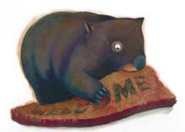 | 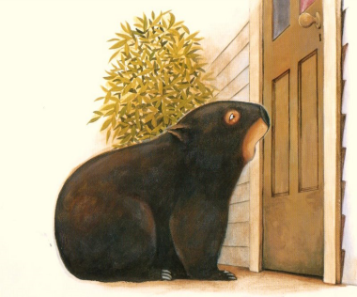
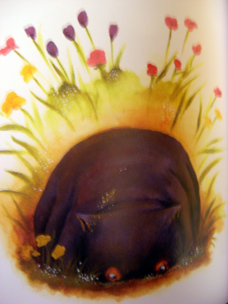  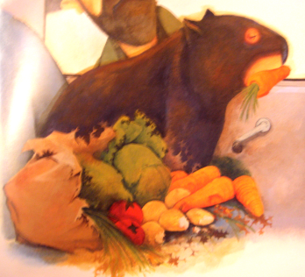 | 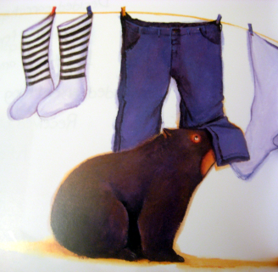
 | 