POETRY
Just kidding
Messy Room by Shel Silverstein

Whosever room this is should be ashamed!
His underwear is hanging on the lamp.
His raincoat is there in the overstuffed chair,
And the chair is becoming quite mucky and damp.
His workbook is wedged in the window,
His sweater's been thrown on the floor.
His scarf and one ski are beneath the TV,
And his pants have been carelessly hung on the door.
His books are all jammed in the closet,
His vest has been left in the hall.
A lizard named Ed is asleep in his bed,
And his smelly old sock has been stuck to the wall.
Whosever room this is should be ashamed!
Donald or Robert or Willie or--
Huh? You say it's mine? Oh, dear,
I knew it looked familiar!

Limerick by Edward Lear
There was an Old Man with a beard,
Who said, 'It is just as I feared!
Two Owls and a Hen,
Four Larks and a Wren,
Have all built their nests in my beard!'

A Word to Husbands by Ogden Nash

To keep your marriage brimming
With love in the loving cup,
Whenever you’re wrong, admit it;
Whenever you’re right, shut up.

Be Glad Your Nose is on Your Face
by Jack Prelutsky

Be glad your nose is on your face,
not pasted on some other place,
for if it were where it is not,
you might dislike your nose a lot.
Imagine if your precious nose
were sandwiched in between your toes,
that clearly would not be a treat,
for you'd be forced to smell your feet.
Your nose would be a source of dread
were it attached atop your head,
it soon would drive you to despair,
forever tickled by your hair.
Within your ear, your nose would be
an absolute catastrophe,
for when you were obliged to sneeze,
your brain would rattle from the breeze.
Your nose, instead, through thick and thin,
remains between your eyes and chin,
not pasted on some other place--
be glad your nose is on your face!

Read these poems and then, together with your
neighbor, think about the following questions:

Which of these poems do you like most and why?

What do all these poems have in common?

In what way are they original?

What mood do they convey?

What do you think is their purpose?

Are they really poems at all? Why (not)?

That nasty Old Man of Vienna
He took Camomile Tea
Who lived upon Tincture of Senna
When that did not agree
There was an Old Man of Vienna
Who seldom, if ever, stood still
There was an Old Man on a hill
In his Grandmother's gown
He ran up and down
Which adorned that Old Man on a hill
Resembled the point of a pin
So she had it made sharp
And played several tunes with her chin
And purchased a harp
There was a Young Lady whose chin

FACTS on LIMERICKS
Read through the short information sheets on the walls to answer the following questions. Do not copy the whole text, only jot down the most important key words!

What were the main reasons why Limericks were sometimes criticized and not accepted as a lyrical genre?

When and where did Limericks develop? What were they like in the beginning?

Where does the term “Limerick” come from?

Who popularized the Limerick form in England?

-----------------------------------------------------------------------------------------------------------------
FACTS on LIMERICKS
Read through the short information sheets on the walls to answer the following questions. Do not copy the whole text, only jot down the most important key words!

What were the main reasons why Limericks were sometimes criticized and not accepted as a lyrical genre?

When and where did Limericks develop? What were they like in the beginning?

Where does the term “Limerick” come from?

Who popularized the Limerick form in England?

-----------------------------------------------------------------------------------------------------------------
A Form of Poetry? Limerick Poems? Limericks the genre?
The form of poetry referred to as Limerick poems have received incredibly bad press and dismissed as not having a rightful place amongst what is seen as 'cultivated poetry'. The reason for this is three-fold:
- The content of many limericks is often of a bawdy and humorous nature.
- A Limerick as a poetry form is by nature simple and short - limericks only have five lines.
- And finally the somewhat dubious history of limericks have contributed to the critics attitudes.
------------------------------------------------------------------------------------------
Limericks - The History
Variants of the form of poetry referred to as Limerick poems can be traced back to the fourteenth century English history. Limericks were used in Nursery Rhymes and other poems for children. But as limericks were short, relatively easy to compose and bawdy or sexual in nature they were often repeated by beggars or the working classes in the British pubs and taverns of the fifteenth, sixteenth and seventh centuries. The poets who created these limericks were therefore often drunkards! Limericks were also referred to as dirty.
------------------------------------------------------------------------------------------
Origin of term 'Limerick' come from?
The origin of the name limerick for this type of poem is debated. As of several years ago, its usage was first documented in England in 1898 (New English Dictionary) and in America in 1902, but in recent years several earlier uses have been documented. The name is generally taken to be a reference to the City or County of Limerick in Ireland^{[4][5]} sometimes particularly to the Maigue Poets, and may derive from an earlier form of nonsense verse parlour game that traditionally included a refrain that included "Will [or won't] you come (up) to Limerick?
------------------------------------------------------------------------------------------
The Limericks of Edward Lear
The limerick form was popularized by Edward Lear in his first Book of Nonsense (1845) and a later work (1872) on the same theme. Lear wrote 212 limericks, mostly nonsense verse. It was customary at the time for limericks to accompany an absurd illustration of the same subject, and for the final line of the limerick to be a kind of conclusion, usually a variant of the first line ending in the same word.
LIMERICKS

By Edward Lear

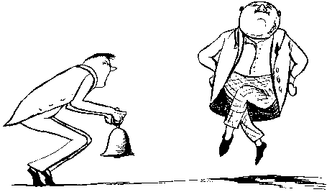
There was an old person of Filey,
Of whom his acquaintance spoke highly;
He danced perfectly well,
To the sound of a bell,
And delighted the people of Filey.

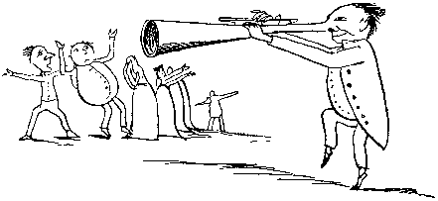
There was an old man of West Dumpet,
Who possessed a large nose like a trumpet;
When he blew it aloud,
It astonished the crowd,
And was heard through the whole of West Dumpet.

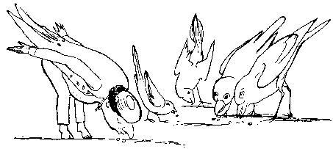
There was an old man of El Hums,
Who lived upon nothing but crumbs,
Which he picked off the ground,
With the other birds round,
In the roads and the lanes of El Hums.
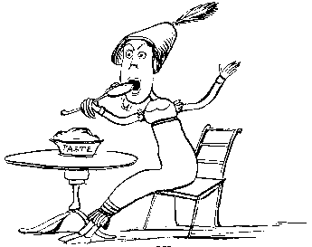
There was a young person of Kew,
Whose virtues and vices were few;
But with blameable haste,
She devoured some hot paste,
Which destroyed that young person of Kew

Recipe for writing a limerick:

What are the typical words to start a limerick?

What is the number of lines?

What is the rhyme scheme? (use letters to illustrate that)

What is the rhythm? (use stress marks)

In pairs, find words that rhyme with…

skirt | owl | skin | bread | throne | free | dark | mice | swear | old

Now try to come up with places that rhyme with…. (If you cannot come up with real places, just make something up!)

van | home | rid | pen | path | win | Roland | cow | butter | true

Now choose at least one word pair from the tables to write your own Limerick!

- For homework design an A4 Limerick sheet, on which you write your Limerick and illustrate it, for example with a drawing.
- Learn your limerick by heart to present it/ act it out in front of the class. Don’t forget to bring along your Limerick sheet so we can glue it onto our Limerick poster!

Teacher instructions

Suitable for a fifth/ sixth form
After they have put the verses into the correct order, ask them which of the poems this one resembles the most ( Limerick: special type of poem provide additional information)
Facts on Limericks: Cut the handouts in half to save paper. Also cut the information sheet (preferably printed on colored paper) and put them onto the walls while the pupils are working on the poems.
Creative part: glue all the poems onto a big poster, on which they may also note down some of the factual information for decoration in the margin.
Have fun!

