SS 2010

designed for an Austrian Upper School by Verena Vorraber
A Poetry Project
Lecturer: Ms. Elisabeth Poelzleitner
Methodology of Teaching Literature and Culture
Table of Contents

Student’s Handouts …………………………………………………………………………………2
Inspiration Sheets ……………………………………………………………………………………6
Teacher Notes …………………………………………………………………………………………8

Poetry Project
HAIKUS
"Haiku" is a traditional form of Japanese poetry that consists of 3 lines. The first and last lines of a Haiku have 5 syllables and the middle line has 7 syllables. The lines rarely rhyme. However, modern English haikus do not follow this rule very strictly.
A syllable is a part of a word pronounced as a unit. It is usually made up of a vowel alone or a vowel with one or more consonants. The word "Haiku" has two syllables: Hai-ku; the word "syllable" has three syllables: syl-la-ble.
- Warming Up: What am I? Haikus
Instruction: Use a Haiku to describe something that comes to your mind. Your classmates will later attempt to guess what you were describing.
Here are two examples of "What am I?" Haikus:
Green and speckled legs,  Hop on logs and lily pads  Splash in cool water. | In a pouch I grow,  On a southern continent --  Strange creatures I know.
Taken from: http://www.kidzone.ws/poetry/haiku.htm
- What’s the Epiphany
The content of a Haiku often focuses on a moment in a person’s everyday life that does not seem to be special on its face, but that is indeed very special for the person concerned. In those moments people realize something of great important, i.e. they have a moment of deep insight (epiphany). So some even say 'Haiku is an epiphany put into (very few) words.'
evening walk  at the top of the hill  the loudest bird  Sophia Frentz (17) | sandy footprints  leaving their mark  on the world  - Tara Blackshaw (12) | helping dad  move the rose bush  scent of mum  Dave Robertson (Katikati)
footprints in the sand  following us  destroyed by waves  - Shavaughn Vaega | among the swans  angry voices –  family photo  Sophia Frentz | half light  the river scarred  by a heron  Beverley George
full moon at Motuhoa  stingrays  cloud the evening tide  Barbara Hart (Tauranga) | soft mist …  a mother cups  her baby’s head  Joanne Watcyn-Jones | fallen leaf –  the stream carrying  another silence  Eduard Tara (Romania)
a field in bloom –  the foal’s tracks  follow the mare’s  Carole MacRury (USA) | a moment before sunrise  ice singing  beneath the swans’ feet  Martin Lucas (England) | dappled sunlight  an old dog shakes the river  from his coat  Sharon Dean
Taken from: http://www.haikuoz.org/

Instruction:
  - With a partner discuss the haikus above: What kind of experience might the writer have had when he/she produced this piece of art? Can you think of a similar experience you once had? Identify the epiphany in the respective haikus.
  - Choose your favorite haiku, the one that touches you the most – and paint a picture of the moment captured by the poem. (The painting should cover about half of your sheet – see the draft on the right - and copy down the haiku at the top of your sheet)
  - Then try to put into words how this haiku makes you feel, which mood it creates and what the author might have felt when he wrote it. Write down your thoughts beneath your painting (about 3- 5 sentences) and make sure that there is enough space left at the bottom of the sheet (see the draft on the right). When you are finished hand your work in anonymously.

- The best Haiku definition - My favorite definition of a haiku:

Home Assignment: Choose a haiku you like, either from my selection, or any other haiku you find on the internet. Write a short story that leads up to the epiphany of the haiku.
- The Poet in You
Instruction:
I have prepared two inspiration sheets for you that should inspire you to choose Themes you want to write about. I also have suggestions concerning the form of your poems. You can stick to these forms if you want to. If not, feel free to invent your own form that you think expresses your Theme the best. It is only important that you are able to explain why you have chosen this or that form for your respective Themes.
Try to produce three pieces of poetry that are different in their Theme and in their form.
Suggestions for the form of your poems:
- Haiku
- Snapshot poetry
- Concrete Poetry
Take your time for getting inspired! You can have a look at my inspiration sheets - Memories and Dreams and The World We Live In! And you should also read Five Reasons to Write Poetry.
And always remember, you can only do it right!
When you are finished hand in your works anonymously into the poem box!

Five Reasons to Write Poetry
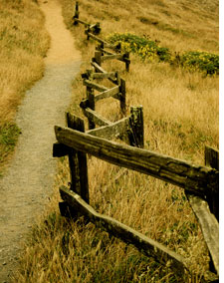
by HENRIK EDBERG
One of them:
As you write, not only do ideas bloom, but you do also. Your vocabulary gets broader, your understanding about relationships between ideas grows and how this affects you and the world comes closer together. My biggest problem in dealing with people was not knowing whom I was, somewhere between egoless and consumer. Writing poetry enables the I in Identity, from which you can clearly communicate the you to the you in someone else.
People aren’t always going to be able to understand you, but writing poetry gives you an opportunity for personal space in which to critically think while expressing yourself to others in a coherent picture. Doesn’t mean you’ll come off all-knowing and wise, but that you’ll be given an opportunity to effectively communicate at your own pace which can come at a premium in this busy world.
.
Taken from: http://www.positivityblog.com/index.php/2008/07/30/five-reasons-to-write-poetry/

Snapshot poetry
When most people look through an old photo album, they remember the emotions associated with the pictures. A snapshot poem attempts to recreate the same emotional responses as the pictures. Using words and meter, the author first tries to paint a vivid and descriptive picture in the reader's mind, then finishes by capturing the emotions associated with that picture and expressing them in a way that makes the reader feel them as well.
Write your own Snapshot Poem:
Instruction:
How to Write a Snapshot Poem (A suggestion)
- Step 1
Look at (or if you have forgotten your picture, think of) the picture that has a very special emotion attached to it in your mind. If you haven’t found a picture, recall a memory that you associate a strong emotion with.
- Step 2
Choose two specific sensory feelings from this memory. For example, if the memory is of your first bike ride, you might choose the roughness of the hand grips and the pounding of your heart with the fear of falling.
- Step 3
Write a stanza for each sensation. Although four lines per stanza is not a requirement--snapshots poems have no formal structure--any less might not depict a clear enough picture. Use illustrative language and make the meter flow from one line to the next. When read aloud, the poem should sound smooth and not have any difficult rhythm breaks. For example, when writing about the pounding of your heart, your stanza might read:
Pounding I can feel in my throat
Racing heart and racing breath
Matching rattle of chain and spoke
Blood pumps loud through my ears.
- Step 4
Use a third stanza to convey the emotion of the experience to the reader. For example, in your poem about your first bike ride, your final stanza might read:
Fear gives way to freedom
The world is open wide
My wheels have wings
The tires sing my joy.

Info on how to write snapshot poetry is taken from: http://www.ehow.com/how_6306607_write-snapshot-poem.html

Another example for a SNAPSHOT POEM:
Mornings,
I reluctantly walked to the school bus corner,
Climbed aboard the yellow and black monster,
Sat three and four to a seat
Sat well away from Billy Ratliff
Who like to hit people,
Not because they offended him
But for the pure pleasure of it.

At lunchtime
Passing through the smell of burritos,
hot dogs, and pizza slices,
Tray sliding along the shelf
Students laughing and talking
I knew I didn't belong.

Teacher,
You tried to turn the pages of my life
With praise,
Yet all I heard were the questions
I could not answer.
Example taken from: http://www.kyrene.org/staff/apiendel/snapshot.poem.htm

If you haven’t found a suitable memory yet, or if you prefer to make up a fictitious situation, search for inspiration on the Memory and Dreams inspiration sheet.

Concrete Poetry
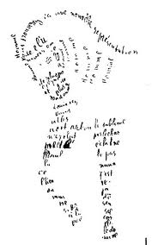
Concrete poetry is poetry in which the arrangement of words is important in conveying the intended effect.
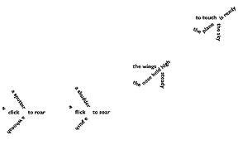
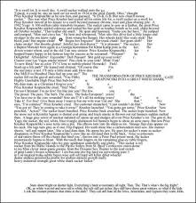

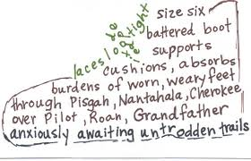

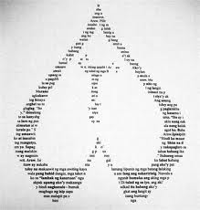

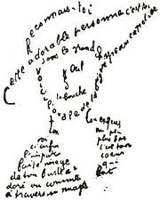

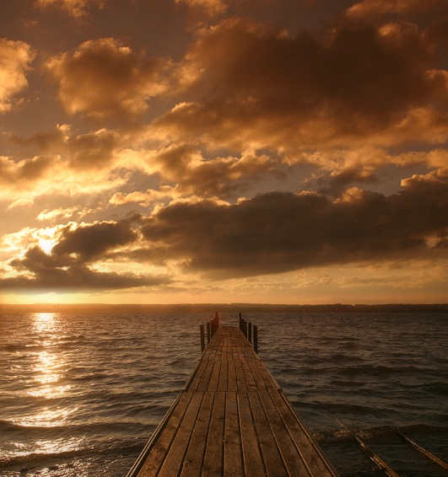
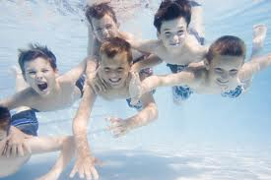
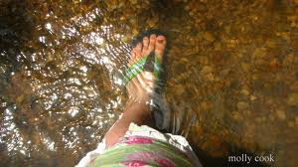
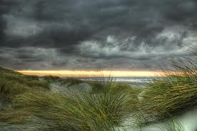

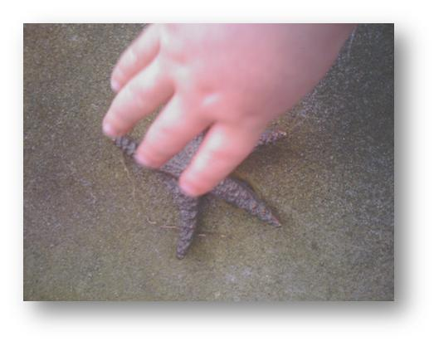
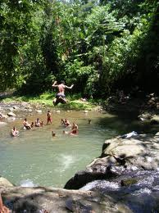
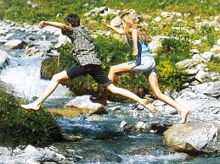


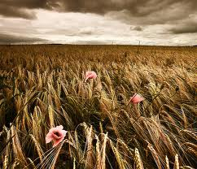
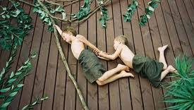
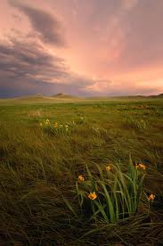


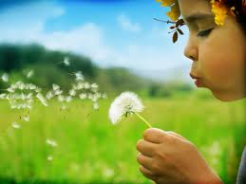


Memories and Dreams





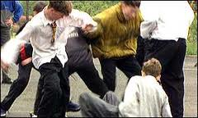

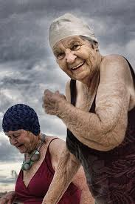



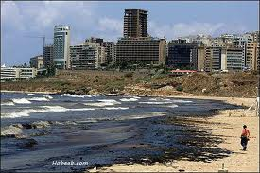

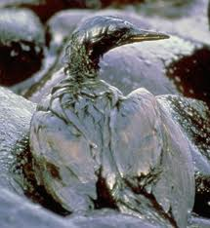

The World We Live In






Teacher Notes
Time: 3x 45 min
- Warming Up: What am I? Haikus
Estimated time needed: writing - 10 min, guessing - 5 min = 15 min
I would let students read out aloud their produced works one after another and other students can immediately guess what is being described.
- What’s the Epiphany
Estimated time needed: reading and discussing with a partner – 7 min, painting – 11 min, writing – 7 min, second round – 5 min, third round 5 - min, (break) putting works on the wall, reading them and résumé - 15 min = 50 min
After students have handed in their works, I will hand them out again so that everybody has another student’s work. Then each student adds his/her interpretation beneath the first interpretation. Then again the works are handed in and handed out again and a third student adds his/her interpretation of the haiku. Then I would put those works on the wall and students have about 8 minutes to read through their works. Résumé: It will be interesting to see that the interpretations of one and the same haiku might differ to a great extend. This should show students that poems leave much space for personal interpretation. And is not a surprise, as poems are expression of very personal perceptions of the world. This activity should show that there is no need to be afraid of poetry. Poetry should rather be enjoyed.

Packing list: water or oil colors, brushes, cups, pencils, sheets of paper, something to put students’ works on the wall in the end, like glue stripes.
- The best Haiku definition
Estimated time needed: first round – 5 min, second round - 2 min, announcing of the winner plus copying down a definition – 3 min = 10 min
I would spread the definitions in the classroom and number them. Students walk around and read them. They should note down their top choices, read those again in a second round and finally decide what their favorite definition is (e.g. make a point on their favorite definition). The teacher then announces the winner and the students copy down their (personal) favorite definition. This is an activity that should make students active again (as they have to walk around) and students should fully enjoy as there is absolutely no pressure to produce anything on their own.
Example definitions:
Lynette Arden (Adelaide, SA) 'haiku are small and humble poems that depict the everyday world around us, aiming to give a flash of insight into that world.'
Susan Murphy (Sydney, NSW) 'Nothing is ordinary and to notice it without intruding, saying only what's needed, quite naturally touches eternity.'
Beverley George (Pearl Beach, NSW) ‘A haiku is a brief poem, built on sensory images from the environment. It evokes an insight into our world and its peoples.'
Laryalee Fraser (British Columbia, Canada) ‘A good haiku instills a moment with new awareness which surprises and satisfies the reader.’
Jan Rikken (The Netherlands) ‘For me a Haiku is the "condensation" of a personal feeling evoked
by a natural phenomenon, into a little poem, without the explicit
expression of that feeling.’
Vasile Moldovan (Romania)
“A Haiku Poem is heavy water and perfume essence in the same time; a
pearl appearing from pain and hope; the moment that passes in no time
and that you meet a few while in life; hurry up, don't lose it!”
David Terelinck (Guildford, NSW) Haiku is a journey along a road lined with small windows. Each
time we pause to peer into one of these, we are astounded by the
beauty and depth of the vista behind them.
Example definitions taken from http://www.haikuoz.org/
- The Poet in You
Estimated time needed: 60 minutes

ad. Snapshot Poetry

For this unit students should bring a photo to class that they associate a strong emotion with; the photo can evoke good or bad memories. Tell students that this could be the joy of their first bike ride, the excitement of their first school day or the sadness of the last picture of a loved one who died. The picture should be very vivid in their mind.
Also bring a box (poem box) in which students can put their poems anonymously.

I would probably do a poetry contest this is why students should hand in their works anonymously. And after the project I would scan in the works and make a little poetry book that every student can take home as a memory.
Comment on the contest: I would only do the contest, or display the poems if students have no problem with that. And if there is a contest, I will not tell students how many votes each poem has got, I will only pronounce the winner and I will not even tell them how many votes the winner has received. The contest really shouldn’t be in the foreground, but each single piece of art. I can also imagine only reading the poems to the class or displaying them and giving students enough time to read them and then write down their personal thoughts on what they have just read or discuss their thoughts with their friends.

