Winnie’s Magic Wand

- What do we already know about Winnie?

Winnie

- At what time does Winnie get up?
____________________________________________________
When do you usually get up in the morning?
____________________________________________________

  - Winnie took her clothes out of the washing machine and hung them on the line. Which ones were mentioned in the story? Below are six more pieces of clothing that need to be dried. Draw all the items onto the line.

A pair of grey trousers, a light blue skirt with dark blue dots on it, a long pink coat, and yellow socks with red ribbons.

  - Now walk around with your picture and tell your classmates what is on your line. Try to find the person who has hung up the same pieces of clothes. When you have found each other, sit with your partner and see how many accessories you can think of that cannot be washed.
-----------------------------------------------------------------------------------------------------------------
  - Winnie took her clothes out of the washing machine and hung them on the line. Which ones were mentioned in the story? Below are six more pieces of clothing that need to be dried. Draw all the items onto the line.

A silver hat with golden stars on it, a green sweater with blue sleeves, a white dress with blue stripes on it and a pair of orange socks.

  - Now walk around with your picture and tell your classmates what is on your line. Try to find the person who has hung up the same pieces of clothes. When you have found each other, sit with your partner and see how many accessories you can think of that cannot be washed.
  - Winnie took her clothes out of the washing machine and hung them on the line. Which ones were mentioned in the story? Below are six more pieces of clothing that need to be dried. Draw all the items onto the line.

A pair of blue jeans, a light blue skirt, a yellow sweater with green sleeves and a pair of orange socks with red dots.

  - Now walk around with your picture and tell your classmates what is on your line. Try to find the person who has hung up the same pieces of clothes. When you have found each other, sit with your partner and see how many accessories you can think of that cannot be washed.
-----------------------------------------------------------------------------------------------------------------
  - Winnie took her clothes out of the washing machine and hung them on the line. Which ones were mentioned in the story? Below are six more pieces of clothing that need to be dried. Draw all the items onto the line.

A pair of blue jeans, a light blue skirt, a black evening gown, a green sweater with blue sleeves.

  - Now walk around with your picture and tell your classmates what is on your line. Try to find the person who has hung up the same pieces of clothes. When you have found each other, sit with your partner and see how many accessories you can think of that cannot be washed.
  - Winnie took her clothes out of the washing machine and hung them on the line. Which ones were mentioned in the story? Below are six more pieces of clothing that need to be dried. Draw all the items onto the line.

A dark blue coat, grey socks, white pants, an orange T-shirt and a purple night gown.

  - Now walk around with your picture and tell your classmates what is on your line. Try to find the person who has hung up the same pieces of clothes. When you have found each other, sit with your partner and see how many accessories you can think of that cannot be washed.
-----------------------------------------------------------------------------------------------------------------
  - Winnie took her clothes out of the washing machine and hung them on the line. Which ones were mentioned in the story? Below are six more pieces of clothing that need to be dried. Draw all the items onto the line.

A pair of black trousers, a light blue T- shirt, a white hat and a red coat with yellow flowers on it.

  - Now walk around with your picture and tell your classmates what is on your line. Try to find the person who has hung up the same pieces of clothes. When you have found each other, sit with your partner and see how many accessories you can think of that cannot be washed.

- “ ‘I’ll try again. I’ll turn this apple tree back into an apple again.’ She picked up the wand, and shouted, “ABRACADABRA!” Guess what happened next! Do you think, the spell worked this time?
I think………………………………………………………………………………….

- “It was nearly time for the Magic Show. The wonderful new spell would be a disaster.” Circle the words that describe Winnie’s feelings at that moment:

worried happy hopeless proud sad nervous miserable relaxed depressed scared down in the dumps

- “Then Wilbur ran through the cat flap with the new wand” Which words best describe Winnie’s feelings when she gets her new wand?

angry relieved surprised ashamed happy sad
disappointed jealous frightened nervous proud

- Wilbur: you need a new wand for Winnie, but you don’t know where to find one. Ask someone to explain you the way. Mark the right path on your map!
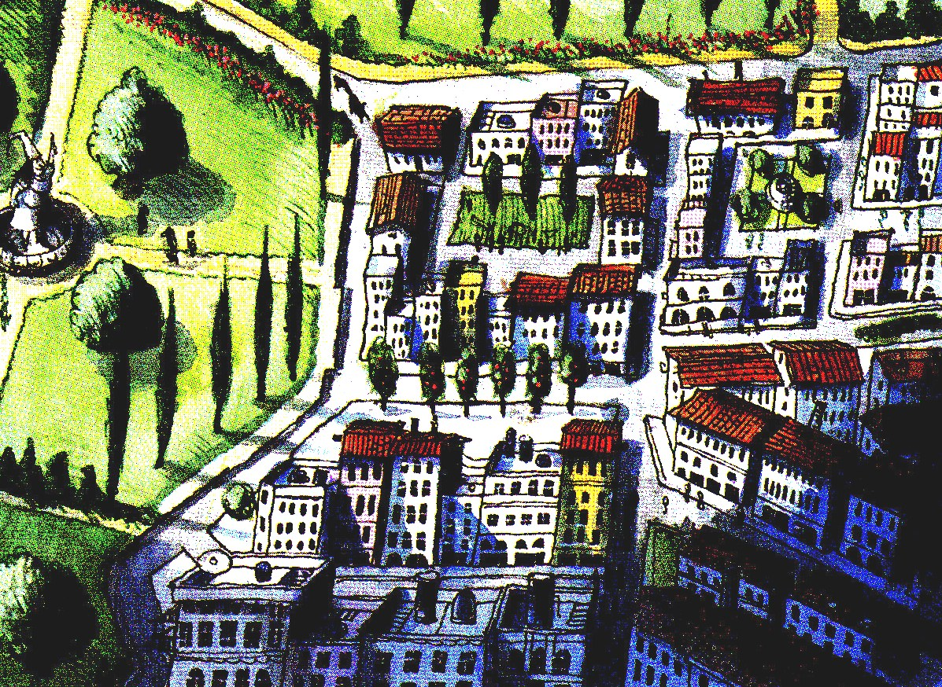

- “ ‘I’ll try again. I’ll turn this apple tree back into an apple again.’ She picked up the wand, and shouted, “ABRACADABRA!” Guess what happened next! Do you think, the spell worked this time?
I think………………………………………………………………………………….

- “It was nearly time for the Magic Show. The wonderful new spell would be a disaster.” Circle the words that describe Winnie’s feelings at that moment:

worried happy hopeless proud sad nervous miserable relaxed depressed scared down in the dumps

- “Then Wilbur ran through the cat flap with the new wand” Which words best describe Winnie’s feelings when she gets her new wand?

angry relieved surprised ashamed happy sad
disappointed jealous frightened nervous proud

- Witch: You know a place where wands are sold. Describe the way to Wilbur, who is looking for a magic wand for Winnie.

Now review the pages, watching out for the clocks and say what happened when!

When did Winnie get up? ………………………………………………………………………
At what time did she do the laundry? …………………………………………………………..
What time was it when she tried to dry the wand with a towel? ……………………………….
When did Winnie turn the apple into an apple tree? …………………………………………....
Wands
RUS
When did Winnie turn the apple tree into an apple pie? ………………………………………..
At what time did Wilbur arrive in town? ……………………………………………………….
When did Wilbur find the trick wand? ………………………………………………………….
When did Wilbur get back home? ………………………………………………………………
When did Winnie and Wilbur take off for the magic show? …………………………………...

Now have another look at the stage. Try to remember as much as possible. Then try to answer your teacher’s questions!

What color are the carpets?

- Look at the picture for two minutes and try to remember as many details as possible!

- Now try to sum up the main points of the story, by saying what happened at what time…
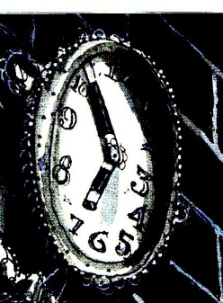
____________________________________________________________________________________________________________________________________________________________________________________________________________________________

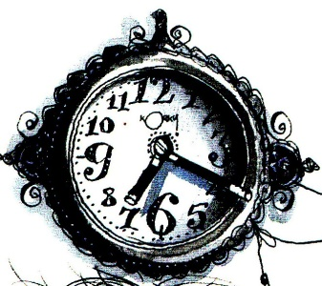
______________________________________________________________________________________________________________________________________________________________________________________________________________________________
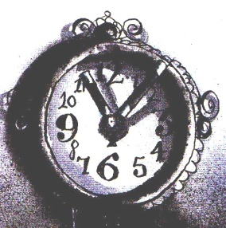
_________________________________________________________________________________________________________________________________________________________________________________________________________________________________

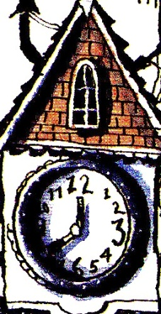
______________________________________________________________________________________________________________________________________________________________________________________________________________________________________

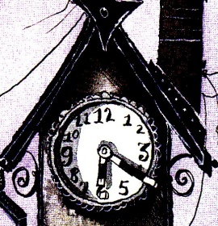
____________________________________________________________________________________________________________________________________________________________________________________________________________________________

Teacher’s instructions

- Suitable for year one or two
- Especially helpful to revise telling the time, telling the way and clothes
- Read out the book to the pupils and stop at the respective pages to do the following exercises:

- Provided the kids are already familiar with Winnie, for example by having read “Winnie the Witch” (lesson plan + material available on www.epep.at). As an alternative, show them the cover of the book and work with expectations (who/what is she, who does she live with, where does she live, what might happen in this book…)
- Useful to revise “telling the time”
- Cut the sheets (dotted line) so that every pupil gets a different sheet. As a fast alternative, delete the instructions (+ clothes) and have them draw their own favorite clothes and label them.
4-6 should be clear
7. You can also place the red sign somewhere else and thus make it easier or more difficult.
- At last, ask your pupils to look at page showing Winnie arriving on the stage (“They arrived just in time for Winnie’s spell”) They should try to remember as much as possible from the scene. Then ask them questions, such as the following:
- How many people are on stage?
- How many microphones are there?
- Is anything lying on the floor? If yes, what?
- What are most people wearing on their heads?
- What time is it?
- This follow-up exercise can be done as a homework.

