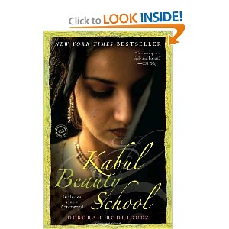
The Kabul Beauty School

(Deborah Rodriguez)

Please note:

- Whenever a question arises while reading, take it down and later discuss it in your group or with your teacher.
- Write interesting new words and expressions that you would like to remember into your vocabulary book. All in all, you should collect at least 20 new phrases. Make sure you do not take down isolated words, but collocations. Please also add a sample sentence.
(e.g. bondage: the state of having your freedom limited, or being prevented from doing what you want; She was terrified at the thought of leading a life of bondage to a man she hated.)
- Write three reading diary entries. You could, for example, comment on passages that deeply affected or shocked you and about which you want to express your opinion and thoughts. Remember not to worry about mistakes, organization and coherence. Just keep writing and let your ideas flow. In each lesson, spend some time on reading and discussing each others' entries and reactions to the book.
- There are six writing tasks that should be distributed evenly among the members of your group. This means that each of you does one or two of them. All the other tasks, unless said otherwise, must be done by all students. Note that activities that should be done at home are marked (HW). You will do the other tasks in class, but you might want to make a neat copy at home.
- At the end of the project, you are going to present your book. Make sure your presentation is interesting and well thought out.

Tasks

Before reading the novel

- Look at the book cover for a few minutes. Guess who the young woman might be. What impression do you get of her? How does she feel? What is she thinking about right now? Write an inner monologue that expresses the woman's thoughts and feelings. Write at least one A4 page. (WRITING TASK A: HW)


- The story takes place in Afghanistan. What do you associate with this country in south-central Asia? Write down whatever comes to your mind. Compare your associations with your group members in class. (Don't worry if you know only little about the country. You will get some interesting information while reading the novel.) (HW)

- Read the poem by Farida Alimi at the beginning of the novel. Give the poem an appropriate title and paint it. In your painting, try to depict the strong emotions and feelings expressed in the poem. Have a look at each others' paintings and discuss them in your first readers' conference. (HW)


While reading the novel

- As already said, the novel contains quite a lot of information about Afghanistan and Afghan customs (e.g. ethnic groups, wedding ceremony etc.). Note pages on which you learn something about the country and its people. At home, you might also consult an encyclopedia or search the internet for more information. In your group, create a nice poster (A3 format) about Afghanistan on which you write important key words and add a few pictures. It's certainly a good idea to integrate your poster into your book presentation.

- Roshanna is the first Afghan woman the reader gets to know. What kind of dilemma is she faced with? What does her sad story tell you about Afghan wedding traditions and customs?

- In chapter two, you find the following statement that might strike you as odd: “I was going to the right place at the right time” (p. 60). What do you think of this remark? Can you imagine why Debbie has such a feeling even though Afghanistan was a very dangerous place at the time? What could have been her motivation for going there?

- When the students for the first class are chosen, the women frankly talk about their lives and the conditions they live in. What are the main troubles they are faced with?

- Explain what the Afghan women learn in the beauty school. How does the education they receive change their lives? In how far is the following Chinese proverb related to Debbie's aid project?:
“Give a man a fish and you feed him for a day. Teach a man to fish and you feed him for a lifetime.”

- What does the reader learn about the conditions in Afghan prisons? What are women in this country imprisoned for? Do you think such draconian penalties are in any way justifiable?

- How are the Talibans depicted in the book? Is the account of their ideology balanced or one-sided and stereotypical? Are there any passages in which it is explained what actually causes their religious fanaticism?

- Debbie has just learnt that her prospective husband Sam has another wife and seven children (p.109). In a diary entry, she expresses her mixed feelings and emotions. Write at least one A4 page. (WRITING TASK B: HW)

- Why do you think Debbie married a man from a culture with a reputation for mistreating women after no more than 20 days? Do you think Debbie made the right decision? Why/Why not? Also keep in mind that her two previous marriages were unhappy and broke apart.
(adapted from http://www.litlovers.com/guide_kabulbeauty.html)

10. Find at least ten adjectives that you associate with Afghan men and Afghan women. Add a typical picture of both sexes (HW). Discuss the adjectives you wrote down and the pictures you chose in class. In how far are they similar or different?

Afghan man Afghan woman
Afghan men | Afghan women

After reading the novel
- What can you say about Debbie, the main character and the author of the novel? What did you learn about her? What are her positive and negative character traits? Is she, in your opinion, a sympathetic character? Do you like/dislike her? Why/Why not? Write a well-structured text of about 200-250 words. (HW) Discuss your impressions in your readers' conference.

- Choose a character. Discuss this! If you were stranded on a deserted island with any character in this book, who would you want to be with? Why? Who would be your last pick? Why?


- What do you think about Debbie leaving for Afghanistan in May 2002? Write a 5-paragraph essay. Your paragraphs should be ordered in the following way:
- thesis statement (=clear opinion statement including the main argument in short form)
- 3 strong arguments
- supporting
- your thesis statement
- a conclusion reinforcing your thesis statement
(WRITING TASK C: HW)

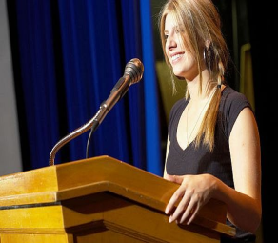
- In America, Debbie's decision to become a volunteer in Afghanistan was sharply criticized by many people who claimed she was acting totally irresponsibly. After all, Debbie has two children and was aware of the dangerous situation in the country after the fall of the Taliban.
After her return in 2007, Debbie gives a public speech in her hometown in order to justify her project. Imagine you are Debbie and write a speech (about two A4 pages) in which you make the audience familiar with your project and its achievements. Point out how important it is to help the Afghan women who still suffer from oppression. You might find the following link useful (http://www.rawa.org/rules.htm). It helps you to find out more about some of the restrictions imposed by the Taliban on women in Afghanistan. By including some of the points in your speech you can underline the necessity for help. To make your speech more effective, make use of rhetorical devices (http://www.virtualsalt.com/rhetoric.htm). (WRITING TASK D: HW)


- The novel is rich in personal stories of women unfortunate enough to have been born into a male-dominated country where they are denied many basic rights. Choose one Afghan woman mentioned in the book (e.g. Roshanna, Baseera, Nahida) and write a really heart-wrenching story (about two A4 pages) about her life of misery for a popular Austrian women's magazine. Your aim is to make the Austrian population aware of the suffering of Afghan women. You could pretend to know the woman personally because you are/were working in Afghanistan. (WRITING TASK E: HW)

- Why do you think the novel was so controversial on its release? Collect a few possible pros and cons of publishing the novel. What is Debbie's intention in writing this book and what's the main message in the novel?

- Write a poem on the topic of Afghanistan. Choose one of the following formats. (WRITING TASK F: HW)

a. Create a list poem that describes what Afghanistan, in your opinion, stands for.

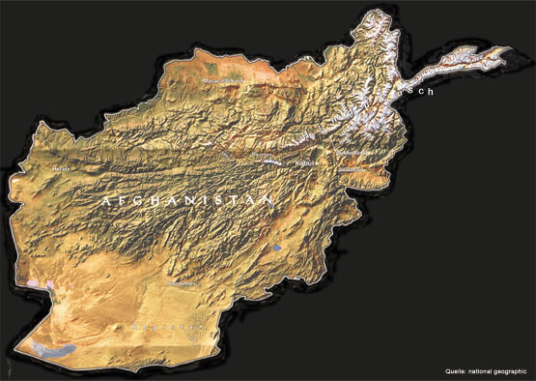
Afghanistan is...

or b: Found poetry: Create a poem by taking words and phrases from the newspaper article below. Don't forget to give your poem a title.

Women fighting the Taliban
Sunday mirror, Aug 15, 2010, by Lalage Snow
THEY march proudly in line... the women soldiers leading Afghanistan hopefully towards a brighter tomorrow.
The 29 women are the first female recruits to train as officers in Afghanistan's army, proof that the Taliban's iron grip on the country is loosening.
They have signed up at a military college near Kabul. Among them are wives and mothers, dressed in the same battle fatigues and desert boots as the men.
A black hijab headscarf is their only concession to femininity.
It's a remarkable sign of how much life in Afghanistan is changing. Only a few years ago, when they were growing up in the shadow of the Taliban's rule, girls were not even allowed to go to school. If they were allowed outdoors at all, they would always be hidden behind the head-to-toe burka and treated as second-class citizens.
Now they talk about freedom, and defying the fanatics who used to terrorise them.
Recruit Habiba Sayed, 28, who is married with four children, said: "Three years ago, my 15-year-old cousin was playing with some friends in the street. I don't know why, but the Taliban killed them all.
"Their bodies were so badly mutilated that my cousin could only be identified by a scar on his hand.
"Then a few months ago a man came to visit his family and was wearing his sleeves rolled above his wrists, which the Taliban thought was too Western.
"They caught him and pulled out his fingernails to punish him. They said if he had worn sleeves above his elbow they would have cut his hands off. Such senseless cruelty is why I wanted to join the army.
"The Taliban don't know what it is to be human. Once my training has finished I aim to be on the frontline if the war continues." […]
(http://findarticles.com/p/articles/mi_qn4161/is_20100815/ai_n54799638/)

Teacher’s notes

The novel The Kabul Beauty School (by Deborah Rodriguez, 282 pages) is suitable for upper school students and is probably more interesting for girls than for boys. The plot is easy to follow partly because the language is rather simple. The novel could be used in a reading project together with the books listed below. All these books share a common cultural element and focus on the difficult situation of women unfortunate enough to live in a male-dominated country where they have very few rights.

Stones into Schools (Greg Mortenson)
The Bookseller of Kabul (Åsne Seierstad)
The swallows of Kabul (Yasmina Khadra)
Not Without My Daughter (Betty Mahmoody)

You might find the following summary and comments on the book useful.

Information about the novel

The Kabul Beauty School is a non-fictional book about one of the strangest foreign-aid projects. Deborah Rodriguez, a middle-aged American trained in emergency and disaster relief, arrives in Afghanistan in 2002 as part of a nonprofit organization. Unlike her colleagues who all have some sort of medical background, she has a hard time finding ways to make herself useful. Deborah wonders how Afghans can benefit from her skills as a hairdresser. It does not take her long, however, to realize that the oppressive Taliban, who have just been defeated, have completely destroyed the country’s beauty infrastructure, which gives her the idea to found a beauty school and train Afghan women in various skills enabling them to work as successful beauticians. By doing this, Deborah helps these women to become economically independent from their domineering husbands, and her students are at least temporarily free from the total control of men.
In spite of all kinds of bureaucratic and cultural difficulties, Deborah does not give up and her project turns out to be quite successful for several years. However, in 2007, she eventually leaves Afghanistan and her Afghan husband Sam because she believes that her life is in danger. Not long after her departure the beauty school has to be closed temporarily due partly to the eruption of violence in Kabul. Even though Deborah is homesick and misses Kabul and her Afghan friends, it is doubtful that she will ever come back.
The novel gives a historical account of events in Afghanistan and provides a highly informative portrayal of what life is like after the fall of the Taliban. Little has changed so far in that being allowed to go to school or to work, for instance, are still nothing but sweet dreams for the vast majority of Afghan women. It is shown that traditions and social attitudes are deeply ingrained and therefore difficult to change.
The reader also gets a real insight into various Afghan customs such as the typical Afghan wedding ceremony and the principle of arranged marriages and polygamy. Additionally, the book contains some information about the country itself. Among other things, the appalling conditions in the prisons and the country’s legal system are sharply criticized by the author.

Information on and suggestions for the reading project

Ideally, four to five lessons should be devoted to the reading project. In the last lesson, the students present their books and hand in their project folders. The rest of the time they work on the tasks in their groups.

