Poetry project for upper school
(Poems about the Civil Rights Movement and Afro-American suppression)

Made by: Perko Jure

Contents
Poetry project for upper school 1
Introduction 2
Pupils’ worksheet 3
1. Pick a poem and paint/draw it 4
2. What do they want to say? 4
3. Write a Haiku 6
4. Fill in the gaps 9
5. Martin Luther King Jr. (Optional exercise for the next lesson) 10
Teacher’s Materials 14
1. Songs for the first exercise 14
4. Solution sheet for the song Democracy, exercise 4 18

Introduction

In this unit the pupils get to know how culture can be conveyed through poetry. It deals specifically with the suppression of Afro-Americans and the Civil Rights Movement in America. Students should get to know how the poets were coping with the problems at that time and how they felt when racism was “a normal thing”. The main goal of this unit is that the pupils learn to read poems and also get to know American culture and history better. The best time to do this class is right after a class on the Civil Rights Movement or racism. The unit has been developed for the seventh or eighth grade of a high school (age of the pupils 17 or 18 years old).

Pupils’ worksheet

1. Pick a poem and paint/draw it
Pick one of the three poems and try to paint the main message of it. After you have finished painting/drawing go discuss your painting with another colleague who has painted the same poem.

2. What do they want to say?
Read the excerpt of the Martin Luther King’s speech and Langston Hughes’ poem “I, too, sing America” and write down what you think they want to say.
After reading the text and the poem and writing down your opinion answer these questions with a partner:

Who is the “I” in the poem?

What are the differences and the similarities between the speech and the poem considering the message?

What are the differences and the similarities between the speech and the poem content wise?

What does Hughes mean with: “They send me to eat in the kitchen”? Can you find a related message in the Dr. King’s excerpt?

Martin Luther King, Jr.
"I Have a Dream"

delivered 28 August 1963, at the Lincoln Memorial, Washington D.C.

I have a dream that one day this nation will rise up and live out the true meaning of its creed: "We hold these truths to be self-evident, that all men are created equal."
I have a dream that one day on the red hills of Georgia, the sons of former slaves and the sons of former slave owners will be able to sit down together at the table of brotherhood.
I have a dream that one day even the state of Mississippi, a state sweltering with the heat of injustice, sweltering with the heat of oppression, will be transformed into an oasis of freedom and justice.
I have a dream that my four little children will one day live in a nation where they will not be judged by the color of their skin but by the content of their character.
I have a dream today!
I have a dream that one day, down in Alabama, with its vicious racists, with its governor having his lips dripping with the words of "interposition" and "nullification" -- one day right there in Alabama little black boys and black girls will be able to join hands with little white boys and white girls as sisters and brothers.
I have a dream today!
I have a dream that one day every valley shall be exalted, and every hill and mountain shall be made low, the rough places will be made plain, and the crooked places will be made straight; "and the glory of the Lord shall be revealed and all flesh shall see it together."²

Langston Hughes - I, Too, Sing America

I, too, sing America.
I am the darker brother.
They send me to eat in the kitchen
When company comes,
But I laugh,
And eat well,
And grow strong.

Tomorrow,
I'll be at the table
When company comes.
Nobody'll dare
Say to me,
"Eat in the kitchen,"
Then.

Besides,
They'll see how beautiful I am
And be ashamed—

I, too, am America.

3. Write a Haiku
Choose one of the pictures and write a Haiku about it.

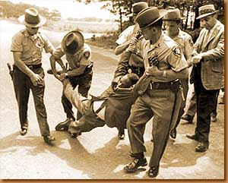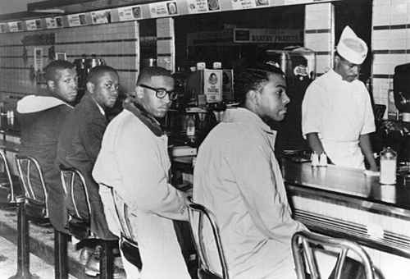

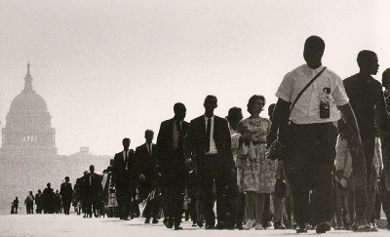

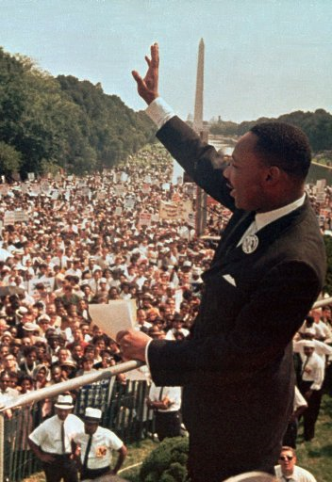

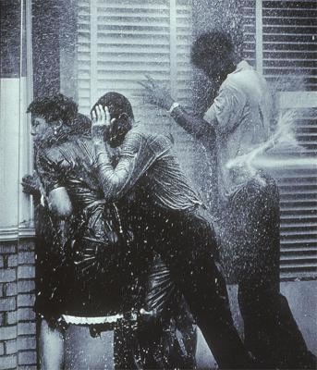

4. Fill in the gaps
The poem beneath was written by Langston Hughes. He describes problems that an Afro-American was facing at that time.
Fill the gaps by just putting the cards on your worksheet. After you have checked with the solution sheet write the answers into the gaps.

Langston Hughes – Democracy

Democracy will ______________________________________________
Today, this year
Nor ever
Through compromise___________________________________________.
I have as _____________________________________________________
As the other fellow has
To stand
On my _______________________________________________________
And own the land.
I tire so of_____________________________________________________
Let things take their course.
Tomorrow is another day.
I do not need __________________________________________________
I cannot live on tomorrow's bread.
Freedom
Is a __________________________________________________________
Planted
In a___________________________________________________________
I live here, too.
I want ________________________________________________________
Just as you.

not come and fear two feet
hearing people say, my freedom when I'm dead. great need.
much right strong seed freedom

5. Martin Luther King Jr. (Optional exercise for the next lesson)
1. Read the song with your partner and try to figure out its message.

2. Then read the biography of Martin Luther King Jr. on your own. When you have finished reading go back into pairs and try to find the references to Dr. King’s life in the poem by underlining them in blue.

3. Take another look at the poem: Who is the speaker? Is he explicit or implicit? Discuss this with your partner.

4. What are the main differences between the biography and the poem? Discuss it with your partner.

5. HOMEWORK: write a short autobiographical poem at home.

Standing Tall
by Jamie McKenzie
In honor of Martin Luther King
http://www.fno.org/poetry/standing.html

Some kings rule their kingdoms sitting down
Surrounded by luxury, soft cushions and fans
But this King stood strong
stood proud
stood tall

When the driver told Rosa
"Move to the back of the bus!"
When the waiter told students
"We don't serve your kind!"
When the Mayor told voters
"Your vote don't count!"
And when the sheriff told marchers
"Get off our streets!"
using fire hoses, police dogs and cattle prods
to move them along
This King stood strong
stood proud
stood tall
Speaking of peace
of love
and children
hand in hand
free at last
free at last

When some yelled for violence
For angry revenge
An eye for an eye
And a tooth for a tooth
He stood his ground
Preaching peace

And when some spit out hate
He stood there smiling
Spreading love
Until it rolled like the sea across the land
Sweeping away Jim Crow
Breaking down the walls
Ringing the bell
Joyfully
For Freedom

Until
Standing on the mountain top
They shot him
Coldly
Hoping to see him fall
Hoping to put him away
To bring him low

But this King
even in death
even today
stands strong
stands proud
stands tall
And we remember

Martin Luther King, Jr.
Civil-Rights Leader, 1929 – 1968
http://www.lucidcafe.com/library/96jan/king.html

Martin Luther King, Jr. was born on January 15, 1929 at his family home in Atlanta, Georgia. King was an eloquent Baptist minister and leader of the civil-rights movement in America from the Mid-1950s until his death by assassination in 1968. King promoted non-violent ways to achieve civil-rights reform and was awarded the 1964 Nobel Peace Prize for his efforts.
King's grandfather was a Baptist preacher. His father was pastor of Atlanta's Ebenezer Baptist Church. King earned his own Bachelor of Divinity degree from Crozier Theological Seminary in 1951 and earned his Doctor of Philosophy from Boston University in 1955.
While at seminary King became acquainted with Mohandas Gandhi's philosophy of nonviolent social protest. On a trip to India in 1959 King met with followers of Gandhi. During these discussions he became more convinced than ever that nonviolent resistance was the most powerful weapon available to oppressed people in their struggle for freedom.
As a pastor of a Baptist church in Montgomery, Alabama, King lead a Black bus boycott. He and ninety others were arrested and judged. King and several others were found guilty, but appealed their case. As the bus boycott went on, King was gaining a national reputation. The ultimate success of the Montgomery bus boycott made King a national hero.
Dr. King's 1963 Letter from Birmingham Jail inspired a growing national civil rights movement. In Birmingham, the goal was to completely end the system of segregation in every aspect of public life (stores, no separate bathrooms and drinking fountains, etc.) and in job discrimination. Also in 1963, King led a massive march on Washington DC where he delivered his now famous, I Have A Dream speech. King's tactics of active nonviolence (sit-ins, protest marches) had put civil-rights on the national agenda.
On April 4, 1968, King was shot by James Earl Ray while standing on the balcony of the Lorraine Motel in Memphis, Tennessee. He was only 39 at the time of his death. Dr. King was turning his attention to a nationwide campaign to help the poor at the time of his assassination. He had never wavered in his insistence that nonviolence must remain the central tactic of the civil-rights movement, nor in his faith that everyone in America would someday attain equal justice.

VOCABULARY:
Seminary - an institution for the training of candidates for the priesthood, ministry, or rabbinate
To appeal - to take a lower court's decision to a higher court for review
Segregation - the separation or isolation of a race, class, or ethnic group by enforced or voluntary residence in a restricted area, by barriers to social intercourse, by separate educational facilities, or by other discriminatory means
To waver – to become unsure

Teacher’s Materials

1. Songs for the first exercise

James Brown - Say It Loud ( I'm Black and I'm Proud ) 1968
Uh, with your bad self
Say it louder (I got a mouth)
Say it louder (I got a mouth)
Look a'here, some people say we got a lot of malice
Some say it's a lotta nerve
I say we won't quit moving
Til we get what we deserve
We've been buked and we've been scourned
We've been treated bad, talked about
As just as sure as you're born
But just as sure as it take
Two eyes to make a pair, huh
Brother, we can't quit until we get our share
(Chours)
Say it loud,
I'm black and I'm proud
Say it loud,
I'm black and I'm proud,
Say it loud,
I'm black and I'm proud, huh
I've worked on jobs with my feet and my hands
But all the work I did was for the other man
And now we demands a chance
To do things for ourselves
we tired of beating our heads against the wall
And working for someone else
Chorus
Ooowee, ou're killing me
Alright uh, you're out of sight
Alright, so tough, you're tough enough
Ooowee uh, you're killing me, oow
Say it loud,
I'm black and I'm proud
Say it louder,
I'm black and I'm proud
Now we demand a chance to do things for ourselves
We tired of beating our heads against the wall
And working for someone else
A look a'here,
One thing more I got to say right here
Now, we're people like the birds and the bees
We rather die on our feet,
Than keep living on our knees
Say it loud,
I'm black and I'm proud, hu
Chorus
Uh, alright now, good Lord
You know we can do the boog-a-loo
Now we can say we do the Funky Broadway!
Now we can do, hu
Sometimes we dance, we sing and we talk
You know I do like to do the camel walk
Alright now, hu alright,
Alright now, ha
Chorus
Now we's demands a chance to do things for ourselves
We're tired of beating our heads against the wall
And working for someone else, hu
Now we're our people, too
We're like the birds and the bees,
But we'd rather die on our feet,
Than keep a'living on our knees
Chorus
Oooow, oowee, you're killing me, alright
Uh, outa sight, alright you're outa sight
Ooowee, oh Lord,
Ooowee, you're killing me
Ooowee, ooowee, ooowee, ooowee, ow
Chorus

KRS-One Sound Of Da Police
Chorus:
Woop-woop!
That's the sound of da police!
Woop-woop!
That's the sound of the beast!
Stand clear! Don man a-talk
You can't stand where I stand, you can't walk where I walk
Watch out! We run New York
Police man come, we bust him out the park
I know this for a fact, you don't like how I act
You claim I'm sellin' crack
But you be doin' that
I'd rather say see ya
Cause I would never be ya
Be a officer? You WICKED overseer!
Ya hotshot, wanna get props and be a saviour
First show a little respect, change your behavior
Change your attitude, change your plan
There could never really be justice on stolen land
Are you really for peace and equality?
Or when my car is hooked up, you know you wanna follow me
Your laws are minimal
Cause you won't even think about lookin' at the real criminal
This has got to cease
Cause we be getting HYPED to the sound of da police!
Chorus
Now here's a likkle truth
Open up your eye
While you're checking out the boom-bap, check the exercise
Take the word overseer, like a sample
Repeat it very quickly in a crew for example
Overseer
Overseer
Overseer
Overseer
Officer, Officer, Officer, Officer!
Yeah, officer from overseer
You need a little clarity?
Check the similarity!
The overseer rode around the plantation
The officer is off patroling all the nation
The overseer could stop you what you're doing
The officer will pull you over just when he's pursuing
The overseer had the right to get ill
And if you fought back, the overseer had the right to kill
The officer has the right to arrest
And if you fight back they put a hole in your chest!
(Woop!) They both ride horses
After 400 years, I've _got_ no choices!
The police them have a little gun
So when I'm on the streets, I walk around with a bigger one
(Woop-woop!) I hear it all day
Just so they can run the light and be upon their way
Chorus
Check out the message in a rough stylee
The real criminals are the C-O-P
You check for undercover and the one PD
But just a mere Black man, them want check me
Them check out me car for it shine like the sun
But them jealous or them vexed cause them can't afford one
Black people still slaves up til today
But the Black police officer nah see it that way
Him want a salary
Him want it
So he put on a badge and kill people for it
My grandfather had to deal with the cops
My great-grandfather dealt with the cops
My GREAT grandfather had to deal with the cops
And then my great, great, great, great... when it's gonna stop?!
Chorus

Bob Marley — I Shot The Sheriff

I shot the sheriff
But I didn't shoot no deputy, oh no! Oh!
I shot the sheriff
But I didn't shoot no deputy, ooh, ooh, oo-ooh.)
Yeah! All around in my home town,
They're tryin' to track me down;
They say they want to bring me in guilty
For the killing of a deputy,
For the life of a deputy.
But I say:
Oh, now, now. Oh!
(I shot the sheriff.) - the sheriff.
(But I swear it was in selfdefence.)
Oh, no! (Ooh, ooh, oo-oh) Yeah!
I say: I shot the sheriff - Oh, Lord! -
(And they say it is a capital offence.)
Yeah! (Ooh, ooh, oo-oh) Yeah!
Sheriff John Brown always hated me,
For what, I don't know:
Every time I plant a seed,
He said kill it before it grow -
He said kill them before they grow.
And so:
Read it in the news:
(I shot the sheriff.) Oh, Lord!
(But I swear it was in self-defence.)
Where was the deputy? (Oo-oo-oh)
I say: I shot the sheriff,
But I swear it was in selfdefence. (Oo-oh) Yeah!
Freedom came my way one day
And I started out of town, yeah!
All of a sudden I saw sheriff John Brown
Aiming to shoot me down,
So I shot - I shot - I shot him down and I say:
If I am guilty I will pay.
(I shot the sheriff,)
But I say (But I didn't shoot no deputy),
I didn't shoot no deputy (oh, no-oh), oh no!
(I shot the sheriff.) I did!
But I didn't shoot no deputy. Oh! (Oo-oo-ooh)
Reflexes had got the better of me
And what is to be must be:
Every day the bucket a-go a well,
One day the bottom a-go drop out,
One day the bottom a-go drop out.
I say:
I - I - I - I shot the sheriff.
Lord, I didn't shot the deputy. Yeah!
I - I (shot the sheriff) -
But I didn't shoot no deputy, yeah! No, yeah!

4. Solution sheet for the song Democracy, exercise 4

Langston Hughes - Democracy

Democracy will not come
Today, this year
Nor ever
Through compromise and fear.
I have as much right
As the other fellow has
To stand
On my two feet
And own the land.
I tire so of hearing people say,
Let things take their course.
Tomorrow is another day.
I do not need my freedom when I'm dead.
I cannot live on tomorrow's bread.
Freedom
Is a strong seed
Planted
In a great need.
I live here, too.
I want freedom
Just as you.

