Lyrics and poetry project

PENNY LANE
(by The Beatles)
http://www.youtube.com/watch?v=PEyJ2EEvRBU

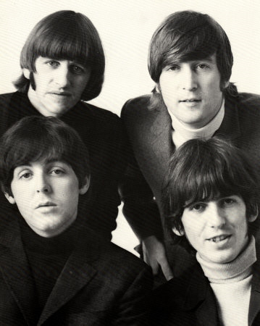
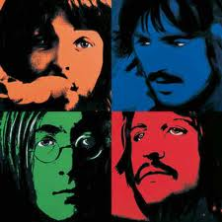

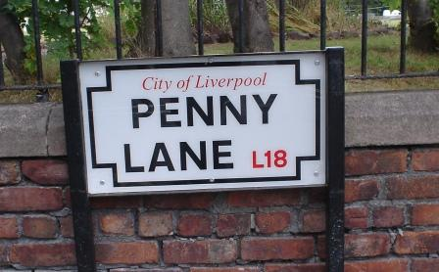

Teaching unit for upper school
(year six or seven)

Martina Fuchs

Methodology of Teaching Literature and Culture
(Fachdidaktisches Proseminar 4)
Dr. Elisabeth Pölzleitner

WS 2010/ 2011
1. Listen to the song and fill in the gaps.

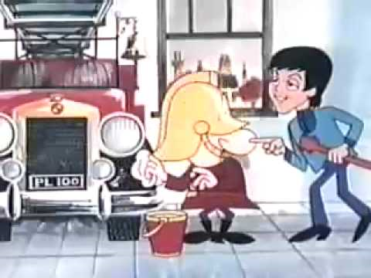
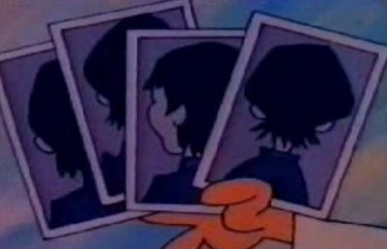
Penny Lane: there is a barber showing ____________________
Of every head he's had the pleasure to know
And all the ____________________ that come and go
Stop and say hello
On the corner is a ____________________ with a motorcar
The little _____________________ laugh at him behind his back
And the banker never wears a mac
In the pouring rain
Very ____________________
Penny Lane is in my ____________ and in my eyes
There beneath the blue suburban skies
I sit and meanwhile back
In Penny Lane, there is a fireman with an hour glass
And in his __________________ is a portrait of the ________________
He likes to keep his fire engine clean
It's a clean machine
Penny Lane is in my ears and in my eyes
Four of fish and finger pies in ____________________
Meanwhile back
Behind the shelter in the middle of the ____________________
The pretty _______________ is selling poppies from a tray
And though she feels as if she's in a _______________
She is anyway
Penny Lane: the barber shaves another ___________________
We see the banker sitting waiting for a trim
And the fireman rushes in
From the ____________________ rain
Very strange
Penny Lane is in my ears and in my eyes
There beneath the blue ____________________ skies
I sit and meanwhile back
Penny Lane is in my ears and in my eyes
There beneath the blue suburban skies
Penny Lane

Vocabulary:
barber: a man whose job is to cut men's hair and sometimes to shave them
mac: a coat which you wear to keep out the rain
pouring rain is very heavy rain
fire engine: fire truck (a special large vehicle that carries equipment and the people that stop fires burning)
poppy: a plant that has brightly coloured, usually red, flowers and small black seeds
trim: something is cut to make it look neater

2. Listen to the song again. Think about the following questions and discuss them with your partner.

Do you know it? Do you know the band?
___________________________________________________________________
Do you like it? Why? Why not?
___________________________________________________________________
What feelings are conveyed in the song and the tune?
___________________________________________________________________
What do you associate with the song?
___________________________________________________________________
Who do you think is the speaker, the”I” in the song?
___________________________________________________________________
Which characters are described in the song?
____________________________________________________________________________________________________________________________________________________________________________________________________________________________________________________________________________
What do you know about the characters? Can you make some assumptions about them?
____________________________________________________________________________________________________________________________________________________________________________________________________________________________________________________________________________
Have you heard about Penny Lane? How do you imagine that place?
______________________________________________________________________________________________________________________________________
Would you like to make any further comments on the song?
______________________________________________________________________________________________________________________________________

3. Paint the song. Take a piece of paper and express the ideas of the song in a painting. You can use all kinds of colours and styles – just be creative!

* 4. Write a short story: Slip into the role of the speaker of the song (1st person narrator) and write a short story based upon a experience with one of the characters mentioned in the song.
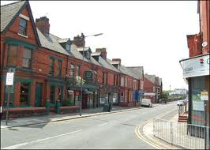
Describe the setting, use names, convey the characters’ moods by describing their behaviour. Use colourful verbs and effective adjectives. Consider why the described situation is relevant in the protagonist’s life.

!!! Remember the features of a short story:
- limited number of characters
- short moment in life, important situation
- one main action, limited places
- often open ending
- text starts with the action itself
- special event in the life of the charcters

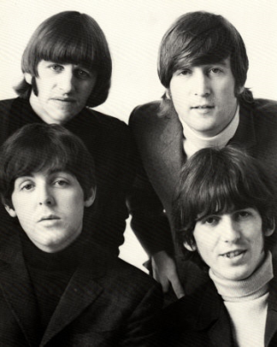
5. Read the background information on The Beatles and Penny Lane.

The Beatles
(http://en.wikipedia.org/wiki/The_Beatles ; abriged version)
The Beatles were an English rock band, formed in Liverpool in 1960, and one of the most commercially successful and critically acclaimed acts in the history of popular music. From 1962, the group consisted of John Lennon (rhythm guitar, vocals), Paul McCartney (bass guitar, vocals), George Harrison (lead guitar, vocals) and Ringo Starr (drums, vocals). Rooted in skiffle¹ and rock and roll, the group later worked in many genres ranging from pop ballads to rock, often incorporating classical and other elements in innovative ways. The nature of their enormous popularity, which first emerged as the "Beatlemania" fad, transformed as their songwriting grew in sophistication. The group came to be perceived as the embodiment of progressive ideals, seeing their influence extend into the social and cultural revolutions of the 1960s.
The Beatles achieved mainstream success in the United Kingdom in late 1962 with their first single, "Love Me Do". Gaining international popularity over the course of the next year, they toured extensively until 1966, then retreated to the recording studio until their break-up in 1970. Each then found success in an independent musical career. Lennon was murdered outside his home in New York City in 1980, and Harrison died of cancer in 2001. McCartney and Starr remain active.
The Beatles are the best-selling band in the history of popular music, and four decades after their break-up, their recordings are still in demand. They have had more number one albums on the UK charts, and held down the top spot longer, than any other musical act.
¹ Skiffle is a type of popular music with jazz, blues, folk and country influences, usually using homemade or improvised instruments.
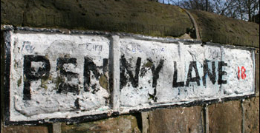

Penny Lane
(http://en.wikipedia.org/wiki/Penny_lane; abridged version)

"Penny Lane" is a song by The Beatles, written by Paul McCartney. The song was released in February 1967.
The song's title is derived from the name of a street in the band's hometown, Liverpool. Penny Lane is named after James Penny, an 18th century slave trader. McCartney and Lennon grew up in the area and they met at Penny Lane to catch a bus into the centre of the city. The street is an important landmark, sought out by most Beatles fans touring Liverpool. In the past, street signs saying "Penny Lane" were constant targets of tourist theft and had to be continually replaced. Eventually, city officials gave up and simply began painting the street name on the sides of buildings. This practice was stopped in 2007 and more theft-resistant "Penny Lane" street signs have since been installed though some are still stolen.
The shelter in the middle of the roundabout' refers to the old bus shelter, later developed into a cafe/restaurant with a Beatles theme. Today it is derelict and abandoned, despite its popularity as a tourist attraction.
The lyrics "Four of fish and finger pies" are British slang. "A four of fish" refers to fourpennyworth of fish and chips, while "finger pie" is sexual slang of the time, apparently referring to intimate fondlings between teenagers in the shelter, which was a familiar meeting place.

Now discuss in class:
Is it important to have heard about The Beatles and to know some of their songs? Why? Why not?
___________________________________________________________________
Think of your hometown. What are remarkable streets and places in Graz? Why?
_________________________________________________________________________________________________________________________________________________________________________________________________________

6. Found Poetry: Read the texts about “The Beatles” and “Penny Lane” again. Highlight 15 to 20 words you like in some sense (excluding articles, prepositions and conjunctions). Arrange the words into a new order to make a poem. (No extra words must be used but you may add articles, prepositions and conjunctions and change the tense of the verbs.) The topic of the song may be kept or changed.

7. Compose a situation poem for a street or place in Graz, similar in theme to “Penny Lane”. Think of a street or place you are familiar with and which you know well. Remeber experiences you had there, think of people you met there, use words and expressions you associate with that particular place, include feelings that come up when you think of that place/ street...
Look at the structure of Penny Lane (name of the street at the beginning of the stanzas,...) and change some words and sentences so that they match with the street/ place you describe.

Teacher’s notes:

- Packing list for painting the song: Bring blank sheets, watercolours, water soluble wax crayons, brushes, cups and rags to clean.
- The writing activities marked with an asterisk can be used as homework tasks. The other activites are planned for a class setting.
- Exercise seven should make the song more relevant for the pupils and involve them personally by linking the song with the pupils’ everyday life and surroundings. For this task, it might be good to collect ideas in a brainstorming session or in a mind map.

