Reading and Culture Project Oberstufe
“War Poetry”

Fachdidaktik PS 4:
Methodology of Teaching
Literature and Culture
SS 2010
E. Pölzleitner

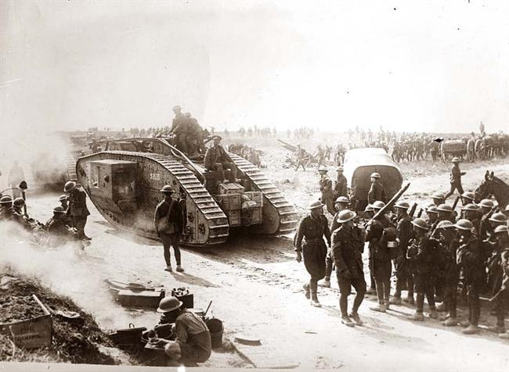
Armin Schmidhofer
0611431

Table of Contents

1. Packing List 3
2. Time – Rough Overview 3
3. Getting 'into' the Topic 4
4. Handout 4
5. Poetry On-Line 4
6. Reading and Discussing the Chosen Poem 5
7. Comparison of Poems 5
Handouts 5
Poems for Poetry On-Line 5

Additional Materials:

- Johnny I Hardly Knew Ye mp3s

Before you make a print-out copy remove header and footer! Careful, this may require you to adjust spacing and paragraphs. Other option: leave them and just empty them plus remove the frames. Even another option: fill in another text into header and footer. there are plenty of choices in life.

1. Packing List

- line
- cloth pegs
- paper
- oil crayons
- water colours
- brushes
- print-outs of poems (several copies)
- student handouts
- memory stick with song (or CD)

2. Time – Rough Overview

Times are merely estimates and have not been proven yet!
Listening to the song, getting into the topic, putting up the poetry line, reading, gathering thoughts, painting, discussing the paintings in small groups and then shortly presenting to the others will probably fill a whole period – if not more. The rest depends on how you want to organise it. If you want to discuss the writing tasks in class, that and the second group work will probably take up another period.

The best solution would, of course, be a double period, in which the students should be able to work on everything except the writing task.
So, in general: 2-3 periods.

3. Getting 'into' the Topic

To build up the right mood and introduce the topic a song might be a good idea. I would propose the 19th c. Irish anti-war song “Johnny I Hardly Knew Ye”. Lyrics are given at the beginning of the students' handout. (NB: There is also a more pro-war song form the US with the same melody and slightly different lyrics).

After having played the song once, you can distribute the handout and play it one more time so that the students can read along.

I have provided here three versions of the song: one traditional version by the Clancy Brothers (03:32), one punk-influenced version by the Dropkick Murphys (03:54), and one slow version by Glendalough (04:48). So if you are in the lucky position of knowing something about the music taste of your class, at least you have some choice.
Of course, you can replace this song with any other song you like.

4. Handout

REQUIRES: 'The' handout, i.e. all the stuff you find at the end of this paper.

Right at the beginning the student receive their handout that will guide them through this short poetry/ culture project.

5. Poetry On-Line

REQUIRES: Line/ string/ rope, cloth pegs, poetry sheets (one poem per sheet, several copies of each poem).

Suggestion for poems (see below; predominance of WWI):

“Anthem to Doomed Youth”, Wilfred Owen, 1917
“Futility”, Wilfred Owen, 1918
“The Charge of the Light Brigade”, 1854
“The Cherry Trees”, Edward Thomas, 1916
“Epitaph on an Army of Mercenaries”, A.E. Housman, 1922
“Another Epitaph on an Army of Mercenaries”, Hugh MacDiarmid, 1935
“'They'”, Siegfied Sassoon, 1916
“Glory of Women”, Siegfied Sassoon, 1917
“To his Love”, Ivor Gurney, 1919

The Titles of these poems have been covered with a black bar (needed for one of the activities). If you want to remove this bar just select the paragraph and change the backgroud colour to white/ no colour, or change the colour of the font to white - which will probably be even better from a stylistic point of view.

For further details see student handout.

6. Reading and Discussing the Chosen Poem

See student handout → Groups 1.

7. Comparison of Poems

See student handout → Groups 2.

The students are to group together with two people who have chosen different poems. NB: It will hardly be possible to end up exclusively with 3-student groups. As a teacher you just have to take care that the groups are not too big. But then again, we are talking about 16-year-olds, who might – maybe, perhaps, possibly – be responsible enough to be trusted with the self-organised group formation. Maybe ;-)

8. Writing Tasks

See student handout.

Handouts

A. Poems for Poetry On-Line

Anthem For Doomed Youth

What passing-bells for these who die as cattle?
Only the monstrous anger of the guns.
Only the stuttering rifles' rapid rattle
Can patter out their hasty orisons.
No mockeries now for them; no prayers nor bells;
Nor any voice of mourning save the choirs, –
The shrill, demented choirs of wailing shells;
And bugles calling for them from sad shires.
What candles may be held to speed them all?
Not in the hands of boys but in their eyes
Shall shine the holy glimmers of goodbyes.
The pallor of girls' brows shall be their pall;
Their flowers the tenderness of patient minds,
And each slow dusk a drawing-down of blinds.

Futility

Move him into the sun -
Gently its touch awoke him once,
At home, whispering of fields unsown.
Always it woke him, even in France,
Until this morning and this snow.
If anything might rouse him now
The kind old sun will know.
Think how it wakes the seeds, -
Woke, once, the clays of a cold star.
Are limbs, so dear-achieved, are sides,
Full-nerved, - still warm, - too hard to stir?
Was it for this the clay grew tall?
- O what made fatuous sunbeams toil
To break earth's sleep at all?

The Charge of the Light Brigade

Half a league, half a league,  Half a league onward,  All in the valley of Death  Rode the six hundred.  'Forward, the Light Brigade!  Charge for the guns' he said:  Into the valley of Death  Rode the six hundred.  'Forward, the Light Brigade!'  Was there a man dismay'd?  Not tho' the soldiers knew  Some one had blunder'd:  Their's not to make reply,  Their's not to reason why,  Their's but to do and die:  Into the valley of Death  Rode the six hundred.  Cannon to right of them,  Cannon to left of them,  Cannon in front of them  Volley'd and thunder'd;  Storm'd at with shot and shell,  Boldly they rode and well,  Into the jaws of Death,  Into the mouth of Hell  Rode the six hundred.  Flash'd all their sabres bare, | Flash'd as they turned in air  Sabring the gunners there,  Charging an army while  All the world wonder'd:  Plunged in the battery-smoke  Right thro' the line they broke;  Cossack and Russian  Reel'd from the sabre-stroke  Shatter'd and sunder'd.  Then they rode back, but not  Not the six hundred.  Cannon to right of them,  Cannon to left of them,  Cannon behind them  Volley'd and thunder'd;  Storm'd at with shot and shell,  While horse and hero fell,  They that had fought so well  Came thro' the jaws of Death,  Back from the mouth of Hell,  All that was left of them,  Left of six hundred.  When can their glory fade?  O the wild charge they made!  All the world wonder'd.  Honour the charge they made!  Honour the Light Brigade,  Noble six hundred!

The Cherry Trees

The cherry trees bend over and are shedding
On the old road where all that passed are dead,
Their petals, strewing the grass as for a wedding
This early May morn when there is none to wed.

Epitaph on an Army of Mercenaries

These, in the day when heaven was falling,
The hour when earth's foundations fled,
Followed their mercenary calling,
And took their wages, and are dead.

Their shoulders held the sky suspended;
They stood, and earth's foundations stay;
What God abandoned, these defended,
And saved the sum of things for pay.

Another Epitaph on an Army of Mercenaries

It is a God-damned lie to say that these
Saved, or knew, anything worth a man's pride.
They were professional murderers and they took
Their blood money and impious risks and died.
In spite of all their kind some elements of worth
With difficulty persist here and there on earth.

'They'

The Bishop tells us: 'When the boys come back
'They will not be the same; for they'll have fought
'In a just cause: they lead the last attack
'On Anti-Christ; their comrades' blood has bought
'New right to breed an honourable race,
'They have challenged Death and dared him face to face.'
'We're none of us the same!' the boys reply.
'For George lost both his legs; and Bill's stone blind;
'Poor Jim's shot through the lungs and like to die;
'And Bert's gone syphilitic: you'll not find
'A chap who's served that hasn't found some change.
' And the Bishop said: 'The ways of God are strange!

Glory of Women

You love us when we're heroes, home on leave,
Or wounded in a mentionable place.
You worship decorations; you believe
That chivalry redeems the war's disgrace.
You make us shells. You listen with delight,
By tales of dirt and danger fondly thrilled.
You crown our distant ardours while we fight,
And mourn our laurelled memories when we're killed.
You can't believe that British troops 'retire'
When hell's last horror breaks them, and they run,
Trampling the terrible corpses--blind with blood.
O German mother dreaming by the fire,
While you are knitting socks to send your son
His face is trodden deeper in the mud.

To His Love

He's gone, and all our plans
Are useless indeed.
We'll walk no more on Cotswolds
Where the sheep feed
Quietly and take no heed.
His body that was so quick
Is not as you
Knew it, on Severn River
Under the blue
Driving our small boat through.
You would not know him now…
But still he died
Nobly, so cover him over
With violets of pride
Purple from Severn side.
Cover him, cover him soon!
And with thick-set
Masses of memoried flowers-
Hide that red wet
Thing I must somehow forget.

WAR POETRY
When Love and Coral Lips Turn into Rifles and Funeral Bells

This handout is for you! Use it in order to profit from this little project on war and war poetry. See it as a present – even though it might be one you do not appreciate that much – and treat it as such.

Your task is to read, work, draw and talk yourself through this paper. It's as simple as that – which doesn't mean that it's not demanding at times. Yet, if you work hard you will definitely get something back... and we are not only talking about good marks, girls and guys.

0. Lyrics: “Johnny I Hardly Knew Ye”
While goin' the road to sweet Athy, hurroo, hurroo  While goin' the road to sweet Athy, hurroo, hurroo  While goin' the road to sweet Athy  A stick in me hand and a drop in me eye  A doleful damsel I heard cry,  Johnny I hardly knew ye.  With your drums and guns and drums and guns, hurroo, hurroo  With your drums and guns and drums and guns, hurroo, hurroo  With your drums and guns and drums and guns  The enemy nearly slew ye  Oh my darling dear, Ye look so queer  Johnny I hardly knew ye.  Where are your eyes that were so mild, hurroo, hurroo  Where are your eyes that were so mild, hurroo, hurroo  Where are your eyes that were so mild  When my heart you so beguiled  Why did ye run from me and the child  Oh Johnny, I hardly knew ye.  Where are your legs that used to run, hurroo, hurroo  Where are your legs that used to run, hurroo, hurroo  Where are your legs that used to run  When you went for to carry a gun  Indeed your dancing days are done  Oh Johnny, I hardly knew ye. | I'm happy for to see ye home, hurroo, hurroo  I'm happy for to see ye home, hurroo, hurroo  I'm happy for to see ye home  All from the island of Sulloon  So low in flesh, so high in bone  Oh Johnny I hardly knew ye.  Ye haven't an arm, ye haven't a leg, hurroo, hurroo  Ye haven't an arm, ye haven't a leg, hurroo, hurroo  Ye haven't an arm, ye haven't a leg  Ye're an armless, boneless, chickenless egg  Ye'll have to put with a bowl out to beg  Oh Johnny I hardly knew ye.  They're rolling out the guns again, hurroo, hurroo  They're rolling out the guns again, hurroo, hurroo  They're rolling out the guns again  But they never will take our sons again  No they never will take our sons again  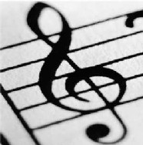  Johnny I'm swearing to ye.
1. Getting started, picking a poem

- Browse through the poems and then choose one that you like – because of the topic the style or any other reason.
- Here are some points you might want to consider:

  - Does your poem convey a rather positive or negative image of war?

  - How is the theme of war presented? Rather explicitely or implicitely? Is the poem more mysterious and obscure or clear and direct?

  - Which particular aspect of war is dealt with?

  - Who (if anyone) is talking in the poem?

  - Under which circumstances might the poem have been produced?

  - So far, have you just been reading through these questions and answered each of them as – let's call it – economically as possible? If you feel that you have to answer in the affirmative, you might wan to re-read your poem, Just write down the first words that come to your mind. Or do whatever else appears suitable to you – as long as it is productive and does not harm or annoy your classmates.
2. 'The' title

- As you might have noticed, the title of the poem is missing. Try to find a suitable title (not what you think the poem might be called, but simply how you would call it).

__________________________________________________________

If you want to know the 'real' title, it is...
…
…
… definitely somewhere on the internet.

3.a. The visual artist

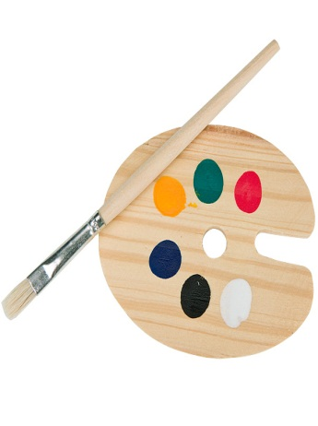
- Once you have thoroughly read your poem take a piece of paper. Now draw /paint your own reflections on the poem. Your drawings can be abstract or quite concrete, held in clear lines or blurred blots. Feel free to do what ever you like. Just try not to mess up your workspace – at least not too much, please ;-)

3.b. For the uncreative...
- Write down five adjectives to describe your poem. This is just, if you feel that your very personal muse of painting is busy somewhere else today. Otherwise, grip a pencil, a brush, an oil crayon and get started.

4. Groups 1

- Once you have gathered your thoughts, finished your oeuvre or – for the lazybones – completed your list of five adjectives (and hopefully they are good ones) you go together in groups with people who have chosen the same poem (which means, if you have chosen poem A and your neighbour has chosen poem C, one of you will probably have to move – unless you can bend time and/ or space).
- Now, have turns at looking at one of your colleagues' paintings and try to guess what she/ he thought felt when she/he designed the picture. Afterwards everybody may explain to the other groups members what he/ she really wanted to say with her/ his painting.
- Finally, present one of the pictures (or word lists) of your group to the other people in class. Just try to comment on them with a few words.

5. Groups 2
- Leave your old groups and look for people who have chosen a poem different from yours. Try to form groups with three different poems (some poems will probably be represented by more than one person).
- The topic 'war' can be dealt with in many ways. Looking at the three poems in your group try to find out what they have in common and in which ways they are unique in their treatment of war.
- If you want to, you can use the three-circle system below to organise your ideas.
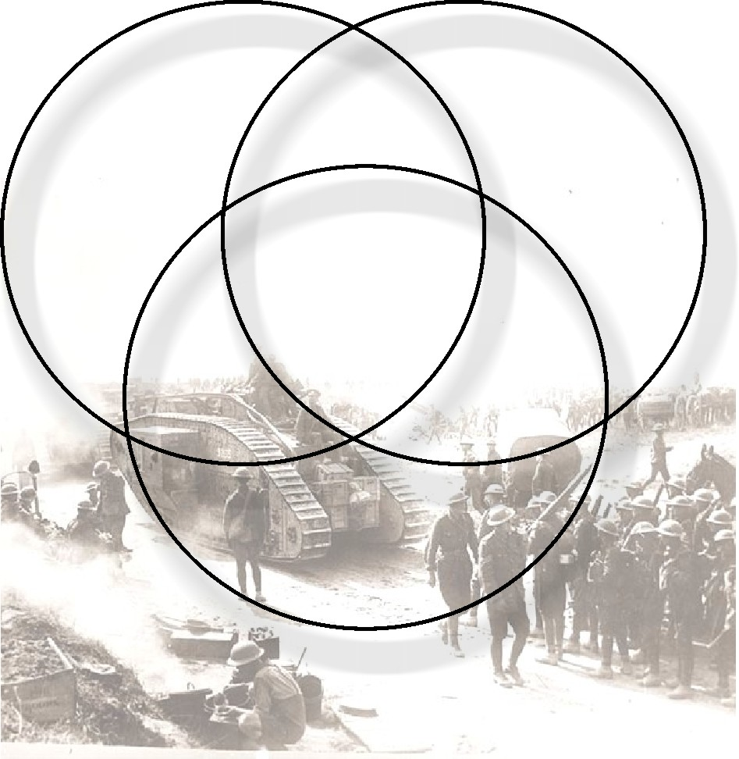

6. The pen is mightier than the sword....

Choose one of the following writing tasks:

- Re-read the poem you picked at the beginning and respond to it in words. You can react directly to the speaker of the poem or its author; you can write a letter, a short essay, or even a dialogue. What is important is that you either criticise the poem and/ or voice your own thoughts and feelings.
- Write your own poem. As you will – hopefully – never have been exposed to war yourself, you might draw inspiration from news reports, stories, photos or paintings. If you feel that you cannot identify with the topic of war at all, you may also write a poem about your experience with violence, hate or anger in general.
- Why war? (This task might sound a little strange at first, but still, give it thought – it's actually worth it!) Imagine you met someone who had never even heard of the concept of war. This person is asking you two very simple questions: What is the idea behind/ the use of war? And why do humans lead wars? Write a short essay or response letter.

