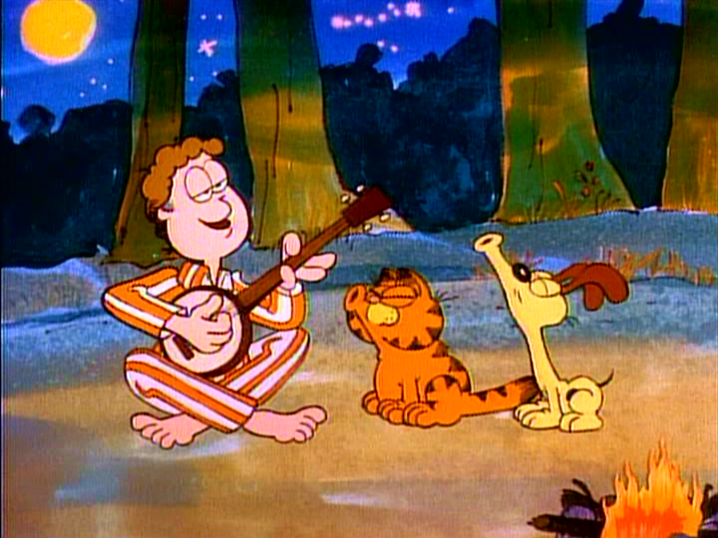

Garfield in the Rough

1. Garfield in the rough
- How many characters are there? ____________________________________
- Who is speaking? _______________________ _________________________
- Where are they? __________________________________________________
Use one colour for each character (Person) and underline what they say.

You know, boys, everything a man needs is provided by the wilderness. Man doesn’t need much. Just give me a sunset. Give me a sunrise. Give me a tent, give me some wood. Give me an old plaid (kariert) shirt. I’m feeling so good. Just give me a compass. Some jerky (Dörrfleisch), that’s tough (hart). That’s all I need to get by when I’m out in the rough. Give me my catnip (Katzenminze), a sofa to scratch (kratzen). Give me lasagna, make it a triple batch (dreifach Ladung). Give me a pillow with plenty of fluff (Fussel). That’s all I need to get by when I’m out in the rough. Good morning. Good morning rangers. Name. Jon Arbuckle. How long will you be staying? We will be staying a week. A week? I will be covered with moss (bedeckt mit Moos) in a week. Is that your cat? Yes, it is. My condolences (Beileid).

2. Garfield must get some water
- Watch without sound. Guess what Garfield says and write it down.

Jon: Here, Garfield. Take the coffee pot down to the lake and fill it with water.
Garfield: ______________________________________________________
Jon: Odie, get out of there. Come on, shoo, boy. Go on.
Garfield: ______________________________________________________
Jon: Good boy, Garfield.
Garfield: ______________________________________________________

- Now watch the scene again with sound on and check if you have guessed correctly.

3. In the Morning
- Student A:
Blindfold your partner. Watch the “Morning scene” and tell your partner what you have seen.

- Student B:
Find out what is happening in the morning.
Ask the following questions:
Where does Odie sleep?
___________________________________________________________
How does Odie wake Jon?
___________________________________________________________
What does Jon do?
___________________________________________________________
Where is Garfield?
___________________________________________________________

4. Wild Animals!
Odie and Garfield go for a walk. They find out that a wild animal is at the lake.
- Student B:
Blindfold your partner. Watch the Wild Animals scene and tell your partner what you have seen.

- Student A:
Find out what Odie and Garfield are doing.
Ask the following questions:
What are Garfield and Odie doing?
___________________________________________________________
Are they happy?
___________________________________________________________
What does the forest look like?
___________________________________________________________
Is it daytime or night-time?
___________________________________________________________

5. A deadly panther!!!
Jon, Garfield and Odie are sitting by the fire and listening to the radio when a news bulletin is broadcast, “The deadly panther which escaped from the local zoo this morning has been seen in the Lake Woebegone area. All residents are warned to stay inside until the beast has been captured.”

- Discuss with a partner what is going to happen next?
- Guess the pictures! The first one who guesses right gets the picture. You can ask the teacher questions about the picture, but she can only answer YES/NO. She removes one label for each yes until you can guess the identity of the scene. Everyone has only three guesses per picture.

picture 1: _____________________________________________________
picture 2: _____________________________________________________
picture 3: _____________________________________________________
picture 4: _____________________________________________________
picture 5: _____________________________________________________
picture 6: _____________________________________________________

6. The Panther Attacks!
Watch the last scene (without sound) and put the sentence strips in the correct order. Then write the story. In the end watch the scene again with the sound on.

7. Summary
Work with a partner and write a short summary of “Garfield in the Rough”. You can use the following words/phrases:

- like/hate camping
- Lake Woebegone
- tent
- water
- to sit by the fire
- to listen to the radio
- panther
- to escape from
- to jump
- in the morning
- to lick
- to run
- to attack
- car
- to get angry
- to scratch
- to bite
- to save somebody’s life

8. Homework
Have you ever been camping? Write a short story (~ 100-150 words). If you have never been camping you can invent a story. You can use some words from the list below.

Some useful words:

- tent
- sandwiches
- forest
- radio
- owl (Eule)
- deer (Wild, Reh, Hirsch)
- snake
- campfire
- to start a fire
- sleeping-bag
- to barbecue
- to collect mushrooms
- to observe (beobachten)
- ranger

Garfield in the Rough (for the teacher)

To do before the lesson

Activity 1 Garfield in the rough
“From transcript to voice”
- Read out the tasks
- discuss the answers with the whole group
- show the scene: 00:05:47 – 00:06:48

Activity 2 Garfield must get some water
“Half the dialogue”
- pupils fill in the gaps
- discuss findings with a partner
- show the scene: 00:07:50 – 00:08:23

solutions:
Jon: Here, Garfield. Take the coffee pot down to the lake and fill it with water.
Garfield: Your wish is my command, master.
Jon: Odie, get out of there. Come on, shoo, boy. Go on.
Garfield: Here’s your water, master.
Jon: Good boy, Garfield.
Garfield: Yes, master. Thank you, master.

Activity 3 In the Morning
“Video commentary”
- show scene: 00:12:10 – 00:13:00

Activity 4 Wild Animals
“Video commentary”
- show scene: 00:18:45 – 00:19:37

Activity 5 A Deadly Panther
“Paper the OHT”
- cut up copies of the pictures as prize
- copy the pictures on OHT; stick post-it labels all over the pictures
- pupils discuss what is going to happen next (5 min)
- pupils guess the situation; every pupil has 3 guesses per picture
- you can only answer YES/NO
- the first pupil who identifies the scene wins the picture

Activity 6 The Panther Attacks
“Silent viewing + strip story”
- cut up the story
- show the last scene (without sound): 00:19:46 – end
- pupils have to put the sentence strips in the correct order
- compare solutions
- pupils write down solution

solution
In the evening Jon, Garfield and Odie were sitting by the fire.
Suddenly, a deadly panther appeared.
Jon, Garfield and Odie ran away.
Garfield climbed a tree.
Jon and Odie tried to hide in the tent, but the panther found them and they locked themselves in the car.
The panther attacked the car and Garfield got angry.
He jumped from the tree right on the back of the panther and bit him and scratched him.
He saved Jon’s and Odie’s life.
Then the rangers came and caught the panther.
Jon, Garfield and Odie were saved and drove home.

Activity 7 Summary
- pair-work
- pupils write summary with the help of some key-phrases/words

Homework
- pupils tell their own story or invent one

