Portfolio for
Fachdidaktik Proseminar 4
Methodology of Teaching Literature and Culture

Elisabeth Draxler
Matr.-Nr: 0512348
SS 2009
Film project: Bend it like Beckham
Class: 6th form
Goals:
- Cultural awareness (minorities, prejudices, typical gender roles,…)
- Listening skills
- Promote creativity
- Speaking and presentation skills
The pupils keep a portfolio for this film project in which they collect their texts.
- Activities
Pre-watching
Show task on overhead transparency
Activity 1:
Write a diary entry into your portfolio about the career of your dreams. Include the following questions:
Why do you want to have that job?
Do you think your dream is realistic?
Which problems will you encounter?

Activity 2
Groups are randomly formed by counting from 1 to the numbers of pupils divided by 4 (depending on the number of pupils) by the pupils themselves. Thus every pupil gets a number and all the pupils with the same numbers form a group.
In groups of 4 discuss the following topic:
What are the “perfect” parents like? Do they really exist? How much control over your live should they have? Do you always do what your parents tell you to do? Do parents really know best? Do you have older or younger brothers and sisters? Which role do they and you play in the family?....
Produce a mind map in your group, which every group member can copy, and put it into your portfolio.

Activity 3
Step 1 “I”: Look at the picture for a short time and make some notes what it may be about.
Step 2 “YOU”: Get together in groups of 4 and compare your ideas.
Step 3 “WE”: The groups briefly present their ideas.


Source: http://johndrake.typepad.com/.a/6a00e008cf8b5c883400e553dee8868833-800wi
While-watching
Activity 4: During the whole movie: The pupils are randomly assigned to groups by drawing a card: Task: Especially watch out how these topics are treated in the film and make note.
Group 1: Women in Football + Homosexuality
Group 2: Family + Generation conflict
Group 3: Multiculturalism + Religion
Group 4: Sports + explicit/implicit racism

Activity 5: Minutes ~00:02 – 00:05: sound off – vision on
Jess is shopping with her sister and Jules is shopping with her mother.
What are the girls talking about? What do their facial expressions indicate? Are there similarities?

Activity 6: Minute ~00:17 Freeze frame
Jess is sitting beside the field and obviously does not want to join the training. Joe joins her. Stop the film.
What do you think will happen next?

Activity 7: minutes 00:18 -00:20 Vision off – sound on
The girls have their football training and the only sound you can hear is Tom Jones’ song “She’s a lady”.
What do you think is going on? How does the song fit into the movie (is it
similar to the other songs you have heard so far in the movie? Why?/Why not?)?
Is there any girl/women in the movie which could possibly be referred to
with “She’s a lady”?

Activity 8: minutes 00:55 – 00:58 sound off – vision on
In the scene Jess visits Jules and they talk about their relationship with Joe, their coach, but they do not mention his name. Jules’ mother overhears the conversation and thinks that the girls are talking about their relationship with each other and concludes, that they are lesbians and used to be a couple until Jess broke up.
Task
What are the girls talking about? Why is Jules’ mother so sad?

Activity 9: Minutes ~ 01:21 – 01:26: Scene of the wedding/the final football game
Together with a partner: One turns his/her back towards the screen, the other one is sitting opposite facing the TV. The sound remains on. Nobody is talking in that scene, there is only music. The pupil watching the film tells the other one what can be seen.
At the end of the scene Jess takes a penalty kick and in her mind the defenders are replaced by members of her family. The pupils should discuss the following questions with their partner:
- Why have the defenders been replaced by members of Jess' family?
- What does this “wall” stand for?
- What do the family members represent?
- Is this scene related to the title?
- Which role does the music play

After-watching
Activity 10 - Crosswords
Find the following words in the crossword. Choose 7 of them and write 2-3 sentences about which role they play in the movie. Then choose 5 of them (you may also choose the same that you chose in the first part) and write 3-5 sentences about your personal attitude, experience,… concerning this word.
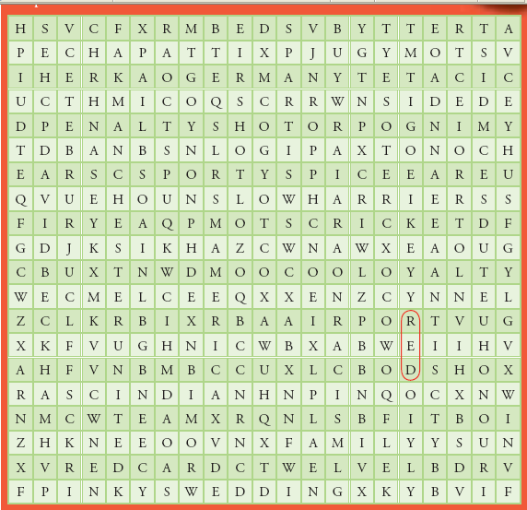
Source: http://www.hi.com.au/engproj/pdf/HEPBeckham1.pdf
Airport, America, chapatti, cricket, David Beckham, family, Germany, honour, Indian, knee, loyalty, Manchester United, Mel C, Paxton, penalty shot, Pinky’s wedding, racism, red, red card, Sikh, soccer boots, Sporty Spice, team, Teetu, twelve

Activity 11 – running dictation
The pupils get together in pairs and do a running dictation together. One of them is responsible for the equal numbers, the other one for the others. They have to walk around in class, try to remember one quote and dictate it to their partners. After that they should find out to which characters the quotation belongs and write 2-3 sentences how the quotation shows the character’s attitudes.
- Anyone can cook aloo gobi, but who can bend a ball like Beckham?

- When are you going to realize you have a daughter, with breasts, not a son!

- You know, Jesminder, I cooked a lovely curry the other day.

- Anyway being a lesbian's not that big a deal.
Oh no, of course not sweetheart. I mean I've got nothing against it. I was cheering for Martina Navratilova as much as the next person.

- Your sister's getting engaged and you're sitting here watching this skinhead boy!

- What family would want a daughter-in-law who can run around kicking football all day but can't make round chapattis?

- You're lucky to have a family that cares that much about you. I can understand you don't want to mess with it. And I don't fancy being busted by your dad again. You better get back.

- Letting me go to America is a really big step for my mum and dad.

- Your mum's a barrel of laughs compared to my dad.
Activity 12: 3 options
* Imagine you are one of Jess’ parents and write a letter to your relatives in India describing the recent events in your family and what you think about it.
* Imagine you are Jules’ mother and write a diary entry about your daughter, all your worries and the latest events.
* Imagine you are Jess or Jules and write a letter from America to your family in Great Britain about your experiences so far.

Activity 13
Get together in your groups and discuss your findings. Try to find additional information to your topic on the internet and answer the following questions. Finally give a short presentation on your topic.
Group 1: Women in Football + Homosexuality
Is the acceptance of women in football the same around the world?
Is homosexuality accepted in the movie? An older woman at the wedding says: “Lesbian? Her birthday's in March. I thought she was a Pisces.” Do you think that reaction is typical for the older generation?
Group 2: Family + Generation conflict
What does Jules’ mother mean when she says: ”All I'm saying is, there's a reason why Sporty Spice is the only one without a fella!”
Which role does your family play concerning the decisions you make?
Group 3: Multiculturalism + Religion
Find advantages and disadvantages of multiculturalism. Why is Britain such a multicultural country?
Group 4: Sports + explicit/implicit racism
With which sports can you earn a living?
Take a closer look at that quotation. Who is talking? Find out why this conversation is important.
…: Look, Jess. I saw it. She fouled you. She tugged your shirt. You just overreacted, that's all.
…: That's not all. She called me a Paki. But I guess that's something you wouldn't understand.
…: Jess, I'm Irish. Of course I understand what that feels like.*
(*Quotation taken from: http://www.imdb.com/title/tt0286499/quotes)

- Lesson Plan
 | Time | Activity
1st lesson | 20 minutes + 15-20 minutes +10-15 minutes | Pre-watching activities 1+2 +3
2nd lesson | 50 minutes / every activity about 5-7 minutes | Watch movie / activities 5, 6 and 7
3rd lesson | 50 minutes / every activity about 5-7 minutes | Watch movie / activities 8 and 9
4th lesson | 30 minutes  20 minutes | Finish the movie  Activity 11, running dictation  Homework: activity 12
5th lesson | 20 minutes  30 minutes | Activity 10  Activity 13: group work
6th lesson | 10 minutes  40 minutes | Finish group work  Presentations of groups

