Portfolio

for

Fachdidaktisches PS 4
Dr.phil. Elisabeth PÖLZLEITNER

SS 2009

Written by: Markus OBERLÄNDER

Matr. Nr.: 0510283

Studienkennzahl: 344

Date of submitting: 20.07.2009
Content
1st task 3
Film: The Incredibles 3
Lesson Plan 3
Activities 5
2nd task 10
Book 10
Steps 10
Activities 13

1st task

Film: The Incredibles
4th form AHS, 13 students
Goals: Speaking: be able to discuss and work with other students actively in class and in groups
Listening: understand American English spoken by Native speakers and work with
Grammar: revise all tenses and grammar
Vocab: students should be able to actively use the learned vocabulary

Lesson Plan
for the first 25 film-minutes

1st lesson:
5’: Show trailer on DVD (duration 2min.)
5’: what is the name of the film? How many students know the film? What kind of film is it?
10’: 1st activity: pre-watching
group work – groups of 4
5’: collect information on blackboard
5’: watch first 4 minutes
10:’ 2nd activity pre-watching
pair work
5’: Show video and solution

2nd lesson:
5’: Short revision of the last lesson, what happened until now
10’: Show minutes 05 - 15
5’: explain activity 3 and show minutes 15 - 18
25’: 3rd activity: Grammar revision after-watching
Group work – 4 groups
3rd lesson:
5’: watch minutes 18 – 23
5’ explain activity 4 and show minutes 23 – 25
15’: 4th activity: listening and writing while / after-watching
Pair work

How the lesson plan would continue:
3rd lesson:
20’: watch movie minutes 25 - 45
5th activity: while watching
4th lesson:
45’ watch movie minutes 45-90
Homework: 6th activity after-watching
5th lesson:
15’: students can read their homework
15’: finish watching film
5’: final discussion about the topic -> did students like the movie…

Activities

1st activity:
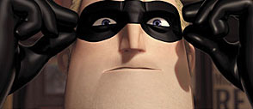
Think of all superheroes you know.
Give their names, show their strength and weaknesses and if possible name their enemies.
Where do they live?
Are these comics or real life actors – or both?
Use your exercise book

2nd activity (04:30 – 05:18):
You know, you can tell a lot out of a woman by the contents of her purse but maybe that’s not what you had in mind hey look Elastigirl Mr. Incredible no it’s alright I’ve got him sure you got him I just took him out for you sure you took him out his attention was on me a fact I exploited to do my job my job a simple thank you would be suffice thanks but I don’t need any help whatever happened to ladies first whatever happened to equal treatment hey look wait the lady got me first well we could share you know I work alone well I think you need to be more flexible

Solution:
You know, you can tell a lot out of a woman by the contents of her purse but maybe that’s not what you had in mind hey look Elastigirl Mr. Incredible no it’s alright I’ve got him sure you got him I just took him out for you sure you took him out his attention was on me a fact I exploited to do my job my job a simple thank you would be suffice thanks but I don’t need any help whatever happened to ladies first whatever happened to equal treatment hey look wait the lady got me first well we could share you know I work alone well I think you need to be more flexible

How many characters are in the text? _________________
Do you know their names? __________________________
Who is speaking which part? _________________________
About what? _____________________________________
Where are they?___________________________________
Use one color for each character (Person) and underline what they say.

3rd activity (15:40 – 17:25):

Grammar revision
1st group: describe the scene
2nd group: present activities: what is going on right now?
3rd group: recent events: what must have happened in the scene before?
4th group: prediction: what is going to happen next?

4th activity (23:40 – 24:35):
Work in pairs:
Watch the scene without sound and put the sentence strips in the correct order.

Solution:
I thought you’d be back by 11
I said I’d be back later
I assumed if you came back at all you’d be back later.
Well, I’m back – OK?
Is this rubble? (Geröll)
It was just a little workout. Just to stay loose.
You know how I feel about that. We can’t blow cover again.
The building was come down anyway.
What? You knocked down a building?
It was on fire! Structurally unsound.
Tell me you haven’t been listening to the police scanner.
I performed a public service. You act like that’s bad.
It is a bad thing – Uprooting our family again, so you can relieve the glory days is a bad thing
It’s better than acting like they didn’t happen
Yes they happened, but this, our family is what’s happening now, Bob. You’re missing this!

5th activity:
Culture comparison:
- Spot three differences between your town / home / family and the video
- Find three similarities

6th activity:
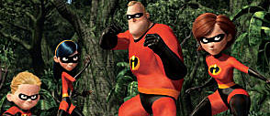
Construct the story until the end in ten sentences.

2nd task

Book
Bryson, Bill (2001): The lost continent. Travels in small-town America. Perennial: Harper.

Reading project for 7th form AHS

Steps

1st step: Research – Reading diary
Look up on the internet what is meant by “Travel literature”
Do you know any books which deal with travel literature?
If so, which?
If not, do you think you might be interested in reading a book before going on holiday to a specific country? Which advantages can that have?

2nd step: Buying the novel
Visit Amazon.com or go to the English Bookshop to buy the following book:
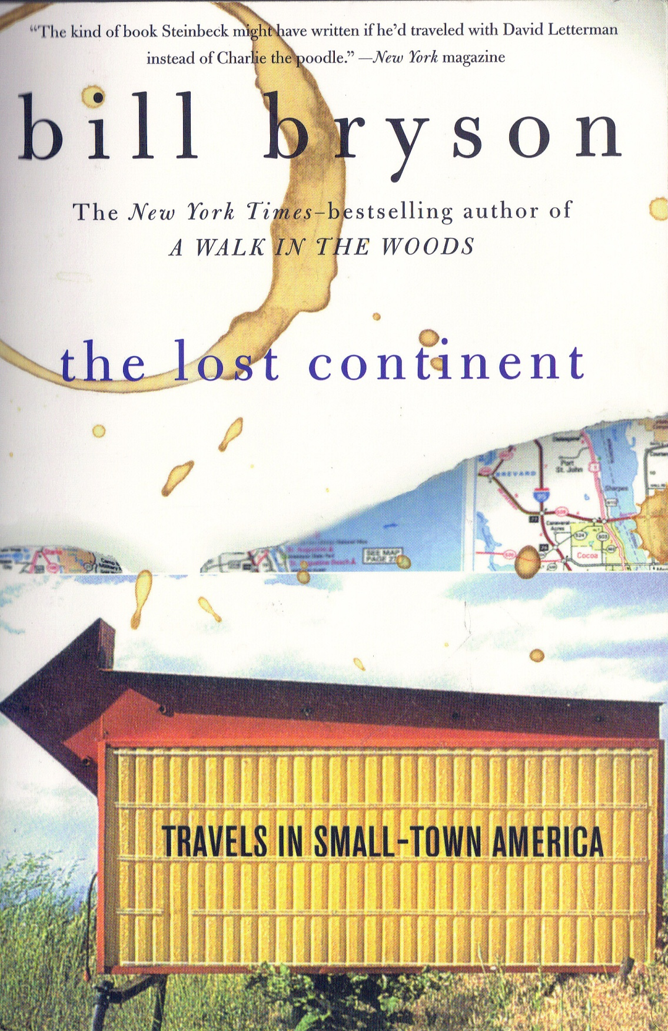
Bill Bryson: The lost continent. Travels in small-town America

Read the brief plot summaries and some readers’ comments.
Write a short diary entry: What do you expect from the book? What might be the content? Do you think you’ll like it? Why?

3rd step: While-reading through the whole book
The teacher has given you an A3 map of the U.S.
Draw Bryson’s journey on the map. Note: only the bigger cities are marked in the map – try to follow his route as well as possible.

4th step: Readers conference and workshop tasks
1. Work in your group and share your reflections and questions. Read each other’s diaries and try to answer each other’s question. Ask your teacher for help in case of disagreement or open problems.
2. In each reader’s conference choose 10 vocabulary items that you would like to remember and write them into your vocabulary book.
3. Do the workshop tasks carefully and collect all the tasks in a folder

5th step: Preparing the presentation
One activity will be a presentation task – an extra sheet is provided
Distribute the work load evenly among the group members.

6th step: Project folder
Organize your project folder and hand it in for final assessment. Also hand in your reading diary.

Activities
Activity 1: Getting Started – Reading diary
“Travels in small-town America”
What can be meant by this title? Isn’t the US one of the largest countries of the world with mega-cities? – Comment on it.

Activity 2: Entry for your reading diary
The author describes his journey to the US 25 years after he had left the country.
Imagine what your hometown would look like in 25 years.

Activity 3: Oral group presentation
4 groups with 4 students each
Group presentation is on the XX.XX.2009
Book p.4 – p.42
Get together in groups of 4 and carefully prepare your topic

In class discussion: One group includes one student per topic
Group work: 1. “John Deere and the Rednecks” – what is meant by that – describe them in detail
2. Describe the land in detail and show it on your map
3. White collars – who are they and where can they be found?
4. The land in Great Britain – culture shock to the US? Describe main differences

Activity 4: Entry for your reading diary
“How do the descriptions in the book differ from what you can see in TV series and movies? Or are they the same?”
Find 5 main differences/similarities throughout the whole book”
Activity 5: Readers’ Conference
See step 3
Discuss the first 3 activities in your group

Activity 6: Written entry to reading diary (app. 250 words)
p.14-20
small cities are described (gas station, grocery & grain elevator)
Would you like to live in such a city or would you rather like to live in a mega city like New York or LA? Why?

Activity 7: Group & class discussion
p.31
“Where do you come from, honey?”
“Great Britain.”
“Well, I’ll tell you one thing, honey”, she said, “for a foreigner you speak English real good.”
Comment on this in your group
What might be the problem for the misunderstanding?
Has anybody experienced something like that somewhere else?
Have you heard the following dialogue:
“Where do you come from?”
“Austria”
“Ah – Australia! Beautiful country”

Activity 8: Answer the following questions
Use your reading diaries, your memory and the internet to answer the following questions.
1. What do we learn about the author?
2. Why did he emigrate to England and then came back to the US?
3. What is his home state and where did his parents live?
4. Did he recognize everything while travelling through his home state?
5. Can he identify himself with the people there?
6. How does he describe the land?
7. He names one example how life is in his home town – comment on it
8. How does he describe the people in his home state?

Activity 9: Read the transcript of a TV scene and comment on it
From: Blue Collar TV – Season 1
“Politically corrected up fairy tales – Little Red Riding Hood”
Well, are you kids ready for this?
My little niece brought home the other day, this book full of fairy tales. It’s been all politically corrected up. That’s right. Now in this country, I guess, fairy tales are offensive for the kids.
So I’d like to tell one for you now.
It’s the story formerly known as “Little Red Riding hood”. It’s now called “Vertically challenged Native American Riding hood and the endangered wolf”
Once upon a time, Vertically challenged Native American Riding hood wanted to take a vacation at her chronologically advanced grandma’s house. On the way, she ran into a wolf that had recently been put on the endangered species list. “Hey where are you going Vertically challenged Native American Riding hood?” said the wolf. “I am going to my grandma’s house for a togetherness celebration”. The wolf told Vertically challenged Native American Riding hood a shortcut to grandma’s house. Unfortunately the shortcut was through federally protected wetlands. So Vertically challenged Native American Riding hood was fined for disturbing the fragile ecosystem. When she finally got to grandma’s house she saw that Grandma looked much different than usual but accepted and celebrated their differences.
“What plus-sized eyes you have, Grandma”. “The better to see and not judge you with”
“And what plus-sized teeth you have, Grandma”. “The better to eat you with – but I can’t, because I’m a vegetarian. And I also have Irritable Bowel syndrome”

Irritable Bowel syndrome – and he doesn’t even eat her. I tell you what, this book is full of tree huggers and tofu-farting fairies.
I tell you how it ends right there: I walk into Grandma’s house, shoot the wolf, chuck Grandma in old folks’ home, get Little Red Riding hood out of that hood and we shack up eating wolf steak.
Now that’s a fairy tale!
Mark all the politically-corrected phrases you can find
Find appropriate “normal” phrases for them
Activity 10: Discussion
Why is political correctness so important in the U.S.?
Does the whole country suffer from problems or only some areas? Which?
Discuss in your group and then discuss your findings in the whole class

Activity 11: Entry for your reading diary
p. 244-260
“Here’s a riddle for you. What is the difference between Nevada and a toilet? Answer: You can flush a toilet.
Nevada has the highest crime rate of any state, the highest rape rate, the second highest violent crime rate (it’s just nosed by New York), the highest highway fatality rate, the second highest rate of gonorrhea (Alaska is the trophy holder) and the highest proportion of transients – almost 80 percent of the state’s residents were born elsewhere. […] So you may understand why I crossed the border from Utah with a certain sense of disquiet. But then I got to Las Vegas and my unease vanished.”
What do you think after having read these lines and the following chapter?
What makes Las Vegas so special? Give examples (you may also describe your own experience)

Activity 12: Entry for your reading diary
p. 298
“Well that was my trip, more or less. I visited all but ten of the lower forty-eight states and drove 13.978 miles. I saw pretty much everything I wanted to see and a good deal that I didn’t. I had much to be grateful for. I didn’t get shot or mugged. The car didn’t break down. I wasn’t once approached by a Jehovah’s Witness. I still had sixty-eight dollars and a clean pair of underpants. Trips don’t come much better than that.
Now, after reading this book about America, which part did YOU like best? Why?

Activity 13 – Reader’s conference
p. 298
My gaze drifted idly over the box scores from the previous day’s games and I realized with a kind of dull shock that I didn’t recognize a single name. It occurred to me that all these players had been in junior high school when I left America. […] Who do I think I was fooling? I was a foreigner now. […] The waitress gave me a sideways look that was suspious and yet friendly. “Say, you don’t come from around here, do ya?” she said. I didn’t know how to answer that. “No, I’m afraid I don’t,” I replied, just a trifle wistfully. “But, you know, it’s so nice I sometimes kind of wish I did.”
What does the author maybe want to tell us in his last sentence?
Discuss this question in your group

Activity 14: After reading – written work for reading diary
Have you ever been to the U.S.?
If yes: Are there any similarities to what you have seen? Which?
If no: After reading this book, would you like to visit the US? Why?”

Activity 15: After reading – written work for the reading diary
Write a letter to the author telling him your feelings about the book after reading it. Would you like to take the same journey? Did you like the style of writing? Did you like the genre? Are you going to read more of his books? Give reasons.

Activity 16: Final project – Fächerübergreifend with Geography
Duration: 3 lessons Geography, 3 lessons English (Computer room if necessary), homework
Plan a 2 week visit to the US – which Cities, Places, Parks do you want to visit and why?

Plan a journey you really want to do.
Observe distances and time.
Include photos, background information and the approximate costs for your journey.
Search for flights, hotel rooms, entry fees,… to create a real journey.
Decide whether you go by car (rental car, hotels?, camping?)
by RV (camping?)
by bus and train (stops, transportation)
Decide whether you want to have a rather cheap or rather expensive holiday

Layout:
1 Road-map per day (app. km, cities you visit, app. roads you use, starting point, final point)
1-2 pages per day with short background information, photos

Hand in your project with your folder on XX.XX.2009

